

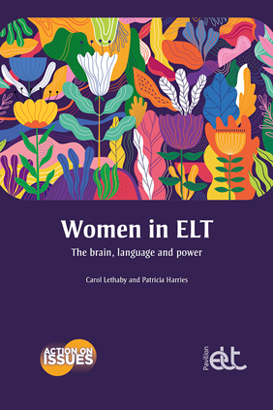

Launching the Action on Issues series, Women in ELT explores how and why sexism and gendering is so prevalent in English language teaching, and offers practical ways to combat it.

Gender inequality has far-reaching historical roots across much of society, and the story of women’s status and position in ELT is an intrinsic part of this complex history. In this thought-provoking book, Carol Lethaby and Patricia Harries explore how gender inequality applies to ELT, arguing that by looking at the origins of the patriarchal system and making connections between the history of the English language and gender inequality within the ELT industry, we can shine a light on the reasons for the existence of this far from simple problem.

Part 1 provides an accessible, evidence-based exploration of the history, theory, neuroscience and current circumstances that make sexism and gendering so prevalent. Part 2 develops these themes further, giving examples and applications to English language teaching and learning. The book then offers practical ways for teachers and teacher educators to face these issues in their own contexts – both within the classroom, and in the wider ELT industry. As well as drawing on their own experiences, the authors have interviewed several prominent ELT professionals.

There are no easy answers; but Women in ELT provides accessible evidence-based research and discussion alongside practical ideas and strategies for making a difference.

Form more information click here.



