Halloween Reading Club from OUP

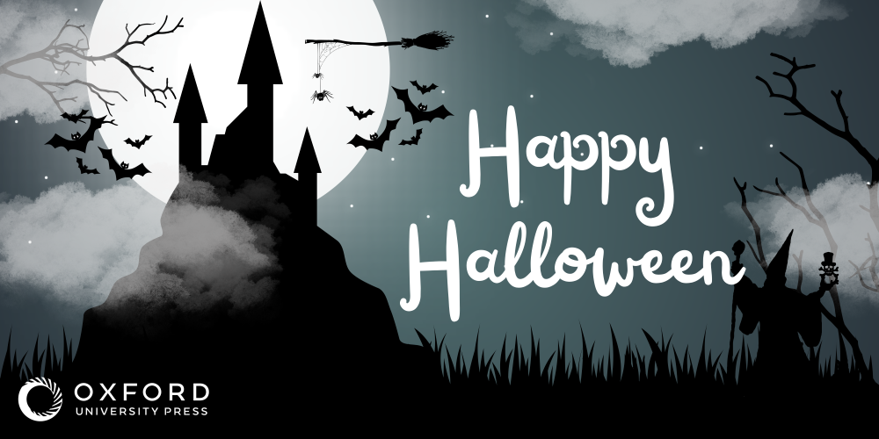

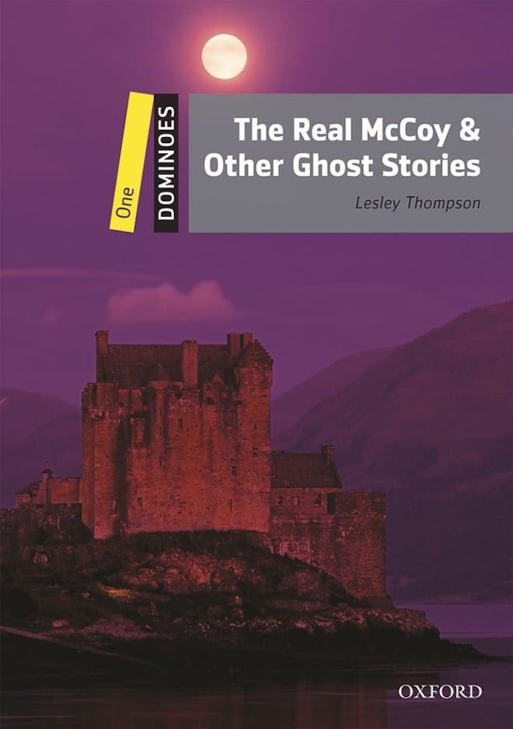

The Real McCoy & Other Ghost Stories
Dominoes Level 1, CEFR A1,A2

'Are you scared, Gordon?' asks Heather. Four friends talk of ghosts in a hotel in Scotland. That night Gordon sees and hears something strange in his room. But is it really the ghost of Lord McCoy? These six stories tell of ghosts – friendly, sad, and bad – from Britain, Australia, New Zealand, America – and Egypt!
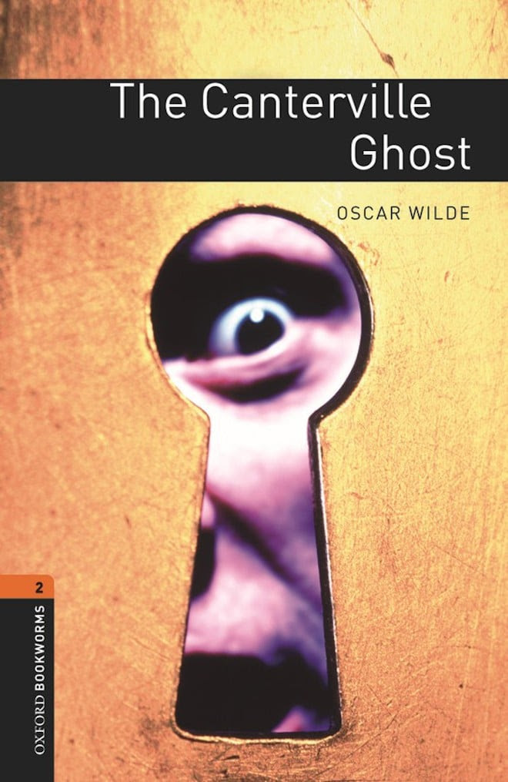
The Canterville Ghost
Bookworms Level 2, CEFR A2,B1

There has been a ghost in the house for three hundred years, and Lord Canterville’s family have had enough of it. So Lord Canterville sells his grand old house to an American family. Mr Hiram B. Otis is happy to buy the house and the ghost – because of course Americans don’t believe in ghosts.

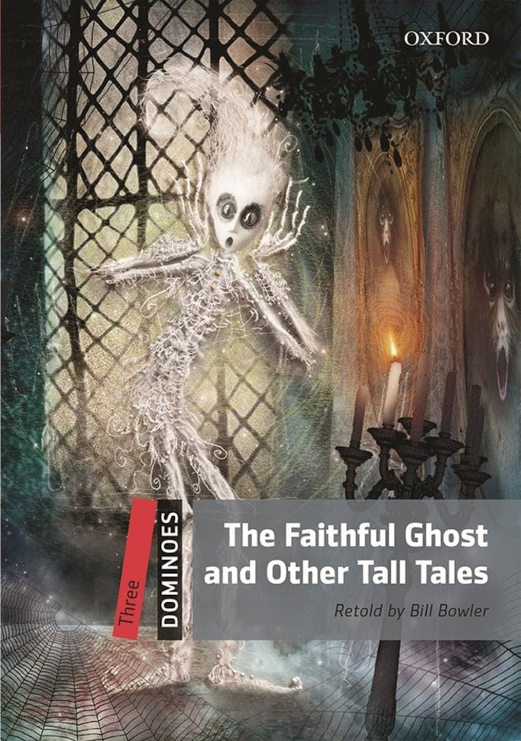

The Faithful Ghost and Other Tall Tales
Dominoes Level 3, CEFR B1

A 'Tall Tale' is a story that's hard to believe, and the five tall tales in this book all tell of ghosts. Some have dark secrets buried in the past, others bring messages for the living. Some are laughable, some are sad, and some are just evil. Either way, you're sure to find some frightening reading between the covers of this book.

