

Using AI Images in the Classroom

Jamie Keddie, Spain
The following image is an example of a visual pun. In other words, it depicts an idea as a play on words. Can you work out what it is?



Answer: a hot dog (= a hotdog )
Do you get it? 
I am happy to say that no dogs were forced to wear lipstick or dress up as Marilyn Monroe. It's not even a real photograph – it's an image that was created by DALL-E3, an artificial intelligence image generator.



The hotdog image is part of a series that I have created for a new LessonStream lesson plan titled "Visual puns". In each case, students have to work together to work out what the play on words is.
It took me about 30 minutes to create each of the images in the lesson plan – not because DALL-E3 is difficult to use, but because it can be unpredictable. You never really know what you are going to get from the prompt that you provide.
For example, the second image – the one of the recalcitrant beagle – took me three attempts. The first two didn't really work:
1. A dog that looks relieved because it doesn't have to wear lipstick 
2. A dog running away from a makeup artist
3. A dog refusing to wear lipstick 
Behind each image is a process. It's a process of communicative trial and error and personally, that's where I think the value lies for language teaching.

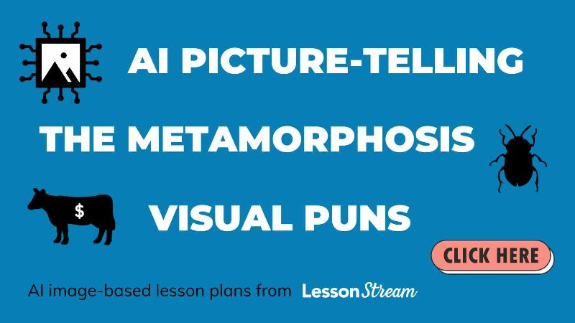

Personally, I am quite excited by the possibilities that AI image generators offer teachers. But I am also concerned for the disruption that it is going to cause content creators in the short term and eventually humanity.
Elon Musk (or "Elton Musk", as my dad calls him) recently said that within three years, AI will be able to write novels which are on par with Harry Potter. If you feel sceptical about that, just look at what it can do visually.
First of all, a cathedral made of potatoes.

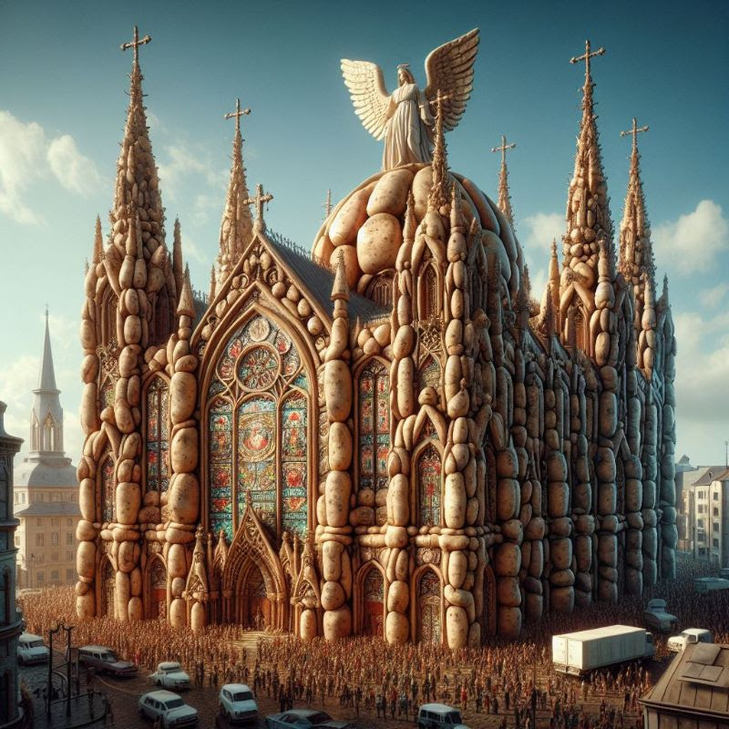

And now, a potato made of cathedrals.


It's an incredible tool but one to be approached with trepidation.
A LessonStream LIVE
Some time ago, I went LIVE on YouTube with LessonStream member Steve Sinclair to explore an idea for using AI image generators in the classroom. You can watch the recording here.
At the end of the video we show you how to use DALL-E3. It's very simple.

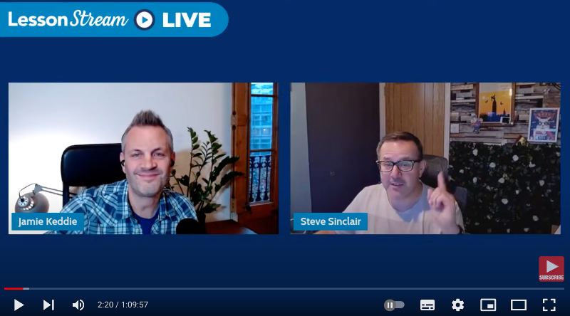

AI Picture-telling with Steve Sinclair

https://www.youtube.com/watch?v=a-2-Vsrpn54

More
Here I go LIVE on YouTube again to share more ideas and express some concerns.
"Ten ideas for using AI images in the classroom"
PS
In this new blog post, I tell the story of how I accidentally created this image using DALL-E3.

Coming soon! Please check the Pilgrims in Segovia Teacher Training courses 2026 at Pilgrims website.



I really hope that this isn't a metaphor of what artificial intelligence is about to bring to the world!

Coming soon! Please check the Pilgrims in Segovia Teacher Training courses 2026 at Pilgrims website.

