Dear HLT Readers,
Welcome to the October issue of HLT. Before I introduce the issue, let me share some Pilgrims information with you.

In August Pilgrims trainers and other staff members met in Newbury, UK. The text Pilgrims Trainers Planning for Summer Courses 2025 tells you all about the meeting, the outcomes and our plans.

Among others, the text announces a series of Pilgrims Cafés which give a taste of Pilgrims courses, including those planned for 2005 in Segovia. You can find the details of the whole project and of the first café below.

Coming Soon…

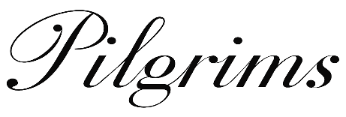


Café topic: Teacher Survival Kit

When: Saturday October 19th 16.00 – 17.15 Central European Time
Where: zoom

Facilitated by: Stefy Ballotto  and Magda Zamorska 

Our cafè will focus on avoiding or fighting burnout, finding sources for activities, maintaining energy and enthusiasm, learning how to relax or gain confidence and discover what makes you a happy teacher. We will explore how to preserve your sense of humour, and mental as well as physical health in this challenging task we call TEACHING. Looking forward to sharing a ‘stress free’ afternoon with you.

Stefy and Magda



We can also meet at TESOL France if you are attending. See you there.

As for the issue itself, the main body of articles comes from Turkey, but there is also a smaller section (Lesson Outlines for YL) from Bulgaria.

I would like to thank the Host Editors for their hard work and dedication. So, without further ado I am handing over to Stefan Rathert and Zhivka Ilieva.

Enjoy the October issue.

Hanna (Hania) Kryszewska
HLT Editor
Email: hania.kryszewska@pilgrimsteachertraining.eu

Zdjęcie to co ZAWSZE

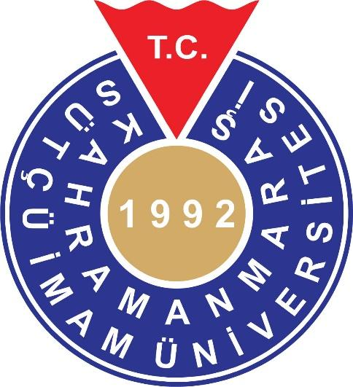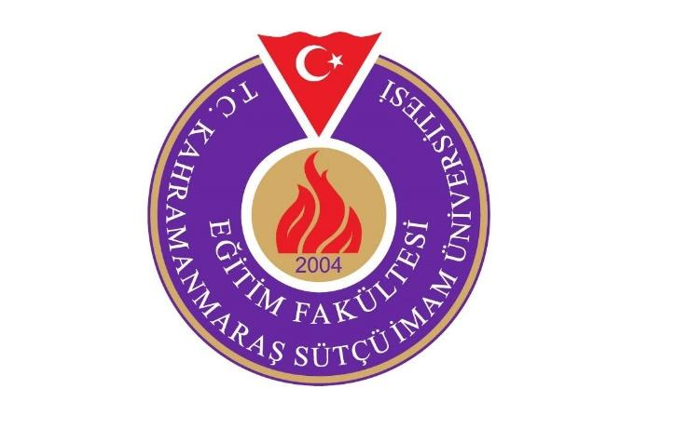

Dear HLT Readers,

There have been at least three reasons for me to ask Hania Kryszewska if I could become the host editor of this HLT issue. The first reason is that, in 2006, HLT was the starting point for me to dive into the world of academia by getting an article published - other contributions followed. So, host editing this issue is a thanks to Hania and her HLT team for providing me (and others) with opportunities to share their ideas that are of interest for the community of language students, teachers, teacher educators and material designers. The second reason is my strong conviction that HLT is a golden opportunity for those who have a word in language learning and teaching to develop professionally and personally. Finally, as many pre-service teachers at Kahramanmaraş Sütçü İmam University, Türkiye, contributed to this issue with outcomes of their course work, I hope that other teacher educators are encouraged to help their students get their term papers or lesson ideas published in HLT or elsewhere – hard work but worth the efforts.

Coming to this issue, there are four articles that are thoroughly revised term papers of the Coursebook Evaluation course (Fall Term 2023) in the ELT undergraduate programme at Kahramanmaraş Sütçü İmam University, Faculty of Education. Ayşe Yılmaz engages in An Investigation of Cultural Elements in Reading and Writing Texts in a Local English Language Coursebook for Use at Turkish Secondary Schools, and Berra Nur Öztoprak, Yağmur Oktay, Hacer Göktaş, Tuğçe Erkınacı and Tuğçenur Caner conduct an Evaluation of Speaking Activities in a Local English Coursebook for 12th Graders: Interactional Patterns, Language Functions, Open and Closed Questions. Ebru Öksüz, Ayşe Büyükeryılmaz and Hande Harmankaya examine Cultural Diversity in a Local ELT Coursebook Used in Türkiye, and Kübra Nur Küçükbesleme, Beyza Nur Erko, Sinem Dertli, and Elif Özcan deal with a topic of vital importance, The Representation of Human Rights in Local EFL Coursebooks. Şerife Durna, instructor at Kahramanmaraş Sütçü İmam University, completes the Coursebooks section with A Comparison of Cultural Elements in EFL Textbooks for 6th Graders used at Turkish and German Schools.

Since I had the opportunity to invite authors involved in the learning and teaching of foreign languages other than English, I am grateful to present articles dealing with the current situation of teaching French and German as foreign languages and Turkish as a second language in Türkiye. In the Teaching Languages section, Mehmet Kurt draws The Itinerary of Teaching French as a Foreign Language in Turkey: A Journey of Ups and Downs, Challenges and Potentials, and Ökkeş Aygün Öztürk has A Critical Look at Some Issues of German as a Foreign Language Teaching in Turkish Secondary Schools. Ali Uzun gives an overview of Teaching Turkish as a Second Language to International Students in Turkish Higher Education. Furthermore, the situation of ELT in Turkey is critically examined by Kübra Nur Küçükbesleme and Ökkeş Aygün Öztürk in their paper Exploring Challenges for Learning and Teaching English in Turkey.

Pre-service Teacher Education contains two articles of different nature: Ceren Keleş aims in her review article at Examining Recent Studies on English Language Pre-Service Teacher Anxiety, while Derya Akbana and Yunus Emre Akbana reflect on their experiences as mentor teacher and supervisor in their paper Flashing Back to Initial Teaching Practicum Experiences: A Mentor Teacher’s Initial Experience.

HLT has recently drawn attention to Eco Issues in a separate magazine section. In their contribution to this section, Filiz Yörük Çevik and Reyhan Ağçam explore Eco-psychological Awareness of Pre-Service English Language Teachers, thereby providing insights into the significance of integrating eco issues into teacher education.

This issue would be incomplete without the lesson plans and ideas of our pre-service teachers at Kahramanmaraş Sütçü İmam University. As you will see, the contributions are linked to well-known methods and techniques, and make use of content and materials that are likely to create a rich learning experience. Sabih Enes İzyaran, Sema Nur Şahin, Merve Gülnida Bakır and Cennet Ünal show how 21st Century Skills can be addressed in the language classroom in Broaching Labour Work as a Topic for English language Teaching – a Lesson Outline Following the Text-driven Approach. In the Golden Classics section, Kader Bilgiç and Nahide Nur Soylu share their ideas on how to benefit from TPR in (young) adult classrooms: Total Physical Response Revisited: Applying a Practice Beyond the Traditional View. Kevser Bolat displays her own and, I am sure, stimulates the reader’s imagination by Using Realia in the Language Classroom to Foster Creativity. Elif Nihan Yılmaz, a high school language teacher, shares her idea on how to use Comics in Language Teaching: A Lesson Idea.

Many of the contributions mentioned so far have been written by pre-service teachers and teachers, groups whose writing for publication is not a matter of fact, indeed often not supported by authorities or teacher educators. At the beginning of my editorial, I claimed that it is especially beneficial for these groups to engage in Writing for Publication as a Tool in Teacher Development – to provide evidence for my claim, an article reporting on HLT writers’ experiences written by Zühal Okan and me and published in ELT Journal in 2015 is reproduced in the CPD section.

There are three other articles by language users (rather than language learners) in the Voices section. Emine Onur and Muhiddin Balçın reflect on what it means to become a flight attendant after graduating from an ELT programme instead of pursuing the teaching career: The Flying Teachers: An Interview. Semanur Aras looks back at her English language experiences and provides useful recommendations in My Journey as a Learner and User of English. Last but not least, Leila Guseinova, who I met during a visit of the Ulyanovsk UNESCO City of Literature Team in Kahramanmaraş, kindly agreed to contribute with Horses, Moms, UNESCO - How Language Learning Creates Unforeseeable Opportunities, a paper full of inspiring memories and thrilling facts about Chinese.

This issue’s Publication section furthermore contains a Book Review: Digitalizing English Language Teaching by Nina Lauder. The book contains chapters written by scholars working at my university.

So, I hope this issue is both informative and inspiring through a diversity of articles. My thanks goes to all contributors for their commitment, patience and energy. And, of course, I am grateful to Hania for all her encouragement and editorial support.

Stefan Rathert
Host Editor
HLT Magazine
Email: strathert@gmail.com

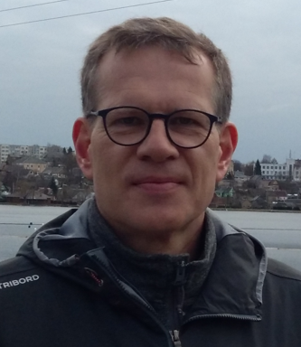

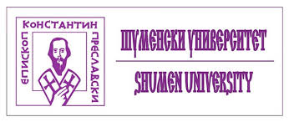

Dear HLT Readers,

We have 4 articles from College – Dobrich, Konstantin Preslavsky University of Shumen,
Bulgaria. Assoc. prof. Zhivka Ilieva presents her extensive reading experiment, and analyses
student teachers’ attitude to their extensive reading programme, to preparing reading diaries
as part of the programme and their opinion about applying similar programmes with young
and very young learners (Reading Diaries and Extensive Reading). This experiment involves future primary and pre-primary teachers in
reading a number of children’s books.

The other three articles are dedicated to work with young learners and belong to last year students of Preschool Pedagogy and a Foreign Language. Vanya Koleva explores using video materials with very young learners. She analyses 5 songs for children in relation to their potential for multiple literacies development and describes the results of such work with her two children ( Foreign Language Teaching to Very Young Learners: Development of Multiple Literacies Through Video Materials). Safet Ahmed describes her work with stories and the results of her daughter both in English language acquisition and in life skills development e.g. crossing the street (Storytelling and Video as a Means of Foreign Language Skills Development in Children). Sofka Miteva presents her ideas about using puppet theatre in the kindergarten and shows various ways of preparing dolls for it (Puppet Theatre in Teaching English to Young Learners).

These articles are part of Project 08-61/24.01.2024 of Dobrich College, Shumen University, Bulgaria.

Zhivka Ilieva
Host Editor
HLT Magazine
Email: zh.ilieva.bg@gmail.com


