Horses, Moms, UNESCO - How Language Learning Creates Unforeseeable Opportunities

Leila Guseinova, Russia

Leila Guseinova is a 4th year graduate student of Ulyanovsk State Technical University, Russia. Her field of study is Intercultural Communication, and her main subjects are Chinese and English. In this article, she shares her personal experience of learning the Chinese language. The idea to invite Leila to contribute to this special issue of HLT came up during her visit as a member of the Ulyanovsk UNESCO Creative City of Literature delegation to Kahramanmaraş, which she also reports on in this paper Email: loberl@mail.ru

Chinese

Of the currently used languages, the Chinese language is the only one that consists entirely of characters. Chinese is the mother of the Korean and Japanese languages. Many people mistakenly believe that Japanese and Korean also have characters, but this is not correct, even though both languages originated from Chinese. It is noteworthy that Chinese characters were used along with letters in Korean writing until the end of the 20th century, and the Japanese language has two alphabets. To date, Chinese characters have been used together with them in writing. Moreover, not all Japanese words and especially names can be written using the Japanese alphabet, so the Japanese cannot do without Chinese characters. Characters are written signs that originally existed in the form of drawings and evolved into a full-fledged type of writing. Each character has its own separate meaning, each of them is an independent word, which in combination with other characters can form phrases, sentences, idioms.

Among the different dialects and variations of the Chinese language, the main ones are Putonghua (also known as Mandarin Chinese) and Cantonese. All these variations and dialects differ in sound, accents, pronunciation of sounds and even a little in writing. Almost all foreigners study Putonghua because it is spoken by the majority of Chinese residents, which makes Chinese, namely its Mandarin dialect, the most popular language in the world. Chinese is widely spoken not only in China, but also in Singapore, Malaysia, Thailand, Mongolia and the Philippines.

Language selection

When people ask me why I chose Chinese to study and not any other language, I always answer that it was an intellectual challenge that compelled me to learn it. When I graduated from high school, I knew that if I chose the direction of a foreign language to study at university, it would be Chinese because I considered this language so difficult that if I did not get out of my comfort zone and study it at university, I might not dare to study it in the future. I was led to such thoughts by the language’s endless variety of different characters and four different tones, the fact that the slightest mistake in writing or pronouncing affects the meaning of everything said.

However, there are other reasons that guided me in my decision, too. It is no secret that the Chinese language has a strategic position in the modern world. China is a superpower and a real economic giant on the world stage, and the Chinese government annually invests in popularising the Chinese language and culture among residents of 149 countries all over the world by opening branches offered in the Confucius Institute. At the moment, the relevance of learning Chinese is only increasing and it is expected that this trend will continue for many more years.

Another important factor is the high standards of education. Higher education institutions in China have high prestige and many of them are among the top 100 educational institutions in the world. Every year, the Chinese government issues scholarships for free education in many universities of the country for foreign citizens. Knowledge of the Chinese language opens up many opportunities in the field of education or business, as well as in many other areas.

Educational trajectory

Initially, I started my acquaintance with the Chinese language at Ulyanovsk State Technical University in Russia when I enrolled in the direction of intercultural communication, the main subjects of which are Chinese and English. However, only basic knowledge is given at the university. Therefore, it is worth understanding that if you really want to master a foreign language, and do not seek to speak at the tourist level, then you need more time, not just a few lessons a week. You need to look for courses, internships, and additional knowledge resources. Studying for four years at the university, you should not expect that someone will come and put a ready-made success in your palm. It does not happen that way. Four years of study should include not only listening to all courses of lectures that follow the program of your university and your direction, but also your additional scientific and practical activities. Look for opportunities! For example, you can always get information from your teachers about upcoming events, conferences, forums and participate in them. Of course, this is not necessary, but I repeat that additional scientific and practical activities and the student's desire to gain additional knowledge and experience are the key to success.

To know the language of other nations means to figure out how they think, how they feel, to know their culture and mentality. When I speak Chinese, it is like I am becoming a part of these people. Even the tone and intonation of my speech changes. It is the same when I speak Russian, English or Azerbaijani. This is the beauty of speaking different languages - thinking and horizons are enriched, a person becomes multicultural.

An insertion: My linguacultural background

I am a bearer of Azerbaijani culture, but I cannot say that I am a native speaker of the Azerbaijani language, since a native speaker is a representative of a linguistic community who knows the norms of the language perfectly and actively uses this language. I was born and live in Russia, the society around me consists mostly of Russian speakers and speakers of Azerbaijani language are only members of my family, so I very rarely practise the Azerbaijani language, only with some of my relatives who do not know Russian, and there is no other way out but to speak only Azerbaijani with them. Russian was my first language, I studied in Russian, I even think in Russian. That is why I consider myself a native speaker of Russian, not Azerbaijani. But I think that if I ever move to my historical homeland, Azerbaijan, then after a year of living there I will be able to safely call myself a native speaker of the Azerbaijani language, too.

My parents are native speakers of Azerbaijani, they were born and grew up in Azerbaijan. My mother went to an only Azerbaijani speaking school, and my father went to a Russian speaking school. During the times of the USSR, Russian was the medium of instruction at schools in Azerbaijan. So Russian and Azerbaijani are equally well spoken by my father, while it is easier for my mother to speak Azerbaijani. My mother can fully express her thoughts in Russian, if necessary, because our family has been living in Russia for more than 25 years. My parents speak to me in both Russian and Azerbaijani, but I always respond in Russian. This means that, unlike my parents, Azerbaijani language is not my dominant language, because I need to make efforts to respond in Azerbaijani to their utterances habitually spoken in Russian.

Learning Chinese

I think that everyone who studies a foreign language dreams of mastering it at such a level that native speakers are surprised by their skills and accents. The education system cannot ensure that all hours of a course are devoted only to a foreign language. Usually, a curriculum is structured in such a way that several hours are allocated per week for learning a foreign language, since there are other subjects for which hours are allocated.

In the first year of my own studies, after three months, I began to look for additional sources of learning Chinese. I learned that the Confucius Institute is the leader in learning Chinese. It is a Chinese government-funded program to promote Chinese language and culture around the world. Thus, I had the opportunity to learn Chinese with native speakers, and, of course, I took advantage of this opportunity. My classes at the Confucius Institute are held online twice a week for one and a half to two hours. In one week, we manage to learn about 16-18 new words and two to four grammatical structures. By the way, to calmly read newspapers in China or listen to a news release, you need to know at least 3,000 characters. Officially, the level of Chinese language proficiency is indicated by the abbreviation HSK (Hanyu Shuiping Kaoshi - Chinese Proficiency Test), it is like IELTS but in Chinese. HSK is also a Chinese language exam system. There are six levels in total, but recently the Chinese government decided to add levels 7-9. Studying for almost four years at the Confucius Institute, my Chinese language level will increase to HSK5 when I graduate from my university. Students who do not practise Chinese outside the university and study it only twice a week will stop at HSK2-3. I am confident to achieve this result with the help of additional online classes at the Baku branch of the Confucius Institute at Baku State University. I find classes at the Confucius Institute very productive because in each lesson we practise speaking, listening, reading, writing, we analyse grammar in detail and, in parallel with all this, we get acquainted with the culture of China. Through studying at the Confucius Institute, I have learned to understand Chinese better, speak with tones, and translate, but I still have a lot to strive for. Learning a foreign language is a continuous, lifelong process, so language learners always have something to strive for, regardless of what level they are at.

At the Confucius Institute, I learned the Chinese character radicals. Radicals are relatively simple elements that make up characters. They themselves can act as separate words, or they can act as an integral part of a more complex character. Learning them will make it easier for you to memorise characters. For practice, I disassembled the characters into the radicals that make up it. For example, in the word 妈妈 (māma) - mother - there are 2 radicals: on the left, 女 nǚ is a woman, and on the right, 马 mǎ is a horse. So a horse woman is a mom. Another very interesting and beautiful moment in learning Chinese is symbolism. Each character, if you turn on your imagination a little bit, is an image of the word that it means. Look at the character 马 mǎ (horse) - take a closer look and you will really see a horse, its head, body and tail. And if you look at the evolution of the horse character from the ancient times to the present day, you can more clearly see the outlines of a horse in it. The picture below illustrates the evolution of this character:


The same is true with the character 鸟 (niǎo) - bird - it looks like a drawing of a bird sitting on a branch. Or, for instance, in the character 哭 (kū) - cry - you can see the outlines of a face: eyes, mouth with nose and a tear. And the character 木 (Mù) means wood; and the combination of characters of three and two 木 - 森林 (Sēnlín) - is a forest.

The meaning of what is said in Chinese directly depends on the tones. If you pronounce the tone incorrectly, the meaning of the entire sentence may change. Let's look at this in the simplest example with the word ma:

• The first tone. This tone is pronounced in a high and even tone. Speak in an even voice; your timbre does not have to be unnaturally high, although it helps to enhance all these tones when you first study. Example: 妈 (mā) - mother.

• The second tone. This is an upward tone. Start at a neutral pitch; your voice should rise until it reaches the pitch of your first pitch. Example: 麻 (má) - cannabis.

• The third tone. This tone goes down before rising again. Example: 马 (mǎ) - horse.

• The fourth tone. This tone starts with a neutral tone or slightly higher, then drops sharply. Example: 骂 (mà) - to scold.

• Fifth or zero tone. This tone differs in that, in fact, it is not a tone. The fact is that some words in Mandarin have no tone; they are silent or neutral. Example: 吗 (ma) is a particle denoting a question.

So, with these words, you can make a funny phrase: 妈妈骂马 (Māmā mà mǎ) - mom scolds the horse. Or a joke question: 妈妈骂马吗? (Māmā mà mǎ ma?) - Is mother scolding the horse?

Another interesting example of the same words with different tones - words 四 (sì) - four - and 死 (sǐ) - death. Due to this consonance in China, the number four has a negative colour and in some buildings there is no fourth floor: after the third floor cones the fifth, or 3+ floor.

Learning and using a language: unforeseeable opportunities

You always need to think more broadly and think about what you are striving for. When my university announced that all students needed to complete an internship, I started looking not only for local firms, but also for government organisations engaged in international activities. Since I set myself the goal of becoming an international specialist, I understood that I also needed to practise in international departments. I have set a rule for myself: “There is a goal and there are ways corresponding to it”. Our university offers options for internships, but leaves the final choice of the place of practice to the student. At the university, I was offered an internship at the dean's office. Yes, it is not bad, but I knew exactly what I needed in the future, so I knew for sure that I needed to do an internship in an organisation that would help me enter the international arena. I started looking for international companies in my city. So I contacted the Corporation for Developing the Ulyanovsk region, which works directly with investors and companies from different countries. They just needed a Sinologist to work with China, and that is what I needed. I am convinced that you need to clearly understand what you want so as not to waste resources and time.

You also need to try as much as possible to prove yourself in accordance with your area of training. For example, I once took part in a cultural event in my city, which many in my group thought was insignificant, but I decided to participate. I read a poem by the Chinese writer Li Bai, and then I was noticed by the local UNESCO office, as Ulyanovsk is a UNESCO Creative City of Literature, and getting to know them became very useful for me. I began working with UNESCO, as part of their delegation. I met a Weibo delegation from China. For our small town, it was a really big event and I was part of this event.

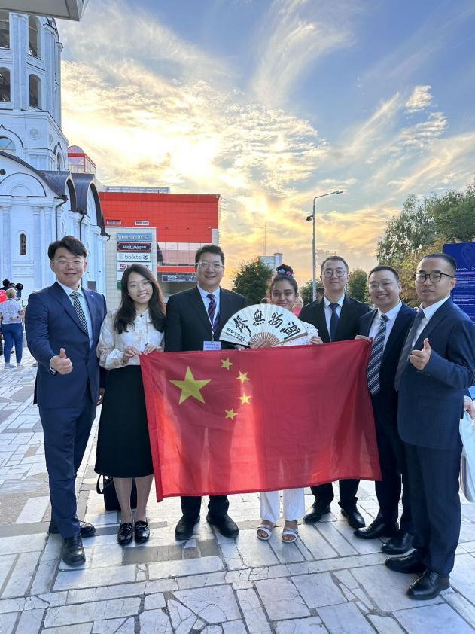

Further, together with UNESCO, I met a delegation from the Turkish city of Kahramanmaraş, candidate city for the UNESCO Creative City Network - excellent professors and representatives of the culture of Kahramanmaraş. UNESCO appreciated my work as a translator and I was included in the official delegation from our city for a trip to Kahramanmaraş to participate in their Poetry and Literature Days in December 2023. Did I know that my performance at an intercultural event with a Chinese poem in my city would ultimately lead me to Türkiye as part of the UNESCO delegation? No, I did not know, but I understood that the efforts were fruitful. I am happy that I took the initiative and took part in that event. I say this because it is vital to grab any opportunity to prove yourself, because this is a chance to gain knowledge, experience and success in your specialty.

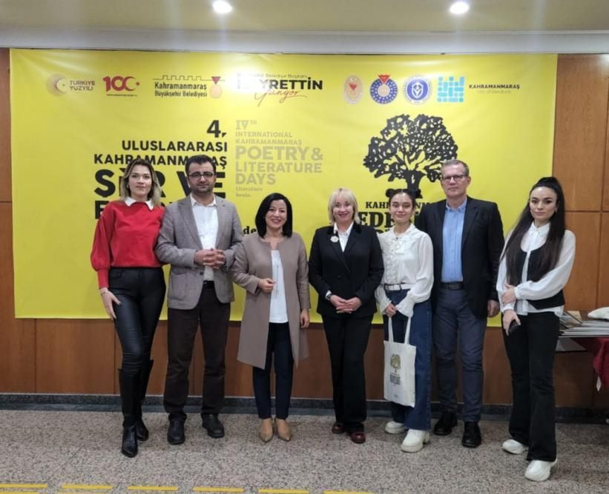



So, what did the cooperation with UNESCO and intercultural activities give me? Thanks to this valuable experience and good reviews from the organisations and directors I worked with, my CVs stood out against the other students’ from all over the world who applied to the same universities in Hong Kong as me. Currently, I have already received two interview invitations from two leading universities in Hong Kong - the Chinese University of Hong Kong and the Education University of Hong Kong.

My lessons learned

At the beginning of my journey, I did not know anything about Chinese, except that it is complex, consists of many dashes, lines and is one of the languages of the United Nations. But after just a month of studying, I realised the following issues:

- Learning Chinese is a powerful memory training. Every day you have to memorise new characters, and there are about 50,000 of them. It is not like learning 30 letters in any language and reading any book or newspaper knowing these letters. Basically, in Chinese you have to learn the words to be able to read books, whereas in languages where writing is alphabetic, you have to learn the alphabet and then you can read anything. In Chinese, reading an unfamiliar word is impossible. You can read a book or newspaper in Chinese if you learn at least 3,000 characters (words).
- Learning Chinese is an introduction to one of the oldest cultures in the world, which is about 4,000 years old, with the hospitable mentality of the Chinese people, their bright holidays, and their amazing world of art, not to mention their breath-taking legends.
- Learning Chinese is an art, because writing a character is like drawing a picture. The whole world demonstrates the art of Chinese calligraphy. Calligraphy teaches concentration, discipline and develops artistic taste.
- Well, as a bonus, learning Chinese is hearing surprise from others and their enthusiasm. “Wow! It must be very difficult!” And: to see the surprise of the Chinese themselves is a distinct experience of recognition, because for them a foreigner speaking their language is also an amazing and interesting phenomenon.

In my opinion, Chinese is the language of the future. There are already more and more ads on job sites where proficiency in Chinese is a requirement and it does not matter whether the vacancy is a lawyer, an economist or a sales specialist - all large companies are moving towards China, which means that specialists are now required with the ability to communicate in Chinese.

For those who have just started or are going to learn Chinese, I have highlighted a few tips that I have benefitted from:

- Set yourself a goal. It will motivate you in difficult moments.
- Find a good teacher who can explain everything to you in an accessible way. Chinese is one of those languages that are almost impossible to learn on your own without a teacher. In this regard, I really liked the Confucius Institute.
- Practice reading by tones as often as you can.
- Learn the radicals of Chinese characters.
- Make up your own sentences from newly learned words.

And, as my grandmother used to say and my mother says, “There is nothing more beautiful than speaking different languages, it is like seeing the whole world.” Learn languages!

Please check the Pilgrims f2f courses at Pilgrims website.

Please check the Pilgrims online courses at Pilgrims website.

