Book Review: Digitalizing English Language Teaching
Nina Lauder, Spain
Nina Lauder is a certified Oxford University Press teacher trainer and ELT and CLIL expert who has handled tasks in over thirty countries. She has authored and co-authored top-selling ELT and CLIL textbooks. Website: www.ninalauder.com / info@ninalauder.com


Digitalizing English Language Teaching
Editors: Asst. Prof. Dr. Yunus Emre AKBANA Assoc. Prof. Dr. Gülten KOŞAR

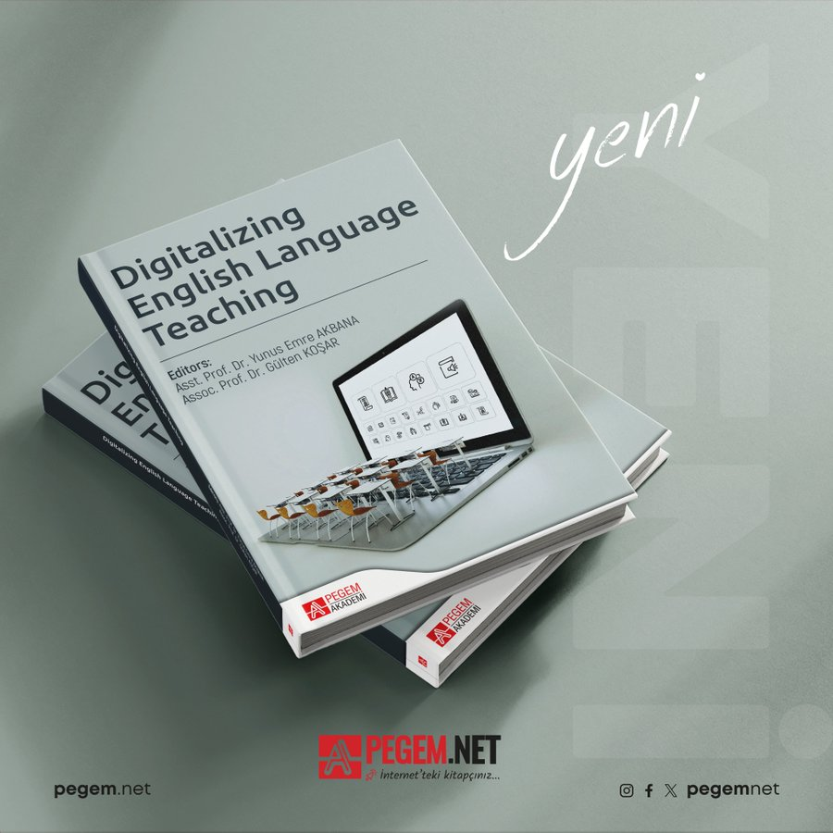
This book provides a comprehensive collection of works which focus on digitalization in the English Language Teaching (ELT) classroom across a broad spectrum. It is designed to provide readers who are interested in using digital technology and pedagogy in their lesson and there is a healthy balance of theory and practice across the chapters.

The eight chapters of the book follow more or less the same structure: an introduction to the skill/topic with a strong theoretical base followed by practical ideas for different age groups. Most chapters also include things like recommendations for schools and policy makers, task questions, references and a sample lesson plan. Each chapter delves into the use of digital technology as a means to develop specific language-related skills. Without a doubt, there is something for everyone in this collection.

Although there is a common thread in all of the chapters on the importance of discussing the impact of developing digital skills in distinct education settings, each of the chapters is focussed on specific aspects of digitalization for different language skills (the ‘four skills’ plus things like vocabulary, grammar or pronunciation). In each chapter, the authors provide an evidence-based theoretical framework followed by research findings and/or practical ideas. At the end of each chapter, the authors provide task questions which invite readers to investigate the specific topic in greater depth and reference material in the form of an extensive bibliography aimed at readers who wish to investigate the topic in question further.
As each chapter deals with a specific topic, some of the main points from each are highlighted here:
- Chapter 1.: The Substantial Need For Digitalizing Language Teaching Methods And Materials (Yunus Emre AKBANA & Gülten KOŞAR) After describing and contrasting the terms digitization and digitalization, the authors give an overview of changes in educational methodology in the 21st century. The authors also identify the need for online teaching skills and methodology to be developed by a wider range of educators.
- Chapter 2.: Digitalizing Teaching Reading (Hacer KAÇAR & Hasan BEDİR) In this chapter the authors take a close look at how to digitalize teaching reading with specific suggestions for different target groups. The authors demonstrate their awareness of the challenges faced when developing reading skills while highlighting that “Reading is used as the foundation for all language acquisition activities” (p. 20). The authors also provide numerous webpages, resources and a detailed sample lesson plan to develop this important skill.
- Chapter 3.: Digitalizing Teaching Listening (Fatma Şeyma DOĞAN & Işıl Günseli KAÇAR) This chapter provides practical advice on how to use digitalization to develop listening skills in ELT settings. The authors describe the benefits of integrating technology into teaching listening pointing out that using multimedia in class can have a positive impact on the development of linguistic competence. Following the same format as the previous chapter, the authors provide readers with a wide range of practical ideas and suggestions as well as sample activities and a full lesson plan.
- Chapter 4.: Digitalizing Teaching Writing (Ömer Faruk KADAN & Sevda DOLAPÇIOĞLU) This chapter highlights the importance of writing in different fields including science, education, engineering or technology. As seen in previous chapters, the authors provide practical ideas based on a solid theoretical framework. There is a section which describes opportunities and challenges when using in a digital environment and a variety of tasks for different age groups and levels are carefully explained.
- Chapter 5.: Digitalizing Teaching Speaking (Stefan RATHERT & Gözde BALIKÇI) Following the format of previous chapters, this chapter outlines some of the challenges teachers face when using digital tools to develop speaking skills while presenting distinct ways to use integrated task-based approaches in lessons. They point out the importance of re-evaluating technology related pedagogy across the board at schools and encourage the use of digital tools and applications to improve speaking skills. An extensive, complete lesson plan is also provided.
- Chapter 6.: Digitalizing Teaching Grammar (Ali ERARSLAN & Abdullah ARSLAN) After discussing theoretical questions like the role of inductive or deductive grammar teaching in ELT settings, the authors move on to look at different resources and techniques that can be used to teach grammar using digital resources. Although the authors are aware of the strength of using online tools for grammar teaching, they also realise that depending on teaching practices and educational settings, using digital tools to teach grammar might not always be feasible.
- Chapter 7.: Digitalizing Teaching Vocabulary (Mehmet ALTAY) After providing a historical and theoretical base on the role of vocabulary teaching in language learning, the authors outline different task-based activities that can be employed in language class. As they point out, “there is no one-size-fits-all vocabulary teaching technique” (p. 155), but there are strategies and resources teachers can encourage students to use when learning vocabulary in a foreign language.
- Chapter 8.: Digitalizing Teaching Pronunciation (Reyhan AĞÇAM) The author begins by discussing the importance of clear pronunciation in terms of comprehensible output. She points out that, in many educational settings, students might only receive a couple of classes a week in the target language which does not necessarily give them time to assimilate pronunciation fully. This may lead to learners lacking confidence in pronunciation which may impact their interactions with others. The author also makes the point that even if students have strong language skills, lack of accurate pronunciation can oftentimes mask their capacities in the target language. As seen in other chapters, the author provides a series of practical ideas and suggestions to help educators introduce the use of digital tools to help develop pronunciation.

As the units follow the same general layout and format, it makes it easy for the reader to compare and contrast different approaches that are presented by the authors of each chapter. Thanks to this structure and to clear signposting, the book is reader-friendly and easy to navigate. On top of this, the excellent and extensive list of reference material at the end of each chapter offer readers the opportunity to further explore the different aspects of language learning in greater depth. It would have been nice to find a short chapter at the end of the book summarising the main points or common threads throughout the chapters, but apart from this, the collection is well organised and easy to read.

One of the nice aspects of this book is that ELT teachers, teacher trainers or trainees on professional development courses can read the chapters in the order they wish or simply read the chapters that pertain to their areas of interest. If teachers are not concerned, for example, about the use of digital tools to develop pronunciation, they needn’t read this chapter. By the same token, if readers are interested in, for example, developing the four skills using digitalization, they can find ample resources and suggestions here. Thanks to the reflection questions and tasks at the end of each unit and the extensive reference material, this book is also ideal for those who wish to develop their techniques through self-study.

In conclusion, this book is an interesting option for educators, decision-makers or trainees who wish to develop or extend their knowledge about techniques and resources which can be used to help learners build their confidence using technology in today’s modern, global world where these skills are key.

You can find more information here.

Please check the Pilgrims f2f courses at Pilgrims website.

Please check the Pilgrims online courses at Pilgrims website.

