Pilgrims News: Pilgrims Trainers Planning for Summer Courses – Segovia 2025

Hanna (Hania) Kryszewska, editor of Humanising Language Teaching Magazine and Pilgrims trainer, Poland



Background

This spring we decided we wanted to meet up and celebrate 50 years of Pilgrims. Also, we wanted to make plans for 2025 - more Pilgrims in Segovia, Spain. Finally, we wanted to meet up as the last time we had been all together under one roof was August 2019.

So, we all travelled to OISE School in Newbury, UK. Dates: 23d-26th August

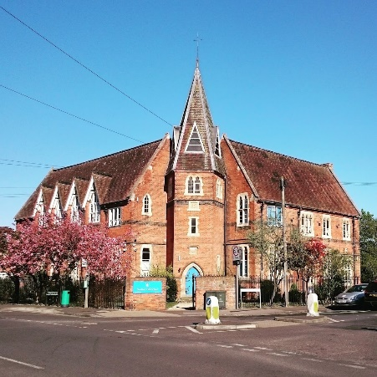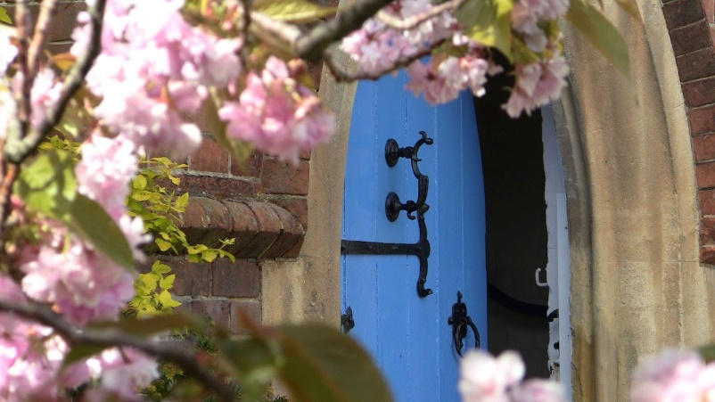

First moments, first impressions

Newbury is a charming and picturesque town, which reminded us a bit of Canterbury; the only difference being that there are no hordes of tourists.

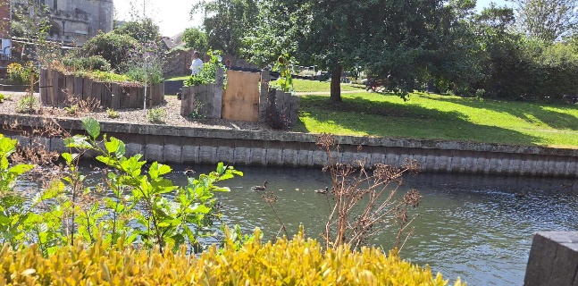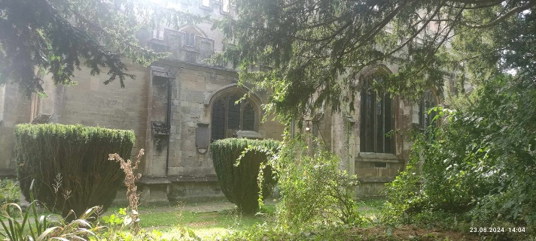

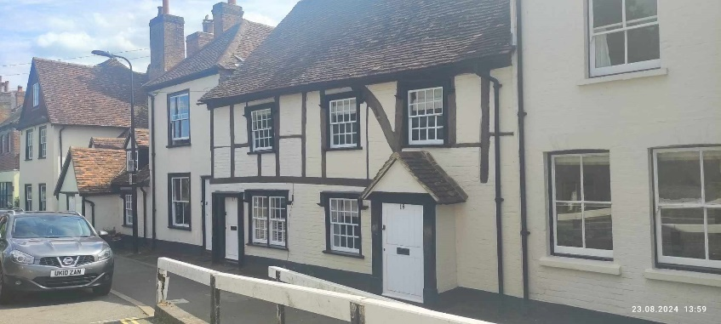

The first evening we ate together, socialised, played games, and exchanged gifts. Like in the old days.

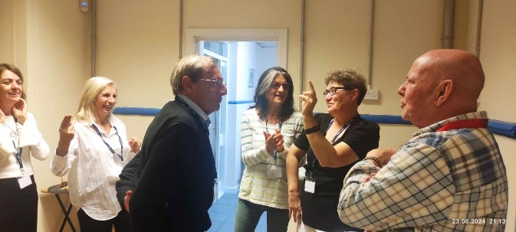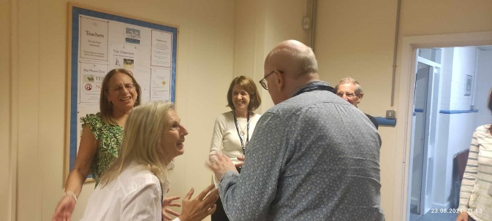

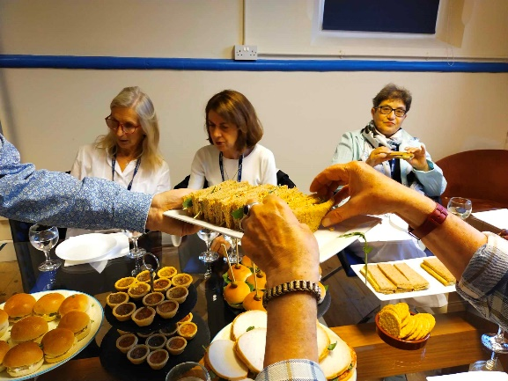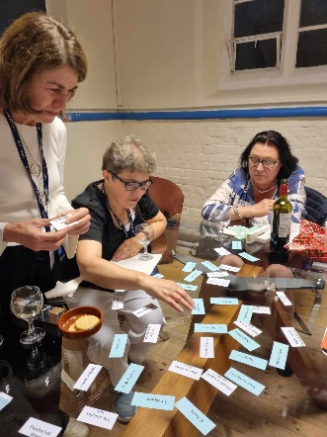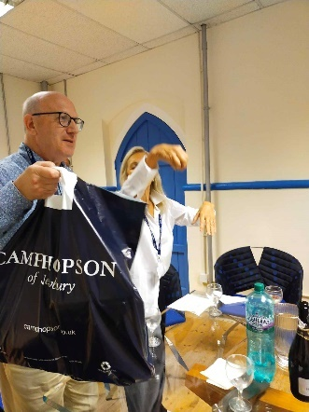

In the morning, we all met in the hall where we had most of our delicious meals. (Bar a quick occasional trip to a pub in town.)

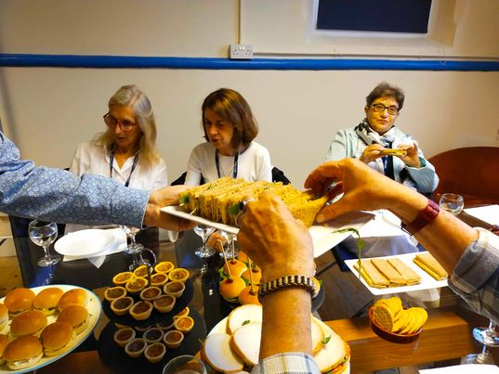

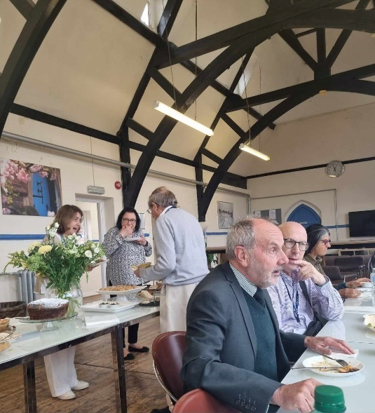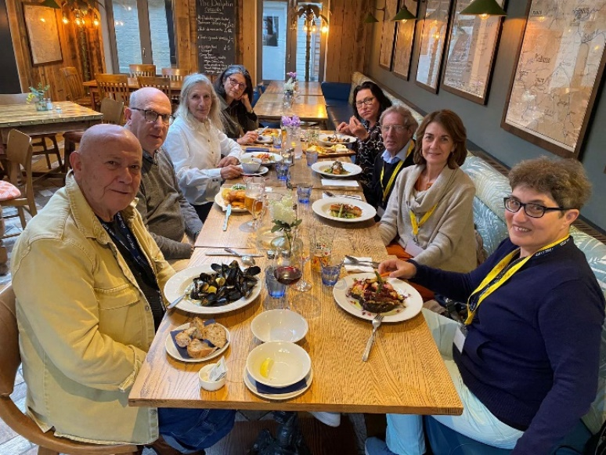

The academic programme

And then the meetings and hard work started. Our mini conference was opened by Till Gins, Lead Officer at Pilgrims, and Phil Dexter, Director of the Summer Programme in Segovia.

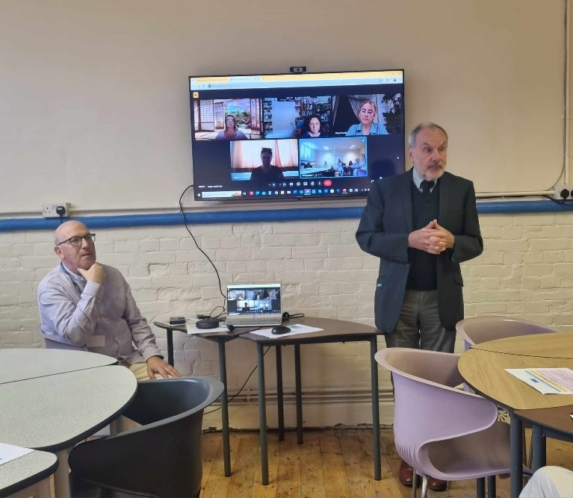

Current situation

First we discussed the reasons for changes at Pilgrims - Brexit, Covid and pivotal staff changes at the top of Pilgrims management. We also remembered Pilgrims at Canterbury,
watching end of the course videos, for example 2016 and 2019. But above all we looked into the future.

Phil Dexter, Stefy Ballotto and Linda Yael shared with us information and feedback from the courses in Segovia 2024 - the high quality of the courses, personal attention the participants received, the venue and social programme to die for, delicious local food and local staff, who willingly shared their local knowledge and expertise. Great stuff! See for yourself!
https://youtu.be/iXVqBtwuRls?si=L3W2GLQeJu3vRpRe
https://youtu.be/NROvk3GmXkw?si=exN5RUb7cYQ3XHXR

Harmony

Then Jana Chynoradska from Slovakia joined us virtually, and she told everyone about new developments in her Harmony Academy Project.

Jana has been a Pilgrims friend and fan for years. She trained at Pilgrims with Adrian Underhill, Bonnie Tsai and Kevin Bachelor along the lines of leadership, and had a lot of support from Jim Wright, Principal of Pilgrims.

Over the years, Jana shared her ideas with HLT readers, e.g.:

- http://old.hltmag.co.uk/aug13/teach01.htm
- https://www.hltmag.co.uk/oct20/three-letters-to-my-teachers

and now she gave us a top up on the key features of her approach:

- challenge assumptions,
- disconnect to connect,
- follow the mindset of kindness and willingness to help,
- be in peace with ourselves.

We also learned more about Learn and Lead Innovation and the Synergy Network. You can follow it up here:

- https://www.learnandlead.eu/
- https://www.facebook.com/learnandlead.harmony/
- https://en.harmony.sk/post/rok-2020-dobry-krok-vpred

More updates and information on new developments and our cooperation with Jana will follow soon, also in HLT and next issue of TTJ.

ELT today and how it shapes teacher training

Then we brainstormed how our courses can or should develop, evolve and improve. Of course, we looked at the current Erasmus catalogue 1 and catalogue 2 for some guidance, so that the courses can be not only cutting edge but also eligible for grants.

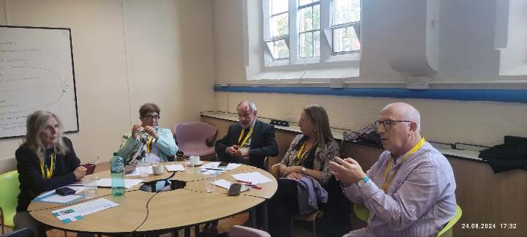



We also brainstormed our current interests and changes we want to introduce in our future programme or programmes overall, and in the individual courses. It will be presented to you in September on the Pilgrims Teacher Training website as the Segovia 2005 summer programme.

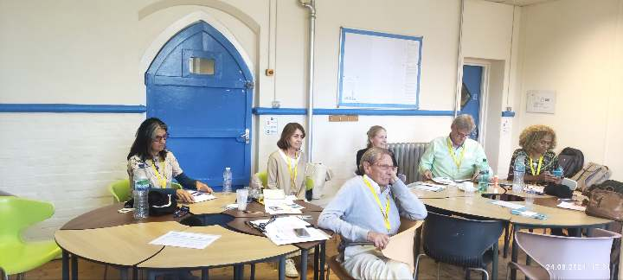

50th Anniversary Plan

In the years 2024/25 Pilgrims is celebrating its 50 the anniversary and to mark this there will many activities which include among others:

- 5 issues of HLT https://www.hltmag.co.uk/
- 3 issues of TTJ https://pilgrimsttj.com/
- 6 Pilgrims Café events at 4.00 pm-5.00pm online /for dates, topics and trainers see below/

19. 10. 2024 Stress-free Teaching and Wellbeing Magda Zamorska and Stefy Ballotto

30. 11. 2024 Teaching at Primary Levels Sharka Dohnalova and Stefy Ballotto with Lea
Luke

18. 01. 2025 Sustainability and 21st C Skills Judit Fehér and Hania Kryszewska

01. 03. 2025 Literature and Drama for Teenagers Peter Dyer and Linda Yael with Gary
Luke

05. 04. 2025 Inclusive Practices in Schools Phil Dexter, Mercedes Berbain and Marina
Marinova

17. 05. 2025 Teenage Brain Phil Dexter, Marina Marinova and Stefy Ballotto

Note. The sessions in the Pilgrims Café gives you a taste of Pilgrims and help you to choose the course which suits your needs and interests best. You can find out more about the trainers here.

For enquiries regarding the cafe the address is cafe@pilgrimsteachertraining.eu

- Erasmus+ event before the submission deadline (in most countries) on 19.02.2025

Note. Apart from this session we offer information about Erasmus+ grants and individual advice at info@ pilgrims.co.uk

- information on the Pilgrims TT website
- newsletter posts
- mini YouTube video clips
- regular Facebook www.facebook.com/PilgrimsTeacherTraining
- other social media presence like Instagram
- presence at conference events
- follow ups to conferences
- and many more

The events will take place between now and June 2025 leading up Segovia 2025.

The Pilgrims Summer Teacher Training programme will run
6th July – 1st August 2025

Discounts

10% off if two teachers book together
15% off if three teachers book together
Early bird - 50 euros off if you book before 18 Jan 2025

The Pilgrims team

The Pilgrims team also include Leah Luke and Gary Luke who are responsible for young learners programmes at Pilgrims.

Leah contributed an article about these courses in 2024, and she promised an update soon.

Together we have been looking at various approaches and ideas that could travel between our courses (language courses and teacher training courses), and the various uses of social media throughout the year.

Special Offer

Teachers who would like some of their pupils to experience a Pilgrims summer course for children and teenagers should guide them to https://younglearners.pilgrims.co.uk/
and let the team know at hello@pilgrims.uk

If 2 pupils book a summer course, the teacher who advised them will not be charged for his/her own teacher training course.

What is more, if 3 pupils book a course, the teacher who advised them will not be charged for their accommodation nor for the course fee.

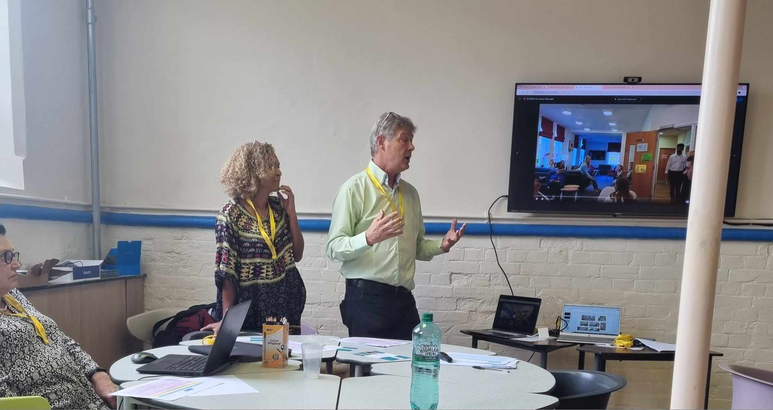

Angela Radford on the right in the photo below is our advertising and promotion expert who oversees the brochures and all updates on social media.

On the left, she is joined by Charlene Lapeck, who looked so well after us in Newbury. What a team!

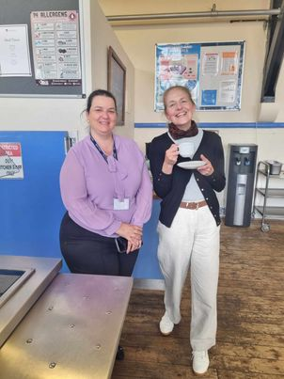

Parting word

Dear trainers and Pilgrims staff,
Thank you so much for such a constructive, memorable, harmonious and pleasurable working weekend with a vision. That’s the spirit of Pilgrims!

Dear All,
Come and join us and enjoy the spirit of Pilgrims. Reward yourself this summer. You deserve it and you are worth it

For all course enquiries the contact address is info@pilgrimsteachertraining.eu

Please check the Pilgrims f2f courses at Pilgrims website.

