Puppet Theatre in Teaching English to Young Learners

Sofka Miteva, Bulgaria

Sofka Miteva is a student teacher at "Preschool pedagogy and a foreign language" at Konstantin Preslavsky University of Shumen, College Dobrich. She has graduated Visual arts school and works as an artist at the puppet theatre in Dobrich. This is the main reason for her interest in artistic activities and their adaptation and application at pre-school and primary school, as well as their integration in foreign language education. She loves literature and reading, arts and painting and children this is the presupposition for uniting her interests in the present article.
Email: mitevasof@gmail.com

Note
This article is part of Project 08-61/24.01.2024 of Dobrich College, Shumen University, Bulgaria.

Introduction

Teaching English to children is a challenge. We have to include activities that allow them action and motion, that engage all senses. In order to involve children actively in foreign language learning, we have to use all possible resources: songs, rhymes, stories, theatre. We have to be flexible and to often change the means of influence in order to keep young learners’ interest lively. Children love motion, dynamics, change. Theatre is a good opportunity to involve them in the preparation of an event. Theatre involves learners in the preparation of decoration sets, costumes and puppets for puppet theatre, realizing cross-curricular links: to arts and crafts, to technologies and construction. We view puppet theatre as an alternative to ordinary drama activities.

Drama in ELT

Drama activities engage children in communication and action, they activate listening and seeing (audition and vision), and when touching the puppets tactility – three of the 5 senses. Thus drama makes language learning lively and memorable.

Phillips (1999: 5) states that “drama is not only about the product (the performance) but part of the process of language learning.” She claims that drama is motivating and fun and part of the chidren’s lives so we consider it is suitable for work in English language teaching (ELT) with young learners even at the kindergarten. Hillyard (2016: 21) shows that “drama can be considered a whole education for everybody in every subject whatever their age, Level, culture or religion and also a way to enhance language teaching to make lessons more motivating, more memorable, more effective and more fun for both teacher and students.” Ilieva (2016: 55) claims that “Dramatising a story and the mere preparation for it allow the participants to communicate using speech and paralinguistic means of communication in order to submit the message – like in a real communicative process. … If the play is designed to be performed in front of the parents or other children from the school or the kindergarten, young learners are stimulated additionally to put more efforts into it in order to learn and play their parts better. Their success at the performance brings great satisfaction and raises their self-confidence and self-esteem.” She also (Ilieva 2021: 26) states that we can “role-play the dialogue as a whole but practise it bit by bit” – situation by situation or scene by scene, this way accentuating the preparation for the final performance.

Puppet theatre in teaching young learners

Phillips (1999: 7) considers drama useful with shy children and children who wouldn’t “like joining in group activities.” When using puppets and masks this helps children “abandon shyness and embarrassment.” Puppets make drama activities more vivid, more visual, the story more attractive, characters and their words memorable. Taking part in such performance aids children see the point in multiple repetitions and rehearsals. All these repetitions aid language acquisition.
Puppets are not new in kindergarten work. They can be used as:
- a lead in and close up; to come to greet children or say them goodbye, or watch their work,
- a means for the teacher to introduce new material,
- a guest who evaluates children’s work or asks questions to check how well they have learned something,
- a guest who needs children’s help,
- a communicative partner,
- a character behind whom the child can hide and speak without shyness.

Learners can make puppets and then use the puppets in the puppet theatre.

Decorative art as preparation

“Children learn by doing. When they are involved in art, crafts, and design activities language can play a key part” (Wright 2001:5). Arts and crafts activities are extremely useful in the foreign language classroom. “Through these activities children acquire words for materials, tools and instruments and various activities in English. They gradually learn the sequence of the activities.” (Ilieva, Iliev 2019).

We suggest the templates for preparing the puppets.

For the backstage we can use a forest picture, prepared by a group of children. Team painting is an emotional and fruitful activity. It aids developing the habits to work in a group, patience, tolerance, sociability, turn taking and working together.
Puppets are prepared by A 1 white card.

In Figure 1 we can see what the squirrel looks like and the templates used for preparing it (Figure 2):
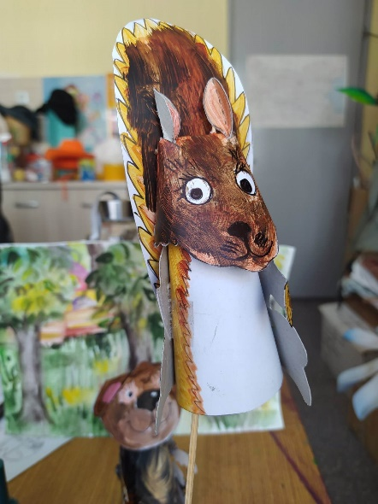  Figure 1. | 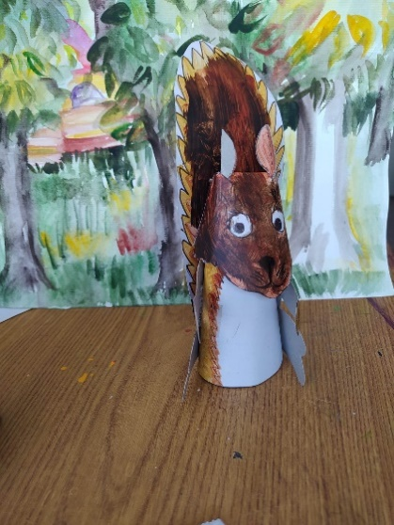  Puppet Squirrel

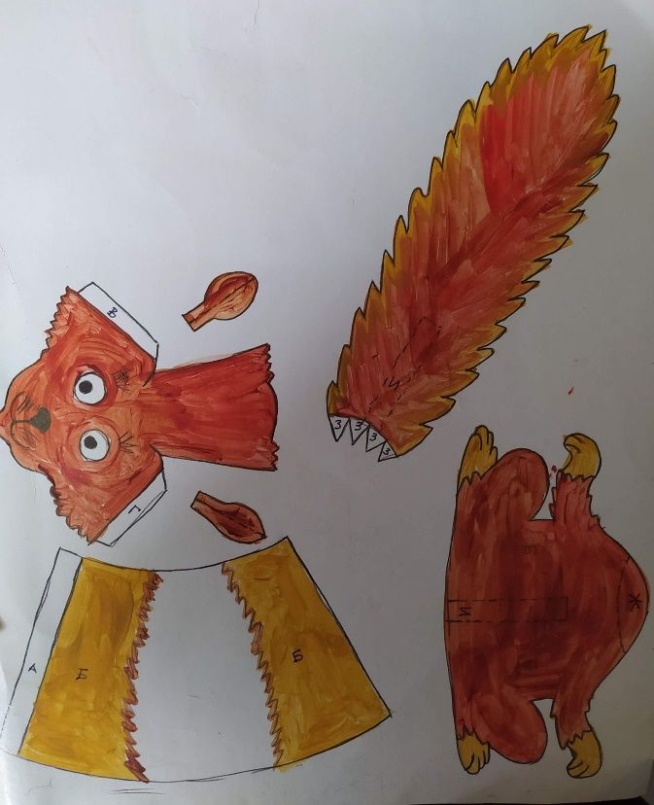
Figure 2. The templates: the body (the cone) and the back with the paws, the head and the ears and the tail

The body is made of a cone. We form the cone and stick it and we stick the back of the puppet to it (see Figure 3 left).
The head is made when cutting and folding as shown and then sticking following the letters. The ears are added in the places especially cut for them (see Figure 3 right).

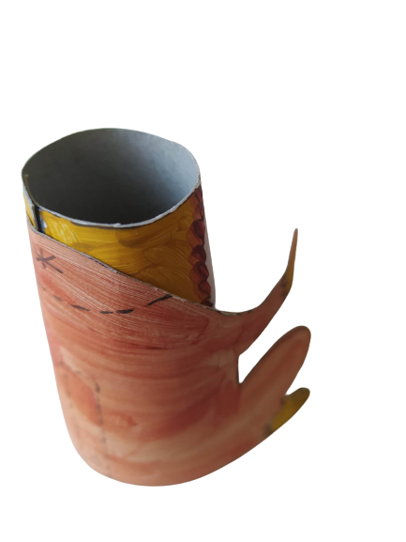 | 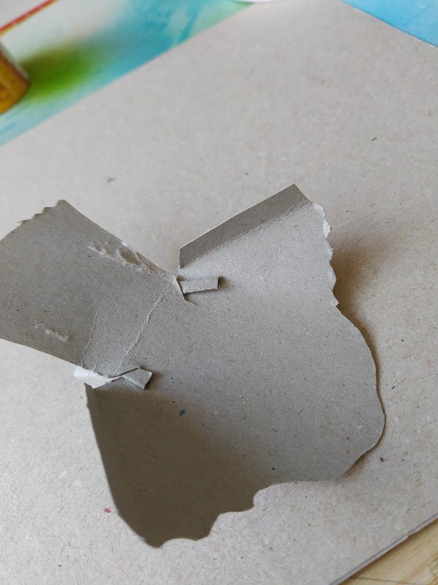
Figure 3. The body (the cone) and the back with the paws, the head with the ears ready to be stuck

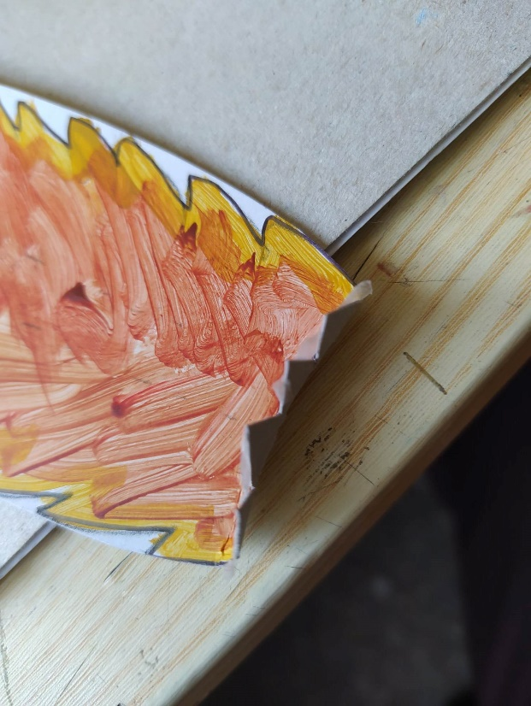 | 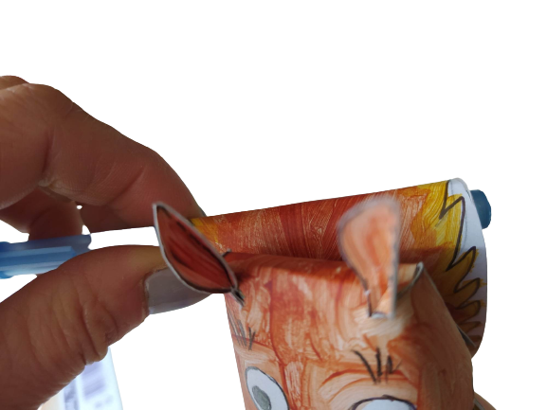
Figure 4. The tail and rolling it.

We complete the puppet adding the tail. We stick the tail using the little triangles at its base (see Figure 4 left) and after sticking it we roll it, forming the curve with the help of a pencil (see Figure 4 right).

The fox is made using a similar template. When preparing the template for the head we have to make a longer muzzle; we colour in orange instead of brown; we colour in white the cheeks, the neck and the breast and we stick the tail in a position characteristic for the fox (see Figure 10).

The turtle is made following similar templates (head, body and back).

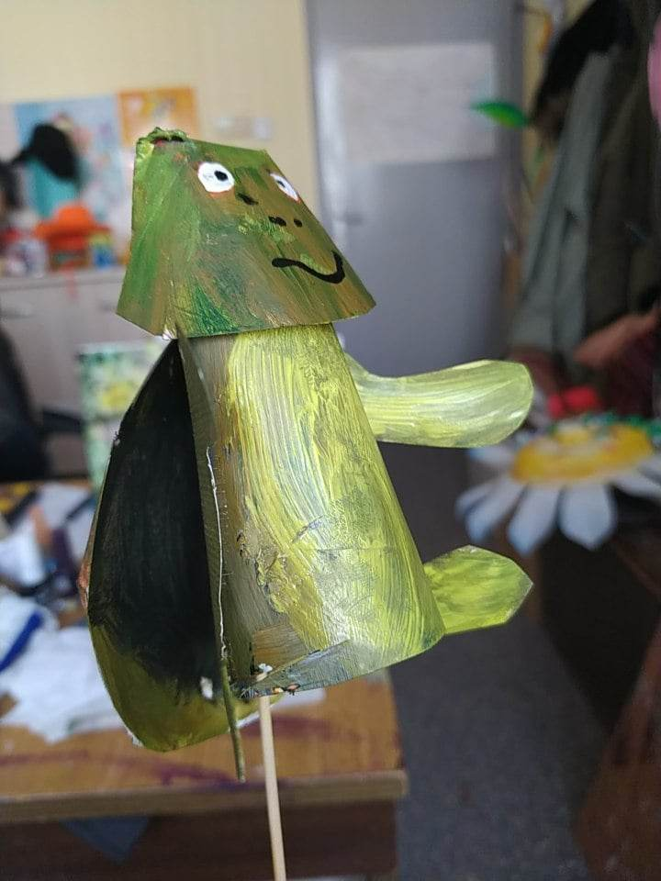  Figure 5 | 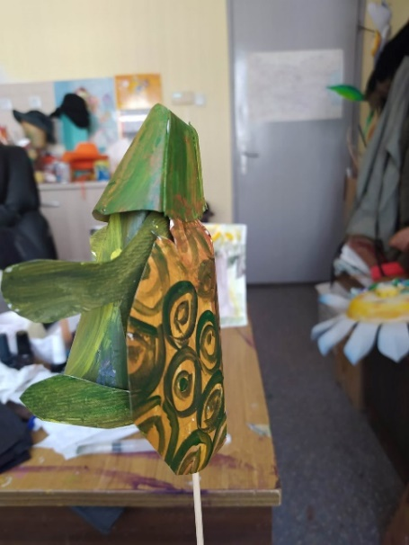  Puppet Turtle. | 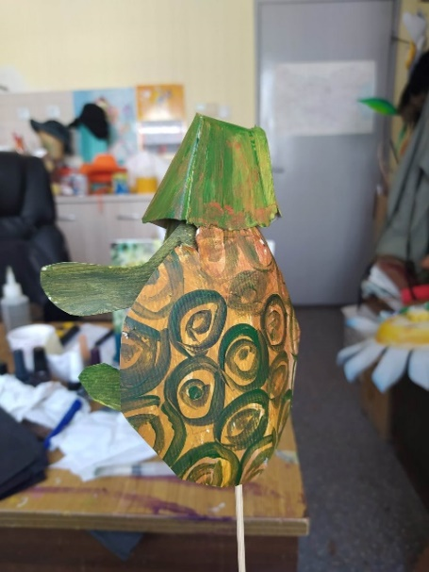

Instead of a tail here we add another back (Figure 6). We fold and stick where shown in order to form a dent. Then we paint circles or polygons. For the breast we use a smaller template than the back (20 cm smaller – 10 by each side) and we do not fold and stick because we do not need a curve here. We use the cone for the body, we add the back with the paws which stay between the carapace and the plastron (the back or the top and the front or the bottom). The head is like the bear’s head (Figure 9) but without ears and a bit more square (Figure 6 right).

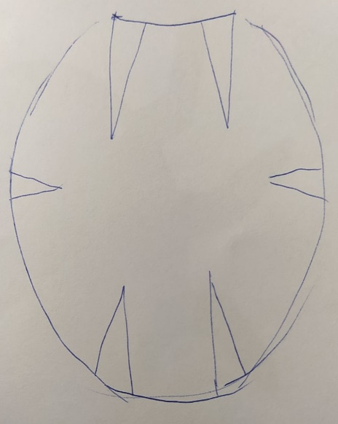 | 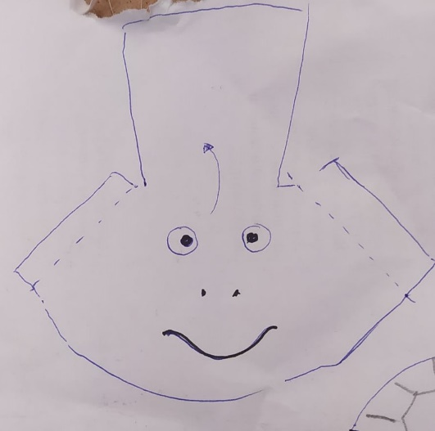
Figure 6. The carapace (back or top) of the turtle

Mr Owl is made like the squirrel: a cone for the body, we add wings and feet instead of back and paws. For the head we use the bear template but without ears and a different form of the face. We can offer another variant of the owl but it would be different from the others. It presents another style of puppet making, therefore I add it as well. We use a plastic bag and fill it with waste out paper. The upper part is stuck down and there are added eyes and wings and yellow feet. With another group we can make all the puppets like owl 2. They are simpler and more suitable for work with very young learners.

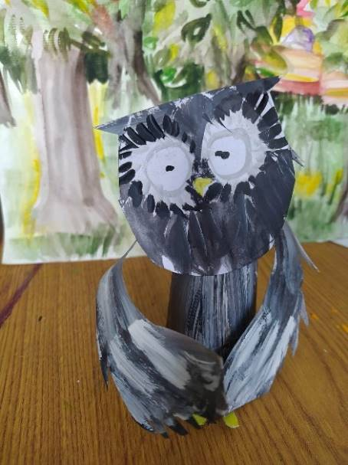  Figure 7. Puppet Mr Owl | 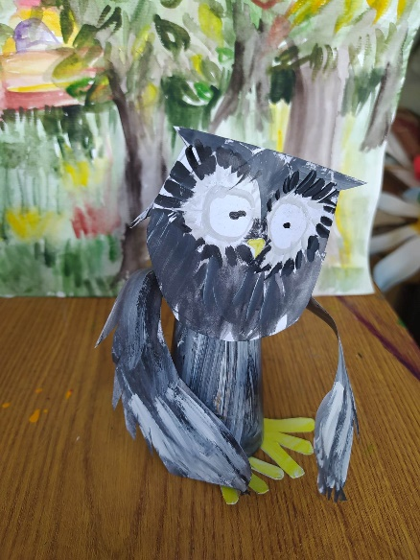

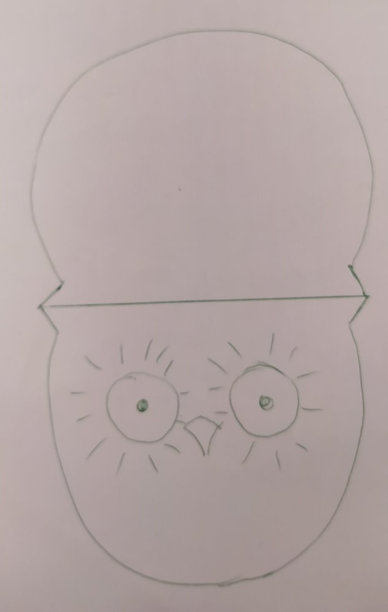 | 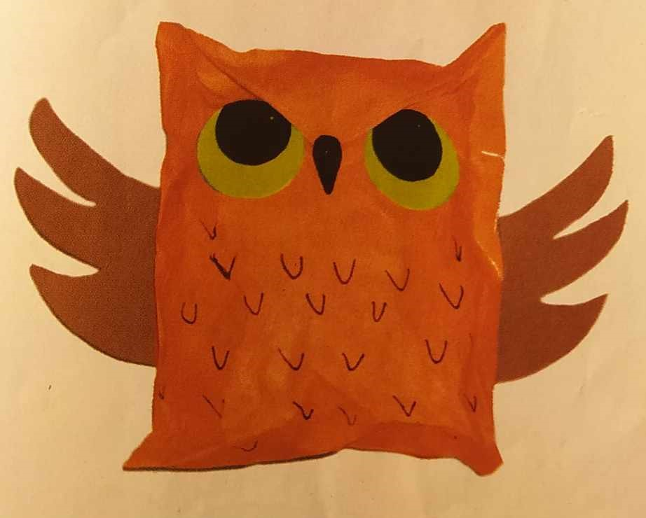
Figure 8. The head of Mr Owl and Owl variant 2.

For the bear we make a new head template. The body and the paws are made using the template for the squirrel’s body.

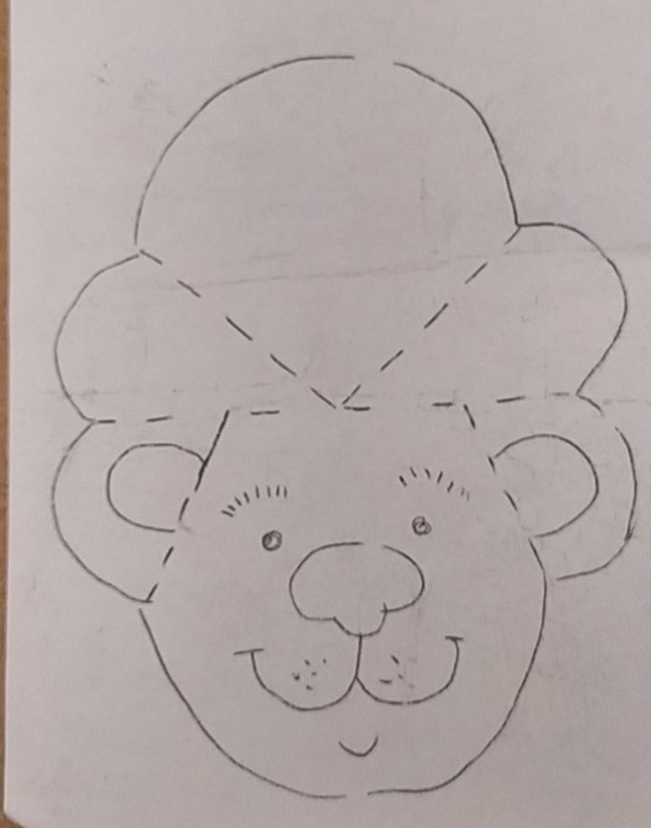 | 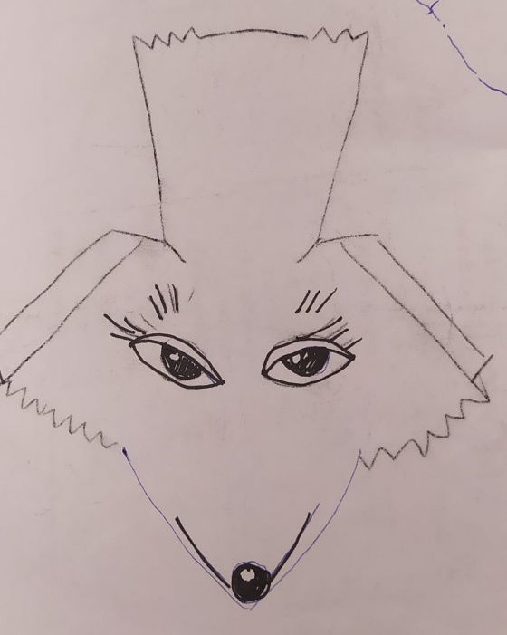
Figure 9. Template for the bear’s and fox’s heads.

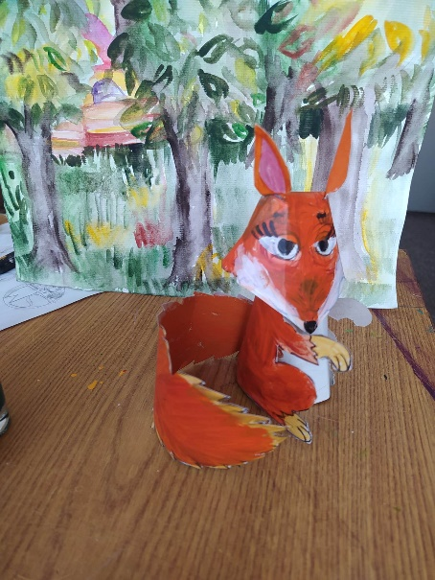  Figure 10. Puppet Fox | 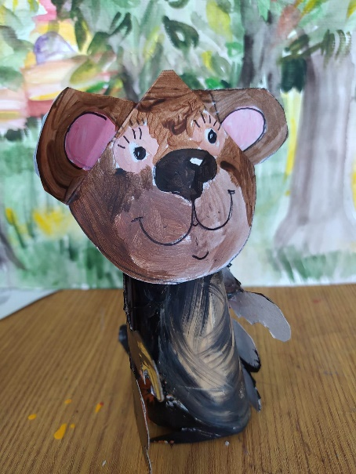  Figure 11. Puppet Bear

These dolls are simple, they do not offer great opportunities for movement. They are fixed on a wooden stick and can turn in two directions. The basic emotions are the intonation of the children and their mimics (their faces have to be above the curtain (if there is one)). These dolls are very suitable for table theatre. Other dolls can be made by household materials. They can be bigger, more flexible, but they will take longer to be prepared and more solid preparation of the children.

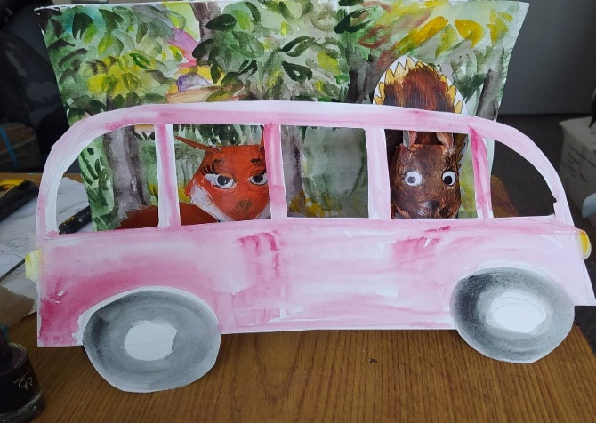
Figure 12. Decoration School Bus

It would be good if behind the screen (a curtain) there are the children that lead the decoration set elements. We recommend the curtain to be placed in such a way that the audience sees the children’s heads so that they see their face expression and mimics when they express the characters’ emotions.

A suggestion

This is a suggestion for small puppet theatre where children prepare the puppets.
“Franklin and the Tooth fairy” by Paulet Bourgeois and Brenda Clark
We divide the story into four scenes:

Scene 1: Franklin and Bear
Scene 2: All animals are travelling by bus to school
Scene 3: At school
Scene 4: At home

We can use the dialogue from the book adding or avoiding certain phrases. We can add additional dialogues between the characters, e.g. between mum and dad discussing what present to choose. We can add a scene In the bookstore where the parents and shop assistant are choosing a suitable book.

The text is a good springboard to discuss and develop the topic of friendship and otherness acceptance, and namely that although different in many ways, children are the same. The story inspires feelings like understanding, tolerance, good heartedness and benevolence. The story and all the activities connected to the puppet theatre and its dramatization realize integration and cross-curricular links to surrounding world: nature (animals and their peculiarities), and social issues (relationships between children, the uniqueness of each child).

Shared experience

At Easter time I staged a small play with cardboard eggs with children. They were impressed by my play and I conclude that it is more emotional and language and the whole experience is more memorable when children take part in the preparation of the puppets, and then use them in their own performance. Parts of the dialogue can be created with the help of the group using their ideas about the happenings and the conversations and even the different scenes.

Some years ago, in Kindergarten Number 7 Prolet in Dobrich, Bulgaria, there was an additional form Puppet Theatre. Children who attended it liked working there, they were very interested in it. Therefore, we consider using puppet theatre in the kindergarten a very useful additional subject that would integrate and implement cross-curricular pathways among various subjects, English especially, that would provoke and keep children’s interest and motivation, and contribute to their linguistic, social and communicative development.

Conclusions

Children love playing; they also love dolls and puppets. As a result of their active involvement in the whole process and their activities during the preparation of a performance, they can experience the whole process of preparation, rehearsals and performance, all the happenings in the story deeply and personally. This way they:

- Develop fine motor skills, a number of other skills that the puppet theatre aids (arms and hands movements, fine motor skills, talking on behalf of someone else and stepping into their shoes).
- Learn to be responsible to the tasks given because the whole team relies on them.
- Work intensively on the preparation of the performance and this work aids memorizing the words and phrases of the characters and keeping them in the long-term memory.

References

Hillyard, S., (2016). English through drama. Innsbruck: Helbling Languages.

Ilieva, Zh. (2021). A Handbook with Drama and Total Physical Response Activities for Pre-School and Primary School Teachers. Shumen: Konstantin Preslavsky University Press.

Ilieva, Zh., (2016). Approaches in the Education of Young Learners Foreign Language Teachers. JoLIE (Journal of Linguistic and Intercultural Education), 2016, 9:1, ISSN: 2065-6599, pp. 47-64.

Ilieva, Zh., I. Iliev, (2019). Cross-Curricular Activities Through Arts and Crafts and English with Young Learners. Humanizing Language Teaching, 21:1, February 2019, ISSN 1755-9715, https://www.hltmag.co.uk/feb19/cross-curricular-activities

Phillips, S., (1999). Drama with Children. Oxford: Oxford University Press.

Wright, A., (2001). Art and Crafts with Children. Oxford: Oxford University Press.

Please check the Pilgrims f2f courses at Pilgrims website.

Please check the Pilgrims online courses at Pilgrims website.

