Positive Psychology in the Secondary EFL Classroom

Tamara Schüszler, Hungary

Tamara Schüszler is a teacher in a secondary school in Budapest, Hungary. In addition to that, she is pursuing her PhD studies at Eötvös Loránd University in Budapest. She is interested in Positive Education and Positive Language Education. Currently, she is working on her dissertation study, for which she designed a set of positive psychology-based tasks. Email: tamara.schuszleratgmail.com

Introduction: what is this article about?

This article presents 5 positive psychology-based activities that you may want to try with a group of yours. The activities meet the criteria for task-based language teaching in the sense that they require target language use on the students’ part while having a real-life element as their integral part (cf. Nunan, 2004; Skehan, 2009). Besides that, in their content, the tasks can all be related to how students can thrive, cope, and maintain their mental health, which makes the tasks closely connected to positive psychology. In each description, you find tips on how to accommodate the task at hand for an online environment, as well. As for the suggested language level of students, most tasks are appropriate for students at B1+ level upwards.

What is positive psychology?

Positive psychology is a new area within psychology, dating back to the early 2000s, when the newly inaugurated president of the American Psychological Association, Martin Seligman proposed that psychologists shift their professional focus from what can go wrong in a person’s psyche to what and how can function properly. This meant a turn from psychology as victimology to how and why people thrive (Csíkszentmihályi and Seligman, 2000). Positive psychology, however, is different from bare (and toxic) optimism or generally learning to be happy, as it rather focuses on people overcoming difficulties instead of denying those difficulties. This makes positive psychology “the empirical study of how people thrive and flourish” (MacIntyre & Mercer, 2014, p.154.).

What is mindfulness?

Some of the tasks below grew out of the idea behind mindful practices, that is, why it is essential here to establish what mindfulness is. Originally, it is a meditative approach in Buddhism (Kirmayer, 2015). In the Western world, it first appeared among interventions aiming at reducing stress among clinically depressed patients. A secular definition is given by Kabat-Zinn, who established such interventions first as follows: “Mindfulness is the awareness that emerges from paying attention in a particular way: on purpose, in the present moment, and non-judgmentally” (Kabat-Zinn, 1994, p. 4). What this means in the case of the following activities is that all of them aim at helping students be in the present moment instead of letting their monkey minds (cf. Bai, 2015) wander into past regrets or future worries.

Activity 1: Mindfulness of your journey through sounds

General focus: to focus attention on noises and arrive in the present moment
to focus in the other person’s story
Language focus: narrative tenses and gerunds
Skills: listening and speaking
Language level: B1 and upwards
Time: 12-15 minutes
Preparation: smartphone, Wi-Fi connection and, possibly, loudspeakers needed
Note: some experimentation is necessary with the website (2 min)
Online version: in the main meeting, everyone is muted except for the teacher; teacher sharing screen and sound

Procedure

1 The teacher tells students they are going to listen to some sounds and their task will be to listen carefully and imagine they are on a journey.

2 The teacher asks the students to close their eyes and plays different sounds from the website https://asoftmurmur.com/ by using the volume buttons to adjust the intensity of the sounds.

3 After hearing the recording, Students are asked to turn to a partner and tell them about their journeys; the teacher asks students a guiding question based on what they want to practice.

Where were you? What were you doing?
OR
What could you hear happening?

4 Teacher goes around monitoring.

5 If needed, in the end, the teacher leads a quick sharing circle.

Anticipated problems: There is no set order to which sound should come after which, so you can experiment. Using a JBL speaker or a PC with speakers for optimal sound is recommended . If the site is not working, you can search for other ambient sound sites or brown noise sites and use other options.
Predicted outcomes: accurate use of narrative tenses OR gerunds (e.g. I could hear crickets chirping) used in speaking; some Students might be reluctant to participate or close their eyes – allow it.

Activity 2: A Mindful Cycle / Full Body Scan

General focus: to perform a full body scan by observation; to focus on the present moment
Language focus: the body vocabulary; feelings vocabulary
Skills: writing and speaking
Language level: B2 and upwards
Time: 20-25 minutes
Preparation: a board and chalk/markers may be needed; ONLINE version: first in a main meeting; then, in breakout rooms (sharing part).

Procedure

1 The teacher talks students through this activity, step by step, by giving the following instructions, and then pausing:
We will complete 4 steps and observe 4 different things now. Come with me, I will set the pace for that.

2 Observe your thoughts. What is on your mind right now? Do not go with the thought, just let it flow through you as if they were clouds in the sky. You are not the weather but the sky. Take notes / Discuss with partner.

3 How do you feel in connection with those thoughts? Take notes / Discuss with partner.

4 Where can you localize those feelings in your body? Take notes / Discuss with partner.

5 What are you doing about it? Would like to change that bodily feeling? Take notes / Discuss with partner
NB if they change the bodily feeling, it may change the whole cycle: they may even lower their anxiety level. At the end, the Teacher can point that out with an example (e.g. I have thoughts about my Physics test coming up, I can detect anxiety as a feeling, and I can feel a lump in my throat so I decide to take a deep breath 3 times.)

Comments: The Teacher can demonstrate the cycle by drawing a stick figure on the board and adding more details to the drawing as part of each step. (See drawing below.)
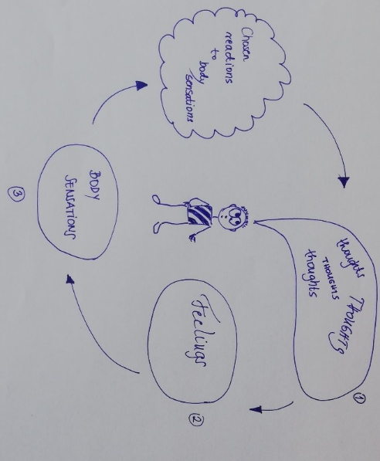

Anticipated problems: Some students might be reluctant to take part – allow them to sit back and observe. Some students might find it difficult to talk about their thoughts, feelings, bodily sensations in English – in this case, drawing and taking notes should be encouraged.

Predicted outcomes: A drawing or notes with their observations; if done as a speaking activity, up to 10 minutes of conversation in the foreign language.

Activity 3: Mindfulness of the Environment / I Was Today Years Old

General focus: to make observations and tell others about them, to focus on the other person’s story
Language focus: narrative tenses
Language skills: listening and speaking
Type of activity: warmer/cooler
Language level: B2 and upwards
Time: preparation in advance + in class: approximately 15-20 minutes, depending on number of pairs
Preparation: This activity must be carefully prepared. Instructions need to be given at least 1 week in advance.
Online version: in a meeting, using breakout rooms.

Procedure

1 This activity needs preparation on the students’ part – they will need to use their phones or the internet. The teacher first gives them these instructions:

You may be familiar with memes made from tweets that start by saying ‘I was today years old’:
So today, please just observe. Try to find something online or offline - at home or outside - that is brand new. Find something that has always been under your nose, but you never realized it.
Please bring your finding or picture of it to our class next week.
(This activity is based on a popular meme format called “I Was Today Years Old When I Found Out”, in which people share things that they have not discovered before even if they are obvious things or so-called life hacks.)

2 Then, the teacher gives students a week to take a snapshot of something they have just found; also, they remind the students not to forget about this task.

3 When the right time comes, students bring their objects or photos to class and share them with their peers in a speed-dating setting, which means that students form two lines, facing each other, having their phones in their hands, and then take turns in talking about the pictures. Every 3 minutes, one line moves so that the partners are changed, leaving their room for more conversations than one.

Anticipated problems: This activity can be turned into an online one easily and may even encourage students to leave their flats, so in the case of online classes, this may be a good breaker; however, timing has to be carefully watched if the Teacher is to send students out “for an adventure” during an online class.
It may be a better idea to assign this as extra homework – with careful and superb marketing, “selling” the idea first. In order to do that, the Teacher might need to show Students memes from the web titled “I was today years old”; alternatively, this task bank also comes with a few pictures that can be used and that are not copyrighted (see the next page).
Predicted outcomes: speaking practice

Sample images

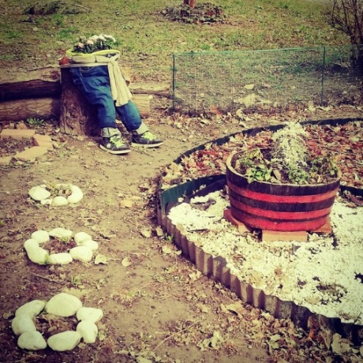

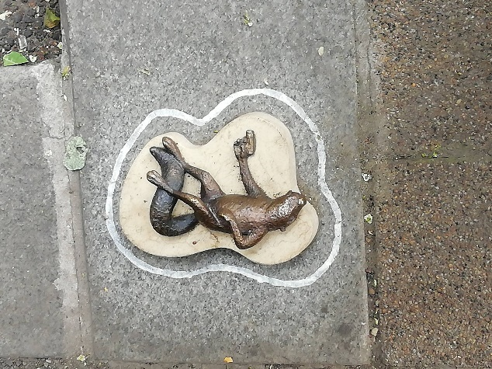

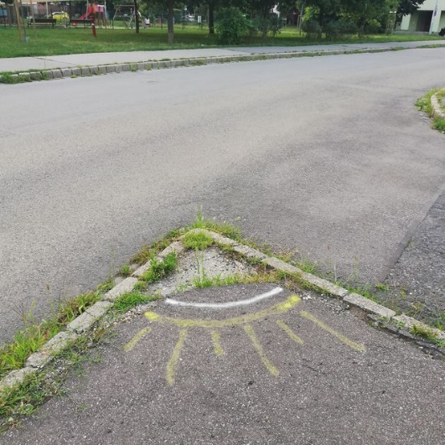

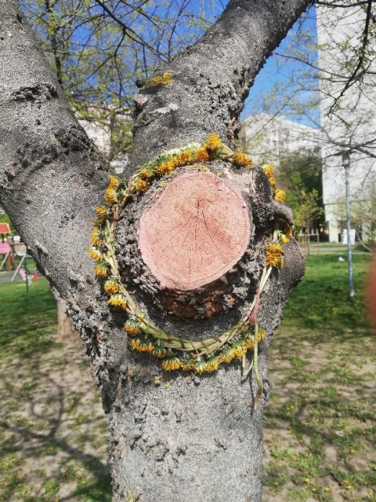

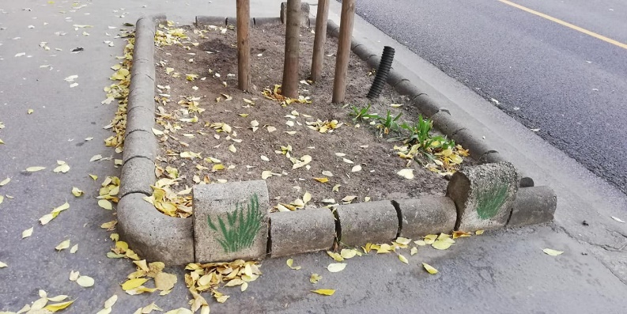

Activity 4: Mindfulness of sounds

General focus: to focus attention on noises and arrive in the present moment; to listen to each other
Language focus: narrative tenses or modals for deduction, feelings vocabulary or sounds vocabulary (or any other vocab focus you want practice or activate)
Skills: listening and speaking
Type of activity: warmer/cooler
Language level: B1 and upwards
Time: 5-8 minutes
Preparation: recording 1 minute of street noises/nature sounds using a mobile phone (can be done anywhere; however, for recording others’ voices, permission is necessary); you can also experiment with opening the window, which is particularly funny if the garbage truck is due to come today.
Online version: in a main meeting where everyone is muted except for the teacher; teacher sharing screen with sound also shared and playing the recording that way.

Procedure

1 The teacher tells students they are going to listen to some sounds and their task will be to listen carefully to what they can hear.

2 The teacher asks the students to close their eyes and plays a 1-minute recording prepared in advance (alternatively, can play any recording containing street/corridor noises).

3 After hearing the recording, students are asked to turn to a partner and tell them about their experiences. The Teacher may ask students a guiding question or questions based on what they want to practice with the students e.g.;

- narrative tenses – Where were you? What were you doing?
- modals for deduction – What do you think might have been heard on the recording?
- feelings vocabulary – What feelings would you relate the things you heard to?
- sounds vocabulary – What sounds could you hear?

4 Teacher goes around monitoring the activity.

5 If needed, at the end, the teacher organises a quick sharing circle.

Anticipated problems: can be a warmer or a cooler activity; outside noises cannot be excluded (and shouldn’t be); Students themselves may make noises – allow it. Some Students might be reluctant to participate or close their eyes – allow it. Some Students might find it hard first to “come back” and open their eyes in the end.
Predicted outcomes: spoken language using narrative tenses or modals for deduction or feelings vocabulary or sounds vocabulary (or any other vocab focus you want to have)

Activity 5: A Pre-test Breather/Mindfulness of Tasks

General focus: to focus attention on noises and arrive in the present moment; to focus on the other person’s story
Language focus: general
Skills: possibly writing
Language level: B1 and upwards
Time: 3 minutes
Preparation: none
Oline version: the instructions can be put into the first section of an online test or its description; the marking done by students can be done in a private message sent to the teacher, meaning that students send the number of the starred task to the teacher via private message. Alternatively, if students can see the whole test at once, the teacher may initiate a poll where everyone can mark which task they would star for themselves.

Procedure

1 Before starting the activity, the Teacher clarifies that Students will be breathing and that it is important that their breathing out is longer than their breathing in.

2 Before students take a test, the teacher helps them arrive in the present moment by giving the following instructions (in italics).
Take a deep breath. (T can count to help the process – 1-2-3 – 1-2-3-4-5 to helps Students make the exhalation phase longer than the inhalation).
- Think of yourself. Have you studied for the test? Think of one thing you know really well. Write it down.
- Now look through the test sheet. Can you find it anywhere? Put a star next to it.
- Start with this exercise.

Anticipated problems: Students might not know the words inhale/exhale. Then, just avoid them by saying breathe in/breathe out.
Note: The inhalation has to be longer than the exhalation because, otherwise, Students may feel like they are short of breath, which may lead to more stress.
Students need to be assured that the Teacher will NOT grade this activity or any product of it.
Some students might be reluctant or too nervous to take part – allow them to sit back and observe.
Predicted outcomes: Students may produce written language even before starting the test – this may also tell the teacher what areas were problematic and what were easy for them (cf. the ones Students starred for themselves).

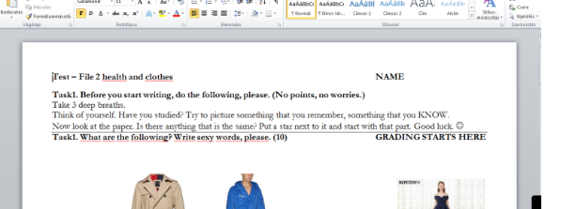
Reflections and concluding notes

Originally, these five tasks were among the ten activities I designed for my dissertation research. I have tried them out with my Students belonging to different groups and have also shared them with my Colleagues. What my post-lesson conversations with Students taught me is that these activities were generally welcome in my classes, especially if students were given space and time and the option not to take part.
When I asked my students how frequently they could imagine doing such tasks, they had varying opinions, which made it even clearer to me that on the teacher’s part, doing such tasks is a brave endeavor for two reasons. For one, the teacher has to let go of control and allow students to decide the extent to which they want to take part – reflecting on their present states of mind and needs. Secondly, it is essential for the teacher to feel comfortable with guiding students through the above activities, which, to me, meant more preparation at first than for a “non-positive-psychology-based” class of mine. Having said that, I feel that peeking into this world and digressing from the curriculum with my groups has facilitated my day-to-day work, too, as my students know that I am open to do so – when there is a real reason behind abandoning the coursebook.

When it comes to feedback from Colleagues, my personal takeaway is this: Teachers who tried these tasks actually used them more creatively than I had imagined; one of them even built a project around the general idea that they got from Mindfulness of sounds. With this in mind, I am convinced that these tasks should be sent on their way and Teachers should be encouraged not only to use them but rather get inspired by them, recycle, repurpose, and reinvent them – in the spur of the moment, mindfully.

References

Bai, H. (2015). Peace with the earth: Animism and contemplative ways. Cultural Studies of Science
Education, 10(1), 135-147. https://doi.org/10.1007/s11422-013-9501
Council of Europe. (2001). Common European framework of reference for languages:
Learning, teaching, assessment. Press Syndicate of the University of Cambridge.
Kabat-Zinn, J. (1994). Wherever you go, there you are: mindfulness meditation in
everyday life. Hyperion.
Kirmayer, L. J. (2015). Mindfulness in cultural context. Transcultural Psychiatry,
52(4), 447–469. https://doi.org/10.1177/1363461515598949
Langer, E. J. (2013). Mindfulness. In S. J. Lopez (Ed.). The encyclopedia of positive
psychology (pp. 618–622). Wiley-Blackwell.
MacIntyre, P. D., & Mercer, S. (2014). Introducing positive psychology to SLA.
Studies in Second Language Learning and Teaching, 4(2), 153–172. https://doi.org/10.14746/ssllt.2014.4.2.2
Nunan, D. (2004). Task-based language teaching. Cambridge University Press.
Revell, J. (2018). Energising your classroom. Ways to give your students a break. Helbling Languages.
Seligman, M. E. P., & Csíkszentmihályi, M. (2000). Positive psychology: An
introduction. American Psychologist, 55(1), 5–14. https://doi.org/10.1037/0003-066x.55.1.5
Skehan, P. (2009). A framework for the implementation of task-based instruction. In
K. Van den Branden, M. Bygate, & J. M. Norris (Eds.), Task-based language teaching: A reader (pp. 83-107). John Benjamins Publishers.
Stevens, M. & Wedding, D. (2005). The Handbook of International Psychology. R

Please check the Pilgrims f2f courses at Pilgrims website.

Please check the Pilgrims online courses at Pilgrims website.

