Tales of Strays ACTION!
Margarita Kosior, Greece/Poland

Margarita Kosior is an educator, conference presenter, materials writer, but also a storyteller and a children’s author. She has written ELT materials dealing with all kinds of social issues. In recent years, she has concentrated her efforts on building and expanding her Tales of Strays Campaign, which uses storytelling, materials writing and English language teaching to talk about our responsibilities towards companion animals and about the bond between people and dogs and cats in order to prevent instances of future neglect, abuse and abandonment.
E-mail: margaritakosior@gmail.com and talesofstrays@margaritakosior.com


Introduction

The treatment and prevention of abuse of companion animals is a critical social issue. Over the years, educators and students involved in the Tales of Strays Campaign have been dedicated to improving the welfare of these animals, with the belief that this will ultimately lead to a better future for all. That is because teaching children about kindness and respect for these animals has the potential to extend its impact to their interactions with fellow humans, cultivating a sense of empathy and compassion.

You can learn more about the campaign, its aims and activities by reading a previous publication titled Teaching for a Better Tomorrow with Tales of Strays. This article is dedicated solely to a project completed within the scope of the campaign during the school year 2022-23.

Tales of Strays ACTION 2022-23

At the beginning of the 2022-23 school year, twelve teachers answered the call and enthusiastically joined the Tales of Strays ACTION project. Throughout the year, they worked with their students on a variety of projects and initiatives related to companion animals. They also took part in the Change Makers’ Conference during which the students presented their work to the other participants. Additionally, these dedicated educators agreed to share their valuable insights with a wider audience during an open online event for colleagues and by writing a report for a compilation available here.

More specifically, in September-October 2022, each teacher selected a group of students of any age of English language proficiency level to be involved in the project. Together with their chosen groups, they decided on the focus of their projects. These topics were either based on a lesson plan from one of the Tales of Strays Compilations or were entirely original ideas crafted by the teachers and students involved. A list of sample topics including dog/cat domestication, responsible companion animal care, understanding dog/cat body language, puppy mills and pet store puppies, service dogs or the role of companion animals in enhancing human well-being, to mention just a few, was available for consideration on the website.

Between October and January, teachers and students worked on their project at their own pace. The students were working towards a collaborative outcome in the form of a group project, e.g. a poster, a video, or a collection of poems.

Following the completion of their projects, the students began preparations for the Change Makers’ Conference held at the beginning of March, while the teachers started working on their written reports for the compilation and on their presentations for the forthcoming open online event which would reach educators across the globe.

Tales of Strays ACTION 2022-23 - work samples

As mentioned earlier, a total of twelve teachers and their students participated in the 2022-23 Tales of Strays ACTION! Project.

Maria Alatzidou (Project Foreign Language School) worked with her B1 and C2 students on the topic of stray animals. The lesson was adapted from a plan by Erëza Mehmeti included in Tales of Strays Compilation: Volume 3, and centred around an exciting escape game.
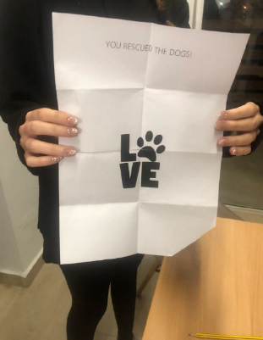

Following this activity, the students conducted interviews with two volunteers working with local strays, aiming to learn more about these animals and the challenges faced by volunteers.

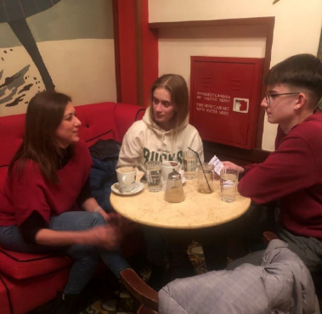

Lia Bezanidou’s B1-B2 students created captivating stories which would not only entertain the reader but also stress the importance of caring for stray animals. The aim of those short stories was to emphasise that dogs and cats do not belong in the streets. Inspired by the Tales of Strays Campaign, Lia’s students made amazing graffiti and recorded the creation of it in a video. Screenshots from the video are presented below:

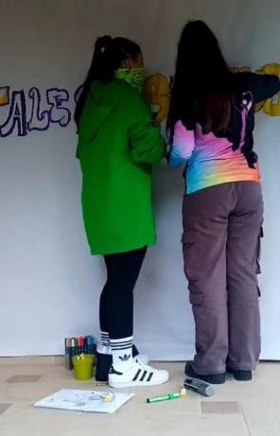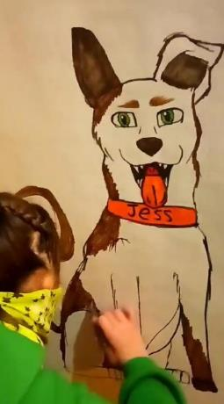
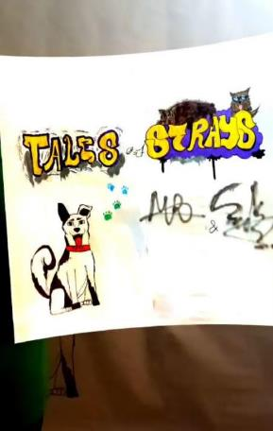

Sophia Dima (Europoint – Petala Foreign Language School) worked with A1-A2 students. Their project was based on Madalina Atanasov’s lesson plan titled “Reading in their eyes” included in Tales of Strays Compilation: Volume 3. The book Toby to the rescue was also used in the preparatory phase of the project. The outcome was a beautifully animated story.

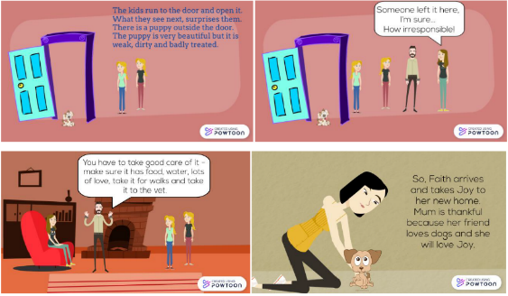
Screenshots from the story written by Sophia’s students.

Maria Doulgeri (Primary School of Nea Potidea) worked with her A1-A2 students on a captivating topic of working dogs. The interesting twist was inviting students to discuss the following question: Can a rescue dog become a service dog? As a follow-up, Maria’s students made posters and flyers on the topic and shared them with the rest of the school community. Upon completing the project, they made some insightful reflections:

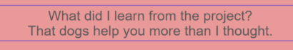

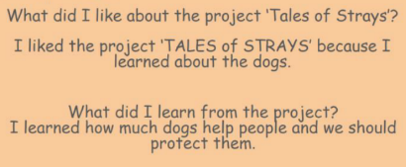

My own individual student, Georgina (A2+ level at that time), presented the work she did based on a short story “When a Cat Purrs” (available soon; details will be provided on Tales of Strays social media). Through this story and a series of creative activities related to it, Georgina explored the “healing powers” of cats, expanded her vocabulary related to feelings, and deepened her empathy by reflecting on the emotions of the characters. Then, through stepping into the shoes, she rewrote the story from the point of view of one of the protagonists.

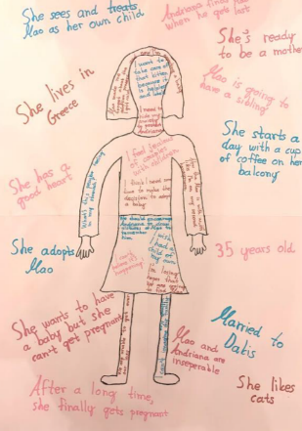

Tanya Livarda worked with her Pre-A1 and A1/A2 students with the aim of raising their awareness about stray animals. She engaged them in creating a dog-friendly newspaper, a board game and a short presentation regarding how to take care of their dog.

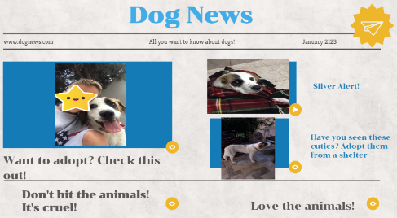

Throughout the duration of the project, Tanya used a variety of materials created for the campaign: picture books Toby to the Rescue and Mae to the Rescue, as well as the lesson plans by Barbara Hoskins Sakamoto, by Lisa Hovarth and by Maria Marilita (all from Lesson Plan compilation 2020).

Theodora Papapanagiotou worked with a number of students at different proficiency levels (A2 to C1). Some of the students crafted heartwarming cat rescue stories, while others engaged in activities based on a poem written by Theodora about her own former stray companion.

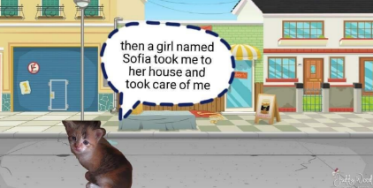

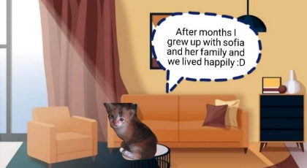
Screenshots from one of the stories, created by Sofia and Olga.

Maria Polychrou (English Drama Microschool) designed a multi-dimensional project that catered to all groups at her language school, ranging from 3.5 to 14 years old. Participants engaged in a variety of age-appropriate activities that targeted language in a multimodal way through a variety of stimuli. Throughout the project, Maria used the lesson plan created by her for the Tales of strays Campaign. Except for that, her students played the roles of architects building a stray animals’ shelter and veterinarians caring for companion animals.

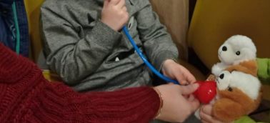

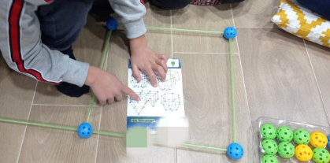

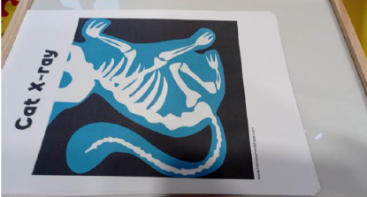

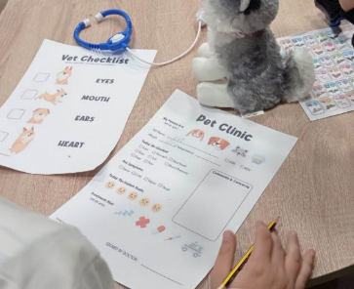

These activities represent just a small portion of the comprehensive range designed and executed by Maria for her students.

Despina Sarantidou’s (ISON Meteora) embarked on the project with her B1-B2 students to explore the intriguing, but also challenging, subject of service dogs, which required extensive research. During the research stage, the students read about an organisation called Therapy Dogs based in Thessaloniki. They reached out and interviewed Therapy Dogs volunteers, which helped them realise the benefits that the human-animal bond can have on every individual.

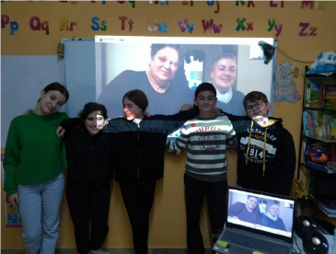
Despina’s students after the meeting with Therapy Dogs volunteers, Ms Pasxali and Ms Stogianni.

Foteini Tzekou (School of English Studies Foteini Tzekou) and her students (A2 level) built their project around the story of Cookie, a stray dog that got hit by a car and got partly paralysed as the result of the accident. Stami Tzora from Strays from Corfu shared Cookie's story with the students during an inspiring presentation. During her inspiring presentation, she talked to the students about Cookie, who ended up in a wheelchair because of people’s lack of responsibility and respect for his life. As a concluding activity, students created drawings and writings depicting Cookie's life.

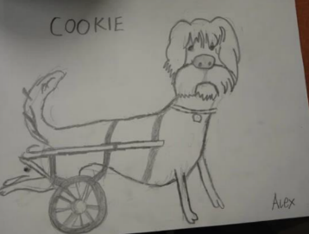

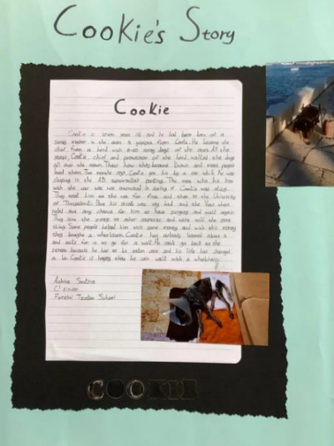

Gill WIlliams (Karakousi Language School) and her A2-B1 students reflected on and shared happy memories, experiences and feelings around living with a companion animal. The aim was to remind students of their own positive feelings towards their cats and dogs but also to appreciate special relationships and experiences others have had with their animals. As a follow-up, the students prepared posters which conveyed their thoughts and reflections.
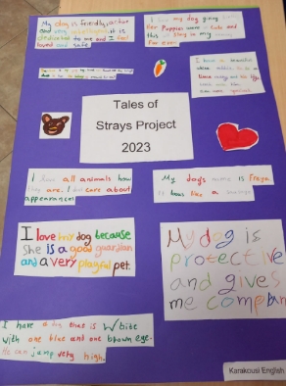

Last but not least, Kiki Xynta (GlobalLand Language School) involved her A2 students in a project aiming to show how companion dogs contribute to human happiness for different groups of people: individuals with disabilities, children, prisoners, elderly people and patients. Throughout the process, the students also gained valuable insights into the importance of adoption and our responsibilities towards our companion animals. They participated in a variety of tasks including writing an acrostic poem and a letter to the Mayor. The purpose of the letter was to draw the Mayor’s attention to the pressing issue of stray dogs being poisoned in the streets of their town, and to make a plea to the Mayor for public support and protection of these animals from such inhumane practices.
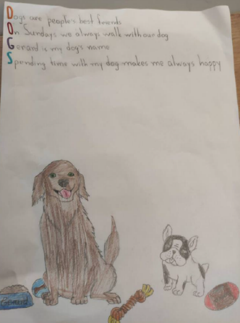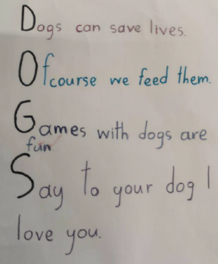

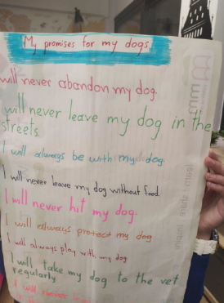

You can read more about each project in the 2022-23 compilation of reports.

Tales of Strays ACTION! 2023-24 - be part of it
Last year marked a fantastic start. This year, we are ready for more. We must not forget that language is a powerful tool that has the capacity to mold our thoughts, behaviors, and actions, and through English language teaching, we can harness this potential.
If you would like to take part in the 2023-24 edition of the project, ask for more information, or support Tales of strays in any other way, please get in touch.
Email: talesofstrays@margaritakosior.com
Website: www.talesofstrays.com
Facebook: /mktalesofstrays
Instagram: /tales_of_strays

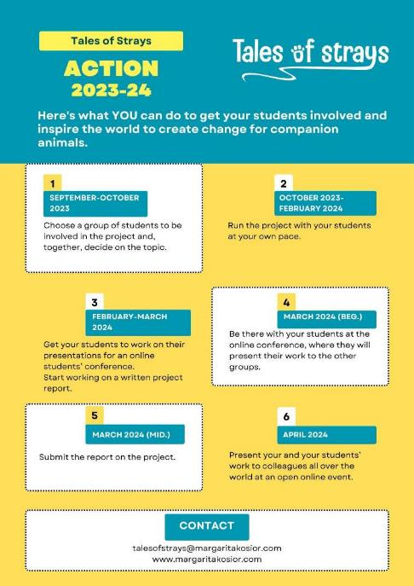

Note: The images featured in this article have been sourced from reports authored by the teachers, freely available online. It's essential to highlight that the parents provided consent for their children to be featured in these images.

Please check the Pilgrims f2f courses at Pilgrims website.

Please check the Pilgrims online courses at Pilgrims website.

