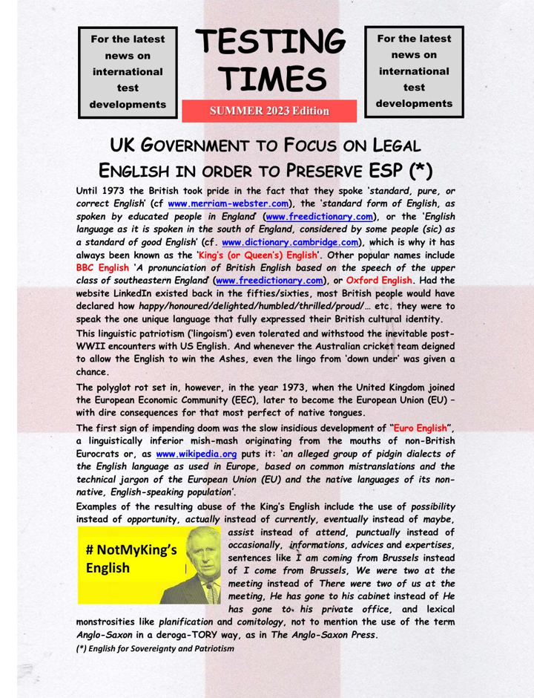

You can download a pdf of the text at the bottom of this page.

