Mind Maps in Teaching and Learning
Anna Cetnarowska, Poland

Anna Cetnarowska is a lecturer at the Faculty of Humanities (University of Applied Sciences in Nowy Sącz, Poland) - Wydział Nauk Humanistycznych, Akademia Nauk Stosowanych w Nowym Sączu). She is interested in modern approaches to learning languages. Her e-mail address is: acetnarowska@ans-ns.edu.pl

Abstract

The article explores the use of mind mapping technique as a powerful tool in teaching and learning. Mind maps are visual representations of information and are useful in organising and connect ideas. The article presents the concept of mind maps and discusses their potential benefits in various aspects of education, such as improving memory and creative thinking. It ends with the conclusion that integrating mind maps into the curriculum might be very beneficial both for students and teachers.

Introduction

The concept of mind maps was developed by Tony Buzan in the 1970s. In recent years it has gained considerable attention in various fields, including education, which constantly seeks strategies to enhance teaching and learning processes. Traditional note-taking methods which are frequently used in classrooms have several disadvantages. They might not be stimulating for the brain, thus inhibiting the process of remembering information (Buzan 2019: 38); they also tend to be monotonous and lengthy (Buzan, 2014: 47). On the contrary, mind maps are more “attractive” for the brain, as they stimulate it and make learning process more meaningful. Buzan defines mind mapping as “a meta-tool that allows you to visually organize and connect your thoughts, ideas, and knowledge in a way that reflects the architecture of thinking. At its core, a Mind Map is the graphical representation of the way our brains naturally process and organize information” (https://tonybuzan.com/mind-maps).
Mind maps are visual diagrams which involve creation and visualization of ideas around a central concept (Buzan, 2019:60). The ideas are linked by arrows in different colours with the addition of some symbols or pictures. According to Buzan, the colour in mind maps (as opposed to monochromatic linear notes) grasps the attention, enhances understanding, boosts motivation and improves the ability to process and store information. The ideas represented in mind maps as pictures or words function as the key concepts which are easily remembered.
Buzan (2014: 92-93) enumerates various rules of making mind maps:
- Use A3 size paper, preferably placed horizontally.
- Start in the centre (place the main topic in the centre of the page, preferably in the form of a picture).
- Use colours (incorporate different colours to distinguish different ideas; it makes the mind map more appealing and stimulating for the brain).
- Connect ideas with lines (lines should represent the relationship between different concepts).
- Use one key word per line (use key words or short phrases to represent ideas and concepts; you can use various fonts and sizes to emphasize essential points but try to keep it simple).
- Use symbols and icons (they stimulate creativity and make the mind map more visually appealing).

An example of a mind map is presented in the picture below:
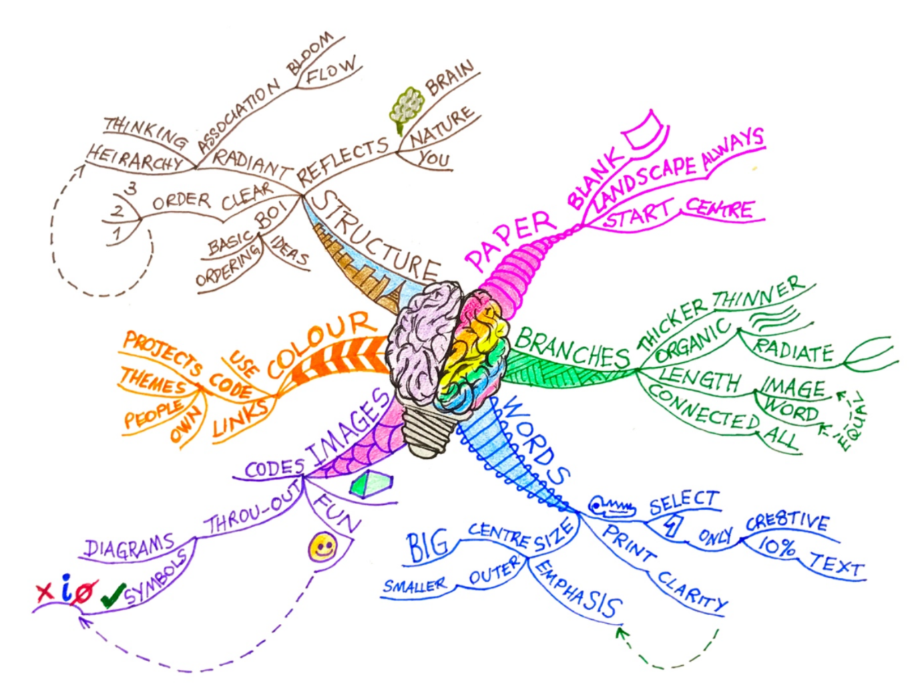
Source: https://tonybuzan.com/mind-maps

It is worth mentioning that Buzan (2019: 160-161) enumerates a number of situations in which mind maps can be used, such as writing a CV, planning a birthday party or making various lists. However, the article focuses on using mind maps in teaching and learning, therefore other aspects will not be discussed.

Mind maps in teaching and learning

Mind maps are a powerful academic tool and can be used in various ways, both in class and at home. Below there are some ideas how mind mapping technique can be used by teachers:
- to introduce a new topic (the teacher writes the key word on the board and the students can add their ideas in the form of a mind map; this will help the teacher check the students’ background knowledge on the subject);
- to summarise the lesson (visual representation of key ideas from the lesson will help students retain and review information);
- to brainstorm ideas (students generate ideas and teachers writes them in the form of a mind map);
- to revise the material (mind maps on a given topic);
- to prepare a writing task (before starting a writing assignment, students can organize their thoughts and prepare a clear structure of the text);
- online mind maps (they can be printed and shared with students as handouts);
- problem-solving tasks (mind maps can help evaluate the advantages and disadvantages of a topic or identify potential solutions to the problem).

The list of potential uses of mind maps both for students and teachers may be endless, depending on their creativity. Here are some examples of how students can implement the mind-mapping technique in their studying:
- note-taking (students can use mind maps to take notes during a lecture or while studying from textbooks);
- planning their studying (mind maps can be used to outline the topics and learning objectives);
- revision (converting study materials into mind maps);
- preparing a presentation or a project;
- summarizing a book or article;
- planning a writing task (organising ideas, preparing the structure of the text in the form of a mind map).

Mind maps are a very versatile tool that can adapt to various learning styles, thus making learning process more effective. The act of creating mind maps itself reinforces learning and understanding.

Benefits of mind maps

Creating mind maps is an active process which requires some effort. According to Spitzer (2007:114), the more active the learners are, the more neural connections are generated in the brain, thus making the learning process more effective. Therefore, mind maps are a very powerful tool in stimulating the brain due to the fact that they require active and deep processing of information. The learner has to select, structure and connect the information in order to identify the relationship between ideas and concepts. Using mind maps allows for a more holistic understanding of complex topics. By stimulating visual thinking, mind maps can enhance memory. As it has been mentioned before, mind maps incorporate both visual elements (e.g. images and colours) and verbal elements (key words) to represent information. Key words are crucial because it is easier to remember them than to remember long sentences. Using key words minimizes the volume of words and maximises the focus on meaning. Last but not least, mind maps are a fun way to learn, as they stimulate imagination and boost creativity (Erdem, 2017: 6).
Conclusion

The article presents the mind mapping technique as a powerful tool in education. The concept of mind mapping is consistent with the idea of brain-friendly teaching and learning. Mind maps promote active learning, organization and creativity, thus enhancing students’ understanding and engagement. As teachers continue to seek innovative approaches to improve the learning process, the integration of mind maps into the curriculum might have great potential for students and teachers around the world.

Bibliography
Buzan, T. (2014) Mapy twoich myśli. Wydawnictwo JK, Łódź
Buzan, T. (2019) Mistrzowskie mapowanie myśli. Helion SA, Gliwice.
Erdem, A. (2017) Mind maps as a lifelong learning tool. Universal Journal of Educational Research 5 (12A): 1-7.
Spitzer, M. (2007) Jak uczy się mózg. Wydawnictwo Naukowe PWN, Warszawa
https://tonybuzan.com/mind-maps

