Becoming Community-Engaged Educators: Engaging Students Within and Beyond the Classroom Walls by George M Jacobs and Graham V Crookes (Editors)

reviewed by Alan Maley, UK

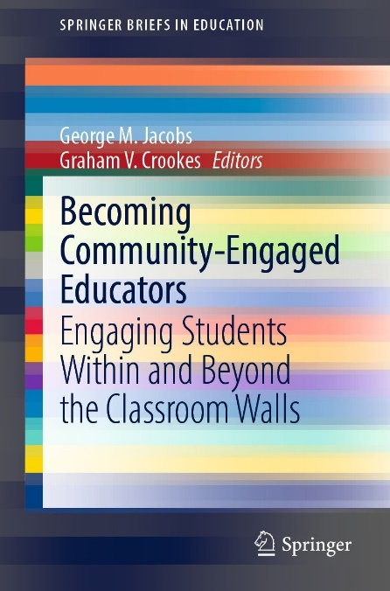

Pp. 86
ISBN:798-981-16-8644-3 (paperback)
Price: US$55.60
Pdf version available free online at https://link.springer.com/content/pdf/10.1007/978-981-16-8645-0.pdf

This book is part of a series entitled Springer Briefs, which aims to offer readers accessible, short (under 100 pages) accounts of a range of issues. This is in stark contrast to most academic publishing, which is often lengthy, theoretical and couched in obscure language, making it inaccessible for the average lay reader or practitioner.
The editors clearly subscribe whole-heartedly to this approach. As they state in Chapter 9, Conclusion, ‘… we are deliberately choosing to call into question the conventional academic monograph as not the most obvious vehicle for swift and motivating forms of professional communication.’
Additionally, they (and the contributors) have a strong belief that teachers should be educators, not mere technicians. As such, they should be active agents of change and not confine themselves to what goes on in the classroom but rather address themselves to issues in the world which their students will have to inhabit. As they state in the Introduction, ‘Only in a small segment of the professional literature on teaching do we find the position that education should lead to social change and societal improvement.’ Their declared intention is to change that.
The book comprises nine chapters: an Introduction and Conclusion and seven chapters on a variety of topics.
In the Introduction the editors set out their position with clarity and vigour. ‘Professors write reports of educational practices for other professors to read…the product of course, while valuable in many ways, is not likely to be a simple or inspiring read.’ They set out the case for a ‘critical pedagogy’, where teachers engage with issues in the world outside the classroom with a view to bringing about change. Their plea is for readers to open themselves to these ideas and to reflect on how they, in their turn, might implement this kind of teaching.
Chapter 2, ‘Tackling Poverty’, ‘describes efforts to use education to overcome poverty in Indonesia.’ After autobiographical detail of how she became involved, Anita Lie outlines her efforts to influence government policies through publishing critical newspaper articles. She also describes projects in rural communities in Indonesia designed to help teachers develop and to ‘build bridges between the standard curriculum and real life.’
Chapter 3 by Joel Jablon is titled ‘To Kill a Mockingbird is a Racist Book’. As a privileged white male, he describes how he had to free himself from unexamined beliefs about racism, which often works through unconscious use of language. He goes on to explain how he began small by introducing novels and autobiographies dealing with racial issues especially in the USA and progressively formed an active, critical learning community. He concludes with six practical recommendations for teachers wishing to move towards an abolitionist model of education.
In Chapter 4, ‘Authenticity as Activism’, Yoshi Grote relates her journey as a gay teacher and the decision she made to become an ‘authentic teacher’, completely open about her identity. She decided ‘that by coming out to my students in the classroom I could better support those struggling with their own sexuality or gender identity, while simultaneously giving a resource to my other students who were curious and needed someone to ask questions to.’ She then describes how she works to un-gender the classroom, including modifying language and by diversifying materials. She too offers a set of practical recommendations.
Chapter 5, ‘Religion and Teaching in America’, by Lisa Liss, ostensibly deals with religious tolerance. It is undeniably passionate and well-intentioned but seems to confuse religious with ethnic intolerance, as in the Holocaust. The major project with her students involved collecting 1.5 million bandages to honour the memory of the 1.5 million children killed in the Holocaust. But it is unclear what they did with them once they had collected them.
Chapter 6, by Linda Ruas is titled ‘Refugees – How Teachers Can Help’. She describes three ways teachers can help: by teaching refugees in the camps, teaching them in the countries in which they settle and in countering the anti-refugee rhetoric spread by many governments and the press. This is an admirably clear and convincing account of the practical projects she has worked on.
Chapter 7, ‘Language Teaching, Environmental Education and Community Engagement’ is by Kip Cates. He documents his own career trajectory, with its pivotal movement when he moved from a highly restrictive institution to a Japanese university where he was given a free hand to implement his environmental programmes. His aims are three-fold, ‘to allow them to draw on their idealism, use English for a meaningful purpose and make a difference in the world.’ He explains how he involved students with global issues partly through projects undertaken as part of their final assignments. He goes on to describe how he extended his work to the national level by founding the Global Issues Special Interest Group within JALT, and to international level through the Asian Youth Forum. He concludes with a set of practical guidelines.
Chapter 8, by George Jacobs is titled ‘Community Engaged Educators for Kindness toward Farmed Animals’. He makes a strong case for this, both on ethical and environmental grounds (farmed animals are a major contributor to global warming). He describes how he implements his beliefs both inside and beyond the classroom. He also deals frankly with some of the dilemmas facing teachers wishing to take up his suggestions.
The collection is uneven in some respects. It covers a range of issues but whereas some of them are vitally important for our continued existence on planet Earth, others are less so. For instance, environmental education will be key to the sustainability of life on earth, whereas LGBTQIA+ issues, though important as a social justice issue, is relatively of less significance. In a follow-up volume collection, perhaps it would be possible to focus on some of the more central issues confronting humanity, such as slavery, inequity, and genocide - among others.
There is also a wide range of experience among the contributors, both as teachers and as writers. Some, like Ruas, Cates, and Jacobs are seasoned professionals with a long record of effective action. Others are by comparison novices. This shows up most clearly in their writing, which on occasion betrays a degree of self-indulgence. Accessible writing needs to be as disciplined and well-organised and expressed as more academic genres.
The editors emphasize that many of the contributors are advantaged by working in contexts which allow them freedom to implement their ideas. Many teachers do not have this freedom, and work under institutional and cultural constraints. They sensibly urge caution – ‘Don’t get fired’ - but recommend taking the small steps which are possible even in controlled institutional settings.
How successfully does the book achieve its aims? It undoubtedly communicates the enthusiasm felt by the contributors. It also documents projects and activities, and offers a range of practical advice for teachers wishing to take up the challenge. So it shows what can be done, that it can be done and how it might be done. It will be an important reference for teachers becoming aware of their role as agents of societal change.

Please check the Pilgrims f2f courses at Pilgrims website.

Please check the Pilgrims online courses at Pilgrims website.

