Tune into English

Fergal Kavanagh, Italy

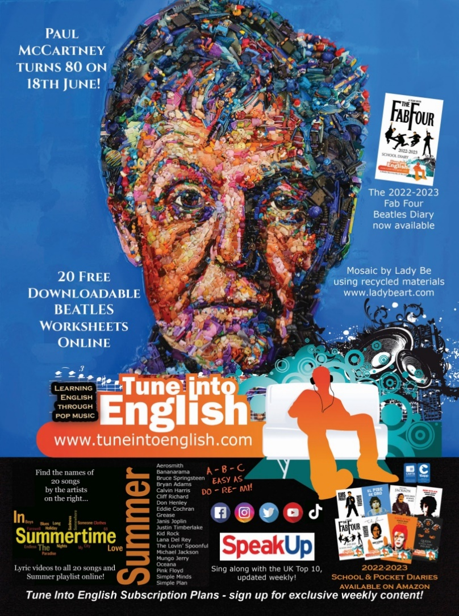
New worksheets

Cups (Pitch Perfect’s “When I’m Gone”) – Anna Kendrick
As students bid each other farewell for the summer break, this fun worksheet submitted by regular contributor Maria Gulczynska, Ancona, looks at what they will miss about their friends, as well as challenging them to the Cup Game.
Kate Bush – Running Up That Hill
Regular users of the site will have already seen this worksheet, uploaded two weeks ago, just before this 1985 single hit Number One following its use in the Netflix series Stranger Things.

Most of the worksheets have been written by your colleagues – perhaps you have prepared one and want to share it?
Song on Speak Up
With the Queen’s Silver Jubilee being celebrated Speak Up Tune’s monthly column looks at the story behind and the language used in God Save The Queen by The Sex Pistols.
With the Rolling Stones celebrating their 60th anniversary this year, Tune’s monthly column of Speak Up looks at the story behind and the language used in (I Can’t Get No) Satisfaction.
You can read previous columns online here.



www.tuneintoenglish.com
The web’s largest free resource for learning English through pop music!
Please check the Pilgrims f2f courses at Pilgrims website.

Please check the Pilgrims online courses at Pilgrims website.

