The Global Teachers' Festival from Macmillan Education

The Global Teachers' Festival is back...and it's early!

How should English language teaching adapt
to help our learners
flourish in tomorrow's world?

From 2nd to 13th November, over 20 leading voices in ELT will come together to share ideas, practical strategies, and fresh perspectives on some of the topics shaping English language teaching today and the world our learners will grow up in. From digital distraction to offering learner choice, as well as special sessions on the Future of Language Learning and Using AI with Intention, and lots more.

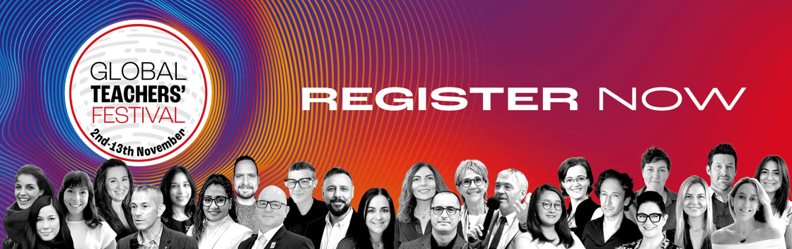

Register directly here.
Explore the full programme here.

And don't forget to share the festival with colleagues who are passionate about continuing to grow as ELT professionals! It's free to register and all those who register get access to a wide range of additional support and resources.

Macmillan Education Limited,
4 Crinan Street,
London,
Greater London N1 9XW,
United Kingdom
email@contact.macmillaneducation.com

