Judo- No Wrestling Involved. Defusing Tricky Situations by Using Empathy

Nick Michelioudakis, Greece
Nick Michelioudakis (B. Econ., Dip. RSA, MSc - TEFL) has been active in ELT for many years as a teacher, examiner, presenter and teacher trainer. He has worked for many publishers and examination boards and he has given seminars and workshops in numerous countries. He has written extensively on methodology, ‘Psychology and ELT’ articles which have appeared in numerous newsletters and magazines. His areas of interest include psychology, student motivation, learner independence, teaching one-to-one and humour. Email: nmichelioudakis@gmail.com . For more information, you can visit his YouTube channel: https://tinyurl.com/k3scpams, or his blog: https://tinyurl.com/36j5byaf

Back in the days when smoking bans had only recently been introduced on the London Underground, a man lit up a cigarette inside a railway carriage. People glared at him, but nobody actually said anything. A guy decided that he had to do something, but what? He did not want to trigger a confrontation…
Pause button: What would you have done?

The Churchill Story
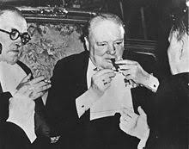
OK – cut to another time and place. Many decades back, Winston Churchill was attending a state banquet in honour of some Commonwealth officials. At some point during the evening, Churchill noticed one of the guests move close to the table, look around, and quickly slip an extremely valuable silver salt-cellar into his pocket.
Churchill was horrified. What could he do? He felt he needed to act, but he did not want to trigger a confrontation. Then he had a brainwave. He moved to the table quickly, picked up the matching pepper-pot, and slipped it into his pocket. Then, moving closely to the other person, he whispered with an air of resignation: “I think they’ve seen us… We’d better put them back.” He then set his down on the table. Checkmate!
[K. Dutton, Flipnosis, p. 1]

Back to the railway carriage
Back to that railway carriage now. The second guy must have read the story above. Here is what he did: He took out a cigarette and leaned closer to the smoker. “Excuse me,” he said. “Have you got a light?” No sooner had he lit up than another passenger exploded: “You do know this is forbidden, don’t you?” And this is exactly what the guy had anticipated. “Oh,” he said innocently, “I hadn’t realised.” Then, turning to the smoker: “I think we’d better put them out….” Amazing!
[ibid., p. 245]

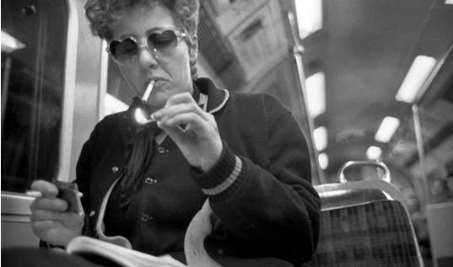

The importance of face
What is brilliant about these stories is that, in both cases, the people who wanted to intervene took face considerations into account. When you challenge someone directly, this threatens their status, and they are likely to retaliate angrily. But if you suggest that you are just like them, that puts a totally different complexion on things. And this is the lesson for us educators: if you find yourself in a similarly tricky situation, remember Churchill. Here are some examples of what you might tell students:
Truancy
“I remember once I had skipped school and my mother came to see the teacher for some unrelated reason. She was worried sick till I got home.”
Cheating
“I once cheated at a test at school. I got the best mark, but of course the teacher knew. He just looked at me and said nothing. I felt terrible…”
Plagiarism
“I recall submitting an essay at the last moment – it was mostly copy-paste. My tutor invited me to her office, copied a section from the essay, and Googled it. There it was – every word of it. I never did it again.”

“I Am Just Like You…”
Notice the common denominator in all these examples: “I am just like you…” Ages ago, I used to practise the martial arts, and as soon as I read the Churchill story, I thought to myself: “This is pure Judo!” In Judo, rather than countering someone’s attack with a blow of your own, you actually follow the movement of their body in order to neutralize them. What an amazing idea! Incidentally, Judo literally means “The gentle way.”

The Moral
It is easier to sway people when you are standing next to them.

Coming soon! Please check the Pilgrims in Teacher Training courses in 2027 at Pilgrims website.

