

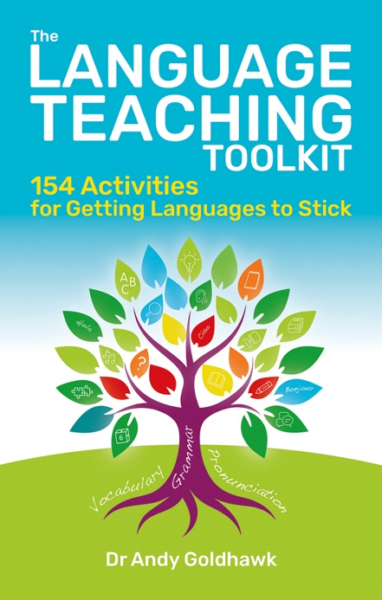

The Language Teaching Toolkit
154 activities for getting languages to stick
by Dr Andy Goldhawk

ISBN: 9781785837692
Price: £14.99
Published by: Crown House Publishing
Date of publication: January 2026
This essential guide offers teachers a practical, time-saving resource they’ll return to again and again.
Lightening the load for Language Teachers

Mastering a new language can take up to 700 hours of guided learning, making it difficult to keep students motivated, engaged and consistently progressing.¹ Teachers must also ensure students develop all four key language skills - reading, writing, speaking and listening. So, when learning a new language requires such dedication, and teaching it demands meticulous care and planning, every minute of lesson time counts.

Today’s language classrooms are more diverse than ever, bringing together learners from different ages, abilities and cultural backgrounds, all of whom require adaptable, student-centred approaches.² This requires careful planning from language teachers to make activities worthwhile and tailored to each student’s needs.

For time-pressed teachers, designing varied, inclusive and effective activities can be a demanding task. Research shows that 40% of teachers work unpaid overtime – which is higher than any other profession.³ As Dr Andy Goldhawk explains, “Finding ideas and inspiration for learning activities can be very time-consuming, which is a problem for our time-poor teachers. I wanted to put together a repository of learning activities in one place for language teachers, to avoid them having to sink hours into searching the internet and numerous other books.”

Andy has drawn on both his knowledge as a lecturer in Education and his 15 years’ experience as an ESOL teacher to write The Language Teaching Toolkit. This practical resource brings together more than 150 dynamic language learning activities that busy teachers can easily embed into their lesson plans. It covers all key language skills and includes guidance on the timing and level of each activity, making it easy for teachers to vary their pedagogical approach and teach in a way that is targeted towards their students’ needs.

Crucially, the activities are enjoyable. “Activities that are fun and engaging aid student motivation, retention, and a positive attitude towards language acquisition,” Andy notes. “When activities are enjoyable, students tend to participate more actively and process information more deeply.”

Together, these activities allow language teachers to reclaim endless planning hours and set their students up for success, while making language teaching more sustainable, creative and rewarding.
Ideal for trainees and early career language teachers, as well as more experienced language teachers.
“Your learners will become increasingly more active, more engaged and increasingly confident in the language they are learning, so get ready so sprinkle these activities across your lessons.”

Crista Hazell, SLE for MFL, international education consultant and author
of Independent Thinking on MFL

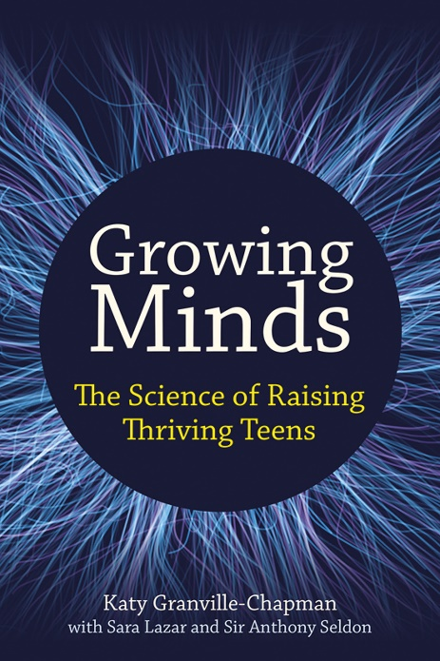

Growing Minds
The science of raising thriving teens
by Katy Granville-Chapman

ISBN: 9781785837951
Price: £16.99
Published by: Crown House Publishing
Date of publication: July 2026

Whether you’re a new parent or a seasoned veteran, this book will change the way you approach your own and your children’s brain health in the best way possible.

Have we become so focused on helping children succeed that we've forgotten how to help them flourish?

Parents have never had more advice on how to help their children succeed. From exam preparation and revision techniques to extracurricular activities and university applications, the pressure to help our children achieve can feel relentless. But Katy Granville-Chapman believes that we may be overlooking something even more important.

In her new book, Growing Minds, Katy explains that while academic success has its place, raising healthy, resilient and emotionally secure young people should be our ultimate goal.

"Every parent wants their child to succeed," she says. "But success is only one part of the picture. If we focus solely on outcomes we risk neglecting the conditions that allow young people to flourish, not just at school, but throughout life."

Drawing on the latest neuroscience, psychology and educational research, this book explores how the teenage brain develops and why everyday habits such as sleep, movement, relationships, nutrition and emotional connection have a profound influence on learning, wellbeing and resilience.

Katy believes that we've become so focused on achievement that we neglect the foundations of lasting success.

"Children don't flourish because every obstacle has been removed from their path," she explains. "They flourish when they develop the confidence, emotional regulation and resilience to navigate life's inevitable challenges. Those qualities deserve as much attention as grades and qualifications."

So, at a time when concern about children's mental health continues to grow and schools are grappling with rising levels of anxiety and disengagement, Growing Minds offers a hopeful alternative. Rather than adding to parents' sense of pressure, it provides practical, evidence-informed strategies that support healthy brain development and encourage families to prioritise long-term wellbeing alongside academic success.

For parents, carers and anyone responsible for shaping young lives.

“What the authors have oﬀered to the world is a work of love of the highest order."
Matthew T. Lee, PhD, Professor of the Social Sciences and Humanities, Baylor University

