A Different Poem: Who are you?

Andrew Wright, Hungary

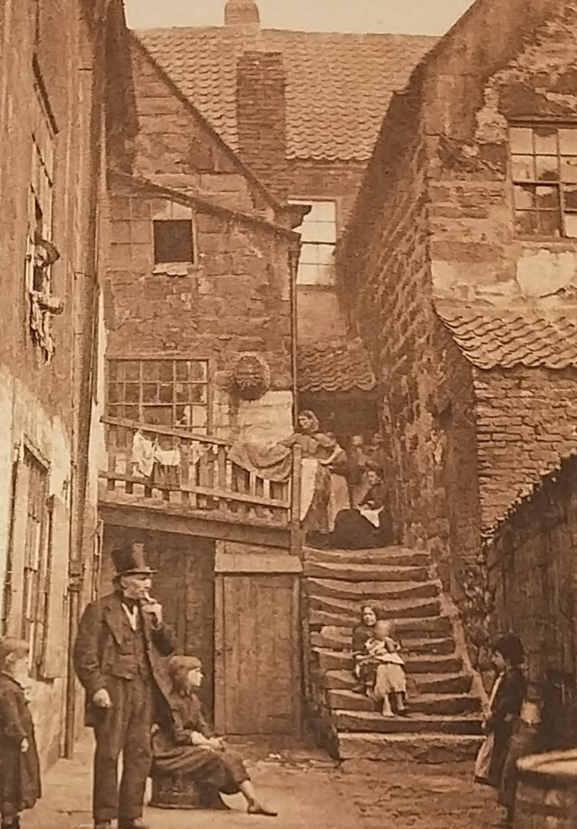

Who are you?

Who are you,
standing there
in front of my door
wearing a top hat,
crumpled,
concertinaed without music?
Was my door
once your door,
in the shadows
of time gone by?
I reach out with my thoughts
to shake your hand.
Did you feel it
as you stood there,
for the photo,
so long ago?
Please, please,
whisper to me,
down the long corridor of time.

Comment
I wrote the poem just thinking about the photo. Now I see the photo again I can see the top hat is not crumpled. If he whispers to me I will apologize about misrepresenting his hat in my poem. But why did my memory mislead me? I think the answer is that our friend Andy who tells ghost stories in Whitby, wears a crumpled hat. Here he is telling stories to my daughters Timea and Alex inside the ground floor room just behind the front door! The door where the man in the top hat was standing!

Andy in Whitby
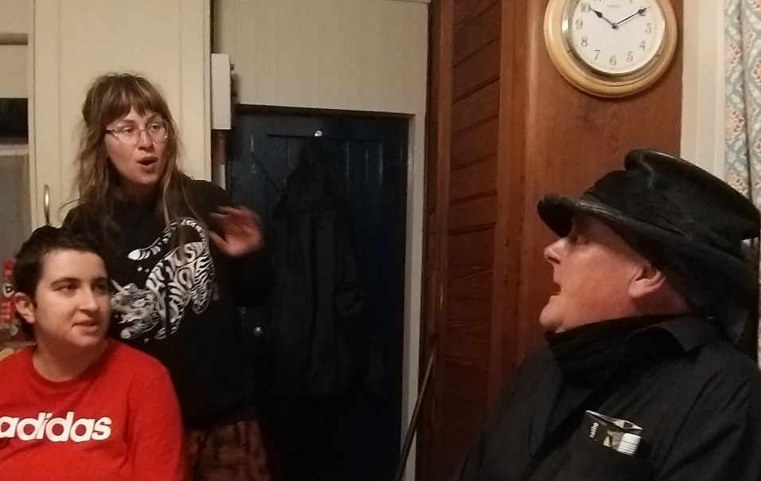
Andy works as Moaning Lisa during the day but also organises ghost walk story tours in Whitby at night. In this photo he came in to see us after one of his ghost story tours…and he seems to have scared the lights out of Alex and Timea! Outside that door is the yard and the man in the top hat.

A morning with Andrew Wright - Storyteller, writer, illustrator and poet
Watch here
https://www.youtube.com/watch?v=yDd_vPH72Zc
Coming soon! Please check the Pilgrims in Teacher Training courses in 2027 at Pilgrims website.

