Introducing TeachAnyClass.org
Chris Sowton, UK
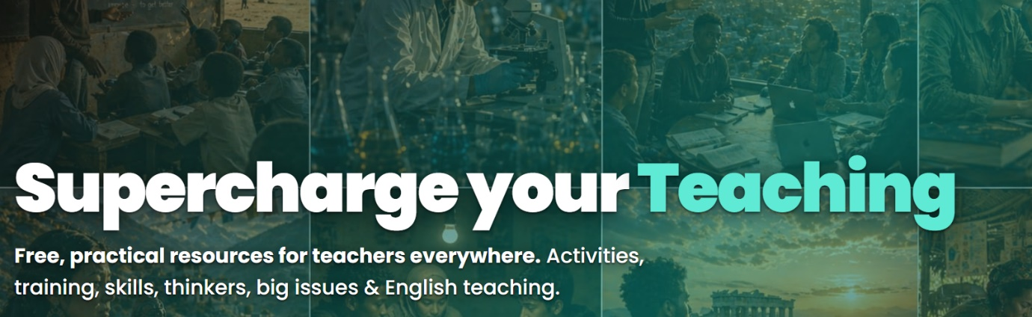
Over twenty-five years of working with teachers around the world - often in large classes, low-resource settings, and contexts disrupted by conflict or inequality - I kept running into the same problem. Teachers were being asked to be flexible, responsive, and creative in the classroom, but were rarely given the material or support to make that possible. Good ideas about teaching are easy to find. Free, practical, usable resources that work in a real classroom with limited materials are much harder to come by.
TeachAnyClass.org is my attempt to close that gap.
What it is
TeachAnyClass is a free website of practical teaching resources, built for educators everywhere rather than any one country or curriculum. It currently holds close to 2,000 resources across eight areas:
- Classroom Activities - ready-to-use activities across subjects and levels
- English Resources - texts, lesson frameworks, teaching tips, grammar and vocabulary support
- Great Thinkers - accessible introductions to key figures and ideas in education
- Amazing Objects - short lessons that use everyday items as a starting point for discussion
- Teaching Terms - plain-English explanations of pedagogic jargon
- Important Concepts - materials on democracy, human rights, and gender equity
- Professional Development - interactive masterclasses on classroom management and pedagogy
- Skills Development - focused resources for building specific classroom competencies
The site draws on the same thinking behind my book, Teaching in Challenging Circumstances: that large classes, limited materials, and difficult conditions aren’t exceptions to be worked around, but the ordinary reality most teachers are working within, and that resources should be designed with that reality in mind from the start.

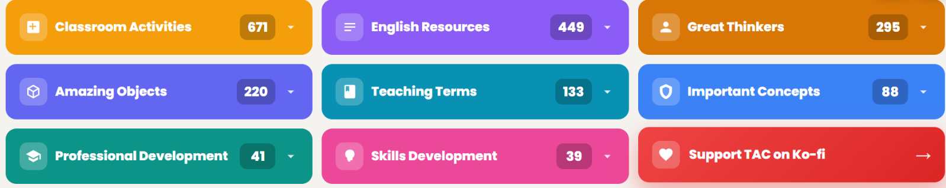
How teachers can use it
There’s no sign-up, no paywall, and no adverts - a teacher can arrive, find something relevant, and use it within a couple of minutes. Content is written in accessible English (broadly CEFR B1), and the whole site can be translated into over 100 languages, since a resource that only fluent English speakers can use isn’t much good to a large proportion of the teachers who might need it.
In practice, that might mean:
- A teacher with a large, under-resourced class picking a ready-made activity that needs nothing beyond what’s already in the room
- A newly qualified teacher looking up an unfamiliar term and getting a clear, plain-English explanation rather than academic prose
- A teacher working through an interactive professional development masterclass in their own time, without needing to book onto a course
- An English teacher pulling a level-appropriate text or grammar explanation together minutes before a lesson
The aim throughout is that nothing requires extensive planning, specialist training, or a particular budget to use.
What it’s trying to achieve
The underlying goal is straightforward: supporting the individual teacher, directly and without friction, is one of the more effective ways to improve learning outcomes for the students in front of them - arguably more direct, in the short term, than large-scale policy or curriculum reform. TeachAnyClass isn’t trying to replace teacher training or professional judgement; it’s meant to sit underneath that, as a free layer of practical support any teacher can draw on when they need it, wherever they happen to be working.
It’s also, in a modest way, in keeping with the thinking that HLTmag has long championed: that teaching works best when it responds to the people actually in the room rather than following a fixed formula. That kind of responsiveness needs something to draw on – an activity to adapt, an idea explained clearly enough to reshape for a particular group of students. TeachAnyClass is an attempt to make sure that material is there, for any teacher who needs it.
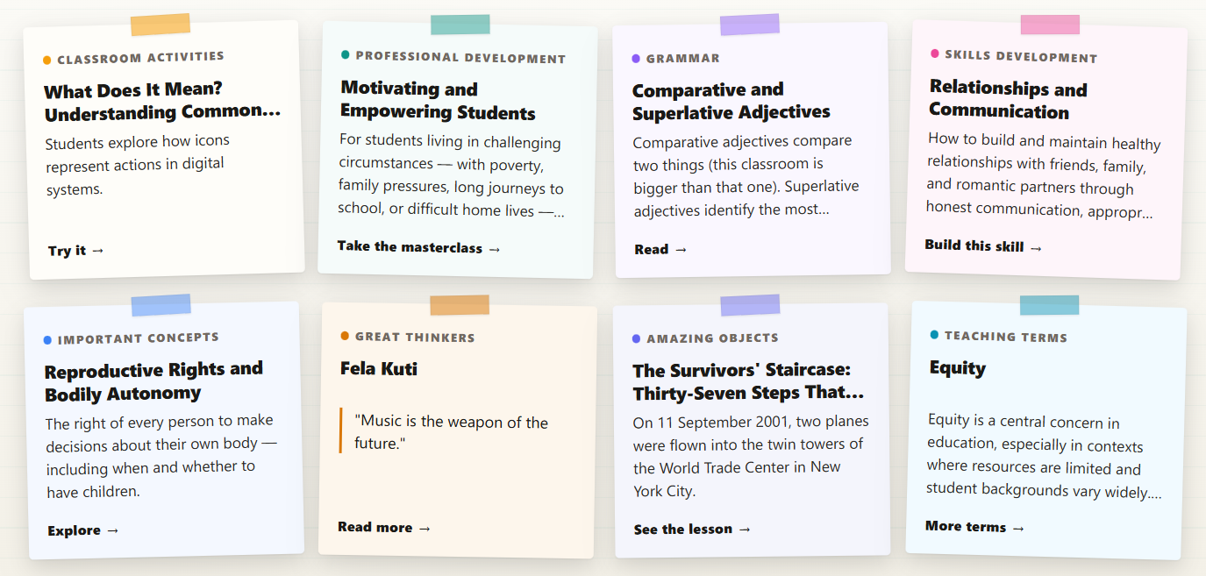

Coming soon! Please check the Pilgrims in Teacher Training courses in 2027 at Pilgrims website.

