
New Talking ELT Podcast Series: Digital Pedagogy
The latest Talking ELT podcast series explores one of the most important topics in education today: Digital Pedagogy. Host Ben Knight is joined by experts Geoff Stead and Sophia Mavridi to discuss how teachers can make informed decisions about technology while keeping learning at the heart of every lesson.
Across the series, they explore digital tools, the evolving role of teachers, and the impact of AI on language teaching. Practical, insightful, and highly relevant, it is essential listening for educators preparing for the future of ELT.
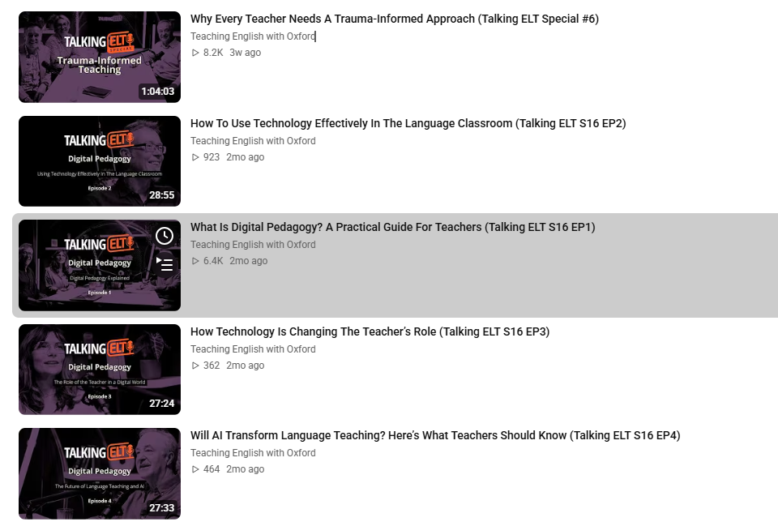
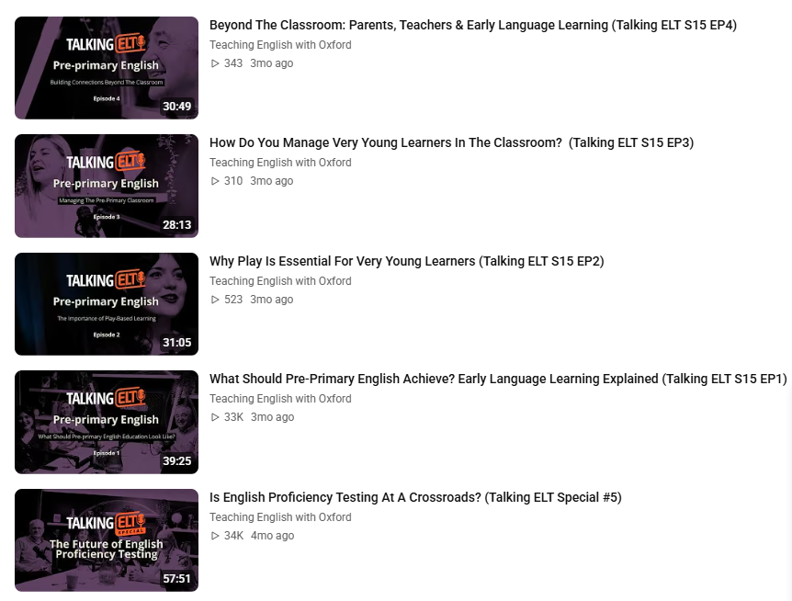
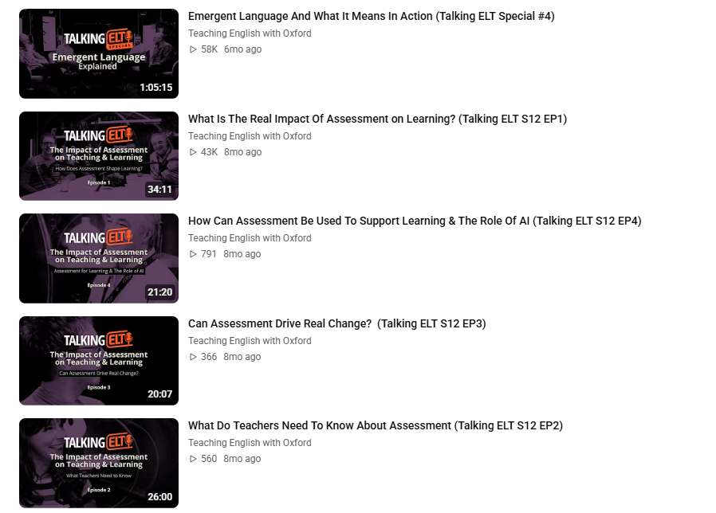 And many many more…

