Hope, Healing and Humanity; Celebrating Ukrainian Identity at Pilgrims at Harrow on the Hill

Leah Luke, Course Director Harrow, Principal of Pilgrims



Leah Luke has been working with Pilgrims for over 30 years starting off as an EFL teacher and now serving as Principal. She is very passionate about her work and will only accept a job in which she believes. Pilgrims Language School creates the environment that influences and transforms individuals through its process. She is passionate about this process and the magical transformation of individuals.

Between August 1 and 13, 2026, the 450-year-old brick archways of Harrow School echoed with a different kind of morning bell. Thirty displaced Ukrainian teenagers gathered under a giant oak for a unique, fully funded charity initiative run by Pilgrims Young Learners. By pairing Harrow’s inspiring setting with the deeply empathetic principles of Humanistic Language Teaching (HLT), Pilgrims gave these children a safe haven to reconnect, build lifelong friendships, and proudly celebrate their rich cultural identity, A Sanctuary for Connection and Culture.

Harrow School

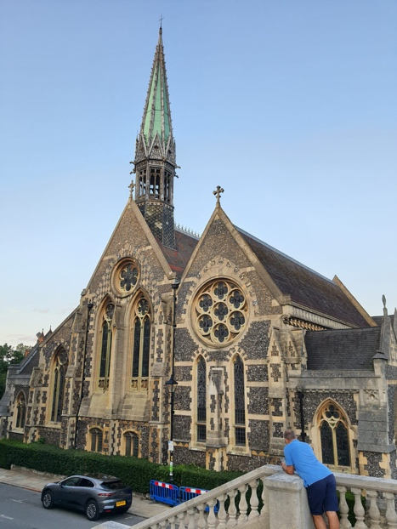

The Pilgrims team understood that language learning thrives when students feel seen, valued, and safe. Under the guidance of dedicated HLT practitioners, the program intentionally created a space where students could heal together and honour their heritage. Displaced into the far corners of Britain, this experience gave them all an opportunity to meet fellow Ukrainians, share stories and reflect on their current opportunities. Separated from home, these teenagers found a new family in one another. Late-night conversations in the quadrangles and shared laughter over meals helped form deep, unbreakable friendships among peers who truly understood each other's journeys.

Staff members acted as empathetic mentors, offering deep emotional support alongside linguistic guidance to create a safe psychological harbour.

The academic programme

Humanistic Pedagogy: Dragons' Den and High-Level Debating lessons were included in the academic program. These relied on advanced HLT classroom exercises that challenged the students intellectually while building their self-worth through high-stakes, collaborative simulations.

The "Dragons' Den" Simulation: Students worked in supportive teams to invent social enterprises or tech solutions designed to help communities and rebuild futures. Pitching these business models to a panel of friendly "Dragons" (Pilgrims staff) shifted the focus from grammatical accuracy to meaningful persuasion, giving the teens a sense of agency and creative control.

High-Level Debating Skills: Structured debates tackled complex, contemporary global issues. Students learned to construct logical arguments and use advanced rhetorical structures. This training transformed their English from conversational survival skills into a powerful tool for intellectual expression, proving to the students that their voices matter on the world stage.

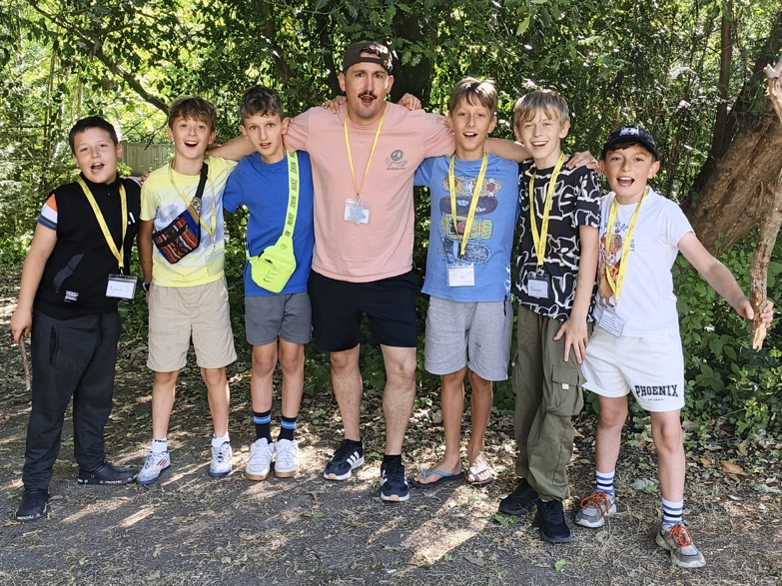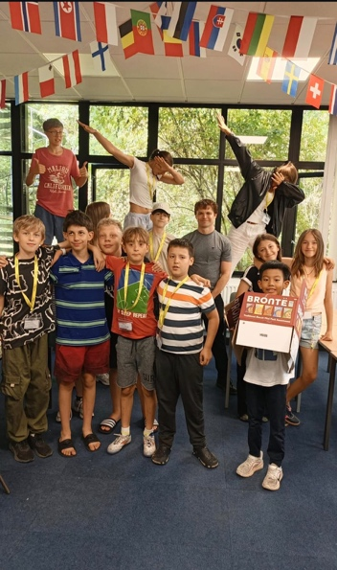

The final curtain

The penultimate night was a mixture of ‘ tears, triumph, and gratitude. The emotional pinnacle arrived on the evening of August 12 during the closing graduation ceremony inside Harrow School’s historic Speech Room. The atmosphere was charged with a profound realization of just how transformative this shared time had been.

Students who had arrived twelve days prior with quiet caution stepped onto the historic stage to deliver speeches ,original poems, small skits and improvisations in confident English. Tears flowed freely as students realized the magnitude of what they had achieved. They expressed immense gratitude to the Pilgrims team for recognizing their worth and giving them a space to just be teenagers again. Standing ovations filled the hall as the teenagers presented handmade thank-you notes, traditional art, and heartfelt gifts to the teachers and leaders.
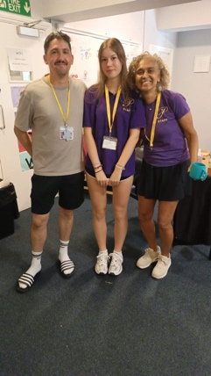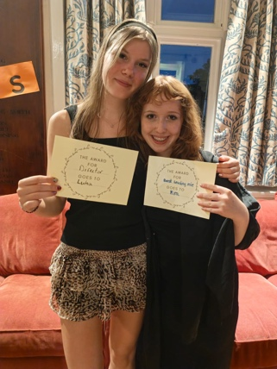

As the students departed the hill on August 13, they left with accredited certificates, a stronger grip on the English language, and the certain knowledge that they belong to a compassionate global community. This charity course stood as a powerful testament to the core philosophy of Pilgrims: language teaching is, at its heart, the act of touching lives, honouring identity, and building peace.

Acknowledgement

Thank you Till Gins, owner of Instill Education and Pilgrims, for funding this incredible experience for so many. Thank you Brightseeds for organizing the students and co-ordinating their transfers. Thank you to Yulia, Simon and Daria for joining the team on this magical Harry Potter themed course. Finally, a huge thank you to all my staff for your dedication, support, professionalism and positivity throughout these two weeks. Together we all created memories of a lifetime.



Coming soon! Please check the Pilgrims in Teacher Training courses in 2027 at Pilgrims website.

