

Teaching Grammar Through Story
Jamie Keddie, Spain
Jamie Keddie is a Barcelona-based teacher trainer and storyteller. He is the author of 'Images' (Oxford University Press, 2008), 'Bringing online video into the classroom' (Oxford University Press, 2014). 'Videotelling: YouTube Stories for the Classroom' (LessonStream Books, 2017).

From the Editor
Twice a month, Jamie Keddie sends out the LessonStream Post – a story or storytelling idea for the classroom. It's free to sign up and you can do so here: https://lessonstream.com

We don't use stories to teach grammar – we teach grammar to tell stories.

Down the memory lane
When considering the grammar of stories, there is a classic example that provides a great way in. Are you old enough to remember this?

I was having a bath when the phone rang.

I often feel grammar teaching focuses too much on differences. If you were learning carpentry, how much time would you spend learning the difference between a hammer and a saw? Surely it's more important to show how they are used and how they work together.
With that in mind, although our bath example can be used to illustrate the difference between continuous and simple forms, it can also be used as a way into story structure at its most fundamental.
• Setup: I was having a bath
• Action: The phone rang
Stories need foundations, and the setup provides them. This is where we create the scene, paint the picture and describe ongoing or unfolding background activity.
At this point, we might decide to use the word interruption (i.e. the phone call interrupted my bath). But that's the wrong way to look at it. In storytelling, the setup does not compete with the action. It exists for it.

Updating the example
I don't know about you, but neither baths nor unexpected phone calls are a big part of my life these days. As a challenge, ask your students to update the example. Here is one of my personal favourites, based on a real-life experience.


I was having a pee when I dropped my phone down the toilet.

A bit of theory
This area of language is less about tense and more about grammatical aspect. By using the continuous form of verbs, we set up the scene and establish ongoing activities. The action then follows – often as a series of simple verb forms. Once you start listening to the stories told around you, you will notice this pattern again and again and again.
https://www.lessonstream.com/blog/how-stories-shape-thinking

How stories shape thinking
how stories work media literacy storytelling using image Feb 25, 2026

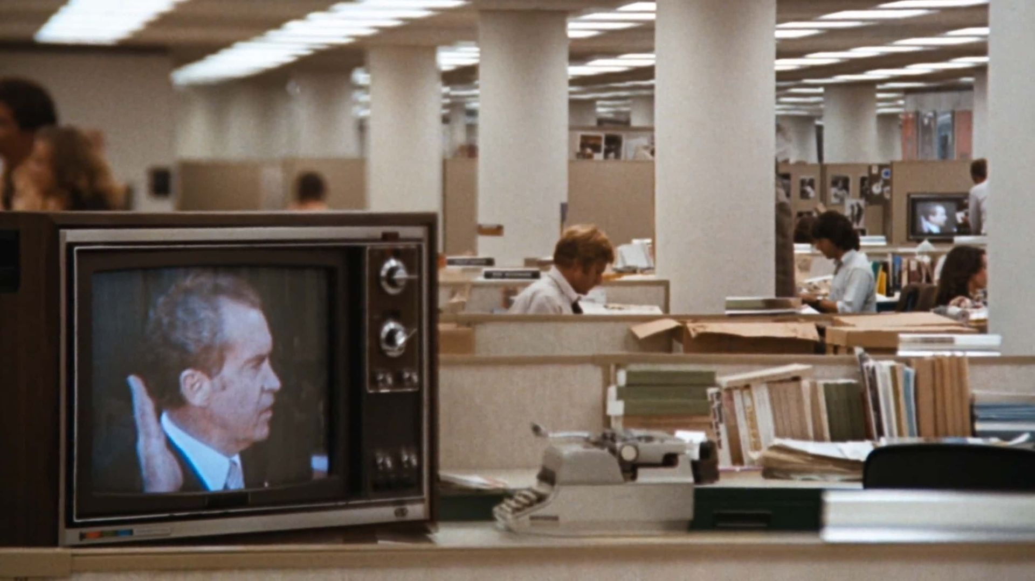
This is a scene from the 1976 film All the President's Men.

Public domain image
This image is 50 years old. It's never been more relevant ... This is a great image for the classroom.
Focus
Show it to your students, have them describe what they see and ask:
• What is going on here?
• How many of the people can you name?
• What's the film?
• What's the story?
• How does it connect with the present day?
Then you can give them the story.
The story
In the foreground of the shot, a televised speech by Richard Nixon. Meanwhile in the background, legendary journalists Bob Woodward and Carl Bernstein (played by Robert Redford and Dustin Hoffman) are working on the story that would eventually lead to his impeachment.
The Watergate scandal is to The Washington Post what the Eiffel Tower is to Paris. Woodward and Bernstein's reporting in 1972 elevated the newspaper to iconic status – a symbol of world-class investigative journalism.
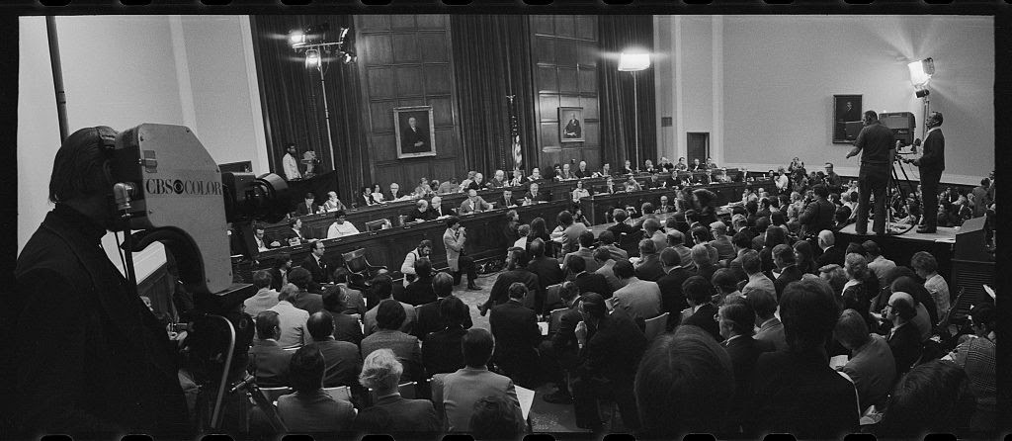
The first day of the Nixon impeachment inquiry, May 1974
Photograph by Thomas J. O'Halloran
Public domain image

A current connection
Today, this image feels tragically ironic. In 2024, Jeff Bezos (who acquired the paper in 2013) made the surprise decision to end the newspaper's tradition of endorsing a presidential candidate. Many regarded this as a cynical move, and it immediately cost the paper a quarter of a million subscribers. Then, earlier this month (February 2026), he cut the newspaper's staff by one third. In between those events, his company Amazon paid $40 million to license a Melania Trump film – a move widely regarded as an attempt to win favour with the president.
Newspapers like The Washington Post are essential to healthy democracies. They investigate corruption and hold power to account – which is exactly why Donald Trump sees a free press as his enemy. Jeff Bezos has weakened one of the world's most respected newspapers. This is a dark moment for American democracy.
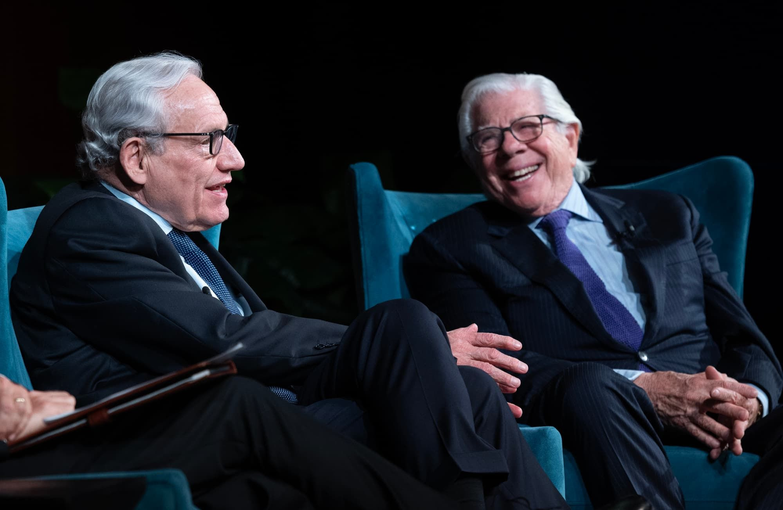
Washington Post reporters Bob Woodward and Carl Bernstein, 2024
Photograph by Jay Godwin
Public domain image
Understanding stories
I love the story of All the President's Men. And I love the scene at the start of this post.
The image is complex and saturated in story. It sits at the heart of a web of narratives intertwined in politics, history, journalism, media, law, cinema, biography, current affairs and a changing world order. And those narratives matter – because stories are never neutral. They are always told from somewhere, by someone, for specific purposes.
Understanding how stories work, how they travel and how they can be used to manipulate and influence is one of the most important skills we can develop. It sits at the heart of critical thinking, and can allow us to make sense of an otherwise overwhelming world.

How stories shape thinking
If you're interested in navigating our story-saturated world with clarity – and helping your students do the same – my new course is for you.
• Explore how stories work and how they shape behaviour and belief
• Equip students with critical thinking skills to recognise stories as tools of influence
• Get ready-to-use teaching ideas that spark genuine discussion and collaboration

Coming soon! Please check the Pilgrims in Teacher Training courses in 2027 at Pilgrims website.

