Making Reading Fun and Easy: 6 Classroom Reading Strategies You Can Count on

Saman Hassan, Pakistan
Saman Hassan, a young and ambitious educator who has been working in a school as an early childhood educator for nearly 3 years, is passionate about educating today’s youth. She has completed online educational courses aimed at supporting a child academically, emotionally, and socially. Saman strives to bring forth dedication, skill, and a desire to positively impact the lives of children. She likes to read books, magazines, and write articles in her free time.



Introduction
We teachers often struggle to get students into the habit of reading. A common mistake many of us make is thinking there is a specific age and time when students should start developing their reading habits, which is later, when they can extract meaning from the text and respond accordingly. What we often overlook is that it is a demanding, time-consuming process that should start in the very early years of education, when a child begins to develop an understanding of the world around them and to become familiar with their surroundings. Students develop speaking proficiency by listening, which is the cornerstone of reading. Good instruction further encourages and engages students in reading.

As an early years teacher for nearly 3 years now, I have had the opportunity to teach English to grade 1 students, and during this time, I noticed that many students were struggling with their reading skills. To my astonishment, this problem has crept into the more advanced levels as well. Hence, I prefer the use of sound and word walls in classrooms, not just in the early years but also in primary years classrooms, which contribute to the development of vocabulary and phonological awareness, both of which are core elements of reading. Being an avid reader myself and recognising its importance, I delved into a thorough study of the most effective strategies educators can use in their English language classrooms to get more students into the habit of reading. I think of sharing these with other brilliant teachers like you, and I promise that by the end of this, you’ll have a toolkit of simple, awesome strategies to turn those sleepy heads into lively beings.

Strategy 1: The grouping technique
Start by splitting a text (story) into four sections, each one to be read by four groups of students. Here's a tip! Make sure that each of the four groups has no more than 5 students of mixed ability for more effective control. After groups 1, 2, 3, and 4 have read their sections of the text, have them join heads to analyse and comprehend what they’ve just read, ensuring everyone is on the same page. Then mix the groups so that each new group formed has one student from group 1, one from group 2 and so on. Now ask them to share their portion of the story with their new team members to connect all parts of the reading text. As soon as all the team members have moved through each of the 4 groups, ask them to present their versions of the story to see which one is the most accurate and closest to the original. This is one of the best strategies I've come across so far because it keeps the students engaged till the very end and provides great chances of collaboration and teamwork.

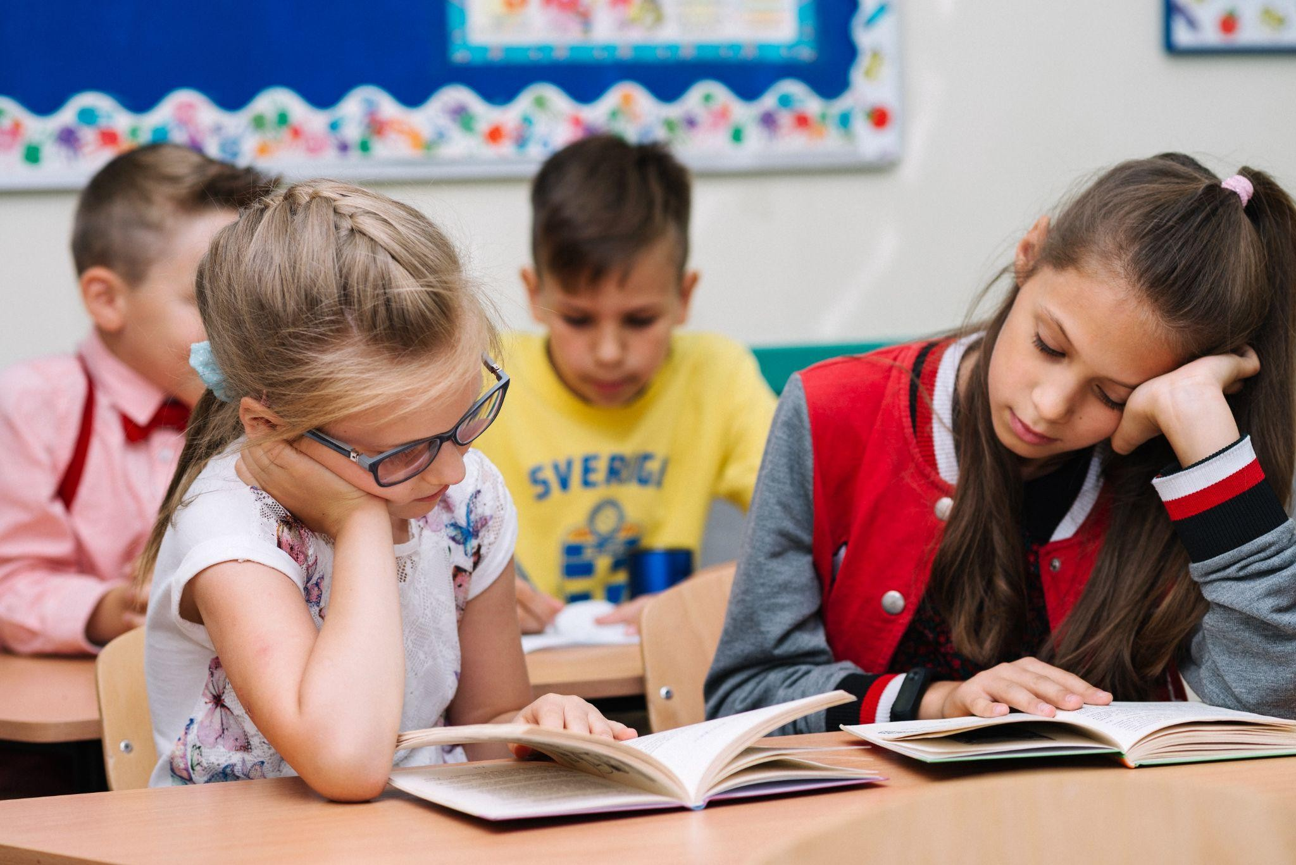

Strategy 2: Picture reading
This approach to reading in the classroom really pays off because the text is paired with pictures and drawings that help with better retention of the content, as it is read. As soon as the students read a portion of a given text, ask them to draw a picture of what they think is happening in it. This strategy is usually good with descriptive texts. Provide them with a range of art materials to let them better express what they’ve understood. When they’re finished drawing, ask them to present their drawings to show how they relate to the story. This strategy is a good one to uncover the different interpretations and perspectives of the text.


Strategy 3: The pop-up quiz
Give each student a copy of the text to read. The teacher and students engage in a reading technique in which the teacher has students keep their heads up and stay vigilant, as they need to continue reading from the same sentence the teacher left off on as soon as they hear their name pop up. After the student reads for a while, he may call out someone else’s name, who will, in turn, start reading from where the prior one left off, and the cycle continues. This reading tactic really requires every student in class to be attentive because they never know when their name will pop up! It is a good one for keeping students focused and for polishing their listening skills.


Strategy 4: Acting out
This strategy is perfect for stories or texts containing a lot of dialogue and action. It is a fun, crowd-famous reading strategy because it also lets them shine their acting and performing skills, which is something that everyone likes to do once in a lifetime. Have the students read a story, then assign a story character to each of the students and ask them to enact the scenes, or maybe even improvise, to make this activity more engaging. For this to happen, they will have to understand the storyline, background, characters and plot to bring it to life.



Strategy 5: The guessing game

Who doesn't like plot twists? So here's a great way to keep your students hooked on the reading text while also thinking creatively. Before reading the final part of the story, ask the students to guess what the ending would be. Then ask them to share their ideas individually to know how closely they could guess. This is a simple and nice way to put their creativity to good use.

Strategy 6: Word chain
This one is the most suitable classroom reading strategy for learning vocabulary. Students are given a certain time limit to read different texts on the topics of their choice, and once the time is up, one of the students is selected to speak out a word he has read in the passage and also tell its


meaning. The other student is then picked up to call out another word starting from the last letter of the word told by the prior student, and the chain of words keeps growing. Hence, in this way, students build a chain of different words learned from different texts, maximising their pool of vocabulary. This reading strategy, if adopted in classrooms, can help your students learn loads of different words along with their meanings in the shortest time span.

Benefits of classroom reading
- Establishing a regular reading routine in classrooms can help make reading a consistent activity that students can incorporate seamlessly into their daily lives.
- Reading practices in classrooms can improve comprehension skills that can help them in making inferences, drawing conclusions, and associating their prior learned concepts with the text.
- Daily classroom reading exposes students to different perspectives, ideas, and experiences.
- It brings accuracy, speed and fluency, contributing to smoother reading experiences.
- By getting involved in this classroom practice, students are exposed to a rich vocabulary, learn sentence structuring and are aided in their English language development.

Conclusion
Reading is one of the most important skills a student can learn, as it is crucial for academic achievement and goes hand-in-hand with social, emotional, and economic health. When people say, practice makes a man perfect, it stands true for reading as well. The ability to read opens up an entire world of possibilities. Hence, it needs to be adopted as a regular practice in classrooms.

Coming soon! Please check the Pilgrims in Teacher Training courses in 2027 at Pilgrims website.

