A Pre-determined SECRET CODE: This Could Save a Life

Judy Boyle, Greece

Judy Boyle is the founder of The NO Project, an award-winning, arts-based, global educational campaign against modern slavery and human trafficking. She has been involved in anti-human trafficking and anti-slavery educational actions for 25 years.
Judy is a teacher, trainer, researcher and author. Her background also includes professional theatre and filmmaking. In 2022, Judy directed and produced It’s Just Business, an award-winning, surreal short film against modern slavery, based on a spoken-word poem by a 16-year-old high school student.
Email: judy@thenoproject.org

The NO Project award-winning lesson plans

The NO Project has created free, downloadable teaching resources on human trafficking and modern slavery. Each lesson is based on a true narrative and is approached with dignity, sensitivity and respect. Designed for upper secondary, young adult and adult learners, The NO Project lessons are ideal for both on-line teaching and in the classroom. Each unit includes slides, artwork, authentic interviews, videos, lexical input, original listening material, and a gentle step-by-step teacher’s guide. Also provided are student autonomous learning resources with suggestions for project-based actions beyond the class. These teaching resources have been featured in the Master’s in Education Program at Havard Graduate School of Education and are being used by thousands of educators worldwide.
The teaching material was created in partnership with The Rights Lab, Nottingham University, UK.

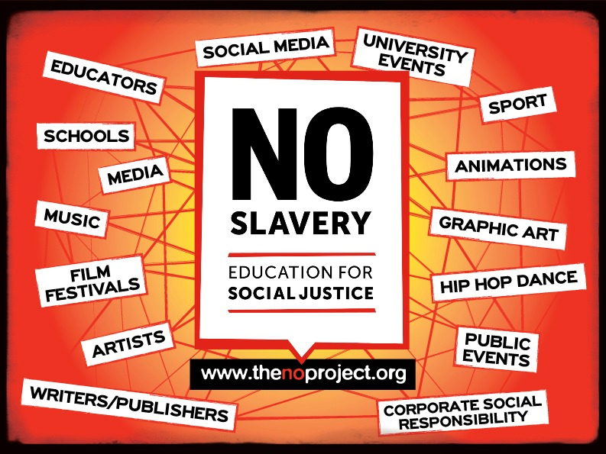

A pre-determined secret code

Some years ago, I was told of the following case by authorities who had been involved in the rescue operation. A young woman from a rural setting had been recruited, transported across international borders and forced into commercial sexual exploitation.
Based in European city, she was exploited by traffickers for over four years.

Each month the traffickers would let her call her family back home, and while she spoke, they would stand right next to her and listen.
‘You say one word to your family, and we will ‘harm’ your little sister.’
And so, controlled by fear, she would tell her family about her ‘happy’ life, where she was making new friends, having a nice time and earning some money. Her reality could not have been further from this, but as in most cases, the trafficker’s threat of violently harming a loved one was an effective means of control.
For four years she lied on the phone as the traffickers stood by listening to what she was saying.

When told this of this case, the following thought came to mind.
But what if she a had created and shared a secret code with her parents before she left her village? A simple, sweet statement or question that in a chatty conversation would seem perfectly normal, but in fact was a pre-agreed, shared statement that meant ‘I am in danger. Help me.’

‘Hi Mama, Yes, yes - I’m fine! But tell me – how’s my little puppy doing these days?
Puppy? What puppy?

She has no puppy.
Exactly. It is an example of a secret code.

A simple, statement in the context of a chatty conversation with the family seems perfectly normal – especially when living in another country and wanting to hear family news.

But it is also vital that the person receiving the ‘secret code’ remains cool and doesn’t suddenly say ‘Oh no! Are you in danger.’ If the call is on speaker phone – this could be fatal.
Again a pre-determined response must also be decided.

‘How’s my little puppy?’
‘Oh, he’s very big now and eats a lot.’

Something very natural, simple which in fact means – I have understood your code and will take action.

Let’s consider a context which might happen on a more local context.
A teenage is out one evening and finds themselves in a situation of danger.
An abuser will want to control the situation usually by manipulating communication in some way.

‘Give me your phone!!’
‘Ok yeah sure here is it. Oh no, look – it’s one o’clock.
Sorry I promised I would call my Dad! last time I stayed our late and didn’t call - he called the police.’
‘What? You’re lying.’
‘No, really. Please, please let me call,’
‘Ok – but we are listening – you say one word and …it won’t be pretty for you.’

‘Ok, Hi Dad, yeah, yeah sorry I’m late. No, everything is fine…my tooth still hurts from the dentist…but I’m good…’
or
‘Dad, I’m fine – oh I’m really sorry… I lost that red jacket you gave me.’

The words ‘dentist’ or ‘red jacket’ are just examples of secret codes which again have been created and agreed upon with trusted adults or friends.
These codes will communicate to the trusted person that ‘I am in danger – help me.’

What action the listener takes is dependent on many factors – but probably contacting the Police to explain the urgency of the situation is the appropriate response.

Simple, ‘natural’ statements are best as a secret code – nothing that might alarm the person in control or sound odd or suspicious. And yes, the speaker has to ‘act’ and appear natural.

Two important points

- Colours are often a good element to include in a secret code.
- And, as stated above, it is absolutely vital that the listener reacts naturally once they realise the code has been given.

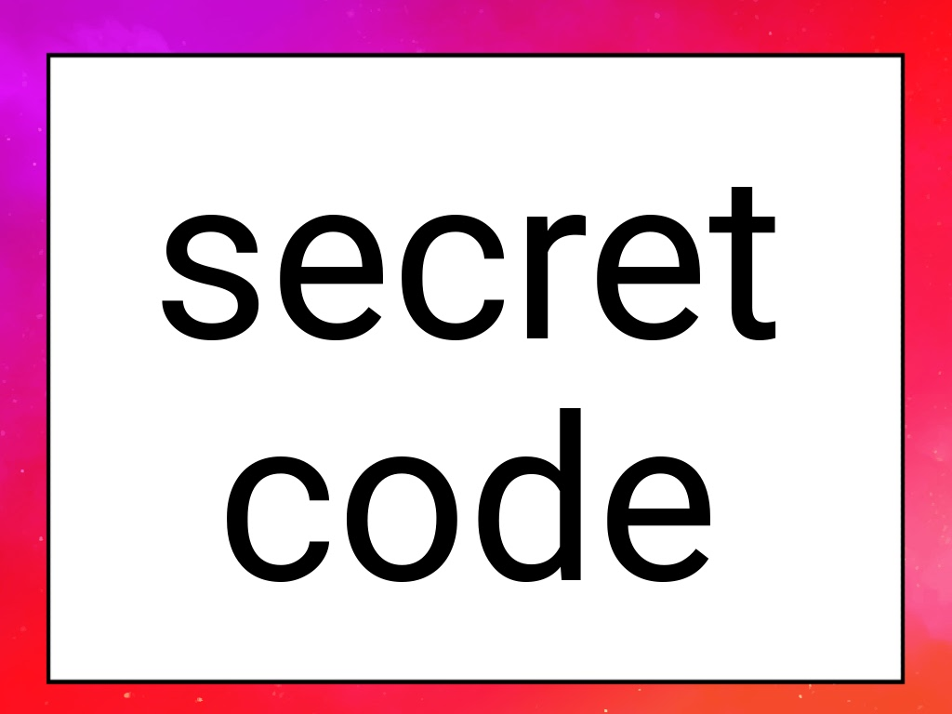

Please, talk to your students about this (if age appropriate).
Discuss the concept, what they might say, and which people would know their code.

Please check the Pilgrims in Segovia Teacher Training courses 2026 at Pilgrims website.

