Letters batch 1: Congratulations to Hania
1
Hello Hania,
I have been reading through the lates issue of HLT and had no idea that you had been at its editor for 20 years. It is scary how time has passed. I just wished to congratulate you for your enormous effort and send a congratulations for your achievements.

All the best,
Peter Dyer
2
Hania
congratulations on your 20 years as editor-in-chief! Quite a feat!

Best wishes
Bruno Leys
3
Dear Hania,
I hope this email finds you well. Just wanted to congratulate you on 20 years as editor of HLT which stays as stimulating as ever. Editing is a massive commitment, especially over time and I can understand the magazine no longer being a monthly affair.
4
Congrats for your 20th anniversary on HLTM!
Best regards,
JC
5
Dear Hania, Congratulations on your 20 years. Starting with Mario must have been really empowering.
X
6
All the best from Ankara.
Claire

Letter 2

Dear Hania,
A colleague and I are conducting a survey on teachers' attitudes and perceptions of the Erasmus+ programme.
May I ask you to fill it out and forward it to your teaching peers, if possible? 
Thank you very much!

https://forms.gle/RY2ZccULHHs5jd6L6

Jelena Kovačević
EFL Teacher, Ekonomska škola Požega
Croatia

Letter 3

Life is change
Climate changes
Climate change challenges
How to act preventively?
How can floods be controlled?
How can peacelinguists help?
Let's keep praying too

Francisco Gomes de Matos
1933-2025
regular contributor to HLT

Letter 4
Hi Hania
Interesting?
Can you turn it into a creative activity?
Treat it as a challenge
Waiting
Xxx
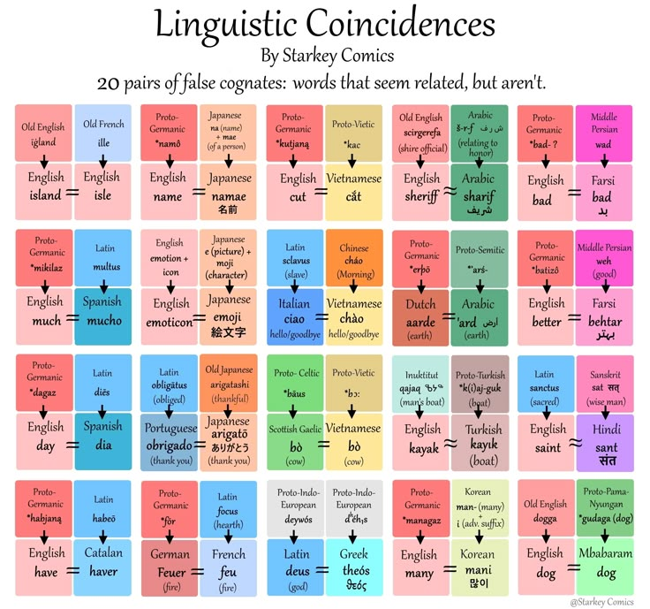

Letter 5

Teaching Grammar, TP and Tiny Habits



Jo Gakonga on LinkedIn

Teacher educator, Online course creator, Video maker
February 8, 2026
This week I've been listening to The Diary of a CEO podcast and the episode that caught my attention was an interview with James Clear (of 'Atomic Habits' fame).
One of the things that he says is that habits are easiest to acquire and most likely to stick if you find them enjoyable and it occurred to me that really applies to this newsletter. I like writing to you so it's no effort to keep it up. Even after five years’ worth of Sundays!
You, on the other hand, might find it more of an effort to read all of my ramblings(!) but there's always the unsubscribe button…
With that in mind, if you could acquire one habit in your professional (or personal) life, what would it be? Maybe commit to clicking one link in here each week and doing something with it? What do you think?!
Something old
OK, let's get going and I'm kicking off with one of Anna's Teaching Tales. This one is some advice on teaching grammar, thinly disguised as a story about my fictional novice English teacher, Anna. If this resonates and grammar teaching makes you feel uncomfortable, you might like it.
Want more? Check out my 'Grammar Confidence Bundle' . It includes two courses:
- Grammar for Language Teachers will make sure you have a strong understanding of how English fits together and
- Teaching Grammar Communicatively will give you ideas and strategies to make it useful and (dare I say it?) fun for you and your learners.
There's a bonus Concept Check Question Cheat Sheet included, too.
Something new
Moving on and my new video this week is aimed squarely at CELTA trainees doing Teaching Practice.
It's nerve wracking when you have to stand up in front of your first class, especially if you have no prior experience of teaching. At this stage of the course, though, perfection isn’t the goal; participation is.
So here is a bit of reassurance and some Top Tips for TP1.
I hope this is helpful (and if this doesn't apply to you, feel very free to share with anyone else!).
Something borrowed
Now, I know that I recommend a lot of webinars, but I don’t go to many myself. Here's an exception even though I'm going to have to stay up late in my part of the world to watch it!
It's a webinar from the IATEFL Learning Technologies SIG and (just as a heads up) the usual scenario with these events is that the live session is completely FREE but the recording is only available if you're an IATEFL member.
It's an interactive panel discussion entitled AI as a Means to an End… An Open-to-Interpretations Forum. There are three great speakers (Thom Jones, Caterina Skiniotou & Hugh Dellar) and a chance to explore how artificial intelligence is reshaping language education in what I hope will be a slightly deeper and more critical way than I often see.
It's next Saturday, 14th February at 11:00 AM GMT
If that doesn't tickle your fancy (or even if it does) and you teach young learners, I've got another free CPD event that you might be interested in, too. This one is from Cambridge on Tuesday 10th February at 10am GMT and again on Thursday 12th at 4pm GMT and it's called Creating lesson aims that support progress for young learners.
Right, that's it from me for today. Let me know about your habit forming ideas and I'll see you next week (as is my habit!)
Best
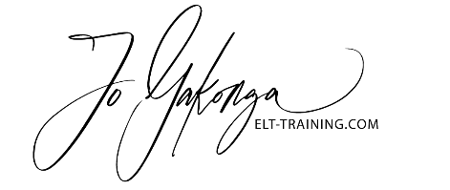

Letter 6

Dear ELT colleagues.

I hope 2026 has started well for you. How are the new year resolutions going?

One of mine was to spend more time keeping in touch with people. I am considering starting a newsletter to the ELT network in which any news (e.g. regarding publications, webinars, conferences, or anything else) can be shared. If anyone has any ideas, suggestions, please let me have them.

This particular "newsletter" is to let you know that Jo Mynard is working on a book on learner autonomy. She needs some contributions from the "global south" and from "marginalized or linguistically minoritized communities.”

If you feel you can contribute to these, please contact Jo directly: joanne-m@kanda.kuis.ac.jp

And best wishes for the rest of 2026. It is supposed to be better than last year, but when one looks at what is happening around the world, one cannot help but wonder.

Carol Griffiths

Letter 7

Letter 8

Trinity College London appoints Murray Orr as Chair of Board

The Trustees of Trinity College London are delighted to announce that Murray Orr has been appointed as the new Chair of Trustees. Murray will take up the post from 12 January 2026 when the current Chair, Mark Damazer CBE, steps down after six years of service on the Board.

With extensive executive experience in financial services, Murray has held a range of non-executive roles including positions with Greenwich University, AQA Education, Chickenshed Theatre Trust and the Royal Institute of British Architects. He brings a strong track record of leadership and strategic insight that will support the growth and direction of our organisation.

On being appointed as Chair, Murray said:

“I am deeply committed to the importance of education in driving societal change, and believe that the arts and communication have a central role to play in creating lasting impact. I very much look forward to working with the team to build on Trinity’s strong foundations and am excited about the extent of innovation across the organisation and what it enables us to achieve next.”

Commenting on his tenure as Chair, Mark Damazer CBE, said:

“I have loved my time at Trinity College London and am enormously grateful for the support of the Trustees, the Chief Executive, Erez Tocker, and all the staff. The challenges have been stimulating – but we have made great progress across many fronts. I am delighted that Murray Orr will be the Chair and I wish him great success.”

The Trustees would like to extend their sincere thanks to Mark for his leadership and dedication throughout his tenure as Chair. During this time, he has guided Trinity through significant challenges, including the pandemic and our digital transformation, while also helping us celebrate Trinity’s 150-year anniversary.

Trinity’s Chief Executive, Erez Tocker commented:

“I am pleased to welcome Murray as Chair and look forward to working closely with him as Trinity continues to evolve. I would also like to express my sincere thanks to Mark Damazer for his dedicated leadership and the lasting contribution he has made to the organisation.”

ABOUT TRINITY COLLEGE LONDON
Trinity College London is a leading international awarding organisation, education publisher and independent education charity with over 150 years of expertise. Our offerings stand at the intersection of heritage and modernity, comprising a globally recognised suite of regulated qualifications and assessments in communicative English, music and performing arts tailored to meet the evolving demands of all learners and the modern economy. We are the awarding organisation of human expression and aim to inspire teachers and learners alike with assessments that are enjoyable to prepare for, rewarding to teach and that simultaneously develop learners with academic, technical and 21st century life skills. www.trinitycollege.com
Mark Cooper
GK & Partners
Good Space
4 Lonsdale Road
London NW6 6RD

Letter 9
Be gentle on yourself
C
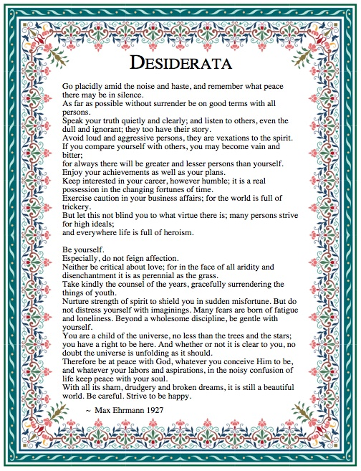

Letter 10

Hi Hania
If you are able to share the attached, I would be grateful.
I am trying to bring awareness to the very great concerns I see in the development of AI
Roy Andersen

Watch here.

Letter 11
Nobody said the PhD was easy. And they were right.
What if you make it a pleasant break from your normal life, though?
Research, teaching, building, caring, continuing - some days require more of us than we thought we had. However, there is meaning in staying. There is strength in showing up again!
If you are in the middle of something difficult, this is for you.
Read here: https://lnkd.in/dXRNWHKs
hashtag#PhDLife hashtag#AcademicLife hashtag#ResearchJourney hashtag#HigherEducation hashtag#Persistence hashtag#MeetThePhDs

Vicky Loras
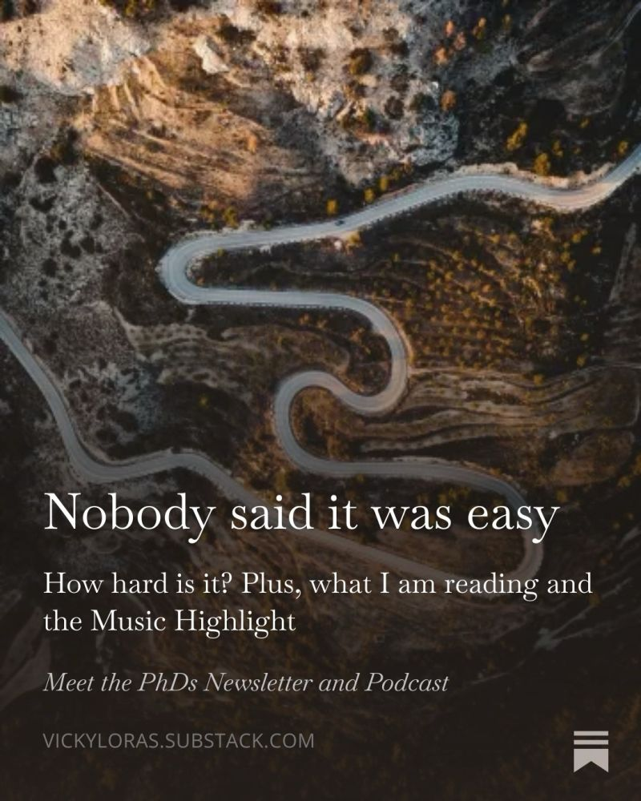

Letter 12
Hania
Interesting, innit?
Or not?
Yours
BT



