New From DELTA Publishing

Business English

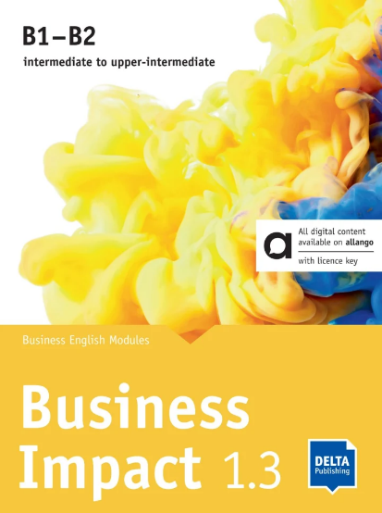
Business Impact 1.3 B1-B2
Business English Modules 1.3.A, 1.3.B, 1.3.C including llango licence key (24 months)
The Hybrid Edition means that you can use both the Print Edition and Digital Edition. You'll find a licence key (for teachers and students) in the Print Edition which gives you direct access to the Digital Edition and all the digital media content on the allango learning platform.
Better English for better business:
Unique structure catering for 60-minute and/or 90-minute lessons
Focus on speaking and communicating in real business situations
Learn more!
Digital Edition allango for teachers and students

For kids
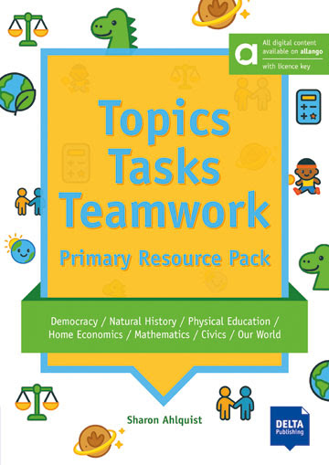
Topics, Tasks and Teamwork
Topics, Tasks and Teamwork uses a fresh cross-curricular approach to build Student engagement, topic knowledge, linguistic competence, and communication skills. This teacher's resource pack provides a ready-to-use bank of motivating lessons exploring topics that early years English learners are commonly interested in. Each lesson includes downloadable activity sheets and is supported by detailed teacher's notes with ideas to help spark your students' curiosity.
Topics, Tasks and Teamwork is divided into 8 units covering topics such as Geography, Natural History, Science, Religion, Democracy, Mathematics, Home Economics, Drama, Civics and Physical Education.
Learn more!
Digital Edition allango for teachers

New Reader
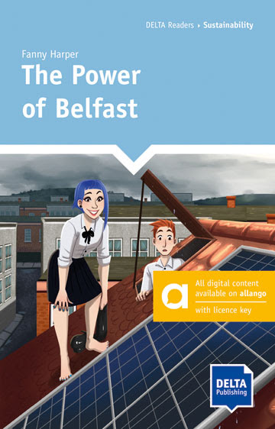
The Power of Belfast
Fionn finds Belfast depressing, but it is all he’s ever known. His talented sister, Isla, is about to escape to study in London. And now, because of the lack of job prospects, his clever best friend is about to leave too. Shouldn't they stay and try to make their home a better place?
From a chance meeting and an empty piece of land arise an idea that might do just that – in more ways than one. And with the help of the community, the idea transforms into reality. Fionn begins to see, that maybe, he too is good at something – and something that is going to make a big difference.
Learn more!

