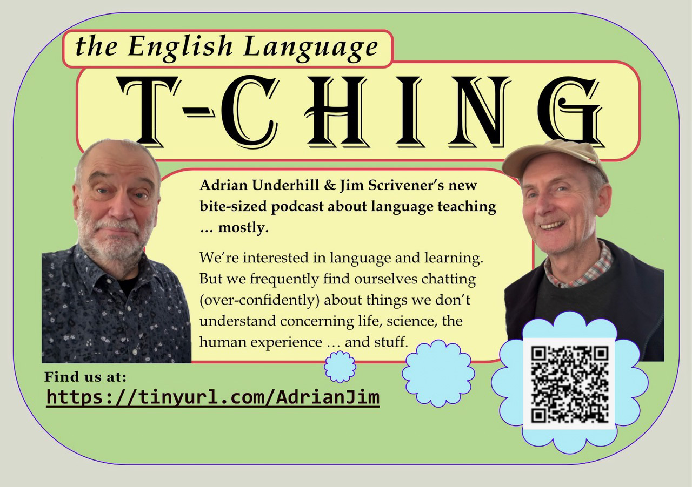

The T-Ching
There have been a number of ELT podcasts over the years, but has there ever been one quite like the English Language T-Ching, the new bite-sized offering from well-known authors and trainers Adrian Underhill and Jim Scrivener?
Of course, language and learning are their core focus, and most of the episodes involve them sharing insights into practical classroom ideas, drawing on their wide experience in ELT. But often episodes begin outside the school, in realms of weird and wonderful science, para-science, psychology, culture and human capacity, and end up drawing those things in to provide new perspectives on teaching and learning. All in all, it’s a highly unusual approach (as we might expect from these two) and emphasises their view that language teaching has to look beyond the course book and grammar exercises. As they actively seek ways to develop new takes on old approaches, both Adrian and Jim happily admit to talking out of their depth on non-education specialist subjects (such as consciousness or intuition), yet manage to distil meaning out of their uncertainties, finding refreshing and catalytic ideas for classroom learning.
Each episode is only around 10 minutes long, something you could listen to on the bus into work, yet they cover a lot of ground. The chat is unscripted and spontaneous yet full of content and wit: short thought experiments that could give a real boost to a teacher’s busy day.
Adrian and Jim invite comments and questions for them to discuss and will invite guests to participate in future episodes
Search for the “English Language T-Ching” on your podcast app or find them at: https://tinyurl.com/AdrianJim
Or use this QR


