Psychology and ELT: How to Become Number One
Nick Michelioudakis, Greece
Nick Michelioudakis (B. Econ., Dip. RSA, MSc - TEFL) has been active in ELT for many years as a teacher, examiner, presenter and teacher trainer. He has worked for many publishers and examination boards and he has given seminars and workshops in numerous countries. He has written extensively on methodology, ‘Psychology and ELT’ articles which have appeared in numerous newsletters and magazines. His areas of interest include psychology, student motivation, learner independence, teaching one-to-one and humour. Email: nmichelioudakis@gmail.com . For more information, you can visit his YouTube channel: https://tinyurl.com/k3scpams, or his blog: https://tinyurl.com/36j5byaf

The Big Lesson we can glean from the fantastic book ‘Unreasonable Hospitality’
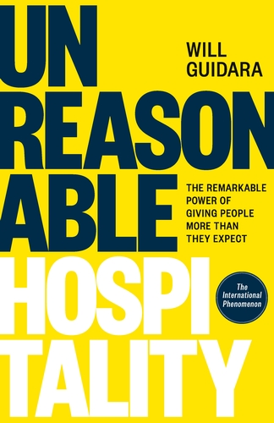

True story: back in 2010, two ambitious young men showed up at London’s Guildhall. Their names were Will Guidara and Daniel Humm – the Manager and Chef of the Eleven Madison Park restaurant in New York. Both Will and Daniel were on top of the world; their restaurant had been included in the list of the 2010 World’s 50 Top Restaurants. This was huge!
The two men were looking forward to the ceremony; although they knew they had made it, they didn’t know their ranking. Will thought they might be No 40 – Daniel though perhaps No 35. Then the whole thing kicked off – starting from the bottom. The first name they heard was… ‘Eleven Madison Park’. They were Number 50 after all…
This is how Will Guidara starts his amazing book ‘Unreasonable Hospitality’. In his own words: ‘That knocked the wind right out of us… It was an honour to be recognised as one of the 50 best restaurants in the world; we knew that. Still – in that room, we had come in last place.’ [p. 3]

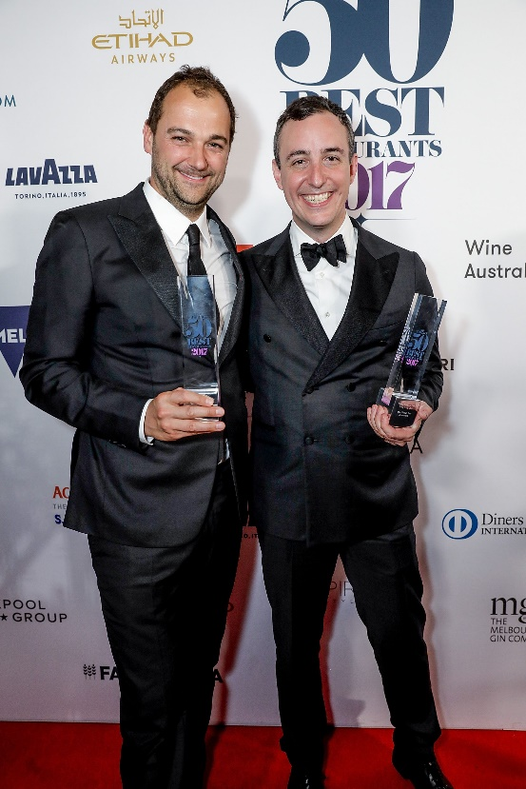

Later that night, they both reflected on what had happened. WG thought about all the great figures in the field of gastronomy: in his words, each of them had contributed something unique; each of them had done something to ‘change the conversation’: ‘These chefs had the courage to make something no one had made before, and to introduce elements that changed the game for everyone.’ [p. 3]
Now listen to what he says about his restaurant: ‘We hadn’t done that yet. We’d worked our butts off to earn a spot on that list, but what, really, had we done that was groundbreaking? […] Nothing.’ He goes on: ‘We had everything we needed: the work ethic, the experience, the talent, the team. But we’d been operating as glorified curators, picking the best features of all the great restaurants that had come before us and making them our own.’
Amazing! Now – what about us? Think about it: yes, most of us do try our best, we pick and choose activities, we adapt materials, we may even come up with 1-2 ideas of our own, but - have we really done anything ‘to change the conversation?’…
Over to WG again: ‘When I was young, my father gave me a paperweight that read, ‘What would you attempt to do if you knew you could not fail?’ That’s what I was thinking about when Daniel and I wrote: ‘We will be Number One in the world’ on a cocktail napkin. [p. 4] (OK – you have to be young and pretty cocky to come up with something like this… )
But then of course the question immediately came up: ‘How?’ If you run a restaurant, there are two possibilities: you can focus on producing truly amazing food, OR… you can focus on something else. Here is WG again: ‘…But as I thought about the impact I wanted to make, I focused on the one thing that wouldn’t [ever change]. Fads fade and cycle, but the human desire to be taken care of never goes away.’ So WG decided he would focus on this other element – the people: ‘Just before I drifted off to sleep, I smoothed out the napking and added two more words: ‘Unreasonable Hospitality’.
Now isn’t this amazing? These words resonate with me because I have always felt that in our field, we keep focusing on the wrong things; just ask a colleague: ‘What do you do? What field are you in?’ Chances are they will say ‘Well, I am a language teacher; I teach languages’. But it may be that if we want to ‘change the conversation’, we need to change the way we look at ourselves and at what we do. To paraphrase the former Starbucks CEO H. Schultz, ‘We are not in the language business teaching people; we are in the people business teaching languages.’ Just something you might wish to ponder…
[‘Wait a minute!’ I hear you ask. ‘What about those two young guys?’ …In 2017, Eleven Madison Park was finally crowned No.1 in The World's 50 Best Restaurants. ]

[Read: W. Guidara: ‘Unreasonable Hospitality’ (pp 3 – 4)]

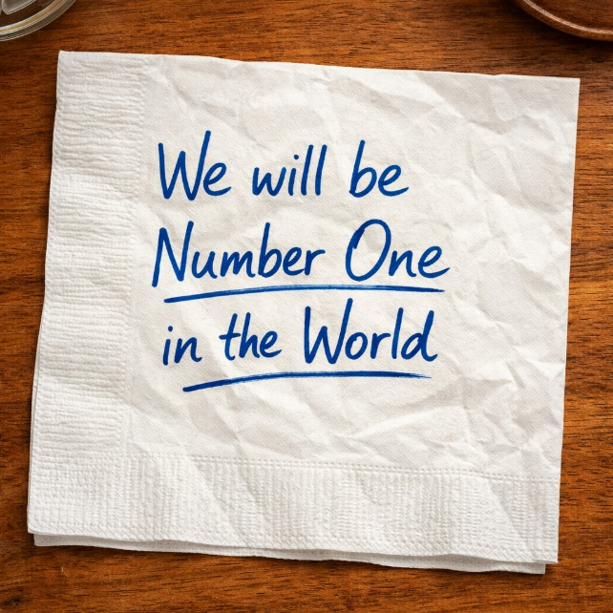

Please check the Pilgrims in Segovia Teacher Training courses 2026 at Pilgrims website.

