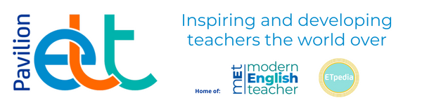

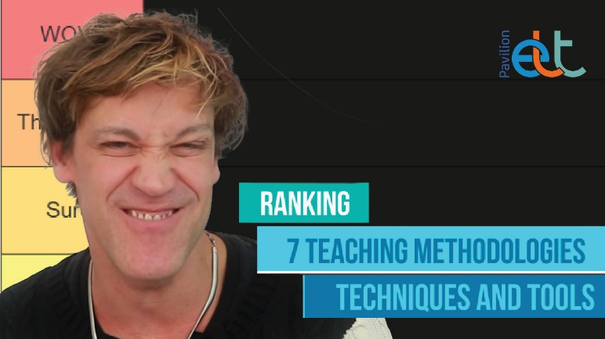

Vlog – Ranking 7 teaching methodologies, techniques and tools

In the ELT classroom, the actions we take often determine whether our students actually learn. In this vlog Rubens Heredia looks at how the methodologies, techniques and tools we use actually stack up in 2026, as he ranks them based on his own research and experiences. Would you agree with his rankings?

Watch here

Blog – The importance of relationships in times of AI



It is hard to attend an education conference or scroll through social media these days without encountering conversations about AI. Much of this is exciting and much of it is genuinely helpful. Yet, it makes Anna Hasper question what the impact may be on communicative language teaching which evolves around student-centred teaching. Shouldn’t meaningful interactions and human connections be at the heart of learning and teaching?

Read here.

Blog – Concept Checking Questions



The issue of concept checking questions comes up frequently in teacher training. In this blog, Gerhard Erasmus explains why his personal view is that even trainers are notoriously bad at them. He looks at when to use them, when not, and how to make proper concept checking questions.
Read here.

New

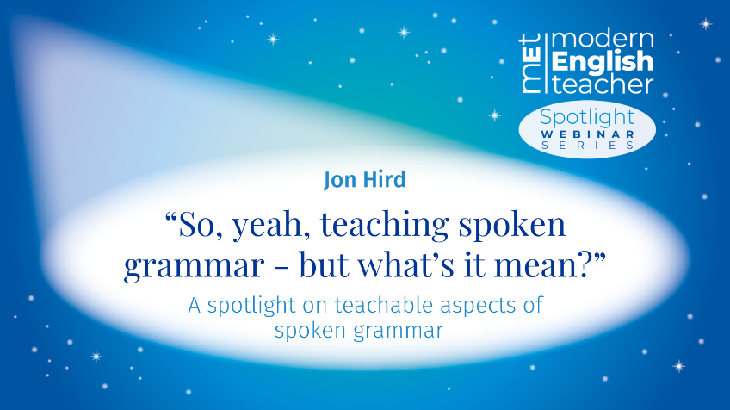

Spoken grammar can be defined as elements of natural spoken communication, but which have not yet become part of our everyday teaching syllabuses. In this practical session, Jon Hird will look at a handful of the many aspects of spoken grammar that can easily be incorporated into our teaching, to help our learners better understand and use language as it really is used and thus connect more naturally and confidently with the real world.



