

Greetings from the President
Brian Tomlinson, President and Founder of MATSDA

Welcome to MATSDA
The International Materials Development Association - MATSDA - brings together teachers, researchers, writers and publishers from all over the world to help inform the field of materials development for language learning. CLICK HERE to watch a video describing MATSDA in more detail.
Membership to MATSDA entitles you to a year's subscription and online access to back issues of its journal, Folio, plus reduced rates for MATSDA conferences and workshops.
Watch a video interview with MATSDA founder Professor Brian Tomlinson on Materials Development in TESOL: Trends and Issues. CLICK HERE or on the still to view. CLICK HERE to see the list of references.

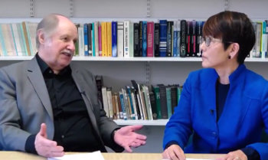

Folio

MEMBERS: Log in to Folio
CLICK HERE to log into the members' area with the latest issue of Folio plus the complete archive of back issues. Each issue features in-depth articles, 'Materials Spots', book reviews and more. To join MATSDA and access Folio, CLICK HERE.
MATSDA Conferences
A very successful MATSDA Conference was held in Beijing on Saturday June 7th and Sunday June 8th, 2025 at the Fragrant Hills Hotel. The Conference was co-hosted by MATSDA, the National Research Centre for Foreign Language Teaching Materials and Beijing Foreign Studies University, with the theme of Humanising Language Learning Materials. The Plenary Speakers were Rod Ellis, Alan Maley, Hitomi Masuhara, Hae-ok Park, Sun Youzhong and Brian Tomlinson and there were over a hundred parallel presentations to select from for the three hundred plus participants.
The next MATSDA conference will be co-hosted by The Autonomous University of the State of Hidalgo in Pachuca, Mexico on June 3rd and 4th, 2026. The theme will be The Role of Written, Spoken, Visual and Mental Texts in Language Learning and the plenary speakers will include Rod Ellis, Maria Ferradas, Hitomi Masuhara, Jayakaran Mukundan, Brian Tomlinson and Sun Youzhong. Details of the Conference can be found on the MATSDA website www.matsda.org
The 2027 MATSDA Conference will be held at the University of Limerick in Ireland and the 2028 MATSDA Conference will be held in the Netherlands.
Publications
1The book based on the 2023 Rufina Conference (Materials for Language Assessment edited by Asma Aftab) has been published by Cambridge Scholars.
2 The book based on the 2025 Lisbon Conference (Developing Materials for L2 Communicative Ability: Theory and Practice, edited by Brian Tomlinson and Hitomi Masuhara) is in the process of being published by Bloomsbury and should be on the shelves in about three months’ time.
3 The revised version of the book based on the MATSDA 2012 Limerick Conference (Applied Linguistics and Materials Development Vol 2, edited by Freda Mishan and Brian Tomlinson) has gone to Bloomsbury to begin the publication process.
4 The book based on the MATSDA 2025 Beijing Conference (Humanising Language Learning Materials, edited by Douglas Bell and Brian Tomlinson) has just been officially approved for publication by Bloomsbury and the twenty-six chapters are in the process of being written and edited.
References
Aftab, A. (ed.) (2025). Materials for Language Assessment. Newcastle-upon-Tyne: Cambridge Scholars.
Bell, D. and Tomlinson, B. (eds) (2027). Humanising Language Learning Materials
London: Bloomsbury Academic.
Mishan, F. and B. Tomlinson, B. (eds) (2026). Applied Linguistics and Materials
Development (2nd ed.) London: Bloomsbury Academic.
Tomlinson, B. and Masuhara H. (eds) (2026). Materials Development for L2
Communicative Ability -Theory and Practice. London: Bloomsbury Academic.
New Committee Member
Niall Walsh from Aichi Prefectural University in Nagoya, Japan has joined the MATSDA Committee as a Promotions Officer responsible for spreading the word about MATSDA, its journal Folio, its conferences and its materials development competitions.
Neill recently gave a very interesting presentation at the MATSDA/TMAC Conference in Beijing on ‘From Passive Reception to Active Creation: Learner-Centered Approaches in Materials Development’ and he has developed a chapter from it for Humanising Language Language Learning Materials.
The MATSDA Materials Writing Competition
2024-25
The 2024-25 competition to develop a unit of humanistic language learning materials was won by Asma Aftab from Pakistan and her prizes were awarded to her at the MATSDA/TMAC Conference in Beijing in June, 2025. The second prize was won by Poo Reun Noh from South Korea and the third Prize by Hoan Nguyen from the USA.
2026/2027
MATSDA is inviting submissions for a materials writing competition in which entrants will be asked to produce a complete unit of material for L2 learners which is driven by written, spoken, visual or mental texts. The unit should appear as it would in a published course and should:
- be designed to provide about three hours of activities for the learners following the course
- be addressed to the learners
- be designed to facilitate clarity and engagement through the use of spacing, staging, colour, choice of typeface, headings, symbols, illustrations etc
- be learner centred
The target learners can be of any age and of any level and be learning the target language for any purpose in any context.
The material should be humanistic in that it is learner-centred and ‘respects its users as intelligent and individual human beings with … experience of language use and life and helps them to exploit their capacity for learning through meaningful experience’. It should include ‘activities which make the language learning process a more affective experience, finding ways to help learners to connect what is in the’ unit ‘to what is in their minds and making the experience of using the’ unit rich, meaningful, personal and enjoyable (Tomlinson, 2023, p. 129).
Together with the unit, entrants should submit a rationale for the materials which provides information about:
- their name and affiliation
- the learners’ age(s), level, reason(s) for learning the L2 and context of learning
- the objectives of the materials
- the theories which have been applied in the development of the materials
- the sources of any references, quotations and texts
Entrants can be individuals, pairs or teams and each developer should provide a brief bio of about 100 words. Anybody can enter but bots are banned.

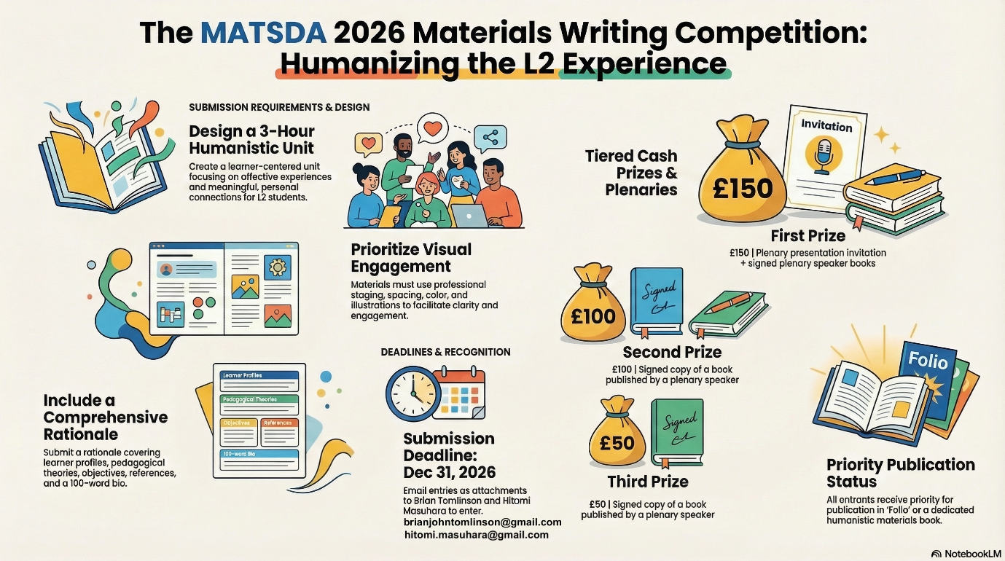

The closing date for entries is January 10th 2027 and entries should be sent as attachments to me at brianjohntomlinson@gmail.com and copied to Hitomi Masuhara at hitomi.masuhara@gmail.com
The prizes for the winners will be presented at the MATSDA 2027 Conference at the University of Limerick and will consist of:
First Prize: £150 + a fee waiver for the MATSDA 2027 Conference + signed copies of books published by the plenary speakers
Second Prize: £100 + signed copies of books published by the plenary speakers
Third Prize: £50 + signed copies of books published by the plenary speakers
All entrants will receive priority status for:
- presenting at MATSDA 2027
- publication in Folio (the MATSDA journal)
- publication in a possible book of text-driven material
Reference
Tomlinson, B. (ed) (2023). ‘Humanising the coursebook.’ In B. Tomlinson (ed.) Developing Materials for Language Teaching. London: Bloomsbury.

Folio
Freda Mishan
Freda is retiring from her position as Editor of our journal Folio after publication of this issue. As President of MATSDA I would like to represent the MATSDA Committee and everyone who has contributed to Folio in thanking Freda for her dedication, hard work and editorial skill in developing Folio into a much respected and influential contributor to the field of materials development. I would also like to thank Freda for her excellent work as a co-editor of the second edition of Applied Linguistics and Materials Development, which will be published by Bloomsbury by the end of 2026.
Welcome Tamas Kiss
CALL for papers for the October 2026 issue of Folio, the journal of the M A T S D A - International Materials Development Association.
We welcome submissions on any aspect of the theory and practice of materials development for language learning, regardless of language. Articles can explore both theoretical and practical dimensions of materials use in language education, including L2 materials evaluation and design, coursebook writing and publishing, materials samples, research and reports on materials in use in international contexts, and book reviews. We encourage contributions from researchers, classroom practitioners, materials writers, and educators working across diverse educational settings worldwide. All submissions should demonstrate originality, clarity, and relevance to current issues in L2 materials development. Interdisciplinary perspectives and innovative approaches are also welcome.
Deadline for submission for the October issue: 30 June 2026
Manuscripts should be sent to: tamask@sunway.edu.my
More information about preparing your manuscript is available at the MATSDA website, at https://www.matsda.org/folio-contribute.html


