Drama Part 2: Improvisation-based Activities for Language Learning Classes

Peter Dyer, France

Peter is a freelance teacher of English and Drama collaborating with teachers of English and businesses coaching in improvisation and presentation skills. He has worked in theatre, film and TV and has run classes for aspiring actors and those in the profession. He has given plenaries and workshops at many international conferences for teachers of English. He also writes articles for teaching publications.

Introduction

The activities I describe in this article are really a follow up from the previous article in which I described physical activities for the language classroom and in which I introduced readers to simple improvisation activities. These following activities are again physical but take improvisation skills a little further. If we can build confidence in our students to use improvisation, we will find it a particularly useful tool in the language classroom.

Activity 1: The inanimate object

Materials: None. A larger space may be more suitable for this activity.
Aim: ￼ To develop improvisation skills through movement. Giving and developing offers. Enrich imagination and creativity. Improvising skills without fear. Concentration.
Energy: Medium.

Procedure: Ask students to form a circle. The leader or teacher first walks into the circle and without planning what to do, places himself in a position and freezes. The position must at first include arms, legs, and torso. I repeat that the body shape must not have been planned but must be simply spontaneous and easy to hold in a freeze position. Ask your students to think what the body shape suggests as an object. The aim is to discover from the teacher’s body, an object not anything human such as a statue. The shape might resemble a kitchen sink or a road sign or a door. When the teacher gets a few ideas, ask one of the students to walk into the circle and to use the teacher’s body shape as that inanimate object e.g. a water pump or a kettle, a large mixing bowl, whatever the shape suggests. When the teacher’s body shape has been used, he must say "thank you". Ask more students one by one to come in and use the body as another object.

Try this a few more times using a student in the circle. Remember, do not plan the shapes, remember, they must be spontaneous because they are more refreshing and challenging this way. A student who plans a position e.g. I’m going to be a tree, will be disappointed if the student entering the circle uses him as something else. Next, pair the class up naming them A and B. A must form a shape and B must use it, A thanks B and then it is B's turn to form a shape. Sound can be used by the user in this exercise too. Help students to relax by telling them not to worry if they can see no objects from their partner’s shape. If nothing comes to them, tell them to form another shape.

Remember to inform your students, that the user of the object cannot alter the shape on offer to suit his concept of what it is, but to make use of what is presented. This is pure, simple improvisation and we need to introduce simple activities to begin with so that students will eventually be prepared for more complex improvisation work. Improvisation is taking offers and using them to develop an idea. Improvisors never say, “NO.”

It is important that students do not perform for you but rather for each other. They must make offers to their partners. Your job is simply to monitor and suggest ideas if there is a block. Students may discover objects from their partner’s shape and not know the word in English. This is where the teacher can assist. Any new vocabulary can be noted and repeated at the end of the activity.

Variation: These objects could again be recalled and used to develop a story line. Philip Bernardi in his wonderful book “Improvisation starters” suggest that students can improvise short scenes or role plays by just starting with a few objects. The objects must be used in the role play or a written shared story. The students have already created the objects to be used and it is always great to use them in another way.

Activity 2. "What are you doing?"

Materials: None. A larger space would be suitable here.
Aim: using input from other students to develop an idea. Building imagination and creativity skills.
Energy: Medium

Procedure: Students form a circle with enough playing space in the centre. One student or the teacher goes into the circle and begins to mime an obvious action using sound. The sound could be the sound of the person using the object or the sound of the object itself. Let’s take an example. The first player mimes brushing his teeth adding a sound to the toothbrush. A second student enters the circle and asks the first student, "what are you doing?". The first student must reply saying something that is not at all connected to the action he is performing. It might be something like, “I’m washing my dog.” This response must be said while maintaining the action of cleaning teeth. The second student now must mime an action appropriate to what was suggested. The first student returns to the circle. This student now must continue miming the action of washing his dog and another student approaches and again asks, "what are you doing?" Again, the response must be an action that is not at all related to washing my dog.
Action e.g.” I’m painting my car.”

- Student A enters and mimes, cleaning teeth.
- Student B enters and says, "what are you doing?"
- Student A says, "playing chess".
- Student B begins to mime playing chess while A leaves the centre.
- Student C enters and asks B, "what are you doing?"
- I’m learning judo.

Variation 1: After some practice, ask the students not to plan what they will say in the circle but rather trust it to spontaneity, it is much more fun this way and the responses are hugely entertaining, e.g. "I'm counting rainbows" This might sound a little silly, but the student who must mime this will find it fun and challenging. Ask students to extend their responses if they can, e.g. "I'm playing chess with a serial killer". Another example could be, "I'm washing clothes on the moon". These provide more colourful stimuli for mime.
Let students suggest rules for the game of elimination, e.g.
1. you must not hesitate to respond to the question, “What are you doing?”
2. you must not repeat what has been said before,
3. you must continue to mime as you explain what you are doing.

Students will use what grammatic structures they know for prohibition e.g.
1. You can’t repeat,
2. you mustn’t repeat, or
3. you’re not allowed to repeat etc.

More rules might be, you can’t hesitate to say what you are doing. Students create prohibitions and rules in all their games, and we can make use of this as a game of elimination.

The teacher can make note of pronunciation and grammar problems for feedback in discussing rules but not when the students are playing the game, interruption by the teacher for grammar or vocabulary correction, can be disruptive. Sometimes students might interrupt the proceedings to ask the teacher for occasionally and that of course is acceptable and helpful to all.

Variation 2: The teacher might ask the students at the end of the game to try and remember in pairs what actions took place in the game and write them down or feedback vocally. Perhaps small groups can remember three actions and try to use these in creating a role play or a written story.

Activity 3: The Machine

Materials: ￼ None. This can be performed in a larger space.
Aim: Group movement, improvisation and dynamics, Grammar
exploration. The language of processes. Passive and active forms active
Energy: High.
Procedure:
The teacher asks the group to think of a manufacturing process which might take place using machines. There will be many ideas and one idea I got from students in Slovenia was a coke making process involving many machines. I ask the students to think of all the different processes which coke making might involve. We then focus on what we think the first machine might be responsible for e.g. A bottle washing machine. The teacher can ask a student to stand in the space and try to become a bottle washing machine using simple but repetitive movements just like a machine. If a student is reluctant to start, the teacher can demonstrate. Demonstrate a machine type of movement to your students which includes repeated movement and accompanying sound. Try to show a transition from left to right or right to left allowing space to move. We must be able to see the dirty bottle entering the machine and the clean one passed on ready for the next machine.

Ask another student to enter and form another part of the machine which would follow using another movement and sound. Encourage ideas from the class and then ask a student to enter and begin being the next machine. The next machine might be the machine which fills the coke bottles. I always encourage the students to use repetitive sound for the repetitive movements of the machines. More students can enter one by one to add to the machine using sound and repeating movements. After this demonstration, ask the students to begin again but this time tell them that you will move among them. Tell them that if you touch their shoulder, they must cease their sound and when you touch them again, they must recommence their sound. This resulting orchestra is quite beautiful, and the teacher would be advised to tape the music for the participants to enjoy later. After completing the machine game, ask students to recall what each person's role in the process was. Perhaps they were crushing or hammering or painting something and passing it on. What was the first student doing and the last student?

This is a perfect opportunity for teachers to demonstrate the use of active and passive structures to describe the process. E.g. This machine is cleaning all the bottles, or all the bottles are being cleaned.

Variation: Ask students to discuss the process of making a product in a factory, e.g. cakes, soft drinks, shoes, cars etc. Discuss a particular process or look at an illustration and see if students can represent this process using their bodies and voices. Students in groups of perhaps 8 members could think of their own process, perform it, and ask the class what the process was and what each section was doing. There is enormous language potential in this exercise. I have also used music which might be applicable for a machine, this can help students find a rhythm for their machine.

When I did this in Slovenia with students on the last night, their parents who had been invited, joined in quite spontaneously. How wonderful.

References

One book I mentioned in this article is called “Improvisation Starters” by Philip Bernardi published by Betterway Books. This book has thousands of ideas the teacher can use to stimulate written or spoken activities. It is one of many resources but this one provides quick ideas for roleplays and written work.

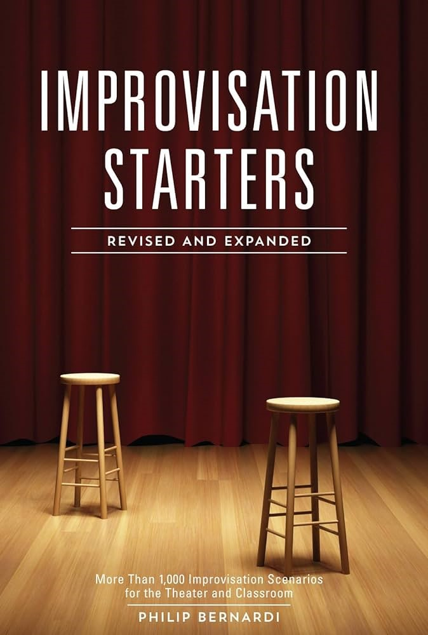

Please check the Pilgrims f2f courses at Pilgrims website.

Please check the Pilgrims online courses at Pilgrims website.

