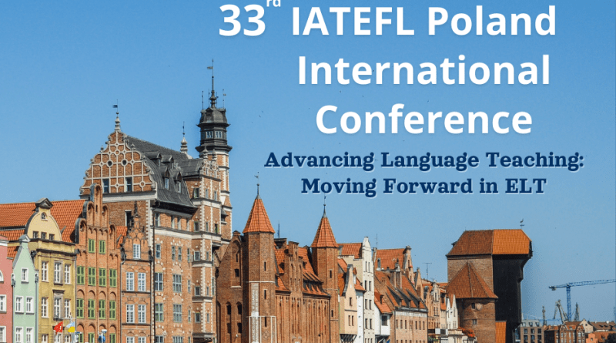

33rd IATEFL POLAND International Conference Gdańsk, 20th – 22nd September 2024

CALL for PROPOSALS

Submit here: https://iatefl.org.pl/conference/index.php?a=login

We cordially invite you to the 33rd IATEFL Poland International Conference in Gdańsk. The conference is one of the largest events for teachers of English as a foreign language with hundreds of participants willing to seek new ways and innovative solutions to be adopted in the learning-teaching environment.
The conference theme is: Advancing Learning Teaching: Moving Forward in ELT
To help explore the variety of issues connected to the main theme of the conference, this Call for Proposals welcomes contributions covering any of the topics in the following areas:
- Practical Takeaways for Your classroom
- Academic Research Results
- Diversity, Equity, Inclusion and Belonging, including Catering for Special Educational Needs (SEN)
- Teacher Training and Development, including Teacher’s Self-Care and Resilience
- Psychology in Teaching and Teachers’ Careers
- Teaching Different Age Groups: Young Learners, Teenagers, and Adults
- 21st Century Skills and Employability, including Learning Skills and Presentation & Public Speaking Skills
- Global Issues in English Language Teaching
- Drama, Art, Literature and Culture in Language Education
- Content and Language Integrated Learning (CLIL)
- Effective Ways of Developing General Language Skills
- Language Assessment, including Evaluation and Testing
- New Technologies in English Language Teaching and Learning
- English for Specific Purposes, e.g. Academic English, Business English, Legal English, Medical English
- English Language Teaching Management and Leadership
- Use of Technology and AI for teachers and in the classroom
- New Digital Tools for EFL
If you are interested in the topic of the conference and would like to attend the conference as a speaker, please fill in the online Speaker’s Proposal and Registration Form. To cover all areas and all levels, we are not only interested in contributions from experienced presenters but would especially welcome proposals from first-time speakers and new teachers.

Presentations options are:
- Plenaries (60 mins.) followed by Q&A sessions
- Talks (60 or 40 mins.)
- Workshops (60 or 40 mins.): workshop sessions must include active audience participation through experiencing and discussing tasks provided by the workshop facilitator.
- Live Lessons (60 or 40 mins.): workshops with real learners (various age groups). Lessons are observed by attendees of the conference. The organisers can provide groups of learners .
- Advanced Lessons for Teachers (60 or 40 mins.): workshops with active participation of teachers – attendees of the conference who would like to polish up their English
- Computer-based Digital Tools workshops (60 mins.): workshop sessions will use a 27-station computer lab to allow for hands-on demonstrations of software or platforms
The main language of the conference is English.

Summary of sessions

You are asked to submit a 60-word summary of the content and structure of your session and provide biodata (max. 60 words). Presentations will be chosen based on your summary, which must accurately reflect the content of your presentation. The programme committee will evaluate all speaker proposals based on quality and relevance.

Important dates
Submissions – Open as of: 08th April 2024 Submissions – Deadline: 11th June 2024 Notification of Acceptance: 15th June 2024
If you have any questions about the conference submission process or require additional information, please send your query to office@iatefl.org.pl For further information please visit our website www.iatefl.org.pl

