An Idea Lost and Found

Mario Rinvolucri, founding father of Pilgrims, UK

Mario Rinvolucri is a retired teacher, teacher trainer and author. He was one of the founding fathers of Pilgrims where he worked for well over 40 years. He started and ran Humanising Language Teaching website magazine for seven years before he handed over to Hania Kryszewska. He regularly contributed to The Teacher Trainer Journal. His books include: Creative Writing, with Christine Frank, Helbling, Multiple Intelligences in EFL, with Herbert Puchta, Helbling, Unlocking Self-Expression through NLP, with Judy Baker, Delta Books, New edition of Vocabulary, with John Morgan, OUP, Humanising your Coursebook, Delta Books, Using the Mother Tongue, with Sheelagh Deller, Delta Books, Ways of Doing, with Paul Davis and Barbara Garside, CUP, Imagine That with Herbert Puchta and Jane Arnold, Helbing, Creative Writing with Christine Frank, Helbing. I believe an almost complete list is to be seen here.

Six years ago, or so…

When Mario was going through his notes and files, he sent me many letters and among them this message.

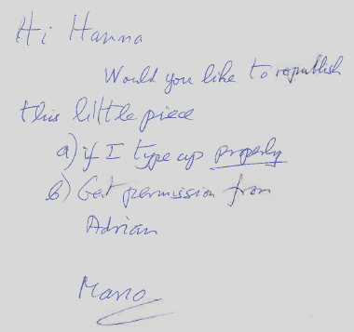

Back in 1987

The ‘little piece’ had been typed in a very old-fashioned way on a typewriter that clearly needed a new ribbon; it was accompanied by this note.

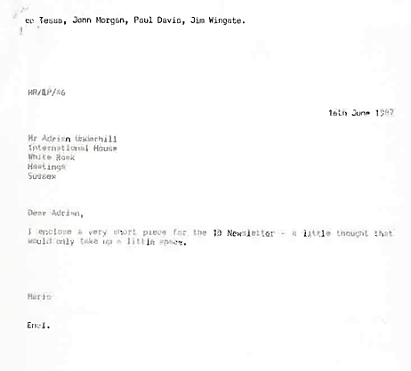

Clearly the letter had been written in the days Tessa Woodward, John Morgan, Paul Davis and Jim Wingate were all part of the Pilgrims scene, and Adrian was “Mr. Adrian Underhill”.

2024

So, I wrote to Adrian asking what happened to the text, and here is his reply:

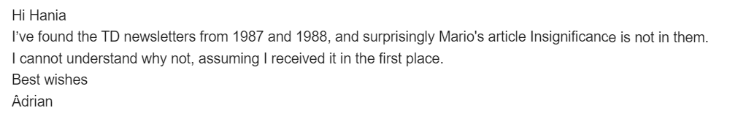

Insignificance (original version)

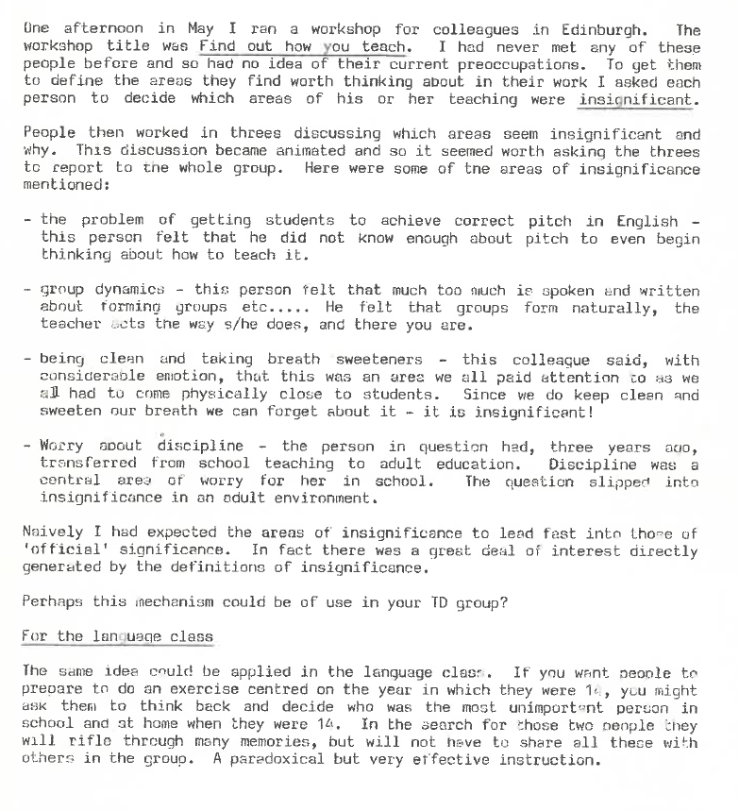

More by Mario

Some articles in HLT I recommend.

Using Questions the Way We Did back in the Last Millennium

Thank You Japan

21 creative-writing techniques: Letters across the classroom

The Alternative Way: Green Line 1 Klett Ernst Klett Verlag GmbH

Creativity through Strict Timing in Story-telling

Some interviews

https://www.tefltraininginstitute.com/podcast/2019/9/3/teacher-supervision-without-observation-with-mario-rinvolucri

https://hlt.digital/profiles/mario-rinvolucri/videos/

Please check the Pilgrims f2f courses at Pilgrims website.

Please check the Pilgrims online courses at Pilgrims website.

