A Day in the Desert, a Lifetime in the Desert

Christopher Graham, UK

Christopher Graham is a freelance ELT consultant and author based in the UK. He has worked in the field since 1981 in over 30 countries for the British Council, ministries of education and international publishers. He has a specific interest in teaching and learning contexts in fragile and fractured societies, teacher in-service education, and ELT and its interaction with climate change. He is Vice President of IATEFL, and was one of the founders of ELT Footprint, a 2020 British Council ELTons winner. Email: christophergrahamelt@outlook.com
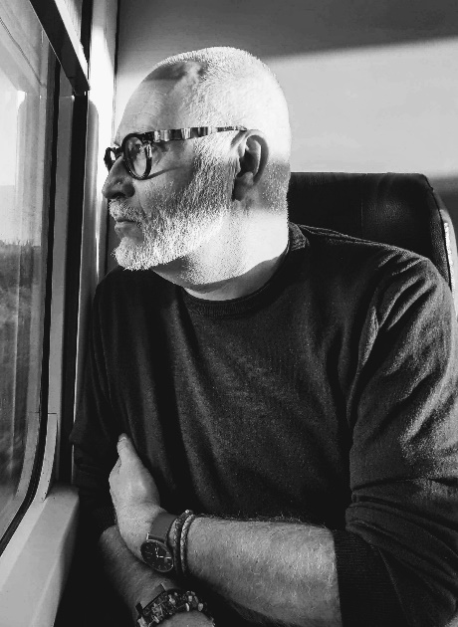

Background
My senses of anticipation and anxiety rose as we headed across the desert. 90 minutes into the journey, we saw it on the horizon, and the closer we got, the more expansive it became. ‘It’ was the Azraq refugee camp run by the UNHCR for Syrian refugees. In the Jordanian desert, but to all intents and purposes in the middle of nowhere. As we parked up and I started to acclimatise myself to the scale of things (there are around 41,000 residents) there was no shortage of images and ideas raging around my head, but perhaps not surprisingly, climate change was not among them.
I was visiting this camp, and the much larger Zaatari camp, as part of a project I’m working on at the moment around ELT and broader education provision in challenging circumstances. One of the things that I did during the day was to observe an ELT lesson. I joined a classroom of grade 10s, young women aged 15 or 16. They were very different from the young women that you might encounter in many other locations. Not bubbly; they didn't seem full of the normal zest. Their eyes were blank, faces drawn - young women who had seen a lot of things. Some will have been married, some were mothers. All will have lived in the camp since they were young and never have left, for any length of time at least. Nor are they ever likely to.
The first thing the teacher did at the beginning of the lesson was a vocabulary recap. But my ears pricked up. The first word the students were calling out was ‘deforestation’ then ‘logging, ‘flooding’, ‘habitat’. I had to bite my lip as there was something in my eye by this point. These young women, living in a context without a great deal of hope were genuinely engaging in an English language lesson around climate change. The whole thing blindsided me.
Part of me was grappling with the thought that these students had got more to worry about than climate change. But most of me was mightily impressed, both with the teacher and with her students. But of course, climate change is important to them. They live in a desert; water is always short there. It matters.
As an adjunct, as I said, many of the students have been in the camp since they were small. As a result of its desert location and the fact they very rarely leave the camp, I was told some of them have never seen a tree. That is an abuse of human rights, in my world, never seeing a tree.
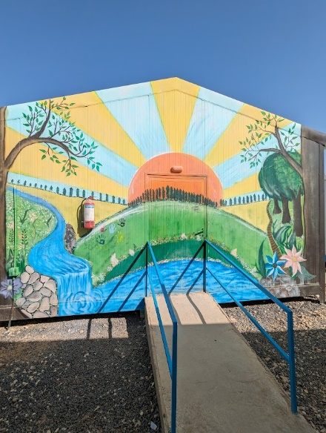
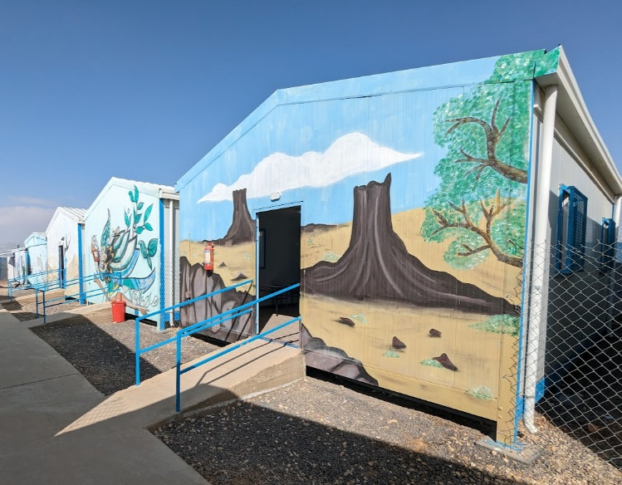
These classrooms, painted by refugee children, add some cheer to the school. Photos by the author. © Christopher Graham 2024.

That was a rather long preamble
To my thinking, perhaps we should be a little bit more optimistic about the interface between ELT and climate change. Now, I am not denying it's a climate emergency, and I'm certainly not saying that we couldn't do more. But what I am saying is that I suspect there is a lot of good climate-related stuff going in ELT classrooms around the world, but sadly we are not always a very joined-up profession, are we? We seem to pride ourselves on sharing ideas, sharing approaches, sharing challenges and so on. But a lot of the time we're quite fortress-like, I think. I only by chance found out about this climate change lesson with these young women, it just happened to be the lesson of the day that I arrived in the school.
Over the last four years, I've been involved in climate change education and ELT, and I’ve found all sorts of interesting and exciting projects literally all over the planet. Wherever you look ELT and climate change education are being integrated.
Perhaps it might be a good idea for me to outline what I mean by the integration of ELT and climate change. For me, the really powerful work is on the educational side, and not so much on the side of mitigating our impact. I’m not suggesting we should underestimate at all the impact of our activities as a global community on the environment, of course. But I do think many of the. behavioural changes around for example, recycling, the ways that we travel, the way we use energy, are really just sticking plasters.
What we really need is systemic change, cultural change, political change, and economic change. Change of this nature is brought about by pressure from communities and movements, and ELT can be a part of the facilitation of this. This is our big opportunity, actually responsibility. Responsibility around giving learners of all ages the tools to engage with the climate debate, which, for better or for worse, is still largely in English. We can facilitate our learners’ abilities to press for change, to lobby, to protest even. We can support them in getting to the facts, and help them identify falsehoods or greenwashing online and elsewhere. We as ELT folk have a significant role to play.
As I said, I think there's a lot going on already at grassroots level - school, university, college, in whatever context, there are teachers all over the world chipping away at this. Teachers are producing their own materials around sustainability, adapting coursebooks, finding videos online and asking learners to recount their own experiences. I know it's going on because of piecemeal conversations I have with people, and by following a variety of Facebook groups and bloggers around the world. Yet I still detect a feeling in our community that we're not doing enough. That’s probably true, but I think we're doing much more than is generally perceived, and I think the problem is about sharing.
I'm one of the founders of ELT Footprint which, even though I say it myself has proved to be an excellent platform for sharing ideas around ELT and climate change. Other stakeholders are engaging too, publishers are increasingly integrating sustainability topics into new coursebooks, often based around the UN SDGs. Ministries of education around the world are also (albeit very slowly indeed) committing to varying degrees of climate change education, and private language schools are engaging.
All of the above is very encouraging but the kind of idea-sharing and collaboration that I'm talking about now is local, peer-to-peer, even within a school. The reason I'm so enthusiastic about local collaboration is that much of the material found on global websites, Facebook pages, or on YouTube, though often excellent, does need adaptation to the given local context. That requires resources, and in many cases, certain skill sets before it can be used in classes. The great advantage of local content shared from one teacher to another, in the same school, within the same education district or through a teacher association is it's likely to be highly relevant to the local context. That matters a lot, as one of the challenges for climate change education, especially with younger learners is ensuring they can see the relevance of it. Locally generated content will also be classroom-ready with minor adaptations, and let's face it, the last thing teachers want is extra workload It will also be accessible within the local context. Not everyone has access to printers or to decent Wi-Fi.
So, what I'm saying to any teachers who might be reading this is get creating and get sharing, but get sharing locally in whatever way works locally. And get supportive - we all need to know that we're making a difference, albeit a small one. Except I believe that through education, we're not making a small difference, we're making a big one. Because ultimately those learners, whether they're young learners, university students or adults have, and will have, influence. And will make change happen.

“this land is made for you and me”,
Woody Guthrie,
This Land Is Your Land, 1940.

Please check the Pilgrims f2f courses at Pilgrims website.

Please check the Pilgrims online courses at Pilgrims website.

