Who Moved My Cheese An Adaptation

Bonnie Tsai, late Pilgrims trainer, France

Bonnie Tsai was everything we expect and respect in a Creative Pilgrims Teacher and Trainer. She inspired thousands of teachers across the world. The most rewarding way for us to keep her memory alive is to encourage other teachers to be brave and not afraid to express their creativity, to develop interests in innovative approaches to teaching, and to find ways to implement them.



Note
Bonnie loved metaphors and inspirational stories. Among my notes I found a story she loved. It deals with change and how we should approach change. In her notes she writes: What are your concerns about new procedures and technology today? And it shows how she interpreted the metaphor in the story. This book published in 1999 has not aged and it the days of a revolution in education due to AI and ChatGPT . It seems it is worth revisiting.

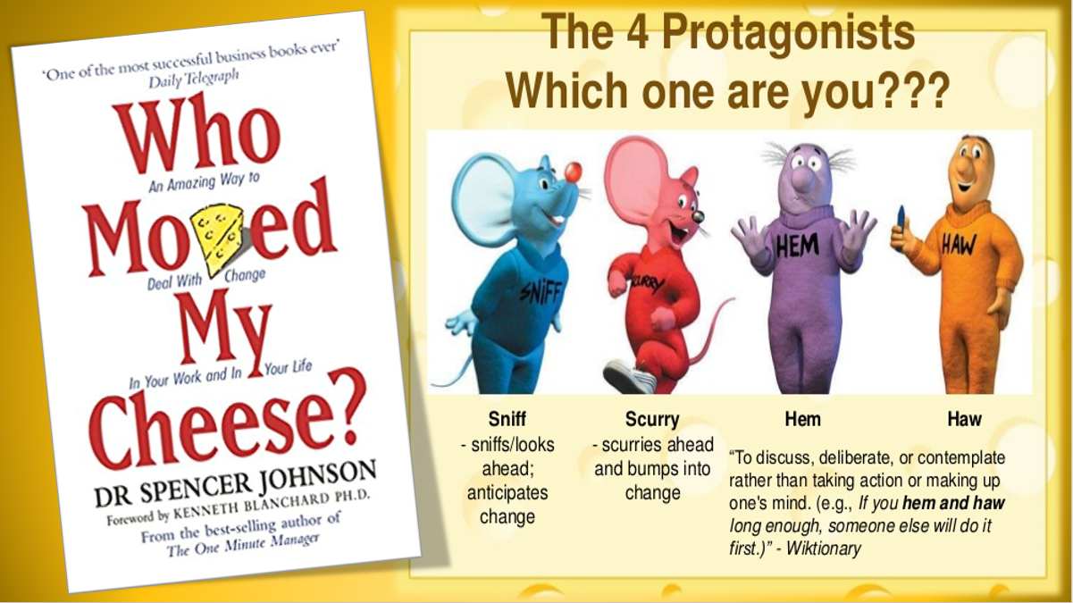

WHO MOVED MY CHEESE?:
What are your concerns about new procedures and technology today?

There are four characters in our story: Sniff and Scurry who are two mice; Hem and Haw who are 2 little people. They are as small as mice but look and act like people today.
The setting is a maze where the mice and th» little people spend their days looking for their own special kind of cheese. Every day they put on their jogging suits and running shoes, leave their homes and race into the mazes to look for cheese.
The maze itself is a labyrinth of corridors and chambers some containing delicious cheese. But there are also dark corners and blind alleys leading nowhere. It is an easy place to get lost.

However, for those who find their way, the maze holds secrets that let
them enjoy a better life.

There are two ways of tackling the maze: Sniff and Scurry used a trial and error method of finding cheese. Sniff would smell out the general direction of the cheese and Scurry would race ahead to find it.
Hem and Haw used a different method: They relied on their ability to think and learn from past experiences. Sometimes they'd get confused by their beliefs and emotions. One day however they found what they were looking for--they found their own special kind on cheese in cheese Station C.
HAVING CHEESE MAKES YOU HAPPY.

They were very happy with their cheese. They became very confident, because there was always lot of cheese and life became easy. Their confidence turned into arrogance. They build up an active social life. As they become more comfortable, they began to believe that they deserved their cheese.

But one day there was no more cheese. Sniff and Scurry inspected the area for changes while Him and Haw paid no attention to what was going on around them. They took it for granted that their cheese would always be there.
When at last they realized that indeed there was no more cheese, their attitudes were very different. Hem thought that it was No NOT FAIR! Haw was shocked and full of disbelief. He refused to hear anything about the disappearance of the cheese.
Sniff and Scurry weren't surprised however, because they could see and even sense the changes around them. So, they put on their jogging suits and running shoes and moved on. Meanwhile Hem and Haw hemmed and hawed. For Haw having cheese meant becoming a big cheese, being in charge of others, having a big house on Camembert Hill. For Hem having cheese meant being safe, having a loving family, living in a cosy cottage.

THE MORE CHEESE YOU HAVE
THE MORE YOU WANT TO HOLD ONTO IT.
Hem and Haw cried over their fate and wondered who to blame. Meanwhile Sniff and Scurry move on and to find a new Cheese Station.

THE MORE IMPORTANT YOUR CHEESE IS TO YOU THE MORE YOU WANT TO HOLD ONTO IT.
Hem and Haw returned to the empty cheese station everyday. They didn't know what to do. They thought they were entitled to benefits. They were suffering from the effects of having no cheese. They were becoming frustrated, angry and started blaming each other.
Slowly Haw began to imagine himself finding new cheese and enjoying it. As this happened, he began to see himself leaving Cheese Station C. Hem wanted to stay because it's comfortable and safe. Outside it was dangerous. So, they stayed. They had trouble sleeping and were having nightmares about not finding any cheese. They tried to deny what was happening.
They decided to work harder. Maybe the cheese was just behind the walls. They started earlier, stayed longer, worked harder, but there was still no cheese.

Haw knew they were losing their edge. He was getting tried of just waiting for something to happen. Finally one day Haw started laughing at himself. Haw didn't really want to start running in the maze again, but he realized he had to. He found his running shoes and took off, leaving Hem behind.

WHEN YOU MOVE BEYOND YOUR FEAR, YOU FEEL FREE.

He started to paint a picture in his mind. He saw himself in realistic detail, sitting on a pile of his favourite cheese. He saw himself eating the cheese he liked. He imagined how much he would enjoy the taste.

He saw more clearly the image of New Cheese. The more it became real, the more he could sense he was going to find it.

IMAGING YOURSELF ENJOYING NEW CHHESE

EVEN BEFORE YOU FIND IT, LEADS YOU TO IT.
One day he found some bits of new cheese and they looked delicious. He ate some and put some in his pocket, perhaps to share later with Hem. When he entered the New Cheese Station, he found it empty. He realized that if he had moved sooner, he would have found New Cheese.
He decided to go back and see if Hem was ready to join him.

THE QUICKER YOU LET GO OF OLD CHEESE, THE SOONER YOU FIND NEW CHEESE.
Haw went back to get Hem, but Hem refuses to join him...He didn't think he'd like New Cheese. He wanted his own cheese back and refused to change until he got it.
So, Haw went back to the mane on his own. He felt it was just a question of time before he found his New Cheese.

IT'S SAFER TO SEARCH THE MAZE THAN REMAIN IN A CHEESELESS SITUATION.
Haw used to believe that cheese should never be moved and that changes were bad. Now, he realized that change was natural. Change could surprise you only if you didn't expect it or weren't looking for it.

OLD BELIEFS DO NOT LEAD TO NEW CHEESE.

“We're not going to get the old cheese back. We have to go and look for some new cheese,” said Haw to himself. But Hem was too afraid to move. Hem was still wondering, who moved his cheese.

IF YOU DO NOT CHANGE YOU WILL BECOME EXTINCT.
Haw was still afraid so he wrote before he left to find new cheese.
What would you do if you weren't afraid?
During the next few days he found a little cheese here and there. He had to admit that he found the maze confusing. THINGS HAD CHANGED SINCE HE HAD BEEN OUT IN THE MAZE. No matter how bad it was, Haw realized that it was better to do something than nothing. He was taking control rather than to just let things happen.

Haw also realized that the cheese had been going off for some time. Mould had began to grow on the old cheese. He had to admit that he hadn't wanted to see what was coming. He should have been watching and anticipating change.
SMELL THE CHEESE OFTEN SO YOU KNOW

WHEN IT'S GETTING OLD.

He searched in the maze for a long time without finding any cheese. One day he came upon a huge cheese station, but it was empty!
Sometimes he felt discouraged and thought about going back to his old Cheese Station. He wondered about Hem. He remembered the good times. Haw was weighed down by fearful beliefs but he remembered that the very best times in the maze was when he was moving along. So, he left a message on the wall for Hem.

MOVEMENT IN A NEW DIRECTION HELPS YOU FIND NEW CHEESE.
flaw laughed to himself. He realized that being afraid was only making things worst. So, he did what he would do if lie wasn't afraid. He moved in a new direction.
Haw began to enjoy himself. He was discovering what nourished his soul. He was letting go and trusting what lay ahead
.
Haw understood that is old beliefs were encouraging new behaviours. He was behaving differently than when he kept returning to the same cheeseless station. He knew that when you change what you believe, you change what you do.
You can believe that change will harm you and resist it or you can believe that New Cheese will help you embrace the change.
It all depends on what you choose to believe.
Haw was glad that he was writing on the wall in many places, because they
marked a trail for Hem to follow.
By now, Haw had let go of the past and was adapting to the future.
One day he found a New Cheese Station. When he went inside he was startled by what he saw. Piled everywhere were great piles of cheese. Some he had never seen before. Then he saw his old friends Sniff and Scurry.
As Haw ate the New Cheese, he realized he had been holding on to an illusion of Old Cheese that no longer existed. He saw that he was able to change when he was able to laugh. The quickest way to change is to laugh at your own folly and move on.

Haw was different from his mice friends. He used his brain to reflect on his past mistakes and plan for the future. He knew that he could learn to deal with change.
He could learn to keep things simple and remain flexible. He could learn not to confuse himself with fearful beliefs.
He could notice little changes and prepare for the big change that might be coming.
He knew he had to adapt faster.
The biggest inhibitor to change lies inside you. Nothing gets better until you change.
There is always New Cheese out there whether you realize it or not.
He thought about going back to find Hem, but finally decided that Hem had to find his own way.
Now Haw inspected the cheese in Station N everyday to see what condition his cheese was in. He often went out into the maze to explore new areas and keep in touch.

MOVE WITH THE CHEESE AND ENJOY

You can read the whole story here.
You can enjoy an animated summary here.

Please check the Pilgrims f2f courses at Pilgrims website.

Please check the Pilgrims online courses at Pilgrims website.

