Starting a New Topic: Cartoons about Clothes

Hanna (Hania) Kryszewska, Poland
Hanna Kryszewska is a teacher, teacher trainer, trainer of trainers. She is a senior lecturer at the University of Gdańsk, Poland. She is co-author of resource books: Learner Based Teaching, OUP, Towards Teaching, Heinemann, The Standby Book, CUP, Language Activities for Teenagers, CUP, The Company Words Keep, DELTA Publishing, and a course book series for secondary schools: ForMat, Macmillan. She is also co-author of a video-based teacher training course: Observing English Lessons, and online course for Orient Black Swan on 21st Century Skills and Teaching the whole person: Humanising language teaching. Hania is a Pilgrims trainer and editor of HLT Magazine. E-mail: hania.kryszewska@pilgrimsteachertrainig.eu

Introduction
A good way to start a lesson, or series of lessons around one subject it to use some cartoons – ideally selected by the teacher as then we have more control over the content and no time is wasted trying to find some and select suitable ones.
Here are some I have used to start lessons on clothes (B1 and above) with some ideas how to use them.

Idea 1
Don’t tell the students what the lesson/s will be about. Ask them to decide what the cartoons have in common.

Idea 2
Rank the cartoons from most funny to least funny and give your reasons.

Idea 3

Identify which cartoon/s deal with. moral issues / you can use the categories more than once:
- sustainability
- dress code
- individual style
- passing fashion
- moral issues
- taste
- materials
- politics
- other

Variation
You can create or add your own categories.

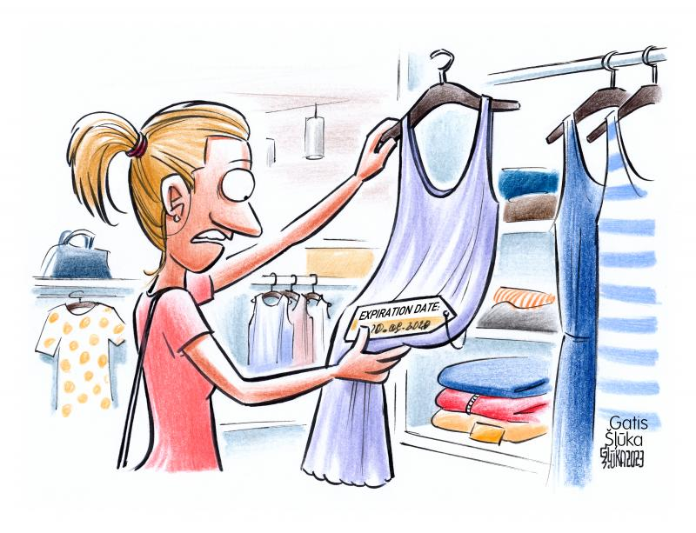

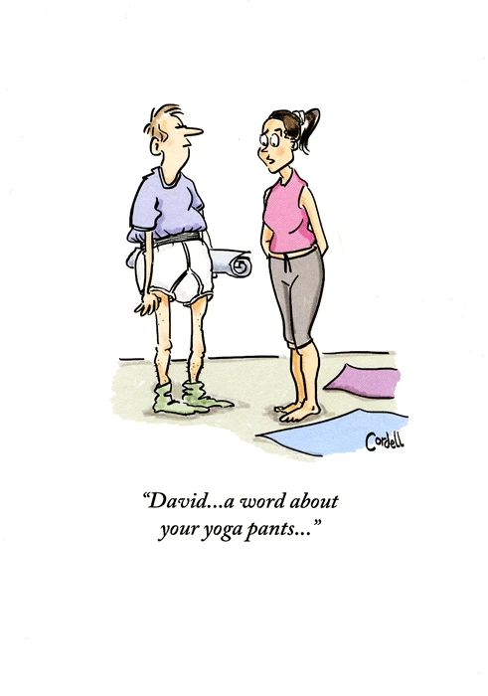
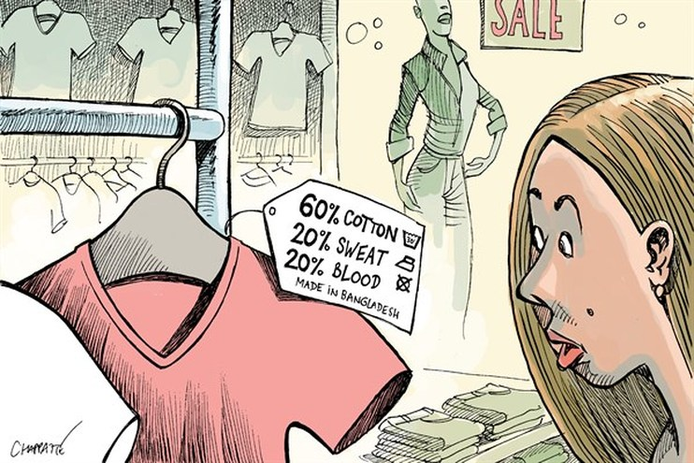

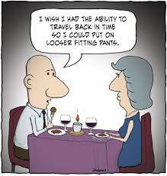

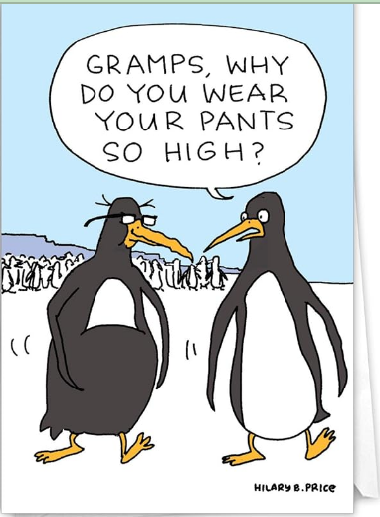

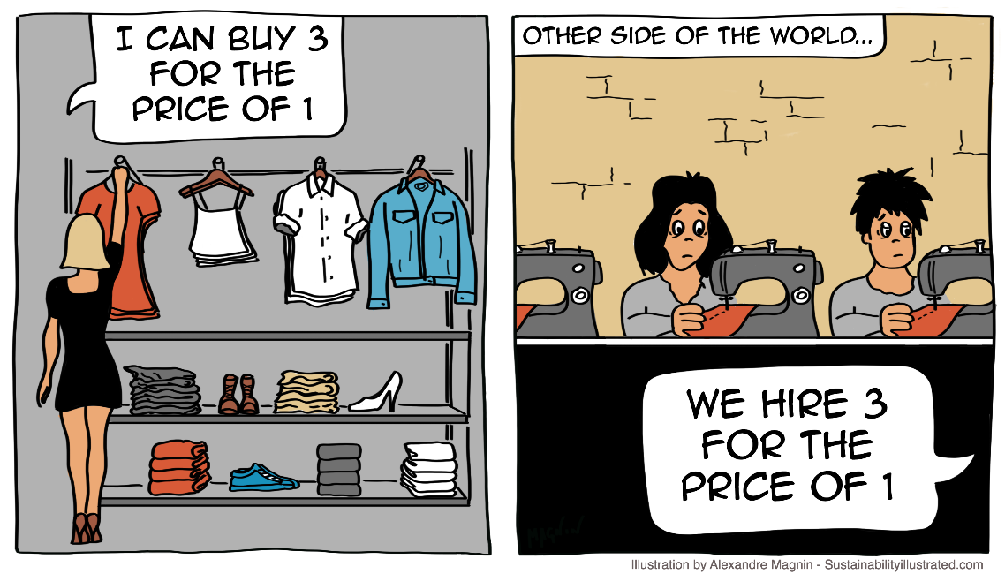

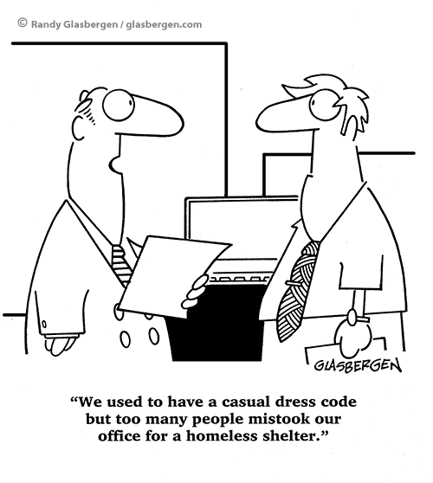

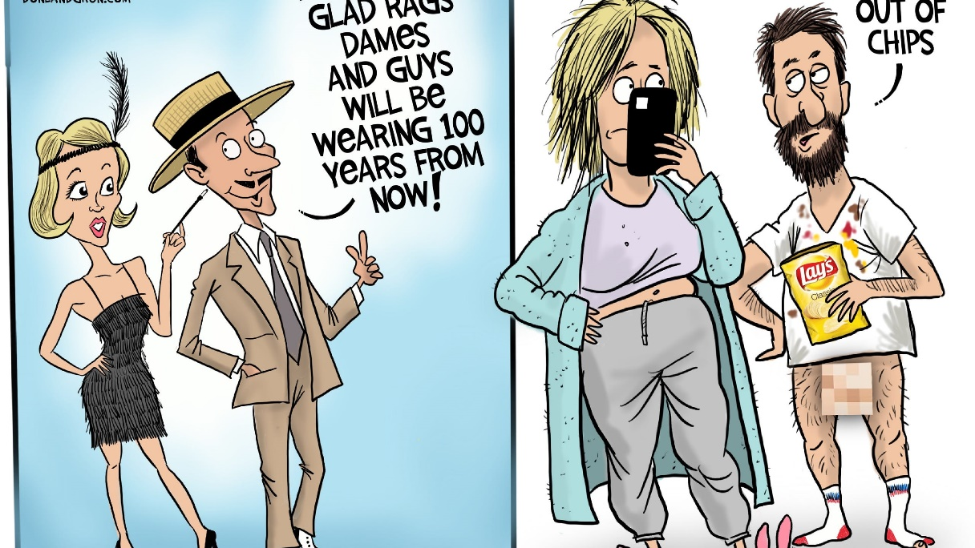

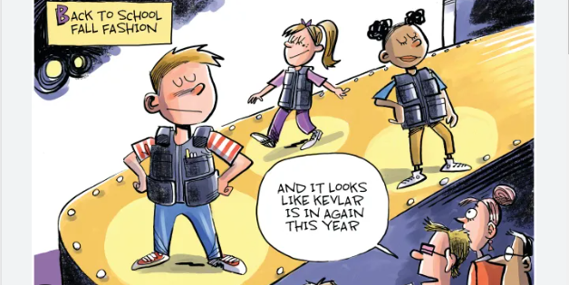

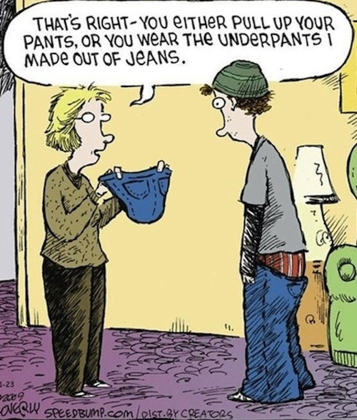

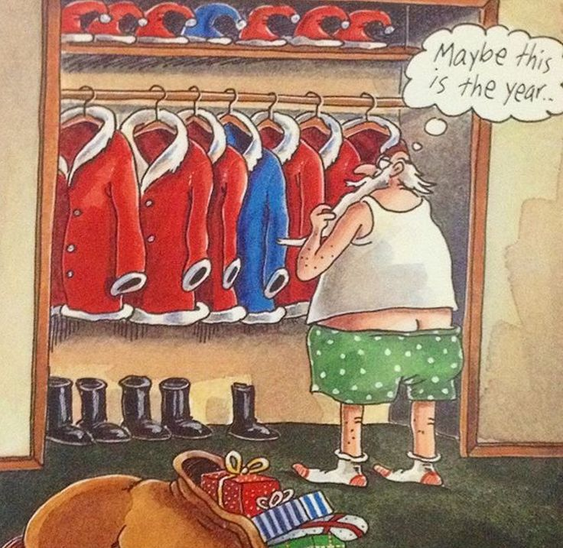

Please check the Pilgrims f2f courses at Pilgrims website.

Please check the Pilgrims online courses at Pilgrims website.

