Climate Psychology Alliance: Useful Links and Resources

Reprinted by permission from here.

Are you looking for help with your climate anxiety? Or perhaps you’d like to find out about some of the individuals or organisations working in this area? We hope this list of resources is useful.
For Young People

Organisations to Connect With
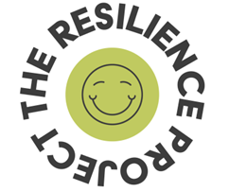
Climate Journal Project - A space, practice and community to help alleviate eco-anxiety. Through guided reflections and challenges, empower yourself and others to transition away from planetary grief and climate change paralysis.
Force of Nature - founded by youth activist, Clover Hogan, Force of Nature empowers young people to turn their eco-anxiety into agency, and work with leaders across business and education to drive intergenerational solutions.
The Resilience Project - An organisation whose mission is to build communities of support across the UK, with mental health at heart. The belief is that facing difficult truths is easier in community, and that stepping forward can result in empowerment and flourishing, rather than exhaustion and despair.

Resources, Books & Articles
'Dare to Care' - a guide for making sense of climate emotions aimed at teenagers and young adults, with reflective exercises. This guide was produced by Klara Wrusch whilst she was interning with CPA.
Climate Is Just the Start - in her new book, activist Mikaela Loach helps young readers understand the climate crisis and its implications.
Climate Courage Journals - resources dedicated to building individual and community resilience in the face of climate change impacts.
Active Hope: How to Face the Mess We're in without Going Crazy by Joanna R. Macy and Chris Johnstone – although not aimed at young people specifically, this book is accessible and guides the reader through reflective exercises that can support people to remain engaged with the climate and ecological emergencies without becoming overwhelmed.
Eco Distress for Young People - a web page produced by the Royal College of Psychiatrists which aims to help you understand the distress you might be feeling and provide you with tools to help you feel better and take action.

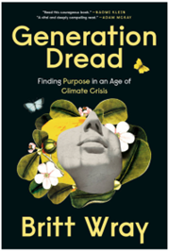

GenDread Newsletter - a weekly newsletter by science communicator, Britt Wray, on how to stay sane in the climate crisis. Britt is “gathering the ingredients for good mental and emotional health in the climate and wider ecological crisis - and sharing the recipes.”
Generation Dread: Finding Purpose in an Age of Climate Crisis - a book by Britt Wray on how to stay sane amid climate disruption.
Youth Activists of Colour - a detailed list of prominent young people of colour who are active in the UK environmental movement.
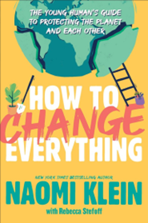
How to Change Everything: the young person’s guide to protecting the planet and each other - a book by Naomi Klein offering readers a comprehensive look at the state of the climate today, how we got here and how to join the fight to protect the planet while looking after each other.
'Older generations can't understand': XR Youth on being heard - a Guardian article about XR Youth members and their frustration with trying to make their voices heard and express the urgency they believe others struggle to fully grasp.
Despite 14 years of formal education it fell to me to teach myself about the climate crisis - an Independent article by Joe Brindle, young founder of Teach the Future, on the lack of climate change education in the curriculum.

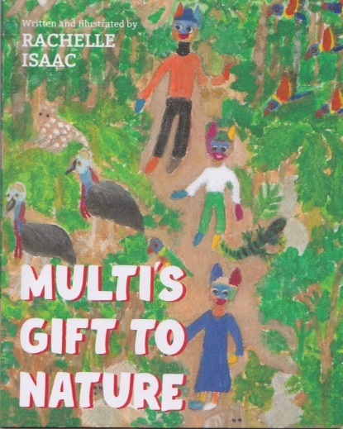
Multi's Gift to Nature - a story for children who are worried about climate change. The story gives children a clear message that their gift is to enjoy nature and it is the adults’ job to solve problems with the help of others. It focuses on a child’s well-being and their relationship with nature. The book is for 7 to 11 year old children.

Podcasts & Videos
Navigating Youth in a time of Climate Change - a CPA podcast episode in which climate-aware psychotherapist, Caroline Hickman, talks with youth activist, Sophia Thornton.
Climate Change - Finding the Silver Lining - a two part CPA podcast episode featuring youth activist, Martha Stringer, in discussion with Caroline Hickman. Part two is here.
From Anxiety to Agency - a CPA podcast episode in which Force of Nature founder and youth activist, Clover Hogan, chats to Caroline Hickman.
Turning Eco-anxiety into Eco-action - A conversation between Caroline Hickman and Clover Hogan as part of Nature History Museum’s Broken Planet series.
Climate emotions wheel - this page has a video and resources for thinking about different climate emotions.
“Not about us without us” – the feelings and hopes of climate-concerned young people around the world - an article written by young people on their experience of being active within the environmental field; the importance of young person involvement.

For Parents, Educators and Carers
Supporting our young people as they face the climate and ecological crisis can be hard. We’re growing a list of resources and organisations here which we hope may help.
What children want us to know about climate change - This brief BBC animation, featuring the perspectives of children, also stems from Caroline Hickman’s research and provides useful guidance for having conversations with children.
Climate Psychology Education Resources - Contains various free resources by CPA member and Educational Psychologist, Dr Louise Edgington.
Generation Next - This guide explores why, how and when to have conversations with your children to support them emotionally and build their resilience in a climate-changed world.
Climate Feelings: Blob Climate Action - A guide and resource for exploring climate emotions with younger children and people who express themselves in non-verbal ways, developed in collaboration between Jo McAndrews (CPA) and Christian Aid
A Guide to Climate EmotionsA Guide to Climate Emotions - This guide, based on, will help you understand and navigate the research of Panu Pihkala at the University of Helsinki and particularly his 2022 paper Toward A Taxonomy of Climate Emotions your emotions about the climate crisis
An Educator's Guide to Climate Emotions - Written by a team of teachers, researchers, and mental health clinicians in consultation with youth climate leaders and climate psychology professionals, offers a variety of approaches for working with climate emotions in educational settings.
The Existential Toolkit for Climate Justice Educators - As feelings of eco-grief and climate anxiety grow, educators are grappling with how to help students learn about the violent systems causing climate change while simultaneously navigating the emotions this knowledge elicits. This book provides resources for developing emotional and existential tenacity in college classrooms so that students can stay engaged.
For Teachers: An Existential Tool Kit - Thomas and Panu discussed the new Existential Toolkit for Climate Justice Educators and the emotional, political, personal and pedagogical challenges faced by teachers in the context of climate change.
Truth without trauma - A free to download e-book aimed at parents/carers to support their children with climate emotions.
The Triple Wellbeing Book – A free to download book developed by Thought Box, aimed at supporting teachers to meet children and young people’s emotional needs whilst educating them about the climate crisis. There are also lots of really useful resources on the Thought Box website.
Eco distress: for parents and carers - A Royal College of Psychiatrists web page for parents, carers, teachers and others who support children and young people, to explain what eco distress is, how to recognise if your child is experiencing it, and how to help them cope with their feelings
Guidance on Effective Climate Change Communication with Children - this guide was commissioned by Globe International and prepared by Caroline Hickman for the Schools Summit of London Climate Action Week 2021.
We need to find a way to talk about eco anxiety - a paper by climate-aware psychotherapist and CPA member, Caroline Hickman, which focuses on children and young people’s perspectives on ecoanxiety, drawing on clinical practice examples & research findings and offering conceptual frames to help us broaden and deepen our understanding of this evolving syndrome.
How to talk to Kids about Climate Change - an article and podcast episode including advicefrom senior psychologist, Susie Burke, of the Australian Psychological Society.

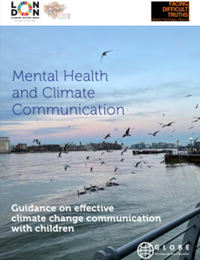
The Kids Are Not Ok - an article by climate scientist J.K Steinberger.
How to Talk to Your Kids about Climate Change: Turning Angst into Action - a book by “ClimateMama” Harriet Shugarman providing tools and strategies for parents to explain the climate emergency to their children in an age-appropriate way.
All the Feelings Under the Sun: How to Deal with Climate Change - a workbook by climate-aware psychotherapist, Leslie Davenport, for younger readers to help them work through their feelings of anxiety about climate change.
Teaching Climate Change - a free & comprehensive curriculum from ThoughtBox Education to empower the climate strike generation and help teachers around the world invite climate conversations into the classroom. Requires sign up.
LifeKind - CPA member Jo McAndrew's website is a rich resource for information, practical tools and training to help parents and educators support children and young people as they face the climate crisis. Don’t miss her blog, including this moving post A Letter to My Daughter.
Parenting in a Changing Climate - Elizabeth Bechard offers practical tools, resources, and inspiration for parents who are worried about the planet future generations will inherit and who want to find a way to cultivate resilience and take action on behalf of the children they love.
Kids Climate Action Network (Kids CAN) - a coalition of Oxford-based organisations and individuals working to create safe, fact-based and empowering climate change resources and information for children, and to support the adults around them.
Climate & Mind - A US based organisation run by psychotherapist, Andrew Bryant. Their website features a wealth of resources on the climate crisis and mental health generally including a fantastic section dedicated to parents and teachers.
Radical Geographer Paul - website of teacher, climate crisis campaigner, radical curriculum author & activist with extensive resources for teachers and schools.
Teach the Future - an inclusive, well organised and persistent campaign by secondary and tertiary education students to greatly improve education on the climate emergency and ecological crisis in the UK.
The Conceivable Future - a guide exploring the ways in which the climate crisis affects our personal decisions about family planning, parenting, and political action.

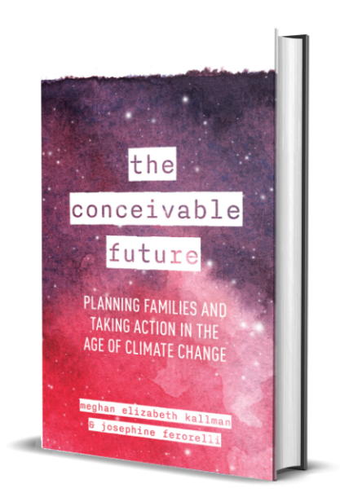
Authors Meghan Elizabeth Kallman and Josephine Ferorelli offer fresh, timely answers to questions such as: How do I decide to have a baby when there's the threat of environmental collapse? How do I parent a child in the middle of the climate crisis? What can I actually do to help stop global warming?

General
Centre for Climate Psychology and Change - provides workshops, events, professional training and consultancy as well as unlearning opportunities in times of global upheaval and climate anxiety
Tips for activists' welfare - Climate Trauma Survival Tips from climate aware psychiatrist, Lise Van Susteren, taken from a 2009 article by climate activist Gillian Caldwell.
Project Inside Out - Renée Lertzman’s work with Project Inside Out applies the latest research and best practices in psychology to help people on the journey from despair, passivity, and denial toward courageous, more impactful environmental action.
Climate Change & Happiness Podcast - Panu Pihkala & Thomas Doherty aim to give language to what you feel about the climate crisis—and also what you might want to feel, feelings you can grow and cultivate.
Climate Psychology Conversations- This podcast by CPA North America captures the heart of what’s emerging in the fields of climate psychology and climate-aware mental health care.

