All About Learning

Roy J Andersen, UK

Roy Andersen is a distinguished educationalist, well recognised for his easy style of writing that enables all to fully understand the complications of education and learning. He is the author of 18 books that explore the intricate relationship between society, education and the evolving world of AI. Email: roy@andersenroy.com, www.andersenroy.com



I was a good student at school. I behaved, did all I was told to do and sort of accepted the low marks and grades I always got. I was 28 in a class of 30 for maths. However, without understanding what this really meant, I always harboured a dream to be a doctor for children. That dream was abruptly shattered when the results of my final school examinations came. I had failed every single examination. I was stunned. I could not quite understand how they could force me to go to school for 12 years and then tell me I failed everything!

Things happened in my life and after some adventures I went back to education when I was 19. This time I was determined not to fail. I worked very hard, a brief stint in the army helped me to know there are no excuses. I passed every test with top marks, was the top student in the whole college and when I left after three years, my grades were among the highest in the country. I went to sea, then into construction and finally turned my interests and attention to education. I never wanted one child to fail in school as I had done.

In total, I have dedicated over 40 years to understand education and how it works. The 18 books I have written are said by professors around the world to be some of the best written about school, society and learning.

The first book I wrote is called The Illusion of Education. Here I explain how the school and higher education process really works. In short, this is say that education still holds to a 19th century plan to create manager and managed citizens in the society, which it achieves by the way it processes students in school. Ability in school is dependent upon the language skills the student has acquired, often from their family background. The mental stamina they have been raised on before school and during the school years to keep focused on what is to be understood, learnt and practised, and to have a strength of character to avoid the many distractions that seek to pull their mind away from their studies. In short, school works through two languages, mathematics and a national language. The student gains competence in their subjects by learning and practicing the numerous rules of these languages. Thus, assessment of the student is made on their ability to express their thoughts and the facts they have learnt which they weave into their presentation.

I found that this is little known by those in and outside of education, with most believing that ability to learn, understand and pass examinations is ‘somehow’ related to a factor of intelligence. This sees smart kids as getting the top marks, who are often noted to be intelligent. Students who score less being thought to be less intelligent, although this is not openly stated in our political times. Yet, it too often lies in the back of a teacher’s mind when they witness how some students seem to understand everything easily and others never seem to understand what they are trying to explain to them.

I realized that if I was to help children learn better, I had to find a way to prove to teachers that learning has got nothing to with intelligence. At least not so with those normally born. To this end, I devoted over 30 years studying genetics and neurology. After which, I wrote Intelligence: The Great Lie, where I explain how our understanding of what intelligence is came from a political idea to counter the revolutionary movement in the 19th century demanding equality. The science of psychology built upon this and so created the IQ test. In this book, I explain all the hidden strategies, the distorted data, just as the lies and fraud, that psychologists employ to convince society in the value of a measurable intelligence. Dean Professor David Martin wrote that this book is one of the most important books written this century, for I explain why intelligence cannot be measured, why the IQ is a myth and why the gene coding of a family does not determine the quality of intelligence related to it. To explain how we do gain our factor of intelligence I wrote Brain Plasticity: How the Brain Learns through the Mind to Create Intelligence. In this book, I explain how the nervous system drives the neurones of the brain into networks to determine the value of information it receives, through the emotional sensitivity of the mind. In this and later books, I discuss what I call The Art of Sensitivity in Awareness.

This explains how the human mind is always seeking security and interest, which teachers may know but never seem to understand, as they teach a class of 30 or so students. Thus, I explain that the human mind, and so that of all students is first asking itself:

Am I safe?

Thus, am I safe at home? Are my parents loving and secure or are they fighting or divorced?Then, am I safe in the highly competitive environment of the classroom, where others may be laughing at me or threatening me? There again, am I safe with the teacher? Do I feel the teacher likes me and will help me or are they unapproachable and even threatening to me? You would be surprised how the latter is more often the case than we may like to admit.

If the mind feels it is not safe in any of these states, then it is trying to discover what can be done for the individual to be safe. When the mind feels it is not safe it drifts in and out of the information presented in a class, and one or more of the RULES just mentioned are missed or misunderstood. When they are, the student struggles through a learning task and too often guesses what to do instead of knowing and understanding what to do. The second question of the mind is,

What is the most interesting thing for me at this moment?

If the teacher does not explain exactly what the purpose of the lesson is to be, so that each individual student understands how to navigate what is to come, and if the teacher does not keep the mind of each individual in the class happily engaged with the learning of the lesson, few do, then the mind drifts to more interesting thoughts, such as the game currently played at home, what they watched on the TV last night and thoughts about who they like or dislike in the class. Again, once the mind drifts, the student fails to keep up with the whole lesson and by the parts they miss, so they fail to understand the relevance of the RULES they missed.

Let me give a simple example to this. In maths, and so equations in physics and science, students are taught that when working through an equation they must first do the brackets and then work from left to right dealing with division, multiplication, addition and subtraction. This is remembered by the acronym BODMAS. Let us consider two students Peter and Jill. Now Jill paid full attention, understood this instruction and worked through the equation 6/2(2+1). First, she did the brackets 2+1 = 3. Then she worked from the left, divided 6/2 to get 3, then multiplied 3 x 3 to get the answer of 9. Now, Peter heard the first instruction of the teacher, to always do the brackets first, but for one of a thousand reasons his mind drifted and he did not hear the rest of the instructions. So he worked through the equation, using his common sense. He did the brackets to get 3, but then he multiplied this by 2 to get 6. He then divided 6 by 6 to get the answer of 1, which is wrong.

Jill got top marks and Peter scored less. It is important to understand this difference in the ability of the two students has nothing to do with intelligence, simply the differences in attention between these two. This is the same with language. whether a student has learnt the rule to know where as opposed to were, will cause them to gain a good mark when they write “Where were they last night,” but gain less of a mark if they write “Were where they last night.” Both languages are built upon rules and a students understanding of these does determine much of the evaluation made of them.

In other words, the differences of ability of students in any class is not determined by their intelligence, but by their levels of confusion as to how much they understood of their previous lessons. The one or two in the class who always score top are the least confused. By their confidence and the respect they have in the class, they tend to have the confidence to question things they do not understand or disagree with and by this correct their understanding. They actually cause the networks of neurons in their brain to change to make this understanding. It is important to know that the brain is not fixed, neurons are always alive and moving as things are learnt or corrected and that neurotransmitters alter in their production levels to accelerate or hinder the movement of signals according to the emotional security of the individual.

It is important to know that when a teacher shouts at a student or embarrasses them, or if they are threatened by remarks of others in the class, the hormone Cortisol can be over produced. When it is, cortisol floods the synaptic gap between the neurones and effectively freezes the learning process. The mind of the student goes completely blank and they are unable to think, learn or give any attention to the learning process. So, teachers should never say to a student you are stupid, as we know that some do, because when they do they cause their student to appear to be more stupid because the teacher has triggered off this chemical process in their brain. I try to keep my class happy and laughing to avoid this occurring from disturbing thoughts outside my class.

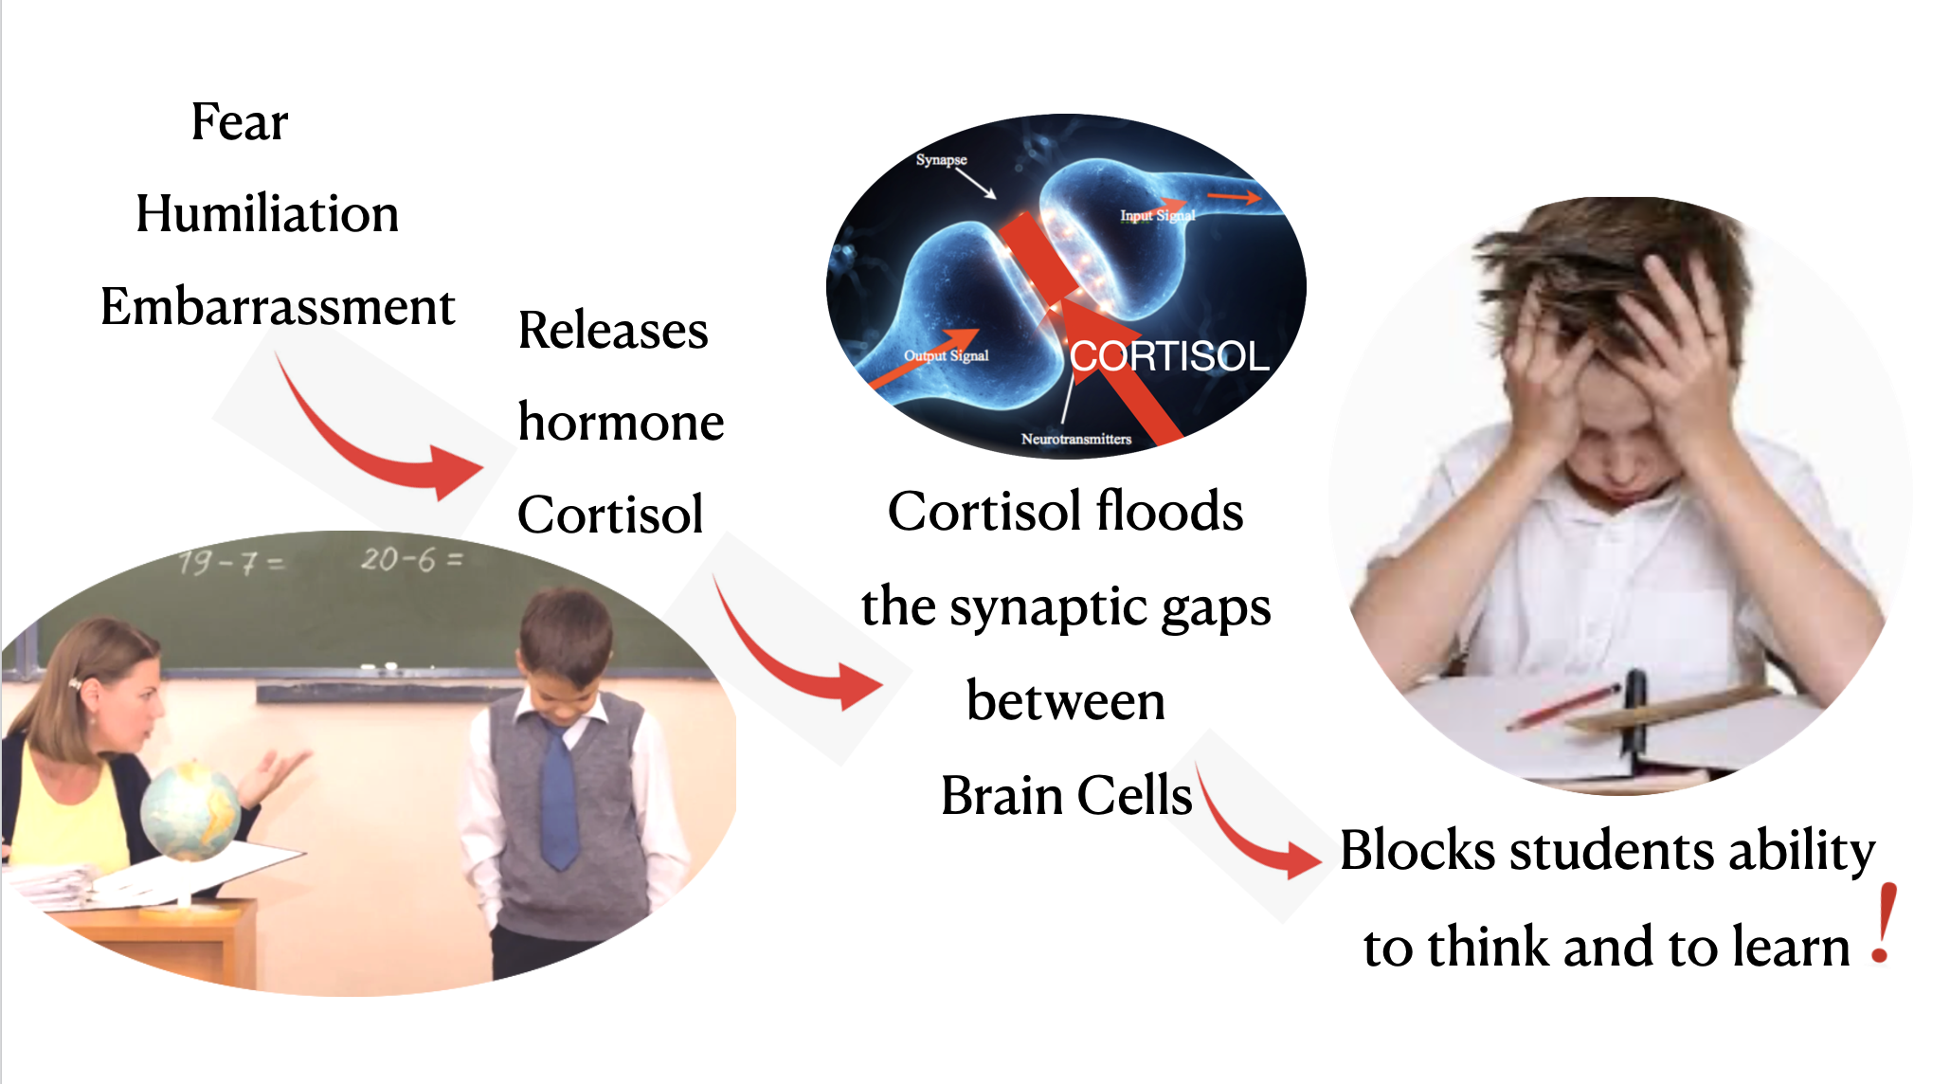

To come back to the ability of the rest of the class, those few who never seem to understand very much and gain the lowest grades are simply the most confused, while the rest of the class who linger between the best and the worst, are simply half confused.

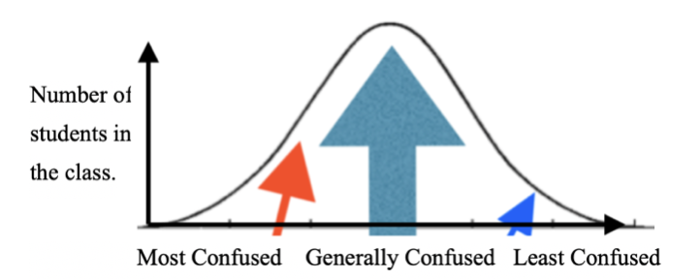

If it may be realised that the differences of apparent ability simply lie in confusion, then the teacher may take a whole different approach to teaching, for now their purpose is to clear the confusion. To do this, I always develop a comradeship with a student. I find some interest they have and I share this interest with them. Once I have taken their mind away from something which they feel they cannot understand or never learn, I go back with them to some point they earlier understood and show them how they can simply rebuild their understanding up from that point.

I explained earlier that I failed mathematics in school, well actually I was told I was not clever enough for this and sat arithmetic, which I failed. When I went back into education at 19, Mr Vanes my new math’s teacher excluded confidence. His very manner made me think anything was possible. I remember as I struggled with an equation, he whispered over my shoulder, “You can do this Roy.” He never knew the hope and inspiration he gave me. After three years, I passed advanced level mathematics with a first distinction! I know is was only because of the manner of this teacher.

When we think of sensitivity it is two fold in learning. First it is for the teacher at all levels, including university lecturers, to consider that the mind of everyone of their students is different and has acquired a different understanding of all the class is thought to have learnt. Therefore, they must not talk to themselves when they address the class, but talk in a way that develops their point through clear steps. They must be sensitive to the experience of each one of the minds of their students. Then, they are to teach their students to be sensitive when they engage information. To explain and demonstrate the difference between hearing and listening, and to give them the confidence to interrupt when they miss or misunderstand some point. They are to explain that the quality of the information they pass to their brain, determines the quality of the memory networks that are built up and how this determines the ability of their memory to relate to future information recognising the meaning and offering suggestions for it. This is why I explain that it is the mind that drives the brain. To understand why and how it does this, I explain in Brain Plasticity, the difference between radial and tangential networks and so how sensory information brings into construction the living brain.

The problem I faced in reaching the individual minds of all in my classes was confounded by the rows of desks that physically separated me from each student beyond the front row. I got over this by arranging the desks in the following manner. Sometimes, there may be too many desks in a small room, but I nearly always have found a way to make this arrangement work. From here, the teacher now has that one-to-one relationship with every student. I find that the open area is like a stage, so the teacher who acts like an instructor becomes like an actor where they juggle with the minds to keep them entertained. Never sit down. Be active and keep the minds of all the students active, questioning and challenging.

It can be very difficult to ensure that each and every student does keep up with all the learning of the lesson, so that no one becomes confused, but I found a way to over come this.

For nine years I was a lecturer in a medical university in Japan. In my first year, I had about 50 students in my classes. The second year, the number rose to about 90, but in the 3rd year I had something like 130 students in my classes. They were so crammed into the room that I knew it was impossible to reach the mind of each one by any normal means. So, I devised a way they could help each other, in the corridor or outside the building. This method I now use in “any” learning situation with participants of all ages above grade 1 up to professors and scientists.

It is very simple to ask the participants to form two rows, which I call Row A and Row B, so that they face each other. In this way, all those of Row A face a partner in Row B, and can now ask each other questions.

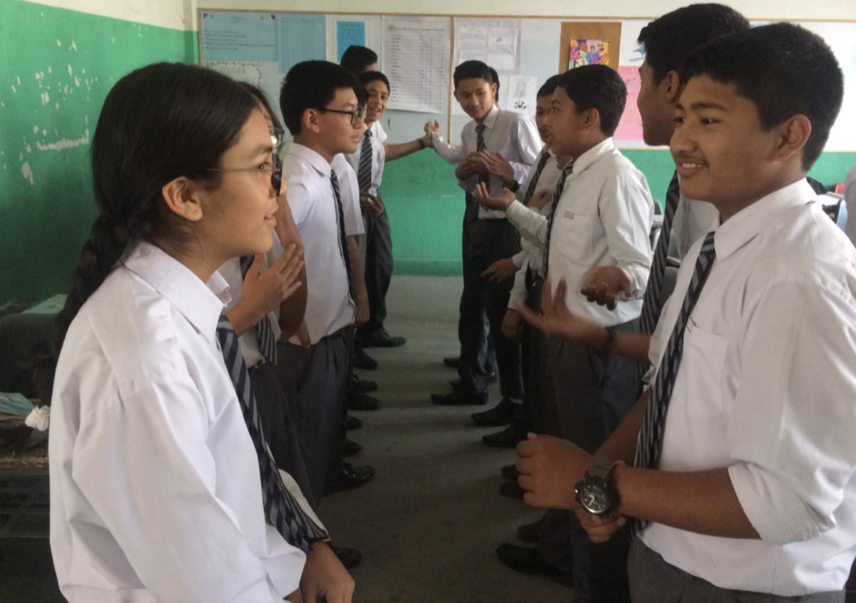

I found that if you leave them with the same partner for too long, their questions and dialogue dry up. So, I would give some signal, a clap of hands, for the person at the end of Row B to move to the other end of their row, and cause each student to move one space up the row. In this way, each student in Row A now has a new partner in Row B. I would continue this shuffling, when I feel there is a need for a new partner. I have found that “all” really enjoy this, and would strongly suggest you please do try it.

In the beginning of the lesson, the students will normally walk in and sit down waiting for you to “turn them on.” Few would have paused before entering the room to reflect on the previous lesson and what they did not understand, making a short list of questions for you. However, if you use this row method at the very beginning of your lesson, just for a few moments, so that students can remind each other of what they did in the previous class or ask each other something they did not understand of a previous time, you will help them to get their minds ready and open for the beginning of this new lesson with you.

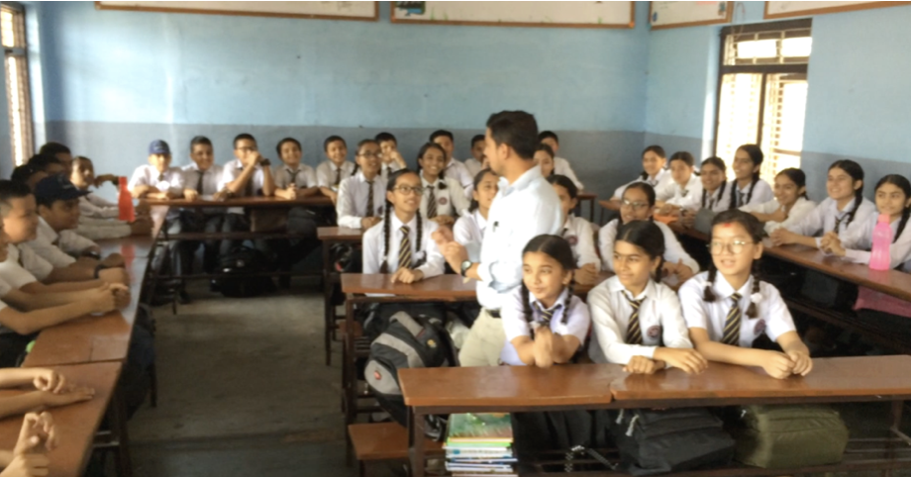

During the lesson, if you may feel the students are losing track, then ask them to stand up and form these two rows, to question each other about what they have learnt so far in this lesson.

At the end of the lesson, I use this row method to give each a chance to question their partner on something they did not understand, or I hold a quiz, which is always great fun but of immense learning.

For the quiz, I divide the class into groups and keep a score of how well each group can answer questions about the lesson. You will find how they love the competition. This really stimulates them to remember parts of the lesson, but most importantly it gives everyone a second chance to see the meaning of the information from a different perspective so they may understand it better. I hope you enjoyed this article and that it may help you in some way as you move to help the learning, grades and lives of your students.

You hold the future of humanity in your hands. Good Luck

Please check the Pilgrims in Segovia Teacher Training courses 2025 at Pilgrims website.

Please check the Pilgrims f2f courses at Pilgrims website.

