Letter 1

Letter 2
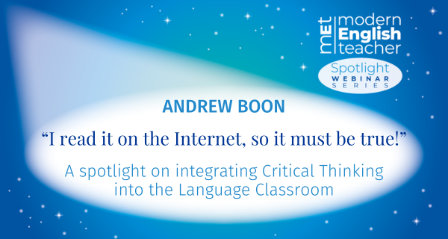

Coming soon from Modern English Teacher

Webinar – “I read it on the Internet, so it must be true!”
A spotlight on integrating Critical Thinking into the Language Classroom

The MET Spotlight Series shines a light on key topics we’ve explored in Modern English Teacher. In these free webinars, our fantastic MET contributors will explore their chosen topic in more detail, and share their expertise alongside practical tips, useful ideas and more.

In the second webinar of the series, Andrew Boon will explore why critical thinking is so essential and examine the vital role it plays in language education. He will suggest how you can incorporate it into your curriculum and demonstrate useful classroom activities.

Sign up for free

Letter 3
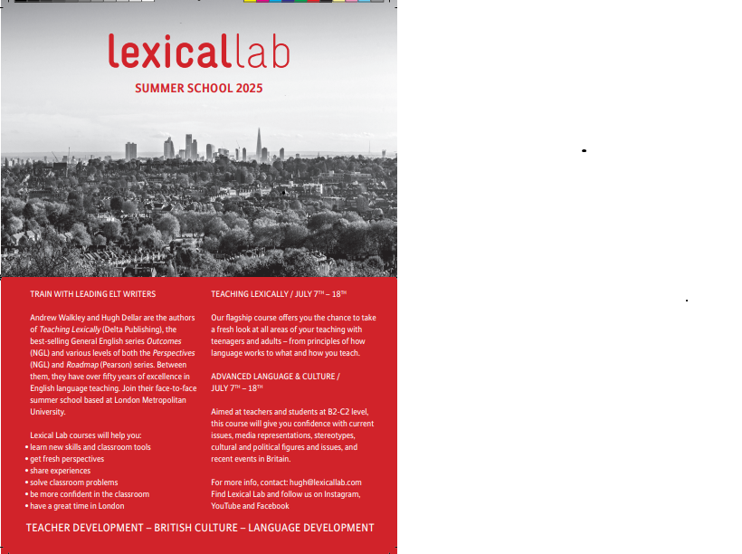
Letter 4

Letter 5
CANELETTO

I sometimes pretend she is still with me at restaurants and other places ask her questions in my head without reply. Just to keep me company as she used to say. So I am not alone when of course I am. I look into the windows where she would be and see her now and again but mostly I see that Caneletto faced ugly man who stares back at me. Of course we all have to go to a place we can never come back from but only when it is all done and all the misdeeds are paid for.

Marc Carver

Letter 6


Welcome to your Pavilion ELT newsletter

In this edition, Gerhard Erasmus explores why the customer isn't always right, Rubens Heredia shares five tips for teaching pronunciation more effectively, and you can sign up for our upcoming free webinar with MET blogger Anna Hasper!



New from Modern English Teacher

Blog – The customer isn’t always right

Is the customer always right? And what does this mean for schools and managers? In this blog, Gerhard Erasmus explores why the customer actually isn’t always right, and instead puts the focus on being a student-centred organisation.

Read now



New from Pavilion ELT

Vlog – 5 tips to teach pronunciation more effectively

Improving their pronunciation is one of the most common objectives of students. However, teachers are often unsure about how to teach and correct pronunciation. In his latest vlog, Rubens Heredia shares 5 tips to help your students pronounce sounds and words more clearly.

Watch now

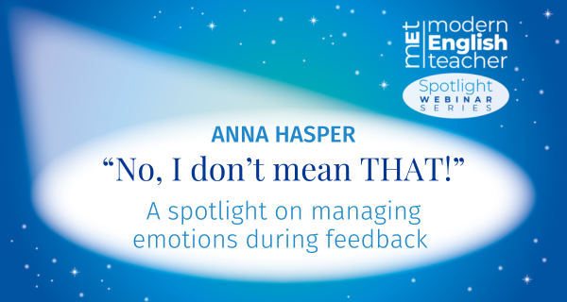

Coming soon from Modern English Teacher

Webinar – “No, I don’t mean THAT!”
A spotlight on managing emotions during feedback

The MET Spotlight Series shines a light on key topics we’ve explored in Modern English Teacher. In these free webinars, our fantastic MET contributors will explore their chosen topic in more detail, and share their expertise alongside practical tips, useful ideas and more.

In the first webinar of the series, Anna Hasper will examine the concept of feedback in a classroom setting, and consider how we can proactively manage learners’ emotions in order to safeguard the emotional well-being of both those receiving and providing feedback.

Sign up for free

Letter 7

Dear Hania

I have just completed a very short and simple book. It is only about 80 pages, but it gets to the root of why children struggle in their learning.

I wonder if you would be interested to translate into your local language and get it published locally to help educationalists in Spain or other countries?

Roy Anderson
roy@andersenroy.com



