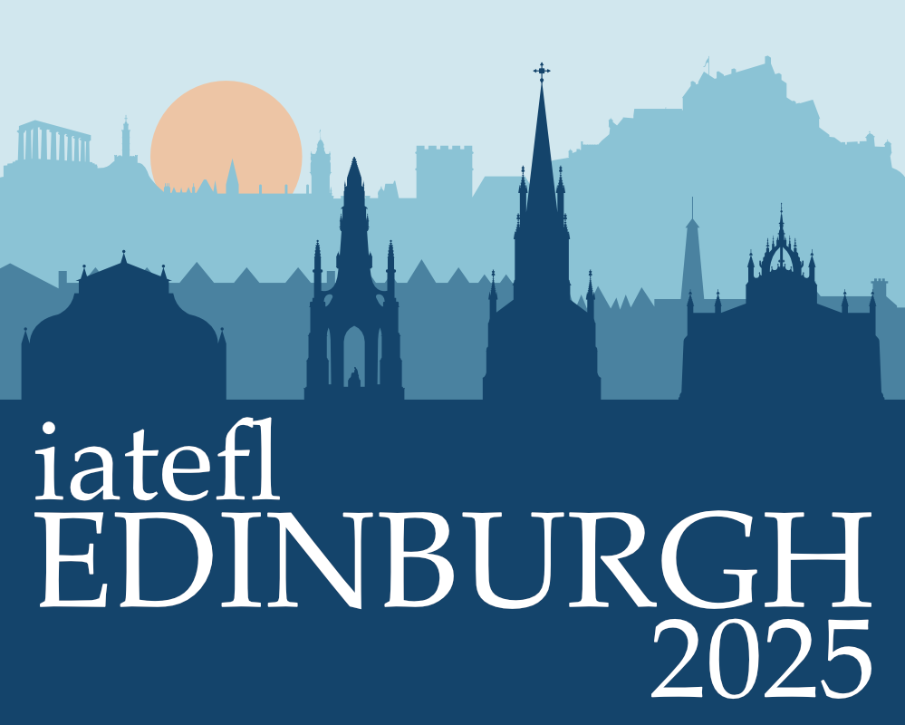

Join us for the 2025 IATEFL International Conference and Exhibition in the beautiful capital city of Scotland, Edinburgh.
The conference will be held from Tuesday 8 April to Friday 11 April 2025, with Pre-Conference Events being held on Monday 7 April at the Edinburgh International Conference Centre.
The IATEFL Conference is a 4 day celebration of the English language teaching profession with over 500 academic sessions, an exhibition of all that's new in the world of English language teaching, and a busy social programme of fun evening events and opportunities to network and be part of the global community of ELT professionals. The academic programme includes headline plenaries, presentations, workshops, panel discussions, lightening talks and poster presentations.

Who attends the IATEFL Conference?
If you work in the English language teaching profession then the IATEFL Conference is for you! The conference is attended by teachers, trainers, managers, freelancers, lecturers, materials writers, publishers, examiners, trainees, researchers, ministries of education, universities, teacher training colleges, national teaching associations and many more. The 2024 conference saw nearly several thousand people from over 100 countries attend an amazing week in Brighton.
The conference is an opportunity to develop your skills and knowledge, share your challenges, build your professional network and be part of a global community of professionals. Come and join us!


