The Thriving Freelancer: Annual Review of My Business 2024

Rachael Roberts, UK



Rachel Roberts works with freelance language teaching professionals to fully monetise their skills and experience so they can transform their lives and those of their clients, through her deep dive programme, Designed to Flourish https://earnlearnthriveinelt.com/designed-to-flourish-group-programme/

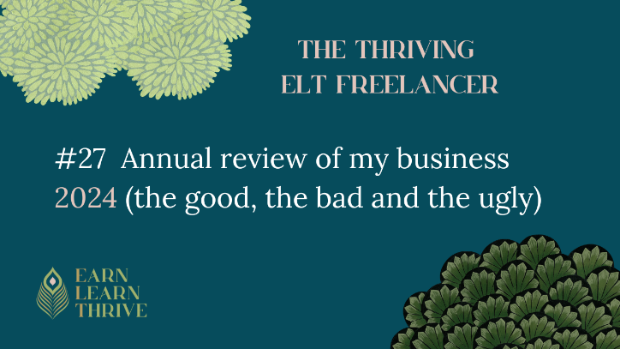
Editorial
The text originally appeared as The Thriving Freelancer:
https://www.linkedin.com/pulse/annual-review-my-business-2024-rachael-roberts-zm22e/

December 16, 2024
Unbelievably this marks the end of my fifth full year of business (I actually started partway through 2019), and so this will be my fifth annual review and writing of a blog post looking back at the last year. I’ve learnt SO much over the last five years, and I see this as an opportunity to share some of that learning, and hopefully inspire and motivate you, as well as letting you learn from my mistakes if you want to!
What went well in 2024
My word for 2024 was ‘Flourish’, with the aim of not only having my business continue to grow and flourish, but also making time for myself to do some more flourishing- more free time, self-care, trips and time with friends and family.
Let’s start with that. I think there’s still a way to go to the ideal work-life balance (it may be something of a fantasy!) but I have seen some improvements this year. I re-joined the gym, and have managed a monthly spa day at least 5-6 times, and a few long weekends away, especially towards the end of the year since I closed my membership, The Confident Freelancer Collective.
Which is one of the big pieces of news of this year, and not something that I was remotely planning when I wrote my annual review last year. But early last year I was at an AwayDay with my wonderful Mastermind group (not one I run, but one I’m in), and the realization hit me in the face that, much as I genuinely loved the membership, It just took up way too much time and headspace, and was getting in the way of doing more impactful things.
So I announced the closure in March, and it officially stopped six months later. And then I had time for something new and exciting, which I’ll tell you about in a minute….
But first to say that I decided to keep the Facebook group open, and to continue working with the community in a much more light-touch way for free, as a service to all my clients. So, if you have ever been a member of the Collective, or have worked with me on a group programme or 1-2-1, or bought a product from Earn Learn Thrive, you’re very welcome to join us.
And the new thing? I haven’t previously announced this publicly, so there isn't a sales page, but I have a new super high-touch mentoring/mastermind group starting in January, called Project Bloom. This is for people who already have a lot of things in place in their business, and it’s kind of working, but they know it could be doing so much better, particularly financially. I have a cohort of six ready to go, but could take two more, so if that sounds like you, just get in touch, and I can send you a PDF with details.
So, what else went well? Financially I’ve turned over a similar amount to last year, but made more profit, which is great going considering I’ve now streamlined (my 2023 word of the year) down from 2 memberships and a group programme and 1-2-1, to just one group programme (via a little detour I’ll tell you about below).
I’m really proud of myself for keeping going on my YouTube channel, adding regular content, and building the subscribers to 2350, and hitting 3000 watch hours. I’ve also steadily grown on LinkedIn, which was a goal from last year.
I’ve also finally cracked a social media posting strategy which works for me, and has saved me tons of time, while being really effective (this is one of the things we’re going to explore on Project Bloom BTW)
And, another Holy Grail, I’ve started earning proper money through passive income products (not just a few hundred a year), and that’s something I’m looking to develop further in 2025.
What have the challenges been?
I think the biggest (and somewhat painful) lesson I finally (I hope!) learnt this year was the importance of maintaining focus, and not trying to be all things to all people. Like many entrepreneurs I work with, I have a lot of ideas, and I enjoy trying new things. Which is great, but also a problem if it takes you off track.
This year I decided to create a course specifically for publishing related freelancers (largely writers and editors). I’ve worked with many of these on my group programme, but in recent years have only really focused on those who want to develop a separate B2C business, such as Jennifer Murray, who has developed a successful copywriting business, or Kath Bilsborough, who, together with her business partner, John Hughes, has set up an amazing group programme for anyone wanting to develop their materials writing skills.
So, I was aware that there are a lot of publishing freelancers out there, who want to continue working for publishers, but who could benefit a lot from getting better at being more visible, personal branding, getting known for something specific, and on the practical side, understanding their contracts better, and learning how to negotiate more effectively.
I therefore created a course around all these points, called We Mean Business: getting visible, pricing, negotiating and getting paid.
And I ran a beta live version of this in May, had 11 participants and, really really positive feedback. I planned to run it again in November, but this time, total crickets. I did not sell a single place. It’s a bit embarrassing to come clean about this, but, hey, I should be transparent about ALL the aspects of running a business, right?
Why do I think this happened?
I think there were quite a few contributing factors. The first group was largely made up of people who had worked with me before in different ways, so there was probably an element of what Gemma Gilbert, my first business mentor, calls ‘superfan false validation’- when people who already know like and trust you go for something and that makes you think everyone will (and then they don’t).
I also changed the format so there was more recorded input with group coaching alongside- it’s hard to know if that had an impact. But I did do some follow up research with those who didn’t go for it, and the main message I got was that they couldn’t really see the return on investment.
Now, I know for a fact that people who did the original programme have made thousands more as a result of things they learnt, but just because I can see the benefits, does not mean everyone else automatically can.
And that’s where my biggest lesson from this comes in. My clients are people who either already have or who want to set up a B2C business (business to consumer, or working with individuals). And that’s who all my marketing is aimed towards. So offering a programme aimed at people who only work and only want to work B2B (with publishers), however much I might think there’s a need for it, would mean a whole load of different marketing to make the benefits clear. I didn’t do this. I just sent a few emails, and it was nowhere near enough for them to buy into the idea.
But, while I could have done a lot more, that would have then confused my usual audience, and created problems there. (And in fact creating this new course already impacted my main business because I was so busy making all the videos etc that I didn’t market my group programme properly in September and October and got a much smaller cohort than usual for November as a result)
So, THIS is why you really can’t market to two different niches (as I am always telling my clients, ahem…). BTW if you’re a publishing freelancer, thinking I could really do with this course, it’s still available on my website under the short courses tab.
What am I planning or working towards in 2025?
I have five main goals for 2025. Firstly, I want to finally start using ads (this has been on my list forever, because there’s quite a steep learning curve involved) to amplify what is already working in my social media, and allow me to grow my audience and mailing list further.
I’d also like to build on this year, and make passive income sales a bigger part of my business. As part of this, I recently soft-launched my self study course, The Confident Freelancer Roadmap. This was previously only available to my membership, but is now a stand alone product. If you’re not yet ready to work with me directly, this is the next best thing, and amazing value for a wealth of information and support.
I’m going to continue to develop and refine my flagship course, Designed to Flourish, as I believe this is super important. I have some time set aside early January to create a couple of new short videos on the 7 stages of a launch and what exactly to post, and on ideas for asynchronous elements within a programme. I have just one place left now for an end of January start – join us?
And, of course, I’ll be working on my exciting new higher-level offer, Project Bloom.
So, what’s the fifth goal? NO OTHER BIG PROJECTS. My word of the year for 2025 is going to be ‘Optimize’ and I’m going to be all about optimizing what I already have in place (which is a big focus for Project Bloom as well).
Final words
Recently I’ve started to ask myself whether all the being busy and full of new ideas and things to do could actually be a subtle way of hiding. A way of avoiding really putting myself out there and saying this is what I do, this is who I help, and I’m damn good at that, want in?
So, I’ll put it out there straight.
If you’re the kind of person who is really motivated to run your own business, and make good money while making a positive impact on the world, I’m great at working with you to identify just where the opportunities really lie, and exactly what steps you need to take to get where you want to be.
On my programme, Designed to Flourish, I work with a lot of English language teachers, but also teachers of other languages, teacher trainers, self-publishers, and anyone who has (or wants to have) a service based business within the language teaching world.
I believe that the perfect business is different for everyone, so I don’t teach a ‘method’, rather I help you work out the perfect ingredients for your particular ‘cake’. However, the underlying principles are the same for everyone, and so you’ll be able to apply them going forward to continue growing and developing your business (or even to start a new one down the line). So working with me is a fantastic investment in your future.
I’m an amazing motivator and cheerleader, and I only work with people I believe in, so if you’re up for it too, together we’ll move mountains.

Please check the Pilgrims in Segovia Teacher Training courses 2025 at Pilgrims website.

Please check the Pilgrims f2f courses at Pilgrims website.

