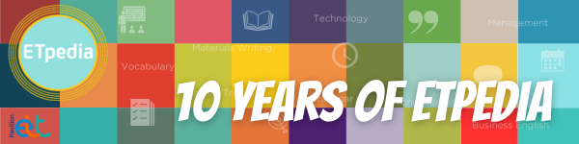
2024 marked the 10 year anniversary of the ETpedia series. The series offers English language teachers across the world thousands of practical teaching tips, ideas and activities. Each book in the series is divided into units of 10 tips on a particular theme or topic, perfect for dipping into whenever needed.

We are celebrating ETpedia Young Learners and ETpedia Teenagers. Below, you can explore a sample from both books.

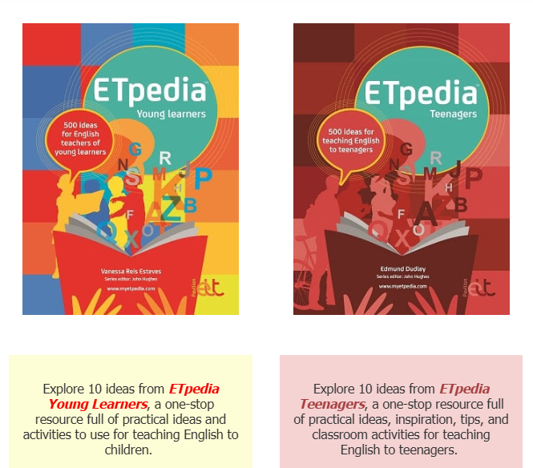

More about the series here.

You can download the two collections of 10 ideas below.

