Reflecting Sustainability in ELT: A Materials Writer’s Perspective

John Hughes, UK

John Hughes is an author, presenter and trainer. As well as writing course materials he also runs training courses in writing at www.writingeltmaterials.com . He would like to give a special thanks to Daniel Barber for his input on this article.

In this article, the author John Hughes reviews a new third edition of a coursebook series ‘Life’ and reflects on the positioning of sustainability within the material.

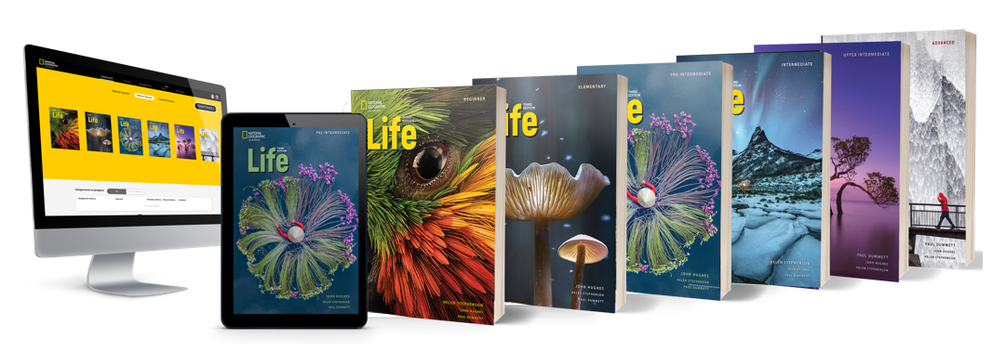

Evolution

It’s now fifteen years ago that I started writing the course book ‘Life’ (National Geographic Learning) with my co-authors Paul Dummett and Helen Stephenson. The first edition of the six-level series came out in 2012 and looked strikingly different to other course books at that time. We had access to high impact National Geographic photography and video as well as texts which had appeared in the famously yellow-bordered magazine. Six years later there was a second edition of ‘Life’ and now the third edition is being launched for 2025.

Reflect developments

By the time you reach the third edition of a series, you don’t necessarily need or want to change too many things. After all, a third edition means you have built up a loyal following of teachers and “if it isn’t broken, then don’t fix it.” However, a new edition is an opportunity to update topics, tweak exercises, and – perhaps most importantly – reflect developments in the world, and especially in the world of education and ELT.

Awareness

In the last fifteen years, awareness of sustainability has been one of those major developments. Perhaps this is best illustrated by the fact that in 2012 (the same year that ‘Life’ first came out) the United Nations held a conference in Rio de Janeiro where it began work on establishing “a set of universal goals” that would “meet the urgent environmental, political and economic challenges” facing the world. Three years later in 2015, its 17 ‘Sustainable Development Goals’ or SDGs were formalised. Now the influence of the SDGs has become widespread with some ministries of education integrating them into school curriculums.

Urgency

When it comes to sustainability, it would be wrong to suggest that the ‘Life’ series has only just discovered sustainability. The association with National Geographic means that we have always drawn heavily on images showing environmental change or texts about the impact of climate. What’s different now with the third edition is that sustainability is more clearly defined that it was 15 years ago and that we are reflecting a growing sense of urgency among students and teachers that our world needs to change. From the perspective of a materials writer, this means you can be more overt about including sustainability as a lesson topic and much clearer about the perspective of your materials.

Writing materials which integrate sustainability brings opportunities but also some challenges. Let’s consider some of these.

Integration

The 17 SDGs provide a range of rich topics to explore and many tie in with the typical units you might find in any course book. For example, SDG 3 is “Good health and well-being”, so it sits comfortably in a series of lessons on food and fitness. Likewise, SDG 4 on ‘Quality Education” seamlessly works alongside a lesson on learning and schools. On the other hand, your approach to handling other SDGs such as ‘No poverty’ (SDG 1) and ‘Reduced inequalities’ (SDG 10) needs sensitive handling and consideration. Yet, with such growing awareness of the need to tackle these problems, materials writers need to encourage critical thought around such related issues as third world debt and human poverty.

There’s also the danger that using a single SDG as the main topic of a unit is that you make ‘sustainability’ somehow separate from other topics. So when creating materials, it’s worth integrating sustainability so it becomes a normalised part of what students read about. For example, one article I adapted for a unit on sport considered how global sporting events like the World Cup and the Olympic Games are being affected by climate change and questions whether such events can ever be considered ‘sustainable’.

Level

Language level is also a challenge for the materials writer because many areas of sustainability come with a set of specialist terminology or high-level words in terms of CEFR. I ran a set of climate-change-words below through Text Inspector and the majority were at B2 level and above. They came from a dictionary of ‘Climate’ words.

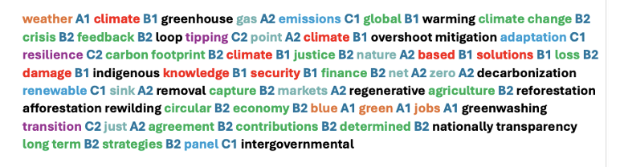

So in order to make sure sustainability topics appear in lower as well as higher level books, you need to find lower-level synonyms or explain concepts in more accessible ways.

Project-based

Of course, students not only need the language to talk about sustainability, but they also want the language to do it. By that I mean, sustainability in our lessons lends itself to project-based learning and encouraging students to actively look for sustainable solutions. One of my favourite pieces of material from Life Third Edition is a video showing Octavio Aburto – an underwater conservationist – working on projects to grow mangroves. In doing so he answers the question, ‘Do humans need water or does water need humans?’ Students watch the video and then they are given a research project to study water sources in their own region. The project ends with a presentation. This type of task encourages the use of language for a range of skills such as teamwork, problem-solving, and communication.

Influence

On a final note, it would be wrong to suggest that integrating sustainability in your ELT lessons and materials will necessarily change all the sustainability concerns facing the world. But certainly it adds to the growing awareness of sustainability, influences the wider world of education, and gives language to a younger generation of learners who expect and deserve change.

You can find some more information here.

References

Dummett, Hughes & Stephenson (2025) Life Third Edition National Geographic Learning

Information on the SDGs: https://sdgs.un.org/goals

The analysis of the words in the Climate dictionary come from https://www.undp.org/publications/climate-dictionary. It first appeared in another article available here: Hughes J (2024) Writing sustainability int your classroom materials, IATEFL Voices 300

Two recent National Geographic Learning post’s on sustainability in ELT: https://infocus.eltngl.com/2024/10/15/what-why-and-how-to-teach-sustainability-in-elt/
https://infocus.eltngl.com/2024/03/20/confronting-climate-change-education-in-elt/

Please check the Pilgrims in Segovia Teacher Training courses 2025 at Pilgrims website.

Please check the Pilgrims f2f courses at Pilgrims website.

