HUPE; A Report from 32nd Annual International HUPE Conference November 15-17, 2024 Valamar Poreć, Croatia

Marta Bujakowska, Pilgrims and IATEFL Poland

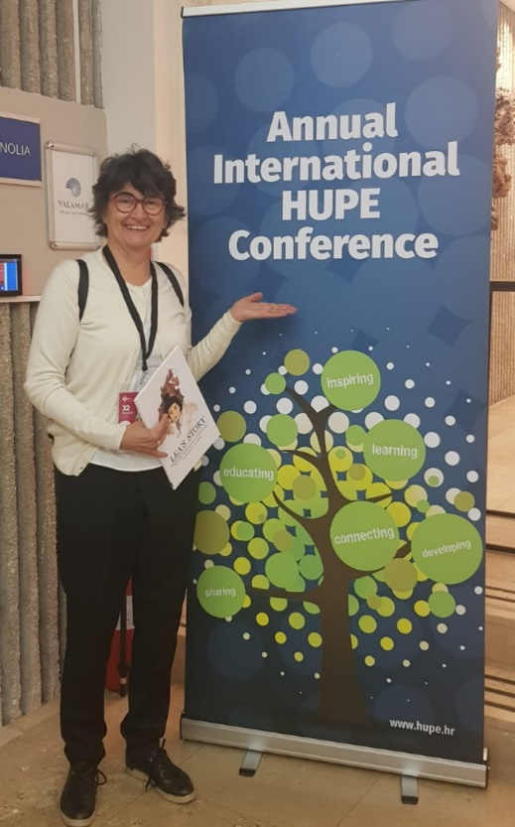
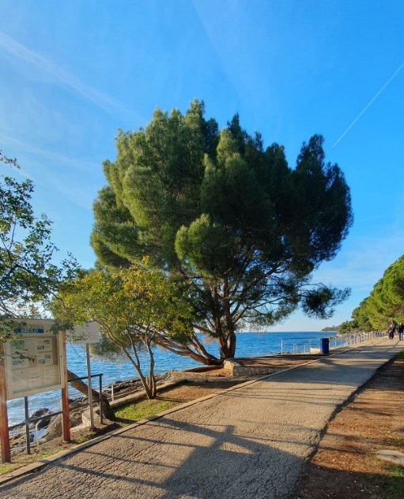

The HUPE (Croatian Association of Teachers of English) Conference in Poreč from November 15-17, 2024, was a vibrant and enriching experience that brought together educators from across the region and beyond. Held in the picturesque setting of Poreč, the event blended high-quality academic input with opportunities for networking in a stunning coastal setting.

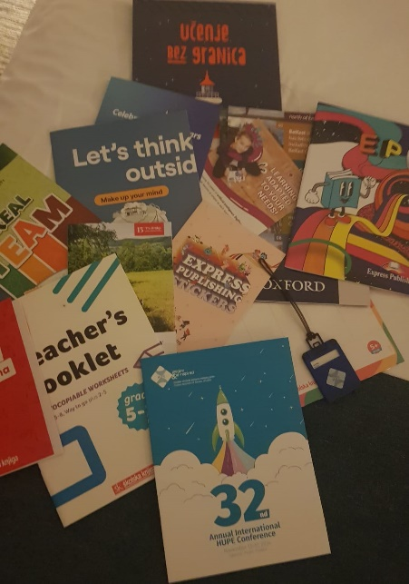
Exploring the treasure trove of useful resources
from the conference bag!

A highlight of the conference was the plenary by Catherine Toomley from the British Council, Italy. She seamlessly blended theory and practice, showcasing how CEFR descriptors can be integrated with ChatGPT to design enjoyable and effective activities for students. This innovative approach demonstrated the exciting possibilities AI brings to education.
Equally thought-provoking was Janos Ujlaki’s talk, Embracing the Future: AI, Innovation, and the Resilient Teacher. His slides were exceptional, visually encapsulating the transformative role of AI in teaching. While his delivery style felt a bit modest, his insights resonated deeply, offering a balanced view of technology's challenges and opportunities.
Finally, Marjorie Rosenberg delivered her signature practical brilliance with tips on making lessons unforgettable. Her relatable advice and energetic presence were a masterclass in impactful teaching, cementing her status as a crowd favourite.
I had the opportunity to present my talk, Redressing the Balance: Tyranny of Toxic Positivity vs. Authentic Optimism. It went well, and I was delighted to hear that attendees felt it met their expectations and addressed their practical needs as teachers. In a world of relentless “good vibes only,” it was heartening to discuss the importance of embracing vulnerability and fostering authentic optimism in schools. The session sparked thoughtful discussions and connected with teachers' shared experiences, making it a fulfilling moment for me.

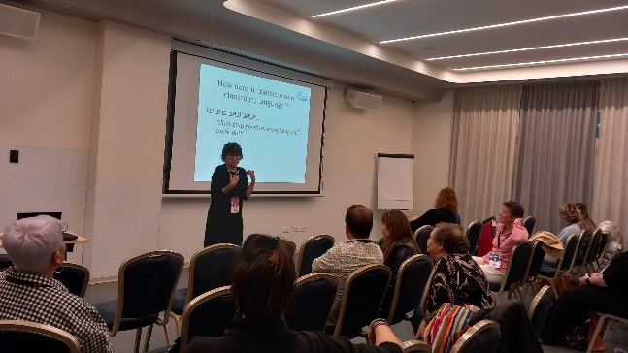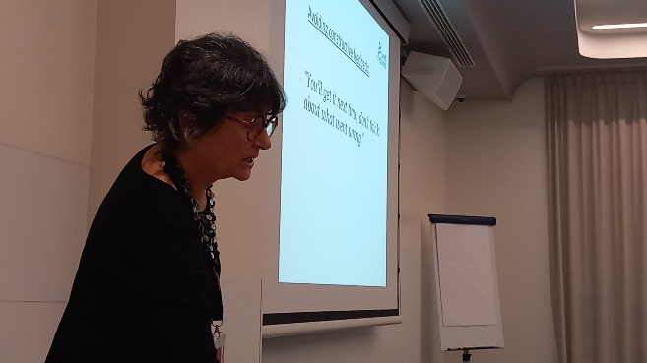

For me personally, the most poignant and thought-provoking presentation was by Tvrtko Pater and Lina Jurević from the U.S. Embassy in Croatia. Their session, Teaching Tolerance: Holocaust Education in the EL Classroom, showcased a visually stunning and deeply moving picture novel LEA’S STORY designed to teach tolerance. Through the lens of history and storytelling, they highlighted the importance of integrating meaningful content into language lessons to foster empathy and understanding among students.
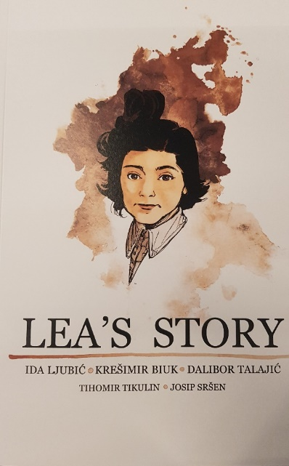
This presentation was not just an exploration of innovative teaching tools but a reminder of the educator's role in shaping socially responsible global citizens. The novel's delicate handling of such a profound topic underscored how English language education can extend far beyond grammar and vocabulary, serving as a medium for significant societal impact.
Their work left a lasting impression on me, emphasizing that teaching tolerance and history through creative approaches is not only possible but necessary in today’s world. A heartfelt thanks to Tvrtko and Lina for such a powerful and inspiring session.
The location in Poreč added a special touch, with attendees enjoying the beautiful coastal views and taking advantage of informal networking opportunities during meals and coffee breaks. The organizers ensured smooth logistics and a welcoming atmosphere, reflecting HUPE’s commitment to excellence in education.
Pilgrims has always held a special place in my heart as one of my favourite workplaces, and I feel immensely proud to be part of such an inspiring and dynamic community. The unique team spirit, innovation and work ethos at Pilgrims never fail to motivate me.
It was heartening to see that many HUPE Conference participants were already familiar with Pilgrims and their renowned courses. For those who weren’t, I shared the exciting news that Pilgrims is back and actively running courses again. I also invited everyone to join our newly relaunched Pilgrims Cafés, held online—a wonderful platform for exchanging ideas and building connections in a warm, collaborative environment.
I look forward to welcoming some of the HUPE participants at the next Pilgrims Café, where we can continue to learn, share, and grow together.
The HUPE Conference 2024 in Poreč was a weekend to remember—a perfect combination of innovation, reflection, and team spirit. Bravo to HUPE for hosting such an impactful gathering!
This conference wasn’t just about professional growth—it was about community. It was a weekend of shared ideas, inspiring presentations, and the chance to recharge among like-minded colleagues passionate about teaching English.
One word to describe the Conference is: COLOURFUL!
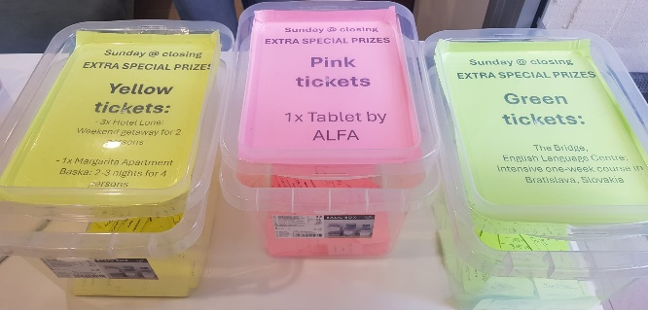
Bright and cheerful raffle tickets ready for the
exciting draw.
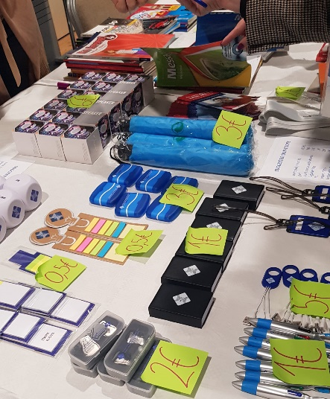
Charming HUPE-branded knick-knacks available for sale—
perfect keepsakes to remember the conference.

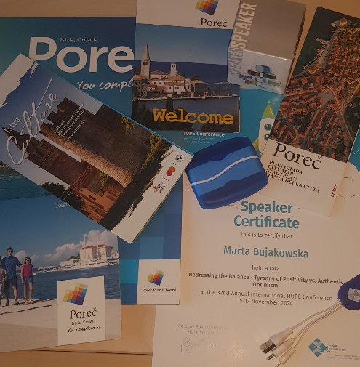
Each speaker received such an array of goodies
in their conference bag!

Please check the Pilgrims in Segovia Teacher Training courses 2025 at Pilgrims website.

Please check the Pilgrims f2f courses at Pilgrims website.

