TESOL France 15th-17th November, Paris 2024

Hania Kryszewska, Pilgrims

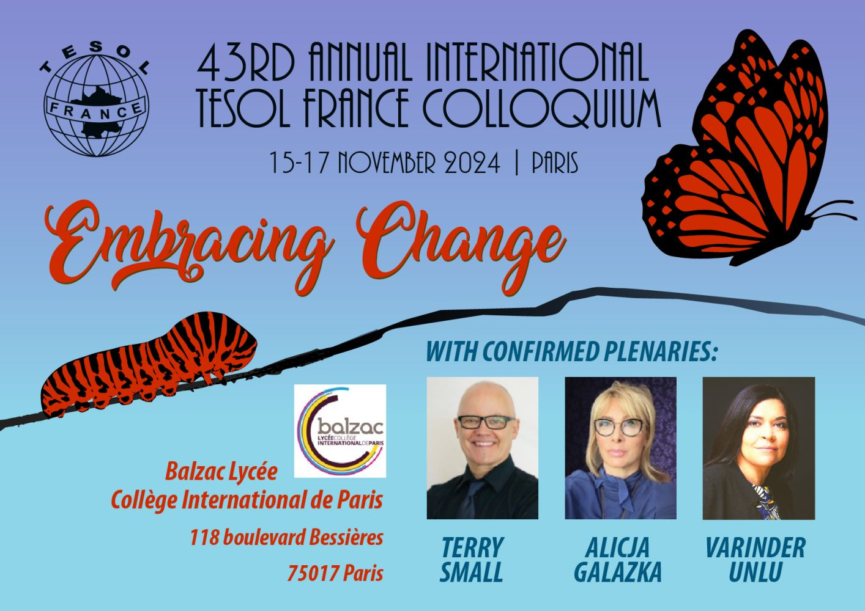

On the way to the hotel
Colloquium 2024 is short for what the organisers called the 43rd Annual International TESOL France Colloquium. The theme was Embracing Change and the venue for the conference was Cité Scolaire Internationale Honoré-de-Balzac, 118 Bd Bessières, 75017 Paris – the biggest secondary school in the Paris area. I think it is a great idea as it puts the learners in the center and I suppose saves money or puts the conference goers’ money in the right pocket. Big hotels and Conference venues but a big school or university are a great idea too. Unfortunately, as it is with schools, the assembly hall where the conference plenaries, exhibitions and socialising took place was poorly heated, so many of us got back home with colds.
But the atmosphere created by the organisers led by Deb, Vicky, Dianne, Alexandra, Yvonne and Sonyth was so warm, nothing was a problem, and they dealt with any crisis in an efficient and light-hearted way.

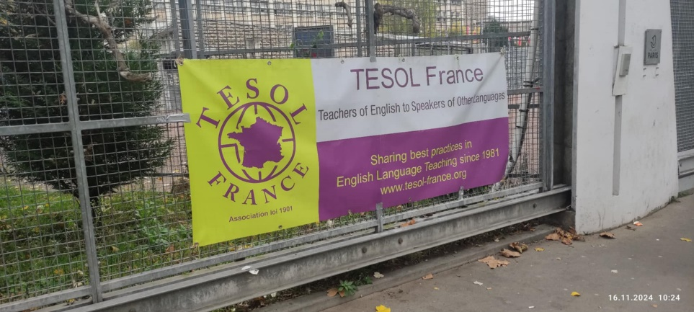
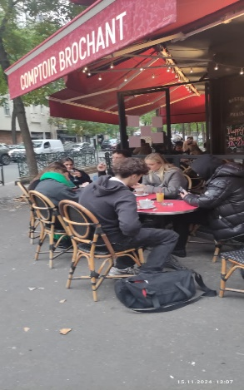
The school entrance and premises guarded like a fortress Students in a cafe

The plenaries were delivered by three inspiring speakers:
Terry Small who believes "Success is a skill anyone can learn." And "Anyone can learn how to learn easier, better, faster, and that learning to learn is the most important skill a person can acquire." focused on the brain and how we can learn better and faster.
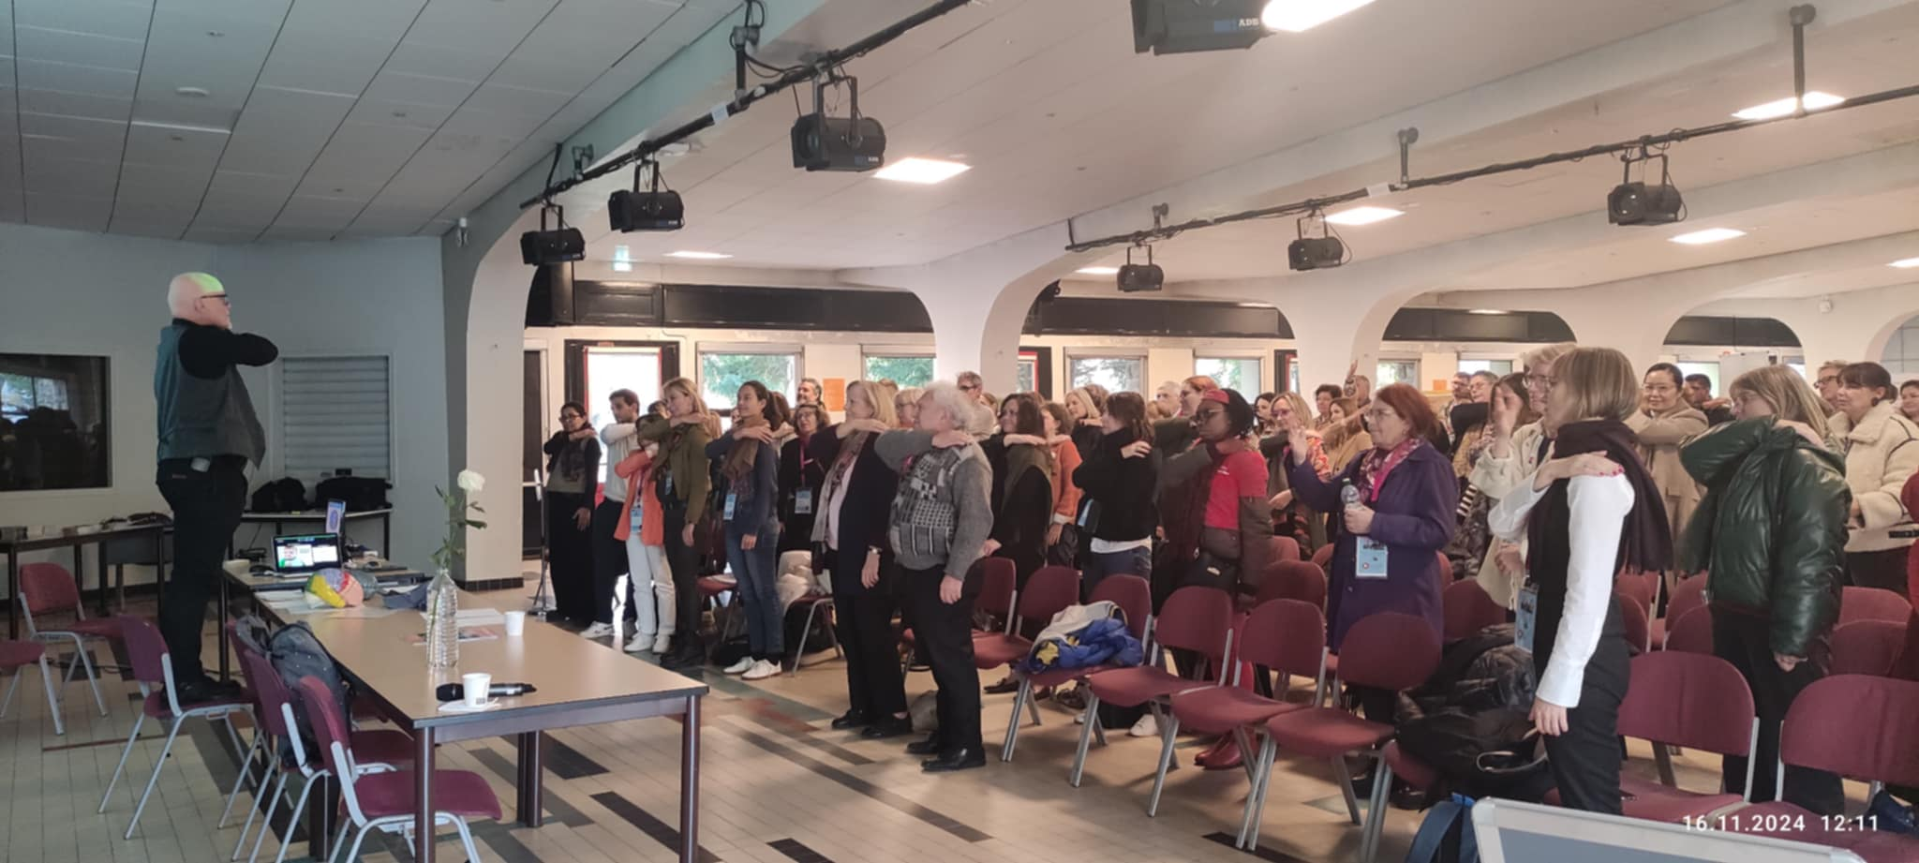
Terry Small in Action
Alicja Gałązka expert in blending cognitive and positive psychology with process drama for language acquisition and championing mental health and well-being initiatives for teachers and students internationally, focused on mental health crisis, enhancing student resilience and wellbeing
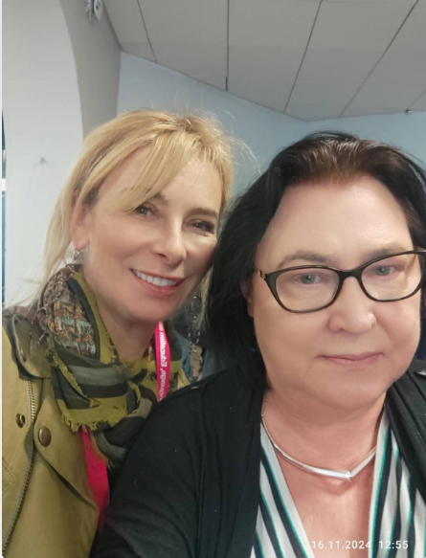 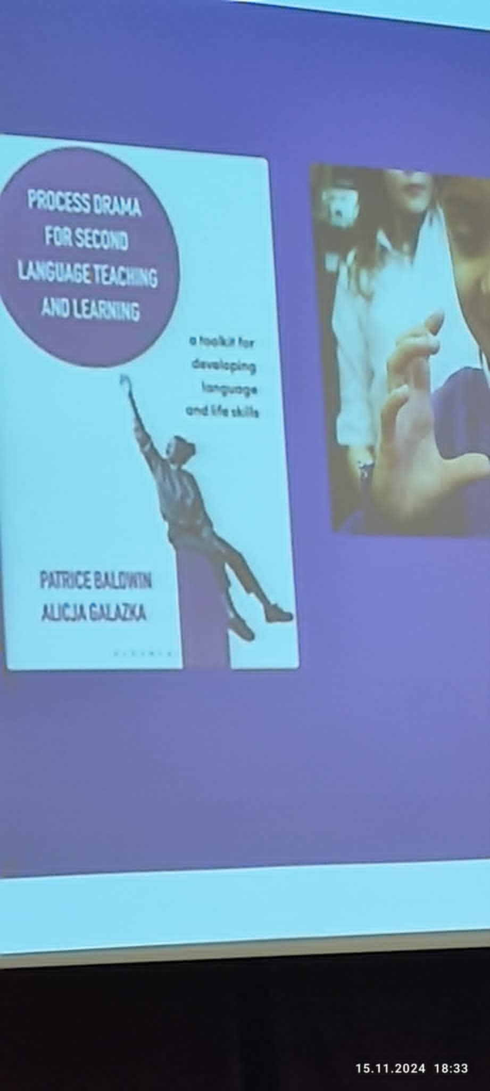
Alicja Gałązka with Hania Kryszewska
Varinder Unlu an experienced teacher and teacher trainer, looked at the changing landscape of education and teacher identity in the emerging new reality, and need to integrate new methodologies, transformative potential and develop resilient professional potential.
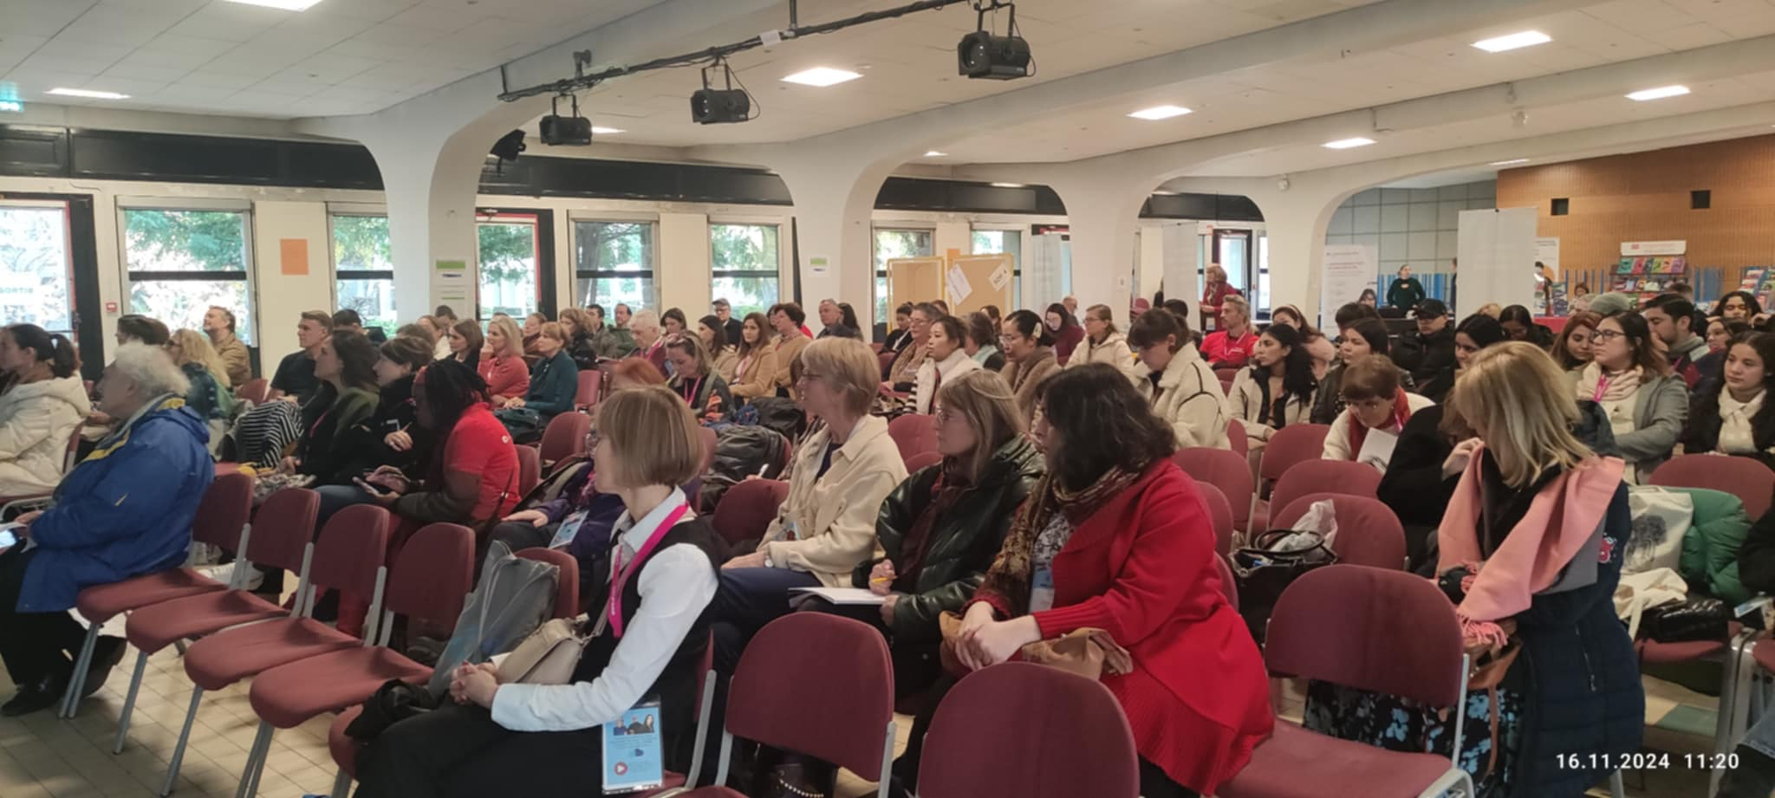
The plenary

The exhibition was relatively small, but very relevant to the French scene and you could see there was a real dialogue not just marketing at the stands.
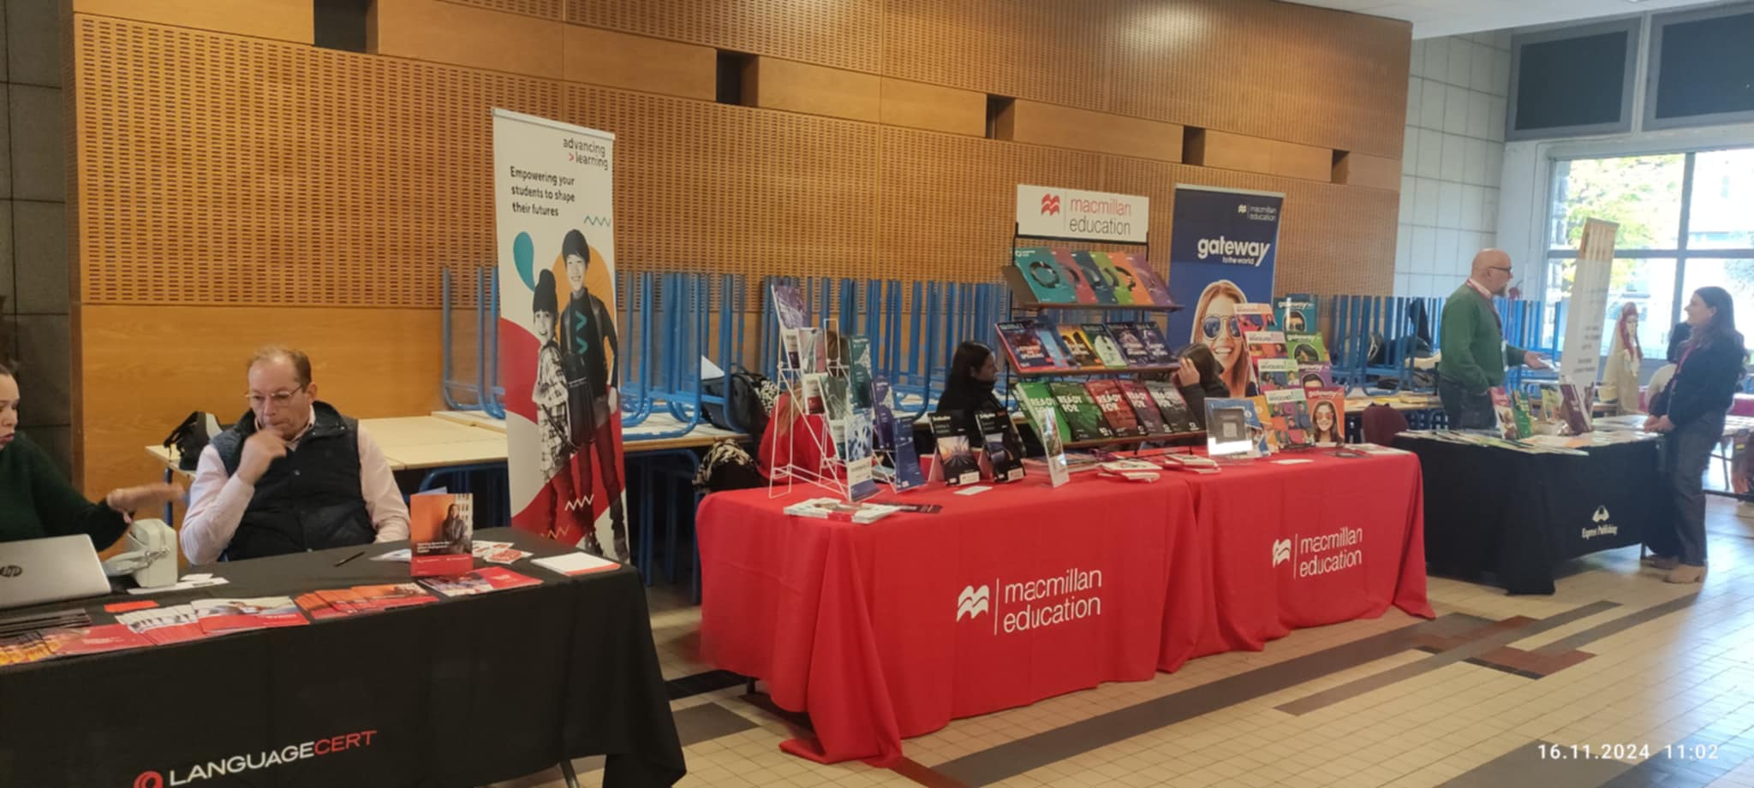
The exhibition area
There were the usual freebies like pens and pen drives, but also eco freebies like seeds of change to be sown in your garden (the disc)
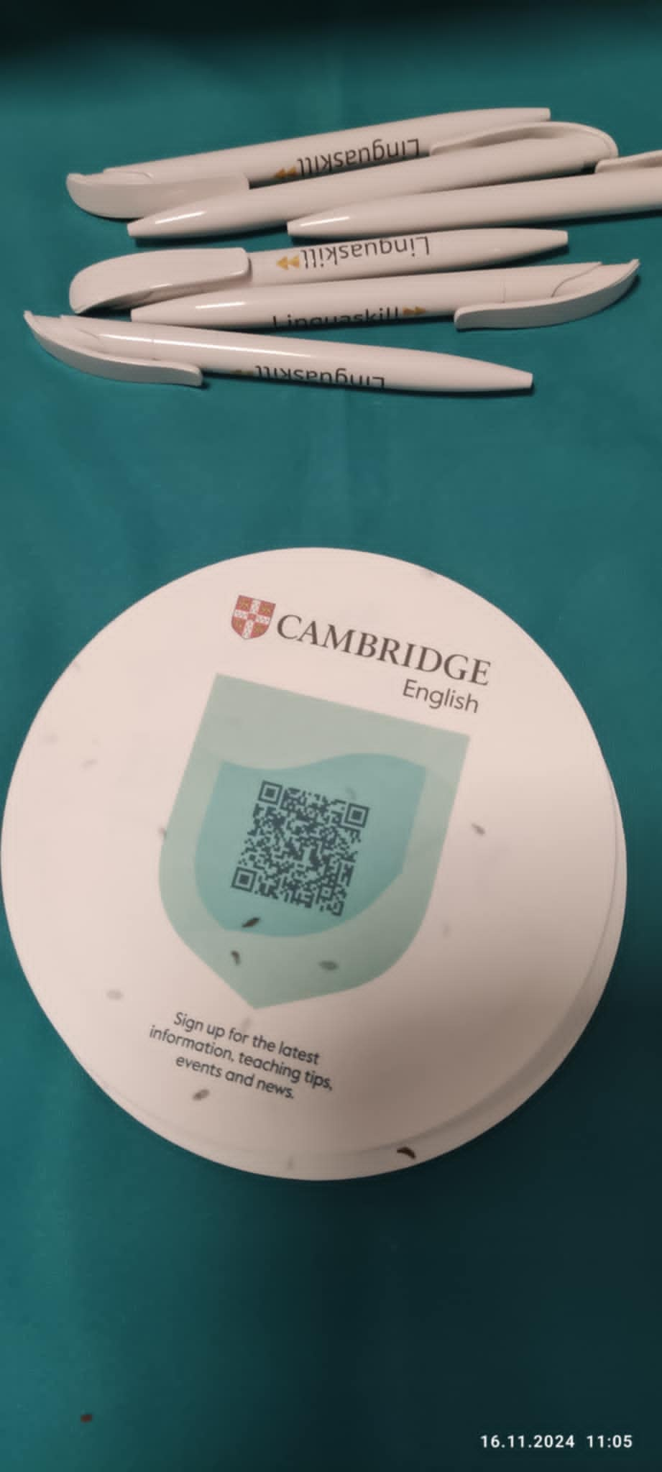
and delicious snacks at lunchtime

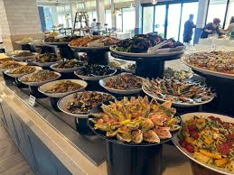
The sessions were very inspiring and well attended, although on the whole the event was not attended by many teachers, considering what a big country France is. I compare it with recent IATEFL Poland conference.
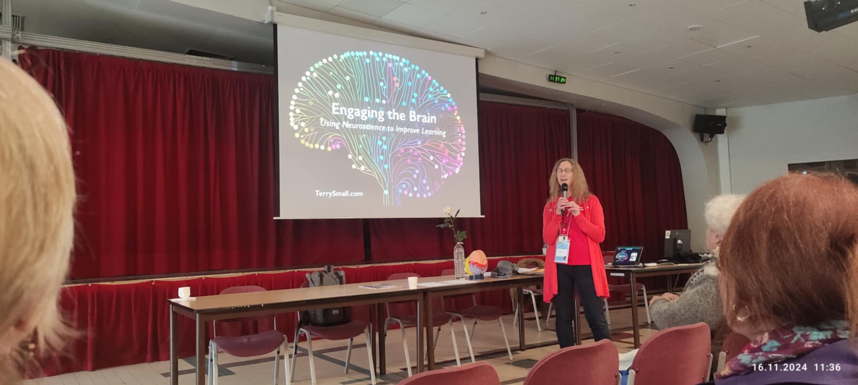
It was great to bump into old friends and talk about good old days like Lonny Gold, recently met new friends at IATEFL Poland like Judy Boyle, make projects for the future like with Jana Chynoradská and Vicki Plant, and finally, make new friends like with Anna Machura and Rachel Paling. Alle of them will be contributing to HLT in one form or another.
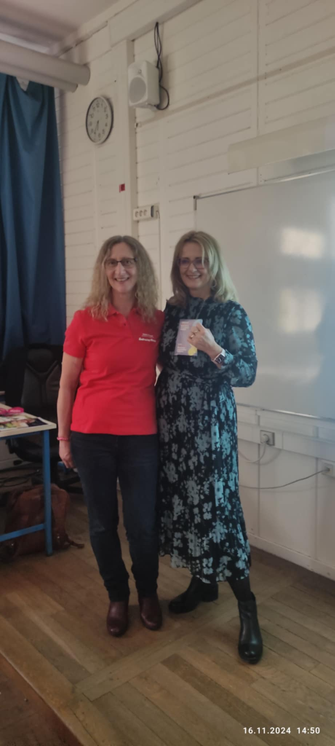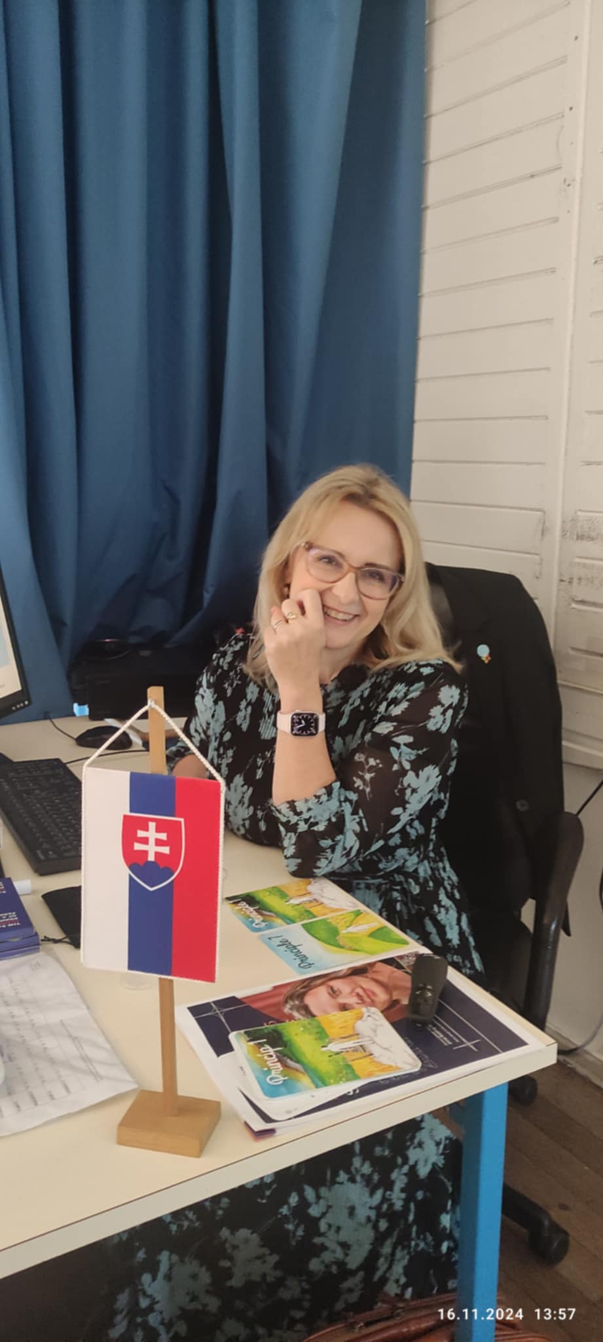
There was no proverbial ‘goodie bag’ with pens diaries and or mugs. But it did not bother me; the taste of the sweets that lingers on, and the personal and professional takeaways are the best mementos.
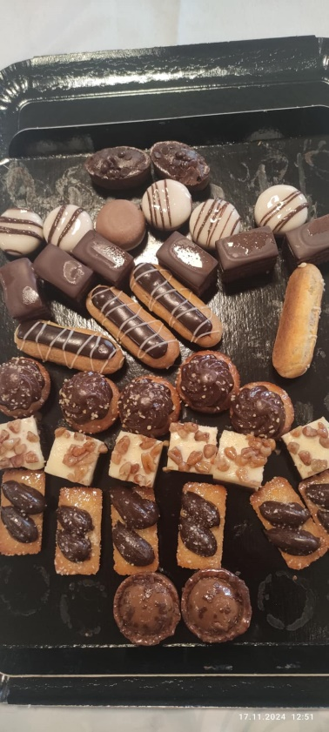

I just made a last-minute purchase to have prizes for my students, and headed home…


Thank you TESOL France. See you next year.


