Graded Readers and Oxford Reading Club: Today and in the Past

Hania Kryszewska, Poland

Background

What is a graded reader? Graded reader books are easy reading materials designed for teaching English as a second or foreign language. They are often adapted from literary classics, films, biographies or travel books, and are written with specific levels of grammatical complexity and vocabulary ( see readers reviewed in HLT from Helbling, Helbling – The Thinking Train , DELTA Team Readers, Collins English Readers, Macmillan and many others). But the readers can also be written from scratch, sometimes by well known ELT authors like Alan Maley or Philip Prowse.

They cover a range of serious or lighter themes and are designed with a focus on grammatical complexity and vocabulary. For example, Level 1 in a series might be restricted to 500 headwords, Level 2 to 600 headwords, and Level 3 to 700 headwords.

Other factors considered when selecting titles include character range, plot complexity, target audience background, and market compliance requirements. Some will touch upon modern issues in 21st settings, others will introduce the readers to e.g. Victorian England and classical stories.

Some graded readers series offer additional tasks, vocabulary tasks, introduce thinking skills, personalisation and promote values.

Overall, they can be an important addition to our methodology and foster learner autonomy.

They can be subject of academic studies and research like the research presented in this paper or enter competitions like The Extensive Reading Foundation.

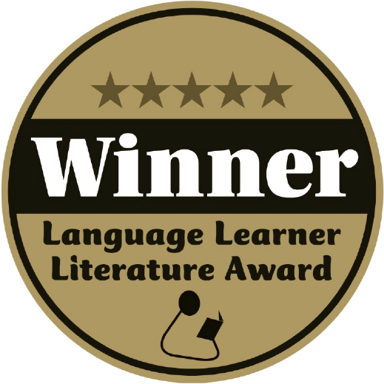

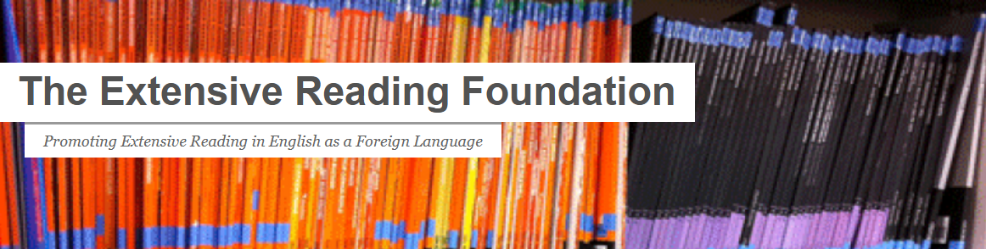
But many teachers admit that they do not know what to do with graded readers in class, or how to organise students’ extensive reading outside class. In fact, this is confirmed my ELT bookshop owners who say that they observe a rise in sales of graded readers at the end of the school year when school authorities buy them as prizes for outstanding learning or other achievements.

Here are three solutions.

Solution 1: Oxford Reading Club from OUP



We're bringing you a couple of exciting additions: our digital library, Oxford Reading Club, is richer for four new readers, and our Professional Development offer has a new feature that helps you find relevant resources in a faster and more efficient way.

Keep reading to find out all about it.

Four new Graded Reader e-books from the Bookworms series have now been added to Oxford Reading Club: two classic novels by George Orwell, and two works of non-fiction.

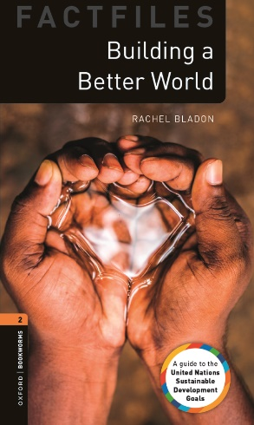

Building a Better World (Level 2, CEFR A2/B1)

In 2015, the 193 countries of the United Nations agreed on seventeen Sustainable Development Goals. This book explains each of the goals and gives examples of the wonderful work that is already happening around the world to end these huge problems. It also gives great ideas of changes that we can all make in our own lives.

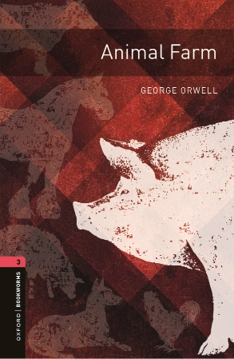

Animal Farm (Level 3, CEFR: B1)

When the pigs become the farm's new leaders, everyone is happy. After all, some of these pigs really are so clever and have excellent ideas. But then things start to go badly wrong. George Orwell's famous book warns us about leaders who only think about themselves, and tells a story that still matters.

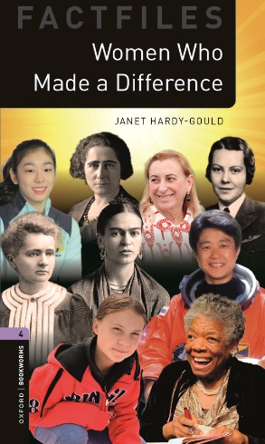

Women Who Made a Difference (Level 4, CEFR: B1/B2)

History and the modern world are full of women who have done extraordinary things in all areas of life, from art and science to medicine and sport. But their stories have not always been told. From the 1800s to the present day, from South Korea to Spain, this book tells the stories of nine fearless women, and shows the great differences they have made to the world around us.

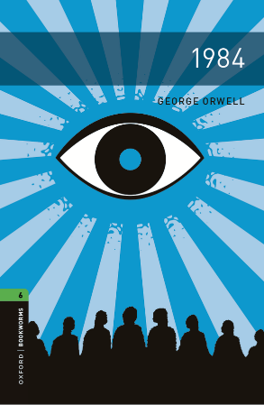

1984 (Level 6, CEFR: B2/C1)

In the future country of Airstrip One, you're being watched. Special screens inform the Thought Police about your every move. Winston Smith begins to rebel secretly. Why, he asks. Why does the government spread lies, rewrite history, promote hatred and war? Why are we denied comfort, happiness, beauty, and nature? And why are we allowed no freedom? Why?

Oxford Reading Club is our digital library of graded readers, suitable for all ages and levels of English. It includes interactive features and activities, such as games, word cards, audio with adjustable speed, and voice recording. We made sure your students won't get bored.

If you haven't done so already, you can register for a free trial, which will give you full access to over 700 titles for 30 days. If you decide to buy it, you can do so via easy e-commerce purchase, available as 1- to 12-month access.

Try it out

Buy access

(Note: This section Has been provided by the Publisher)

Solution 2

OUP had another programme in the past, which is worth remembering. The Golden Classic: Oxford Bookworms Club Reading Circles

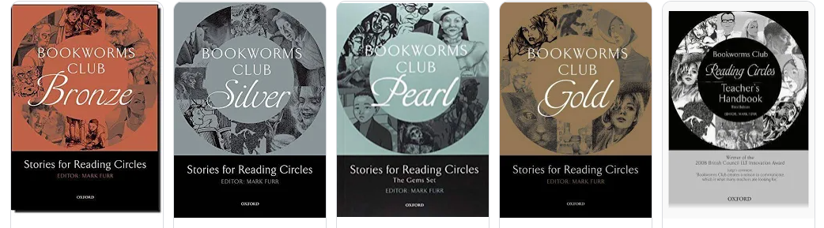

Bookworms Club Bronze, Silver, Gold, Platinum, Diamond, Pearl, Coral and Ruby contains Stories for Reading Circles: eight collections of short stories from Oxford Bookworms with a unique set of teacher’s resources for running successful Reading Circles.

The full Teacher's Handbook, including photocopiable materials, is available here. To my mind it is the greatest gem. It contains great universal ideas to by used with any graded reader, ideas including various roles for the students.
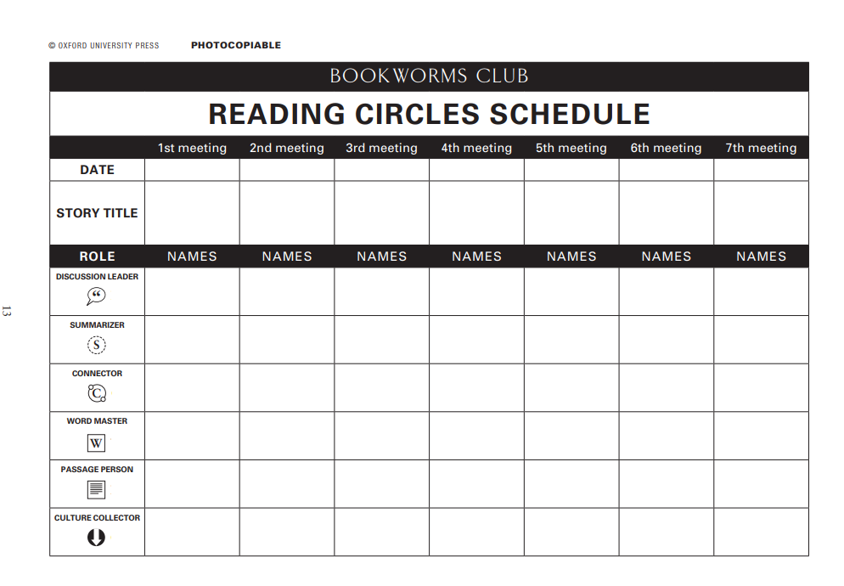
And here is the description of one of the roles i.e. what a connector’s role involves.
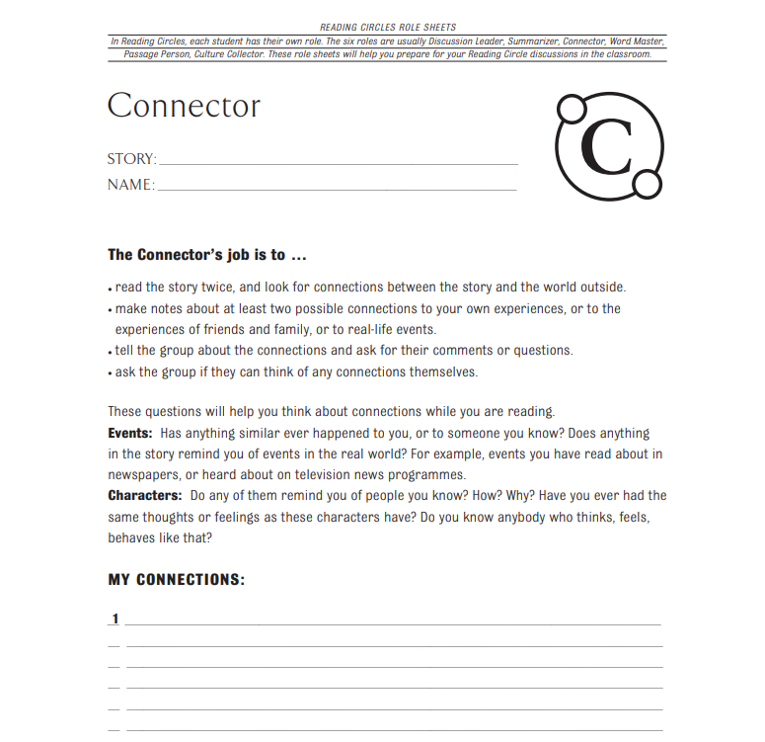
Solution 3

You can also work with a new OUP publication, fresh off the shelf, and try out the Read on! programme.

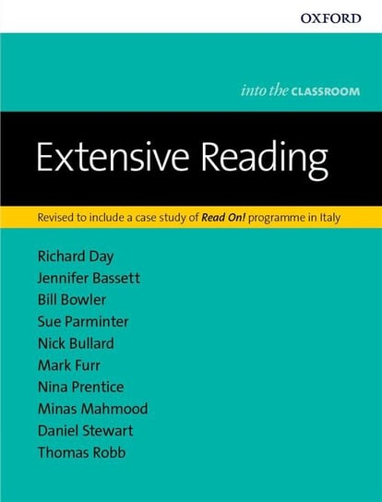
You can read a sample here.

'...non-native speaker teachers can find useful strategies to develop their proficiency in the target language, native-speaker teachers can pick up ideas on how to understand, ...and the new cultural context where they are to teach.' Modern English Teacher - Volume 21/4 'This is an excellent book for less experienced teachers of young learners.' Humanising Language Teaching Magazine for teachers and teacher trainers This is best described as an exceptionally good teacher's resource book. In 28 chapters there are several dozen excellent teaching ideas for 5-12 year-olds grouped into nine sections. Each chapter and section has a descriptive title that actually makes sense, e.g. Chapter 7: 'Healthy competition'. (This is harder to achieve than one might think.) Each chapter ends with a well-founded statement of rationale. The parts are: Knowing and challenging your learners; Encouraging your students to learn; Going beyond the coursebook; Empowering your learners; Assessment; Playing with the sounds of English; Bringing the real world into the classroom; Using make believe, performance, and metaphor; For the teacher: Language and cultural contexts. All the activities encourage the use of spoken English by the teacher (e.g., not a dvd): in the short but informative introduction, the authors say why. This looks like a really good book. The Teacher Trainer Journal, Vol 29/3
source

Parting word
Looking at the number of graded reader series (virtually from every ELT publisher) and the methodology that is being developed around them, I am sure they are here to stay. What is more, they fit in perfectly into self-directed-learning and building learner autonomy. Also, in some environment and contexts social media could enrich the experience and make participation in a reading circle more easily accessible as an extracurricular activity and different from an in-class .

Please check the Pilgrims in Segovia Teacher Training courses 2025 at Pilgrims website.

Please check the Pilgrims f2f courses at Pilgrims website.

