Testing Times Xmas 2024 Edition: The Testing Times ‘Cheat Sheet’ for Language Test Takers

Geoff Tranter, Germany

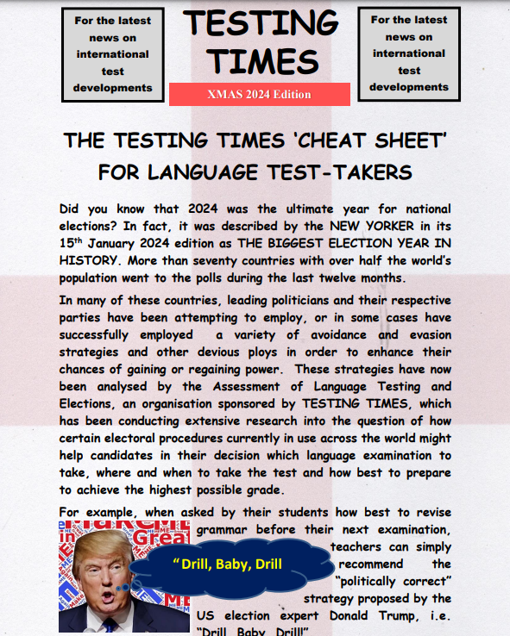

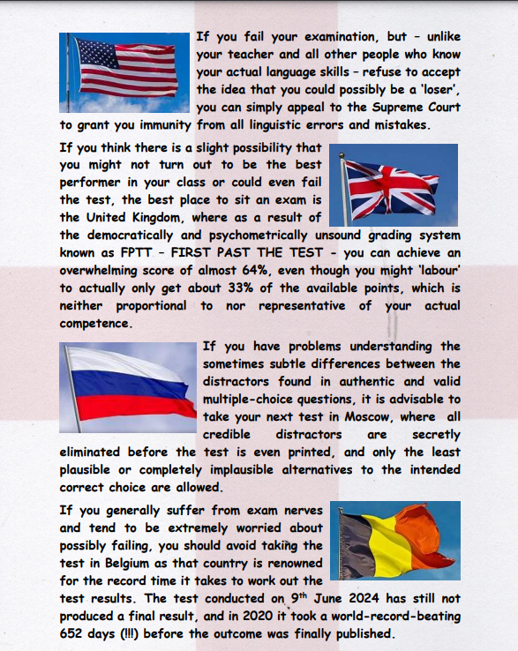





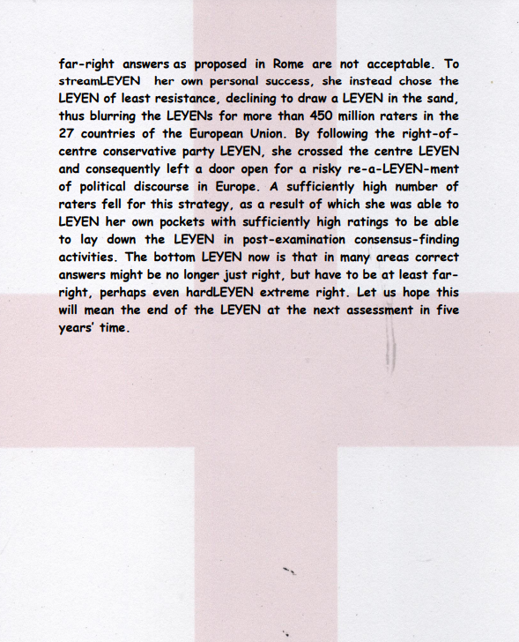

Please check the Pilgrims in Segovia Teacher Training courses 2025 at Pilgrims website.

Please check the Pilgrims f2f courses at Pilgrims website.



