‘Sophie the Lady and Mouse in the House’: Arts and Crafts ELT Project for Young Learners

Sylwia Zabor-Żakowska, Poland

Sylwia Zabor-Żakowska, Poland is an English and Art teacher, teacher trainer, creativity animator, material writer, author, poet and painter. She writes and publishes in Polish and in English. The core of her work is developing thinking and creativity in children. She runs a little Art and Language school www.rzezucha.com. You are welcome to contact her by email: poppies@op.pl

Introduction

The project ‘Sophie the Lady and Mouse in the House’ is directed to the teachers of young learners who are keen to explore the field of developing their students’ creative potential while English teaching. The first part - ‘Prologue’ composes of four lessons which are based on a piece of a rhyming story for children and use Arts and Crafts techniques. True creativity always involves thinking out of the box, which in ELT means broadening and going beyond the well known, standard curricula. It might understandably cause unpleasant discomfort of the unknown among some teachers. ‘Sophie the Lady and Mouse in the House’, however, not only refers to the prevailing and more than welcome children’s need to act creatively but is set among standardized ELT practices to make it easily approachable.

I believe a little bit more of an effort on teachers’ side brings about a great reward – a genuinely successful teaching and thus fluent, English speaking grateful students.
‘Prologue’ – the piece of a rhyming story comes from the book ‘Siedem dni z życia Hrabiny Grabiny’ ‘ Sophie the Lady and Mouse in the House. Seven Days of Their Lives – Rhyming Story for Children’ published in Polish by BOSZ, https://bosz.com.pl/sklep/siedem-dni-z-zycia-hrabiny-grabiny/. Sylwia Zabor-Żakowska – an author translated the story into English for educational purposes. Some fragments of Basia Trembaczowska illustrations are implemented too. You can learn more about the book at the bottom of the project.

About the project

Students’ age: 10 - 13
Level: A2/B1
Time: 4 45-minute lessons
Creativity and critical thinking skills:
- aims: fostering students’ interest and eagerness to think and create, enhancing an ability to express one’s own individual opinion, developing imagination, practicing fine motor skills
- activities: making puppets using a cut and glue technique followed by a freely chosen craft
(drawing, painting, cutting out clothes from fabric or colourful paper), performing the language
chunks with puppets, drawing
Emotional/social/life skills: triggering interest in studying English, building inner motivation for learning, experiencing joy and excitement for learning English, presentation/performing skills,
strengthening concentration skills, enhancing long-term memory, building self-esteem, making one’s own decisions,
Language focus: revision and consolidation of common phrases (questions and answers): Is the person a man or a woman? What is her/his name? How old is she/he? Where does she/he come from? Where does she/he live: in the countryside or in the city? Does she/he have a family? Sisters, brothers, husband, children, cousins? What animal is this? What is its name? Is it she or he? Where does it live: in the countryside or in the city? Does it have a family? Sisters, brothers, uncles, aunts, cousins? Has it got a long or short tail? Has it got big or small ears? Can it run, jump, play hide and seek? I think, I can see. the Present Continuous Tense, They are…, Their names are….They live… clothing vocabulary e.g. a dress, a skirt, trousers and so on. What is she wearing? She is wearing….
New language: to my mind, in my opinion, I believe, I guess, the text of the Prologue (look down below).
Skills: Practicing speaking, writing, listening and reading skills
Cognitive focus: the location of Poland, a glimpse at Polish folk clothes
Materials: two cut-out puppets glued to skewers, worksheets (nr 1,2,3,4), the world map, stripes of paper (approx. 0,8cmx5cm) (17 for each student – lesson 2, 26 for each student for lesson 3), crayons, glue, recorded ‘Prologue’ on a smartphone (if you are willing to do it ). At home all children will need scissors and skewers and eager beavers may need pieces of fabric and/or of used colourful magazines.
GI element: No.12 responsible consumption

PROLOGUE

Mouse in the House is drawing the curtain to invite you to a joyous and exciting adventure.
Join her, you will be happy. That is for certain.

Sophie the Lady is carrying a ladder
and leans it against a brick, tall wall,
pretending to be a real dame, though.
-‘Ouch! Oh! No! Help, help !’ – you hear her call.
She’s slim and tall.
Her eyes, up and down and sideways, roll.

Mouse in the House appears breathless
(must have been reckless).
Nevertheless, she sneaks under her Lady’s dress.
Sophie’s shoes are hard to pull
(would be hard even for a bull).
-’Phew’!She takes them off. Oh !
What she sees, is a stocking hole.

Sophie the Lady is climbing the ladder,
not at all is she a nagger.
Step by step, bit by bit,
she reaches its peak.

There is a little window, high above, in the wall.
She’s not afraid to fall.
She jumps, with pride, inside.
It’s a dark and restless night, besides.
Sophie closes the door,
tiptoes across the floor
and pulls forward an upper drawer,
to get what she’s been waiting for.
It’s time to relish a rose flavoured chocolate
which tastes immaculate.
The moment can last forever and ever.
Whenever, wherever.

Eventually, she puts her head on a soft pillow
and covers herself with a down duvet.
Mouse in the House is rushing from under a willow,
having finished dancing ballet.
She’s poky, moves lumberingly.
Puts Sophie’s shoes under the bed,
creeps silently ahead
and takes slowly a silky thread.

In a caramel candy wrap lies a needle,
but the Mouse feels so feeble
that she fails to thread it
(although she says it doesn’t fit).
She’s been trying hard,
but nothing’s worked out.
Not a thing,
Not at all
-‘Ouch! Oh! No!’

Lesson 1

Procedure and timing:

Step 1 (10 min): Having greeted each other in your own, usual and favourite way tell your students you are going to welcome to your class two personae – characters from a book. Introduce two plain puppets and make your learners think and speak asking the following questions:

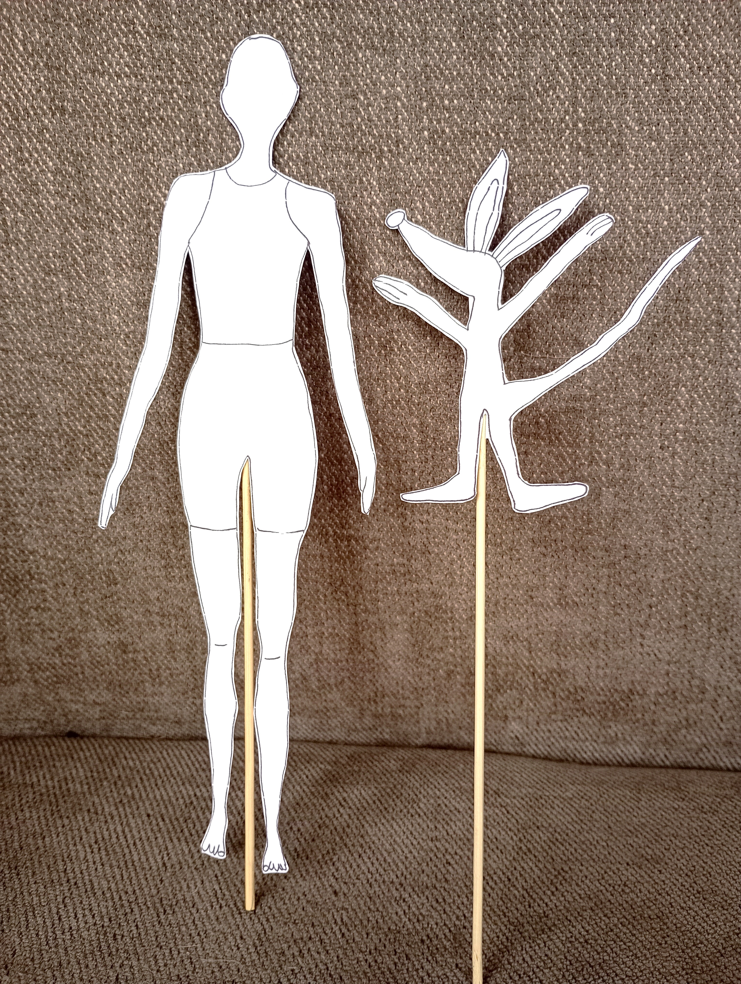
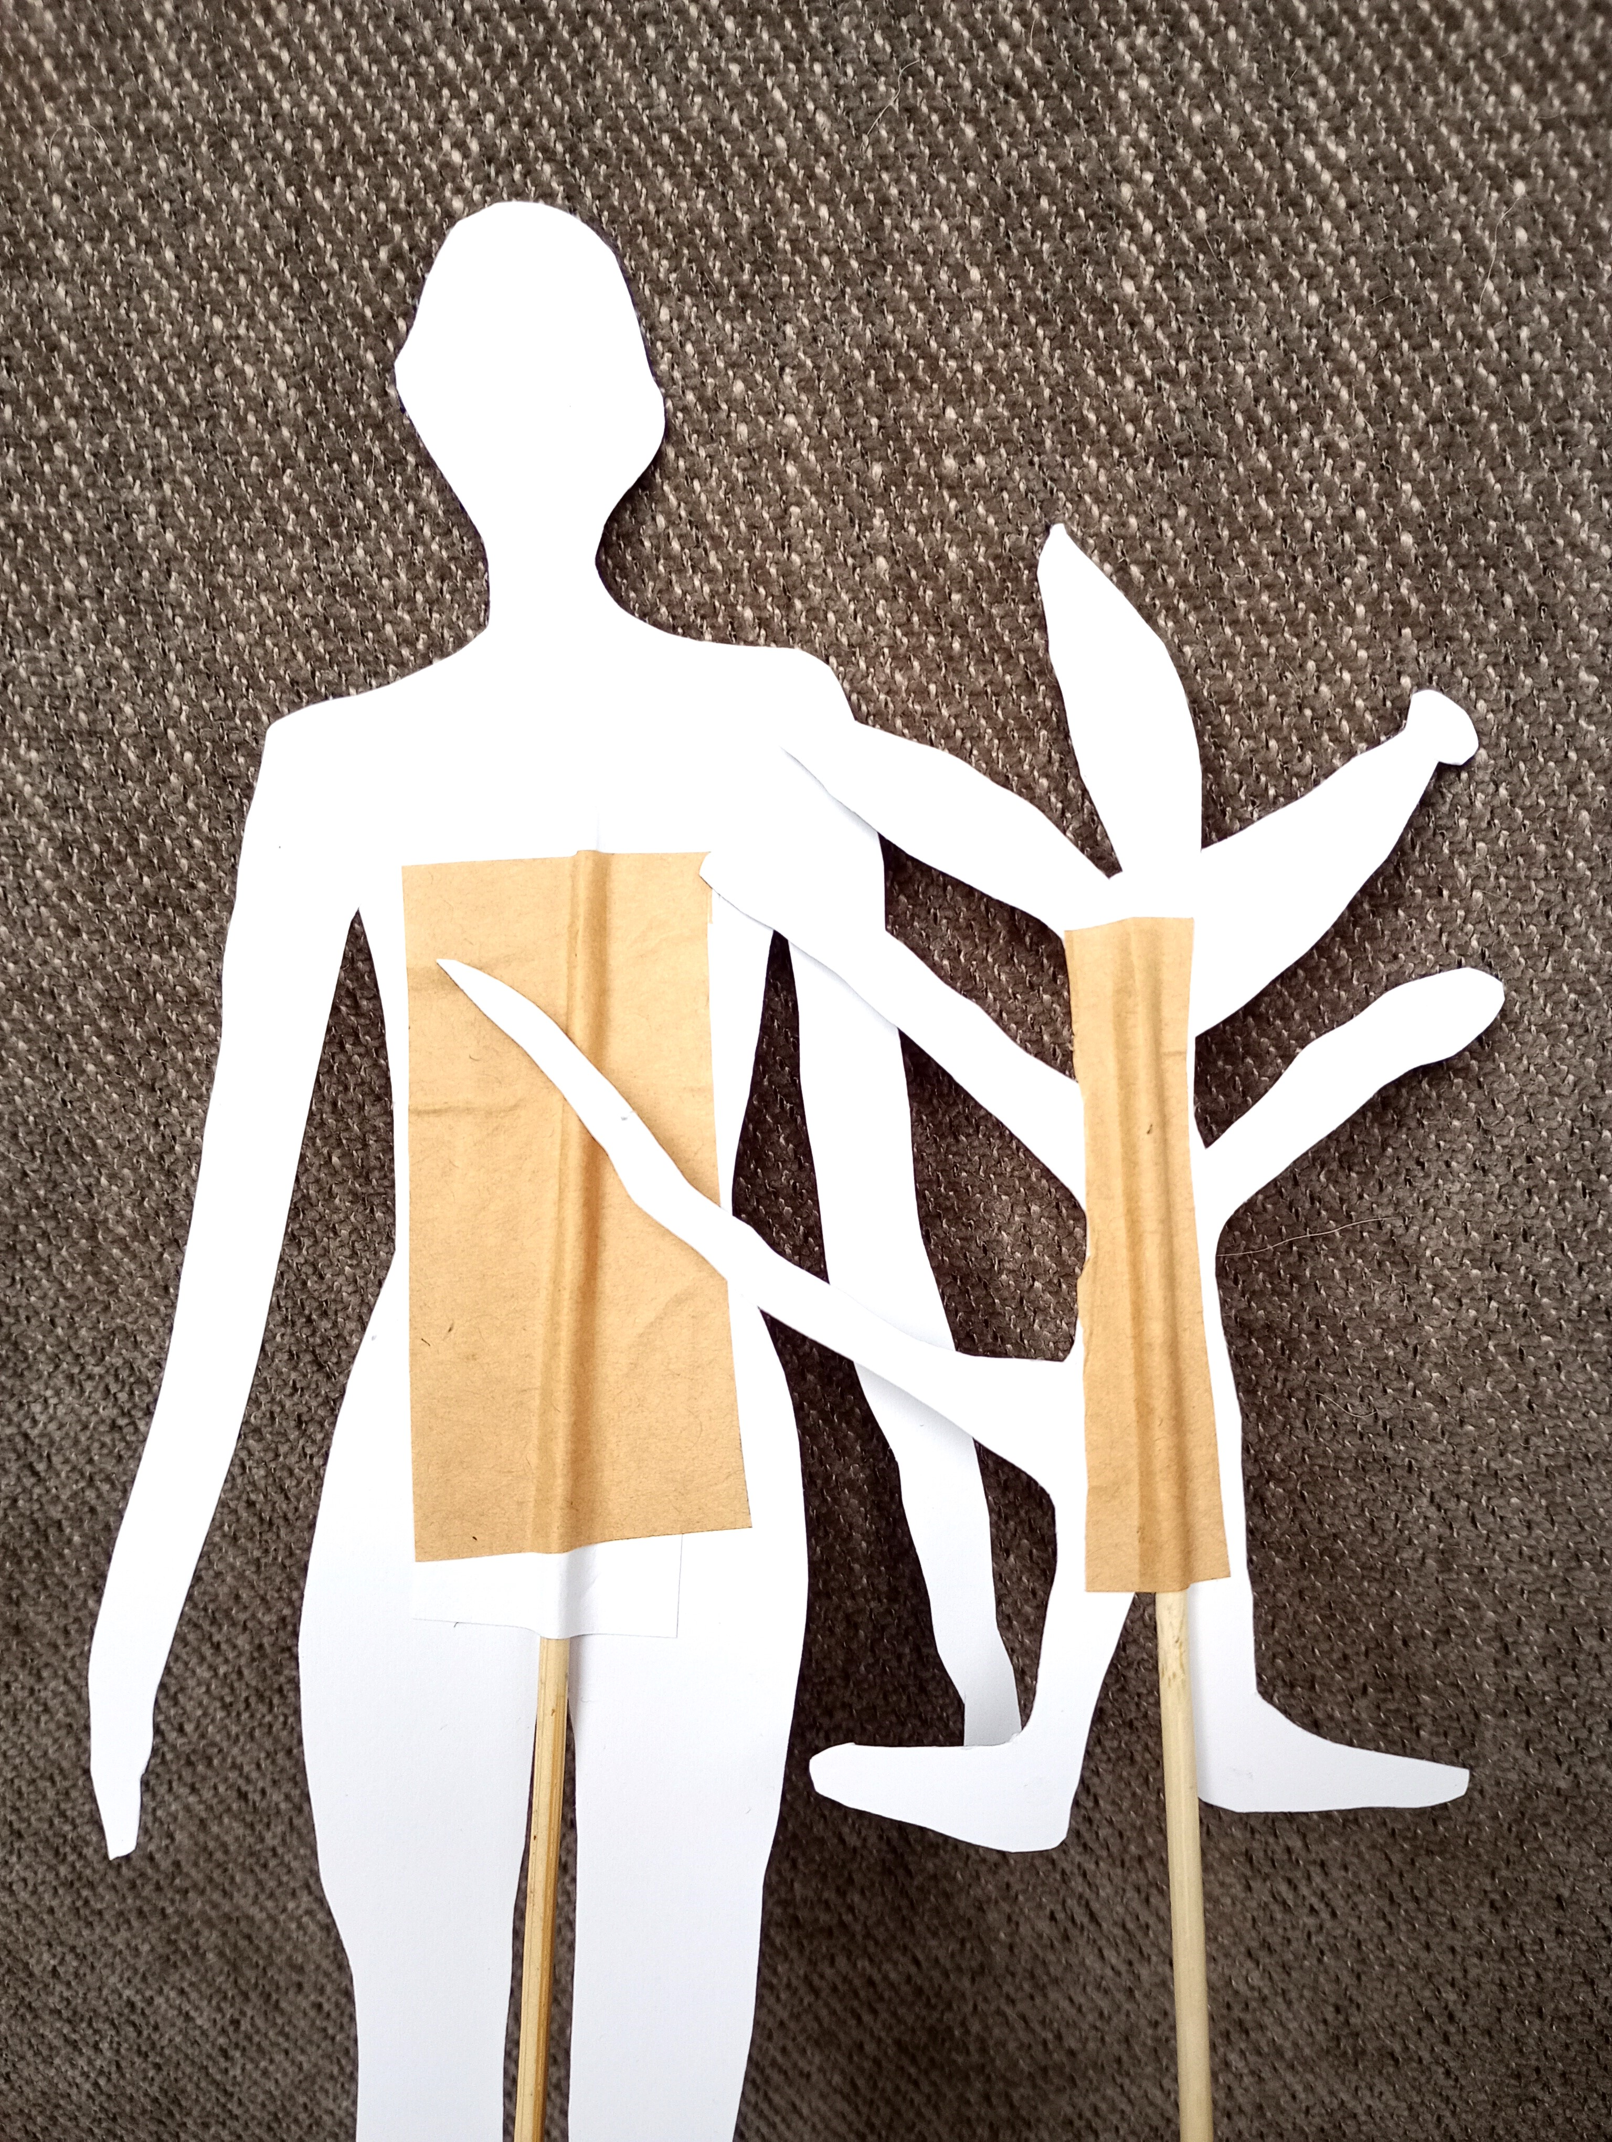
Photo: Sylwia Zabor-Żakowska

Is the person a man or a woman?
What is her/his name?
How old is she/he?
Where does she/he come from?
Where does she/he live: in the countryside or in the city?
Does she/he have a family? Sisters, brothers, husband, children, cousins?

Teach children to use synonyms of I think such as: to my mind, in my opinion, I believe, I guess. At this stage, expecting one-sentence answers focus on accuracy of the answers.

What animal is this?
What is its name?
Is it she or he?
Where does it live: in the countryside or in the city?
Does it have a family? Sisters, brothers, uncles, aunts, cousins?
Has it got a long or short tail?
Has it got big or small ears?
Can it run, jump, play hide and seek?

Step 2 (10 min): Present to children worsheet nr 1, practice saying the answers once again and hand out the worksheets with questions. Now learners need to write the answers.

Hint: You will know best whether and how you need to adapt this task to be the chance to develop your students’ writing skills in the best possible way bearing in mind the long-term aim that they should be able to write correctly in English on their own.
When I work with worksheets my students always paste them in their notebooks.

Step 3 (1 min): Explain to your students you are going to work on a book-based project. Show children the book cover and tell them the paper-version of the book has been published in Polish but the author who is an English and Art teacher translated it into English and prepared teaching notes so that children can learn English from it.

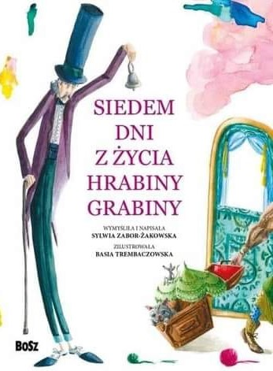
Cover: © Copyright by BOSZ

Step 4 (5 min): Talk about what children can see in the cover; students use the phrase I can see…. .
Talking about what is going on in the picture practice The Present Continuous Tense.

Step 5 (5 min): Presenting the book illustrations ‘reveal’ the ‘right’ answers, the two personae’s names are: Sophie the Lady and Mouse in the House. They live together in the countryside in a castle in Poland. Point on the world map where Poland lies.

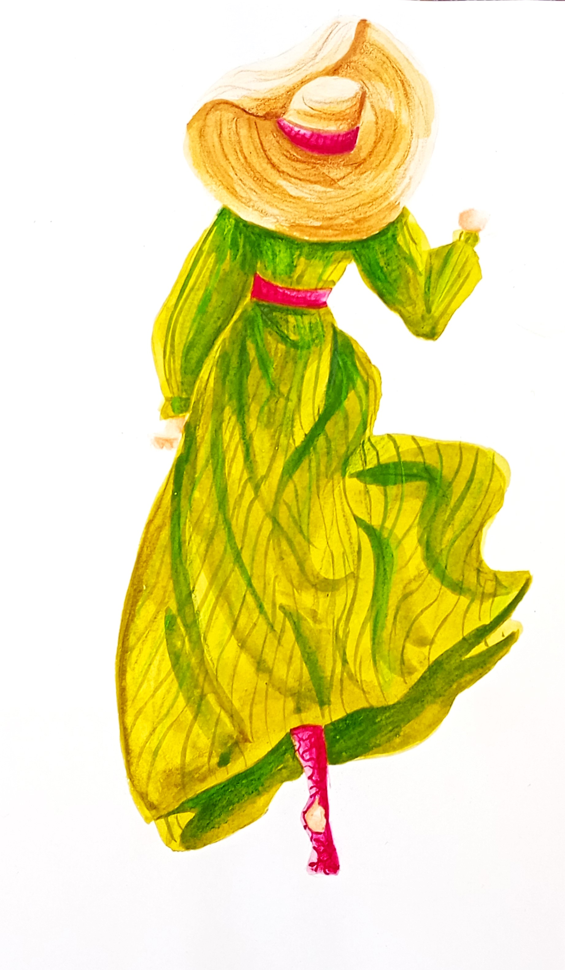
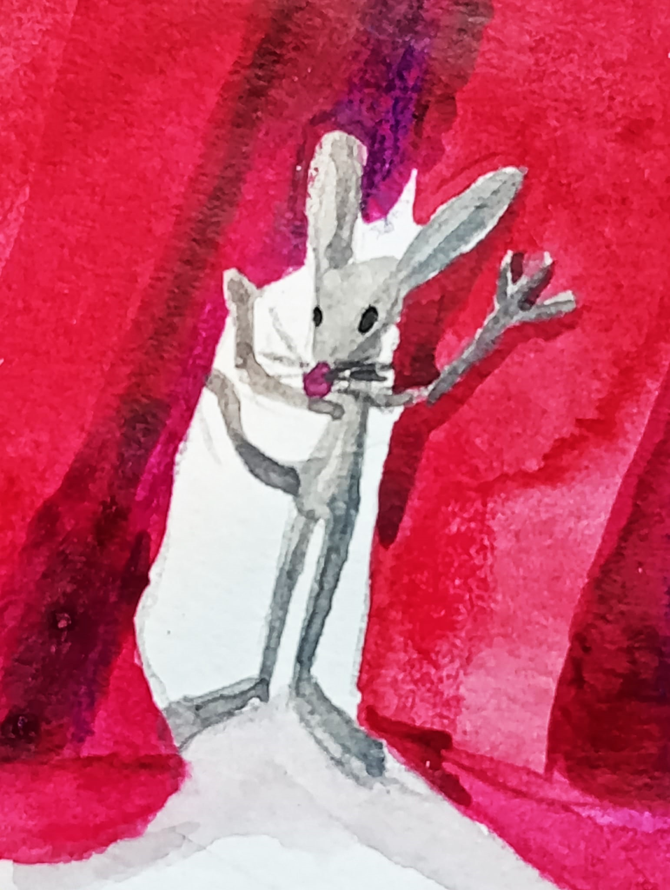

© Copyright by BOSZ
Illustrations: Barbara Trembaczowska
Photo: Sylwia Zabor-Żakowska

Here, you can practice plurals: They are a woman and a mouse. Their names are Sophie the Lady and Mouse in the House. They live together in a castle in the countryside.

Step 6 (2 min): Present to children the below illustration and the first words of the book:
Mouse in the House is drawing the curtain to invite you to a joyous and exciting adventure.
Join her, you will be happy. That is for certain.

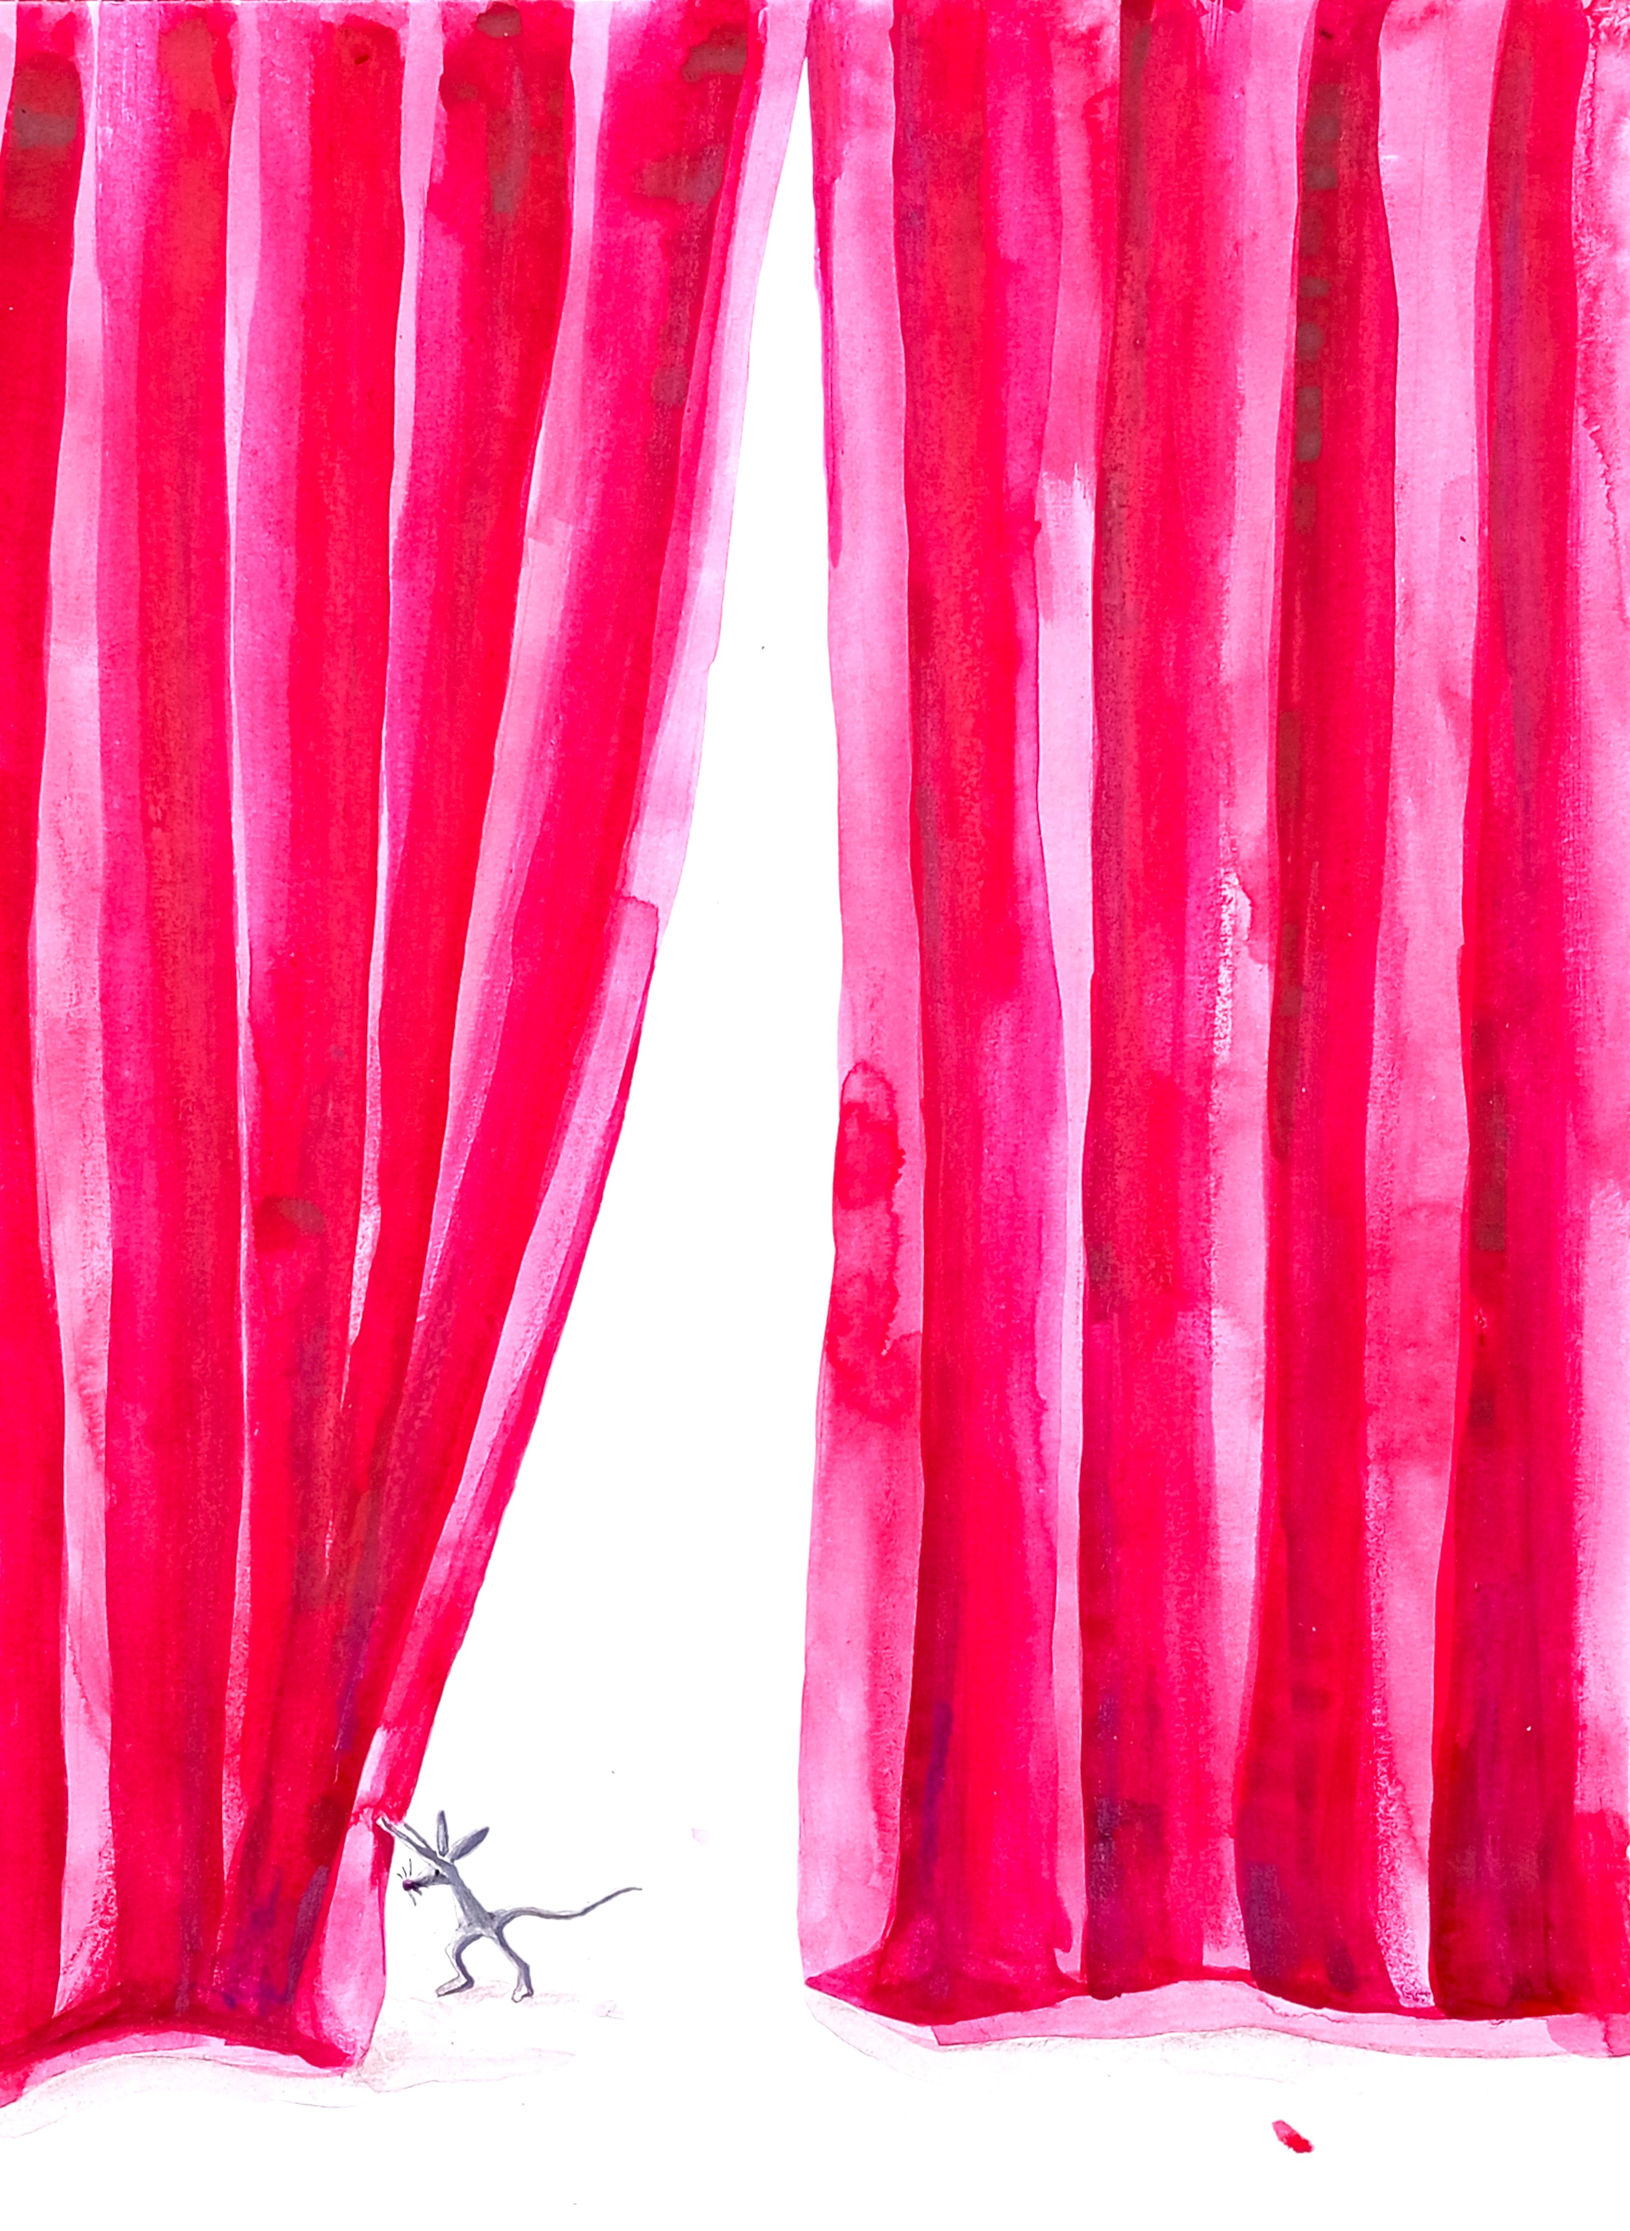

© Copyright by BOSZ
Illustrations: Barbara Trembaczowska
Photo: Sylwia Zabor- Żakowska

Using your mother tongue to translate the words is welcome. Teach children ... is drawing the curtain to invite you to a joyous and exciting adventure and the whole class says the phrase out loud.
Ask the children if they are eager to join Mouse in the House

Step 7 (6 min): Show children the illustration of the castle. Ask them to ‘help Mouse in the House tidy up the castle and collect Sophie’s clothes’. Name the clothes in the picture: ( a hat, a dress, stockings or socks, a scarf or a piece of a skirt ) and think what clothes are missing: e.g. trousers, T-shirts, shirts, shoes, boots, gloves, jackets, tights, jumpers, cardigans.

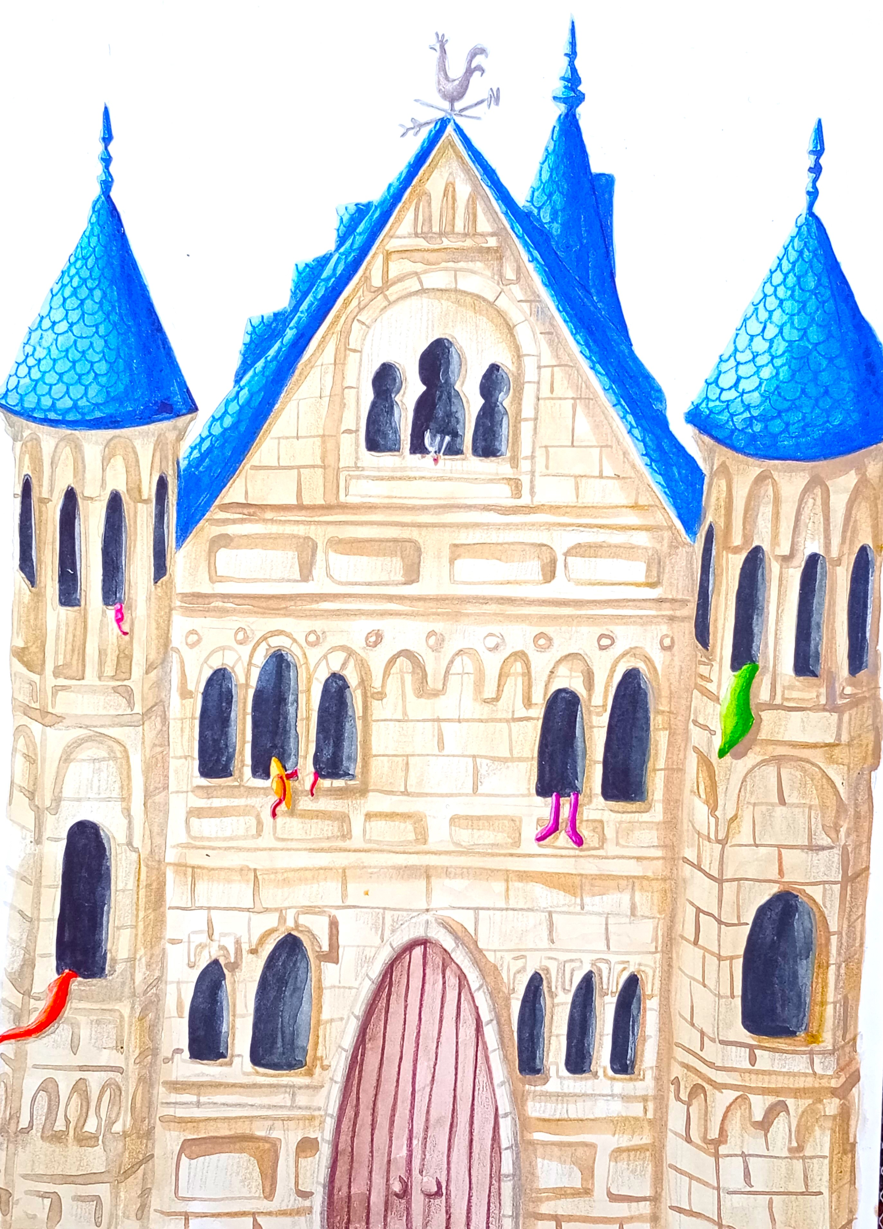
© Copyright by BOSZ
Illustrations: Barbara Trembaczowska
Photo: Sylwia Zabor-Żakowska

Step 8 (3 min): Then give out workheets nr 2 and explain to kids that their homework will be to make Sophie’s and Mouse’s puppets and dress Sophie in the way they want to and using a freely chosen technique: they can draw or paint the outfit directly on the puppet or cut it out from fabric or paper. As for the Mouse puppet they can make it according to their own ideas. Show them the example puppets and cut-out clothes in the photos. Point out to the fact that the paper for the clothes on the middle puppet comes from a used, colourful magazine to protect trees and the pattern of the outfit is typical of Polish folk culture.
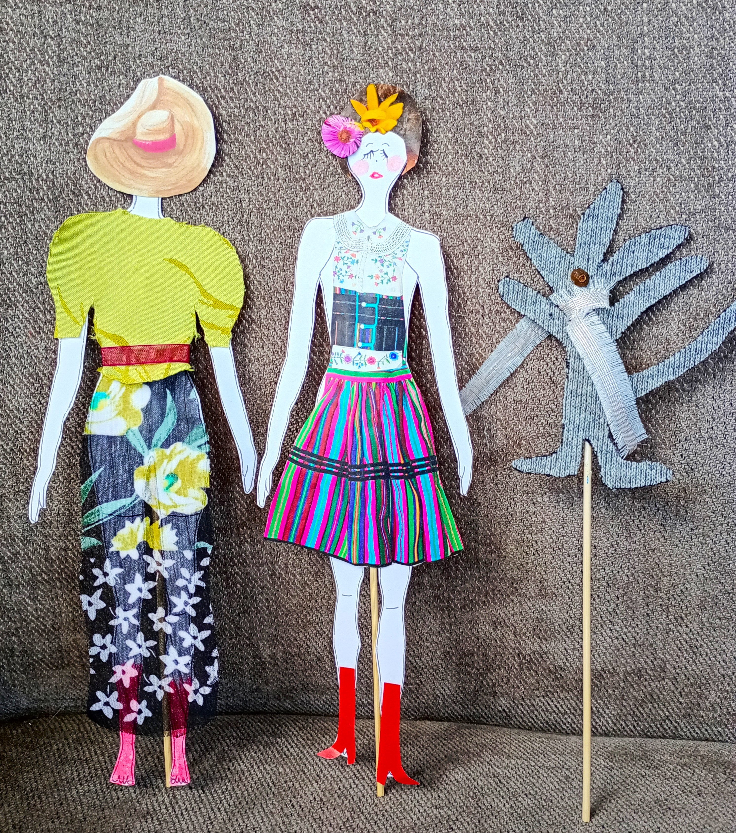
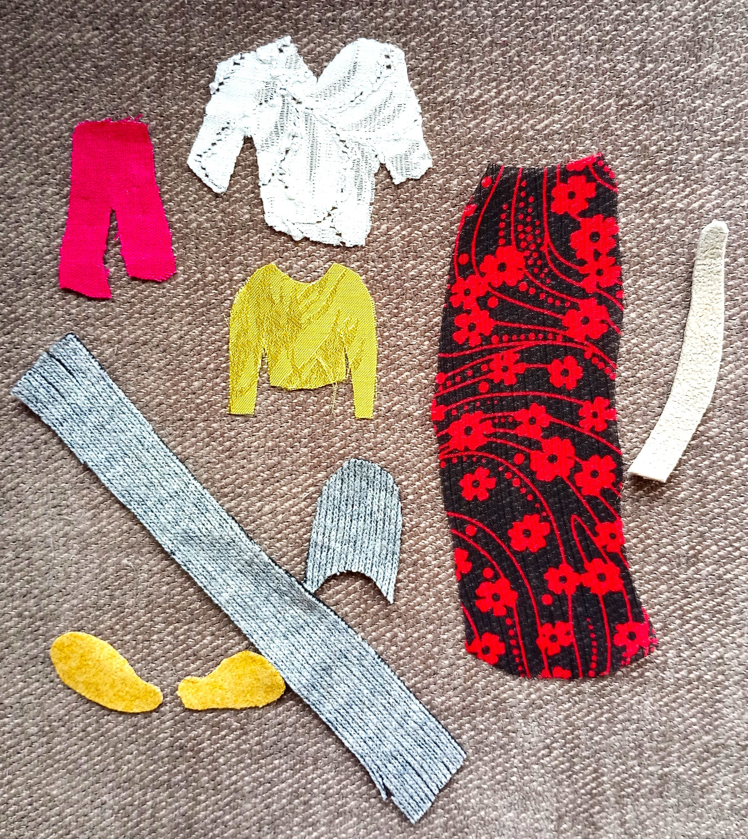
Photo: Sylwia Zabor-Żakowska

Step 9 (3 min): Finish the class listening to the recorded ‘Prologue’ and set homework.
Hint:Make it accessible to your students by WhatsApp or in any different way.
Homework: Listen to the ‘Prologue’ 2/3 times.

Lesson 2

Step 1 (2 min): Greet the students as always and start the class with the phrase:
Mouse in the House is drawing the curtain to invite you to a joyous and exciting adventure.
Join her, you will be happy. That is for certain.

Step 2 (6 min): Ask children to show the puppets, you can arrange the display of them. Talk about what the puppets are wearing: ‘ What is Sophie the Lady wearing ? She’s wearing ……

Step 3 (3 min): Ask children the questions from worksheet to practice the answers, then practice asking the questions by the children.

Step 4 (6 min): Learners say the dialogues in pairs, then in small groups of 4 or 6.

Step 5 (2 min): Teach the word ‘prologue’ and make children listen to it. You can read it out loud or use your recording on a smartphone.

Step 6 (3 min): Put the following list of words on the board and read them out loud as a chant, children repeat after you.

Hint: You can also record it on your smartphone as a chant and make children listen to it.

a ladder
a brick, tall wall
though
call
slim and tall
roll

breathless
reckless
Lady’s dress
to pull
a bull
Oh
a stocking hole

the ladder
a nagger
bit by bit
its peak

Step 7 (5 min): First elicit which of them your students know and after that teach the new ones. You can use a variety of methods here (illustrations, photographs-flashcards, drawing, mime, your native language equivalents, synonyms, simple English definitions).

Step 8 (5 min): Hand out to the children stripes of paper (17 for each student) and tell them to put the vocabulary down on the stripes. When they are done, clean the board.

Step 9 (5 min): Give learners worksheets nr 3,ask them to spread the stripes with the pieces of vocabulary so they can easily see them all and ask them to listen to the ‘Prologue’ and fill the empty spaces with the words on the stripes.

Hint: They will probably need to listen to it three or four times.

Step 10 (8 min): Check if your pupils have done it correctly and read it as the whole class out loud. Set homework.

Homework: Listen to the ‘Prologue’ and read aloud 3 times the text from worksheet nr 3. Ask for volunteers to learn a piece by heart.

Hint: I’m in favour of making use of the good old method of learning poetry by heart with an adaptation though which consists in listening to the text which helps memorising it almost unnoticeably). These days when most children have smartphones and owing to the Internet have the chance to be exposed to English at will, learning by heart has become more enjoyable and can be treated as something special. If it’s done with joy and a bit of excitement it brings about nothing but a learning-teaching success and serves abundantly for studying English.

Lesson 3

Step 1 (3 min): Welcome pupils to your class as usual and listen to the ‘Prologue’.

Step 2 (3 min): Children take their puppets, read the text from worksheet 3 as a whole class and make their puppets perform the actions, e.g.….carrying a ladder, ….sneaks under her Lady’s dress, ...climbing the ladder, ……...reaches its peak.

Step 3 (12 min): Individual learners read the text aloud and if there are volunteers who’ve learnt a bit by heart ask them to recite it in front of the classroom.

Step 4 (6 min): Use the lesson 2 procedure to introduce and teach the vocabulary below:

in the wall
to fall
inside
besides
the door
the floor
an upper drawer
waiting for
a rose flavoured chocolate
immaculate
forever and ever
wherever

on a soft pillow
with a down duvet
under a willow
dancing ballet
under the bed
ahead
a silky thread

a needle
so feeble
it
fit
hard
out

Step 5 (6 min): Hand out to the children stripes of paper (26 for each student) and tell them to put the vocabulary down on the stripes. When they are done, clean the board.

Step 6 (9 min): Give learners worksheets nr 4 and follow the lesson 3 routine.

Step 7 (6 min): Check if students have done the task correctly and read it all together 2, 3 times. Set homework.

Homework: Listen to the recording, read the worksheet 4 part aloud 3 or 4 times, eager beavers learn a piece by heart.

Lesson 4

After the effort of the three preceding lessons reward your learners and spend time enjoying and having fun on the basis of the studied English.

Step 1 (5 min): Greet each other as usual and recite the ‘Prologue’ performing the actions with puppets in a funny and joyful way (you can borrow them from the pupils). Ask children to join in.

Step 2 (3 min): All the children take the puppets and read the ‘Prologue’ out loud performing the actions.

Step 3 (10 min): Eager beavers – volunteers who have learned pieces by heart perform them in front of the class.

Step 4 (20min): Leave children space to draw the fragments of the ‘Prologue’. They can pick what they want to draw. Play the recording a few times while they are working, walk around the classroom and express your interest in their work and talk about which part they illustrate.
Hint: Remember to always appreciate your pupils’ effort, use positive enforcements and praise their work.

Step 5 (7 min): Individual learners present their pictures reading aloud or reciting the related parts. Broaden the display of the puppets by adding the pictures.

No homework this time.

About the book

Title in Polish: ‘Siedem dni z życia Hrabiny Grabiny’
Invented and written by: Sylwia Zabor-Żakowska
Illustrated by: Barbara Trembaczowska
Published in Polish by BOSZ

Audience: Children 4/5 – 12/13
Word count: 4870
Numbers of chapters – 8 ( prologue and 7 chapters)

Key idea

To introduce children into the world of art through a process of creating/designing a book.
To appreciate children’s creative potential and their need to create and give them a chance to experience to a certain degree creating a book.
To invite children to go through a creative process along with the author and the illustrator.
To develop children’s love for reading as well as for creating.

Children/readers are invited to co-create the book with their own ideas, using their own imagination and individual sensitivity so that they become co-authors. They are provided with the creative, artistic ‘assignments’ to explore various artistic techniques (e.g. water paint, soft pastels, collage, pencil, crayons, mixed techniques)

Synopsis

The rhyming story ‘Sophie the Lady and Mouse in the House – Seven Days of Their Lives’, which is a working title, takes young readers for an unprecedented, unexpected and unforgettable adventure that has neither the beginning nor the end and lets children experience the joy of creativity. The reader is the one who is welcome to co-create, design and complete the missing elements with their own imagination, creativity and ideas expressed by a variety of artistic techniques, which helps children practise artistic skills using e.g. soft pastels, water paint, collage etc.

The inspirations coming from Polish, English and Swedish children’s classic literature permeate each other. The whole concept derives from different art branches: imaginary visions that you encounter evoke Marc Chagall’s or Impressionist paintings and the introduction resembles a theatre play (‘Mouse in the House is drawing the curtain to invite you to a joyous and exciting adventure.
Join her, you will be happy. That is for certain.’)

Sophie the Lady and Mouse in the House lead their lives in a mysterious castle surrounded by nature, which has a significant influence on them. Sophie acts as a fairy doing lots of good deeds and helping those in need. Each day brings new adventures and challenges which demand commitment and courage. On Monday she is invited to Alice Gal Pal and Spider the Mate to weave a web. On Tuesday she plants a pearl out of which Treasure Tree will grow. On Wednesday she heals Christopher the Whale with a shell. On Thursday she takes The Cat in the Bag to Trumpeter who lost his creative power and visits Filestra who conducts an orchestra at night. On Friday a swarm of insects help her cook fruit soup for the whole town. On Saturday she blows a hot air balloon out of chewing gum and cherishes the day by the stream. On Sunday she’s over the moon celebrating a family reunion.

Non-material / social/ citizenship/ values like friendship, help, tenderness for each other, love for nature, awareness of a healthy lifestyle, appreciative attitude towards life and joy of life recur in this story of Sophie the Lady, Mouse in the House and their numerous, unique friends who look forward to meeting young readers. The book is also intended to delight adults while reading out loud to children.

If you are interested to get this book published in English, do not hesitate to contact Sylwia or BOSZ .
You can look inside the book here: https://bosz.com.pl/sklep/siedem-dni-z-zycia-hrabiny-grabiny/

The publisher’s note:

The illustrations are taken from the book "Siedem dni z życia Hrabiny Grabiny" published by the BOSZ Publishing House. The English texts were developed based on the Polish edition of the book.
Original title: Siedem dni z życia Hrabiny Grabiny
© Copyright by BoSz www.bosz.com.pl
© Copyright for text Sylwia Zabor-Żakowska
© Copyright for illustrations Barbara Trembaczowska

Please check the Pilgrims in Segovia Teacher Training courses 2025 at Pilgrims website.

Please check the Pilgrims f2f courses at Pilgrims website.

