Tell a Child in Gaza’s Tale: An Invitation
Haneen Jadallah, Palestine/ UK and David Heathfield UK

Haneen Jadallah is an English language teacher, a teacher trainer and a remote theatre specialist. She has an MA degree in Drama and English Language Teaching at the University of Warwick, UK. She is also a Sahin Family Award winner for exceptional progress at Warwick university. She has a special interest and expertise in drama and language learning and intercultural remote theatre. She has developed her own framework for students to create their own plays and to perform them remotely to the outer world. She is passionate about connecting young people in Palestine with their peers around the world through intercultural link-ups and online theatre.
David Heathfield is a world storyteller, teacher trainer and writer from Exeter, UK. He has authored Storytelling With Our Students and Spontaneous Speaking (both DELTA) and numerous articles and book chapters. He provides Creative and Engaging Storytelling for Teachers (CrEST) courses for worldwide participants on Zoom. He and his wife Tammy Heathfield are also Heathfield Creative English Coaching.
www.davidheathfield.co.uk and www.heathfieldcoaching.co.uk
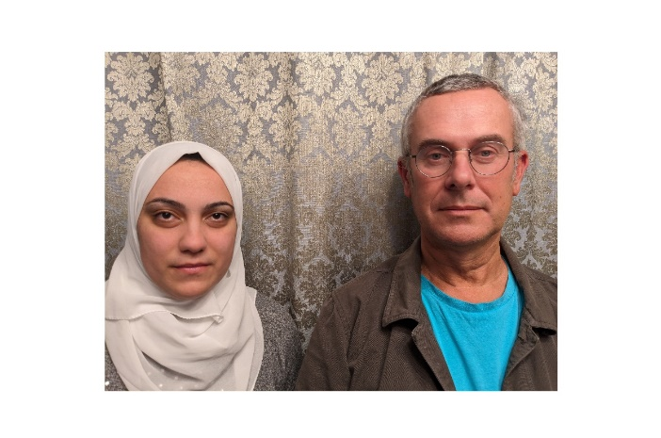
Introduction
Humanising Palestinian learners of English through storytelling was the idea behind our project which was spontaneously conceived on New Year’s Eve. We asked ourselves what we could invite teachers of English, learners of English and storytellers of all heritages, ages and profiles to do which would give them the opportunity to take positive action and amplify the voices of Palestinian children, who are going through the worst imaginable horrors in Gaza.
Background
Back in 2020 during Covid lockdowns globally the World Storytelling Café https://worldstorytellingcafe.com/, a free global online storytelling space (mostly but not exclusively in the English language) hosted in Marrakech, started a regular weekly Tuesday event ‘Young International Storytellers’. Together with John Row, the UK-based curator and main host, I promoted the weekly event and, in the early days, often co-hosted or hosted it. I had the good fortune to know teachers in Gaza because I had just started running my CrEST (Creative and Engaging Storytelling for Teachers) courses and was able to offer two teachers fully funded places on each of my courses. These wonderfully creative teachers invited their students to participate and coached them in preparation for telling stories on Tuesdays. Children from many parts of the world have come together on Tuesdays with regulars from India, Nigeria, Italy and the UK among other parts of the world. The stories, chosen by the children in Gaza, are mostly short and simple fables and folk tales from the oral tradition. Some are specifically Palestinian, many can be called Middle-Eastern tales and many more are universal tales such as Aesop fables. Others are historical stories, songs and fairy tales originating in Europe. Literally hundreds of stories have been told by children in Gaza at the World Storytelling Cafe since 2020. The children’s desire to communicate with people outside Gaza has a lot to do with living under blockade. They want to share their lives, experiences and dreams with other young people around the world.
Shortly after the current critical situation in Gaza began, Haneen Jadallah and I co-hosted a very successful Medical Aid for Palestinians fundraiser ‘A Call for Peace’ at the World Storytelling Café on 26 October 2023 – here is the recording https://www.youtube.com/live/hExuCtrvZ_w?si=zGZ3RngFpNk9zPPK.
Starting on 10 November 2023 I shared a link on my Facebook page every day to a video recording of a child from Gaza telling a story to camera. Nearly all of these recordings are from World Storytelling Café archive recordings on YouTube and Facebook from 2020 to 2022. People around the world, many of them teachers of English who love oral storytelling, have followed and commented, expressing admiration for and solidarity with the children and their teachers whose circumstances we can only imagine. This continued until 13 January when I shared the 65th daily story.
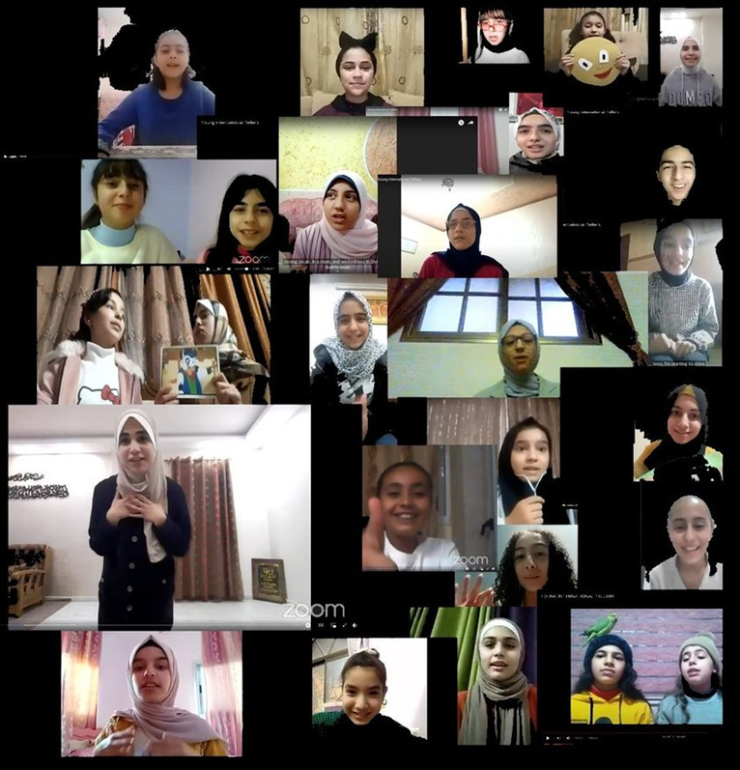
Photo: Children telling the world tales from their homes in Gaza at the weekly Young International Storytellers at the World Storytelling Café https://worldstorytellingcafe.com/ since 2020.

Response
The teachers we know in Gaza have responded with appreciation that their students’ stories were being shared online. Because of Internet access being heavily restricted, neither teachers nor students in Gaza have been able to watch and enjoy the recordings. However, the most important thing for them was to know that the rest of the world could. Since the beginning of 2024 I am no longer receiving replies to the messages I am sending by Messenger for the obvious reason that citizens of Gaza are no longer easily able to communicate online. Their circumstances have become increasingly dire. Here are a selection of comments showing the support teachers in Gaza felt, knowing that the world was listening to the children’s stories which I was sharing from 10 November onwards:
12/11/2023, 16:39
Samir: Thank you so much David for your wonderful attitude towards the situation in Gaza and thank you over and over for standing with us. Thanks to the noble million people over there as well. If I have a lifetime left, I will have to share many stories of what we have experienced.
23/10/2023, 16:44
Shams: So you may know why we are in love of stories ??? since we don't have in our life “.... and they lived happily ever after”
14/11/2023, 14:16
Amal: Your message along with other messages from friends mean a lot to me and make believe that ‘somebody out there cares’
07/12/2023, 18:12
Deyar: Thank you so much David for keeping Palestinians in your heart and for allowing our voices to be heard all over the world 🌸
11/12/2023, 11:57
Sahar: Appreciated efforts dear We can't forget your stand
13/12/2023, 14:19
Hend: Hi, David. How are you? My sister in law, she's German, just asked me if I saw your project, "I wish I were a candle in the darkness - storytelling for Gaza." She says it's beautiful! When she asked I was like😲 David is a friend of mine!! Your project is reaching Germany as well 🤗
24/12/2023
Diana: loads of love & peace from Gaza, you light up our lives with your support and beautiful hearts
25/12/2023
Ruba: Hala is an amazing girl i do not know what is happening to her. Thank you for everything

Further developments
As the crisis continued and deepened Haneen and I launched Tell a Child in Gaza’s Tale on 1 January 2024. Here is a link to the whole project so far in one document: https://drive.google.com/file/d/1BKu7JPXmONEB6y5cbeGlUW6zWi3SmRAP/view?usp=sharing In it you can find photos and links to the 65 tales told by children in Gaza (there are also a few told by two young teenage girls in Hebron in the West Bank). Following on from these are links to the first of the same stories being retold by storytelling teachers of English, professional storytellers as well as learners of English. These are being shared with us with increasing frequency and we hope that you reading this means that these stories continue to flow around the world.
On 28 January 2024 Haneen Jadallah and I had a conversation about Tell a Child in Gaza’s Tale and here is an edited transcription of what Haneen said:
Haneen: I am English teacher at UNRWA schools in Gaza and I am interested in storytelling and drama as a way to empower young people to share their stories with the world and also to find their interests and other people's stories. We were very much interested in innovative methodologies to enhance the students’ English language skills and also to look at them as whole human beings who have got a lot to offer the world and who have got a lot of stories to tell, given the fact that they are facing very challenging contexts on a daily basis. So I see myself as a focal point between the context in Gaza and the context in the UK.
The children were very excited about online storytelling sessions at the World Storytelling Café from the moment Young International Storytellers began in 2020. Sometimes they would make up stories, sometimes they would retell well known stories, sometimes they would tell stories from Palestinian heritage. And irrespective of what story they were telling, they were having a flavour of who they are and who they want to be and what kind of things they want the world to know about them. They were very confident telling these stories, and they were inviting the world to find out more about them.
David: What led to you and me spontaneously coming up with this new project ‘Tell a Child in Gaza’s Tale’ at New Year 2024?
Haneen: Given the critical situation in Gaza and having the children deprived of education, we needed the world to know that those children have got interests, they have got choices, they have got stories and topics that they want to tell the world about. The idea of people retelling those stories and finding the resonances in their own context to these stories and hearing these stories from Palestinian children is powerful. Such a project will give educators, young people, teachers, storytellers in all parts of the world the space and the time to learn about the children’s interests and educational backgrounds and how they were able to deal with challenging circumstances by telling stories on Zoom.
David: The children whose stories are being retold probably don’t at the moment have access to the Internet to know that their stories are being shared and to hear other people, children and adults, retelling their stories. What are the benefits of this project to those children?
Haneen: When all of this clears up and the war ends, the children will hopefully be alive to watch and see who were able to stand up for them and tell their stories and keep their tales alive, so it's very important. When you're facing a difficult situation, very few people are always able to stand up for you and be with you all the way through. So for those children, after the war ends, they will be able to have a look. “Just think all these people were telling our stories and they were keeping us in their thoughts and they were talking about us and talking about our interests.”
So even though they can't access the stories now, they will be very glad knowing this. For example, Sarah was one of my students who also was involved in the World Storytelling Cafe. Although she didn't tell a story, she was watching the stories being told at that time and I've got a picture of her watching you telling a story. She has faced a horrific situation in recent months in Gaza and, after she's left, she started wanting people to listen to her story during the war and what she had to face. And when I shared her story, she was very pleased. When she got access to the Internet again, she could see how many people are following and sharing and caring and seeing the truth, so it's very important.
David: I remember a specific example of a child that you were teaching who told a story. You were there at the World Storytelling Cafe with her and spoke about that. Could you just briefly tell us about that?
Haneen: I was teaching Grade 9 at an UNRWA school in Gaza and I had a very creative student called Deema. Deema was very good in terms of the written language, but she was very shy and she always had a barrier between herself and her speaking skills. So I just invited Deema to tell a story at the World Storytelling Cafe. And she chose to tell The White Elephant. She spent a day, I think, before she went live at the World Storytelling Café, to prepare her story. I think she practiced that with you in a meeting and then when she told it again it was much better because she felt that she was more confident telling it. And she was very glad, knowing that she was confident enough to tell the story to people who she had never met in her life, and they were listening to her and caring about what she was saying. You can find the video recording of Deema telling the story of The White Elephant and Haneen’s response in the link to the project above.
I was very proud seeing her on Zoom for the first time at the World Storytelling Cafe, having all these people from all around the world listening to her when she's speaking English as a second language and for the first time telling a story. So I was very proud that she could break that barrier and feel confident that she was able to share something she loved sharing. I had no power telling her what to choose, because it was completely her own choice. But then I was asked to comment on her performance and on the overall session, and I just thought that those children are facing a lot in everyday life. It's very challenging for them to learn a language that is not spoken in their own context. They don't have the chance to speak it with other people. They don't have the chance to travel, so they have very limited opportunities to study abroad, for instance. It feels like what's the point of me learning English through storytelling? But they found that storytelling is an outlet. They felt engaged in learning the language. So they felt that the ultimate goal is “I am able to use my English to tell my story to the world, something that I have chosen, something that means a lot to me, and it's totally my own choice and my own freedom. When my freedom is taken away from me, I still have the freedom to tell a story.”
That meant really a lot to the children and to us as their teachers.
David: There are 65 stories shared between 10 November 2023 and the 13 January 2024 including Deema’s story The White Elephant. All of those stories are there on the Tell a Child from Gaza's Tale playlist for teachers, for storytellers, for story lovers, and certainly for learners of English adults, children, teenagers, to listen to and to learn and to retell. Some stories are being chosen again and again, often the very short and simple ones, which is great. Let's invite people to listen to some of the stories and maybe decide on a story that they want to tell.
Haneen: I invite teachers, educators, storytellers, young people, kids, children and every human being who believes in the power of storytelling, who believes in the power of education. We invite you, myself and my colleague David Heathfield, to select a story that is chosen by a Palestinian child in Gaza and start retelling this story in your own context. To your learners of English, to your children, to your friends, to people you love. Those Palestinian children have been always hospitable to the people in the world. So let's give them back some of this hospitality by retelling their stories and keep their tales alive.
David: Listening to you, Haneen, makes me realize that what we’re doing is worth doing. So thank you very much.

How you can participate
1. Stories need listeners. The first thing is to choose a few stories in the project link above told by children in Gaza and enjoy them. You can invite people you know to listen too, including learners of English. You can leave your responses as comments on YouTube or Facebook. In some cases, it may be challenging to understand the story fully. This is in part because of the limited bandwidth in Gaza even at the best of times. The good news is that many of the stories have already been retold and recorded by teachers or storytellers whose recording equipment makes the stories clear and easy to follow. In these cases it is useful to listen to the story a second time to fully appreciate the child in Gaza’s tale.
2. Stories need tellers. The best way to pay tribute to a storytelling child in Gaza is to retell their story and share it. You might begin by choosing and retelling one yourself. If you are a teacher, you could tell and teach the story to your students yourself. Share a video recording of you telling the story and, if it’s permitted, invite your students to share video recordings of them retelling the story. You can also go on to invite your learners to select stories they would like to learn and retell. The more times a story is told and retold by different people the better. This the heart of our project. Retelling stories is a rewarding and deeply powerful way of learning English.
Stories
The first stories being retold by language learners are just starting to be shared. Among them you’ll find stories retold by Juana and Juan from Argentina, both 15-year-old students of Maria Teresa Continanza (see posts from 14, 15 and 16 January 2024 in the linked document).
Maria Teresa Continanza writes: Why did I ask Juana and Juan to learn and tell these wonderful stories?
The answer is just simple: Collaboration and learning from others. Juan and Juana are two teenagers who are learning English in Argentina as a foreign language. One day, they told me two important things:
1.They want to learn English to communicate with the world.
2. They want to be teachers of English when they grow up.
So, I thought that if they wanted to be the best teachers in the world, they had to learn from the best ones: Young storytellers from Gaza. I gave them beautiful stories told by young people from Gaza in the World Storytelling café. Juan and Juana felt inspired by children and teenagers just like them who were telling those wonderful stories to share with the world peace, empathy, and hope. (Learning from others)
They also felt it was a very important task because they were sharing stories for the world to listen to Palestinian voices. They were telling stories to the world not to forget. (Collaboration)
They loved retelling the stories. They felt they were learning from wonderful children, but they also felt they were helping these children spread their voices.
Palestinian people will always be in our hearts because of their generosity, their passion for education, and their messages of peace. They open their hearts to all the people in the world, sharing what they have, sharing who they are without selfishness or hate.
Palestinian people are the best teachers in the world, so if I want to show my students what my source of inspiration is, I will send them a story told by a student from Gaza, again and again.
These are Juana's words: I decided to tell the story because it's a way to let them know that I support Palestinian people in the face of what’s happening in their country nowadays. Also, I wanted to show them how beautiful their stories are for me and how grateful I am that I have the opportunity to know all the amazing stories they have done. This activity helped me to increase my English skills like my listening comprehension. Also, doing this activity I demonstrate my respect and appreciation to all the children in Palestine.
And these are Juan's words: I think one of the reasons I wanted to tell a story for the kids in Palestine was to give them what I learned from them. And, I believe that telling their story would be a way to engage with their culture and to foster understanding and connection between us. As for the benefits of doing so, well, I suppose it would give both their English abilities and cultural knowledge a boost. As I want to become an English teacher, listening to a story from the kids in Palestine and retelling it also offered me benefits. First of all, it gave me an opportunity to improve my own English skills: listening to understand and by practicing several times, my fluency. I expanded my knowledge of their culture through stories, stories which have been learned from other people, maybe. In addition, retelling the story allowed me to share my love for the English language with other people. Kids in Palestine are learning English just like me to communicate and tell the world our ideas and thoughts.
Tell a Child in Gaza’s Tale: https://drive.google.com/file/d/1BKu7JPXmONEB6y5cbeGlUW6zWi3SmRAP/view?usp=sharing

