Pop Culture Conventions and Literacy Learning

Paolo Nino Valdez, Philippines

Paolo Niño Valdez is a Full Professor at De La Salle University in Manila, Philippines. In 2022, he was a Fulbright visiting scholar at Hunter College, City University of New York and conducted fieldwork on linguistic landscapes on business establishments and cultural events. Email: paolo.valdez@dlsu.edu.ph

Introduction

Originally intended as a grassroots activity for fans to converge, conventions have become global pop culture events which feature celebrities, brands and supporters from different media. Coupled with the prominence of the internet, conventions have not only attracted the attention of fans all over the world but opened opportunities for different forms of entertainment from different countries to participate in these events. For instance, the growing popularity of Anime, third party toy companies and new artforms have eventually become staples to the growing con culture. With this growth, conventions are significant for global brands across different fields to introduce new products and services capitalizing on the participatory nature of these events. That is, conventions represent a space within the global market where producers and consumers use different modalities to showcase products and experiences.

Since the world has been slowly recovering from the COVID-19 pandemic in 2020, the return of pop culture activities such as conventions or ‘cons’ has been a welcome change for fans around the world. In the case of New York Comic Con (NYCC) 2022, organizers reported a larger turnout as most restrictions implemented in the city during the pandemic were lifted earlier in the year.

Investigations on fandom have pointed out that conventions are rich sites for research as the contact of languages, cultures and practices result in interesting meaning making processes. As an attendee in NYCC, I also took the opportunity to examine the potential of this event to inform my research and teaching as well. Specifically, this entry reports on the uses of languages and multimodal resources in anime and cosplay in conventions.

Originating from Japan, anime gained prominence globally as a major form of entertainment. In the convention, a significant part of the venue is devoted to different anime programs and merchandise. Aside from props from the popular shows, the Japanese language appears prominently. For instance, the Naruto (a popular program) booth, which recreates the popular ramen place in the show includes the Japanese characters 一楽 ラーメン (ichiraku ramen) and large ramen bowl prop is placed in front of the booth. In this instance, the use of the Japanese language signals not only authenticity in terms of cultural identity but also communicates the brand to convention participants. Taken together, language and props that simulate items in the program form a commodity that appeals to consumers.

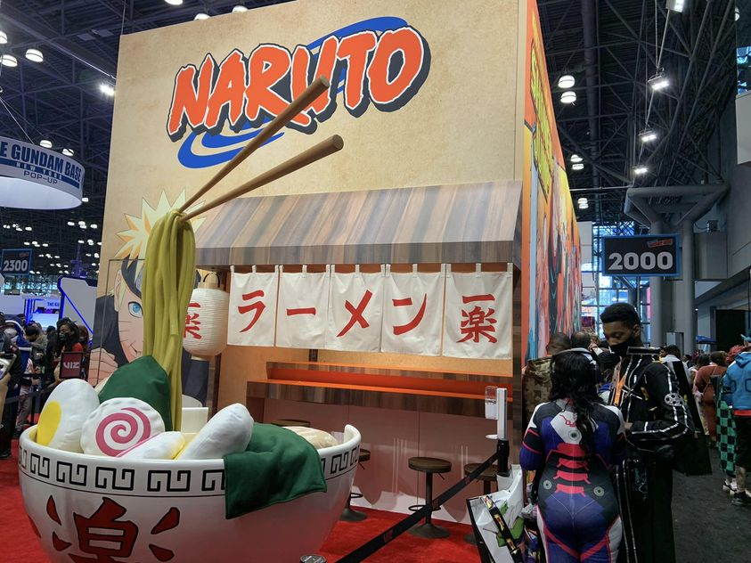

Another significant part of the convention is cosplay. Intended for creative expression, individuals wear customized costumes to recreate characters from popular culture. In addition, cosplayers mimic the characters they portray through actions and language. Previous studies on cosplay indicate the complexity of this process as it entails cosplayers to draw on rich resources from source texts where popular culture characters are based on and materially translate them in creative ways (Hale, 2014). For instance, the recreation of the popular character Venom and T-rex by a cosplayer may not be fully accurate as shown in the comics. However, through customization (painting of available costumes, adding decorations or props), an approximate recreation is done resulting in a remixing of styles which can have varied effects among attendees.

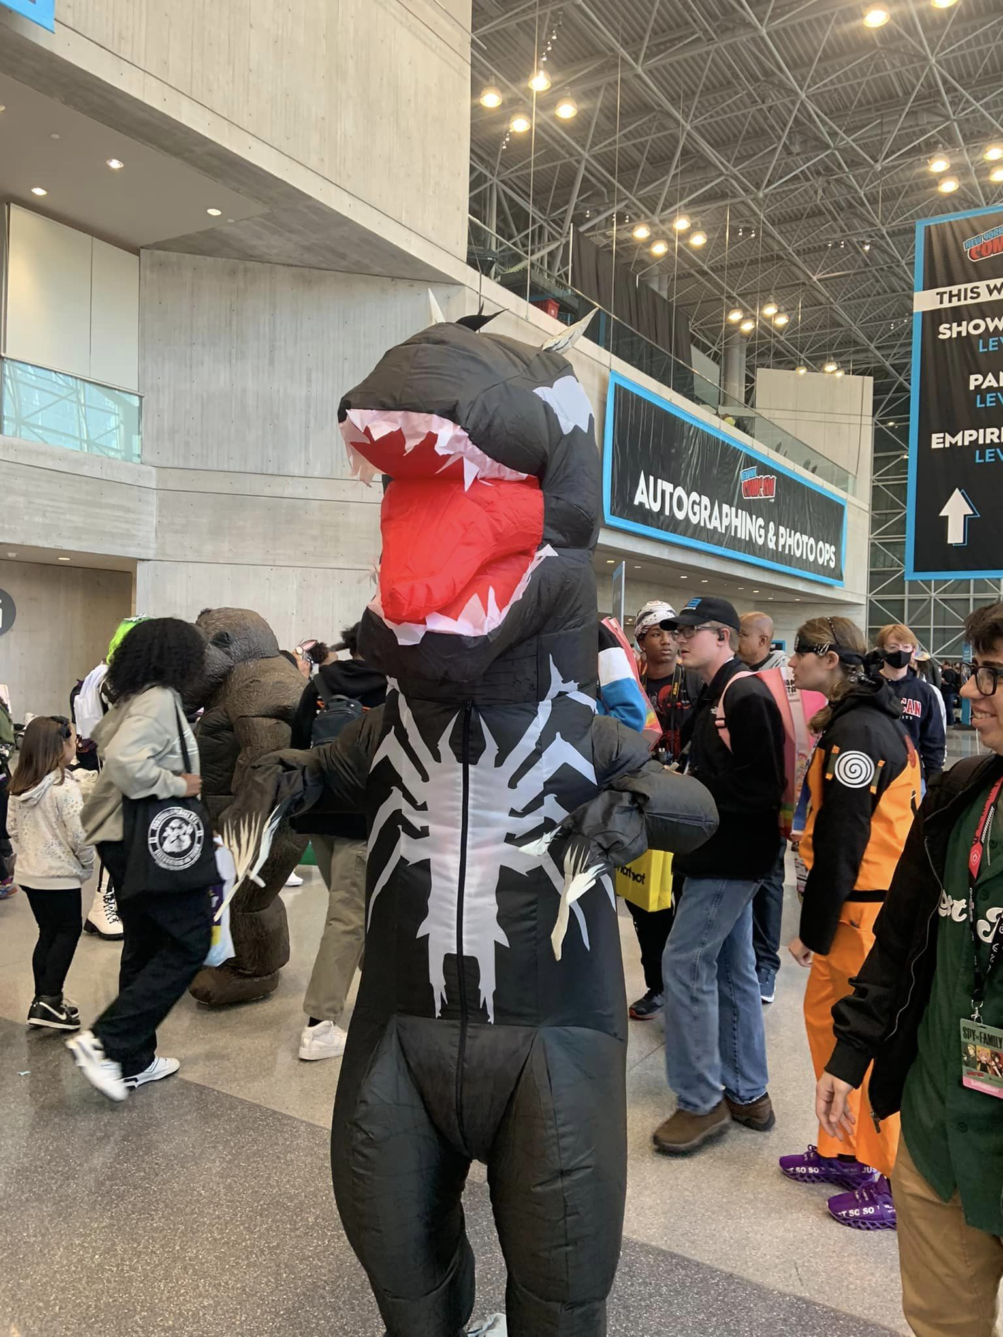

Since conventions are framed as a congregation between industry representatives and fans, affinity spaces are commonplace where more experienced participants help those who are unfamiliar with certain popular culture brands. Significant here is the communication of rich information about the history, impact and future of different properties through communities of practice. To illustrate, when I visited the Ghostbusters New York City Chapter booth, representatives were eager to narrate the origins of their group as well as the process in building and customizing their proton packs, a popular prop representing the equipment in the movie. Interestingly, the building of the equipment entails the use of specific materials but also opens opportunities for customization to make the piece unique to its owner.

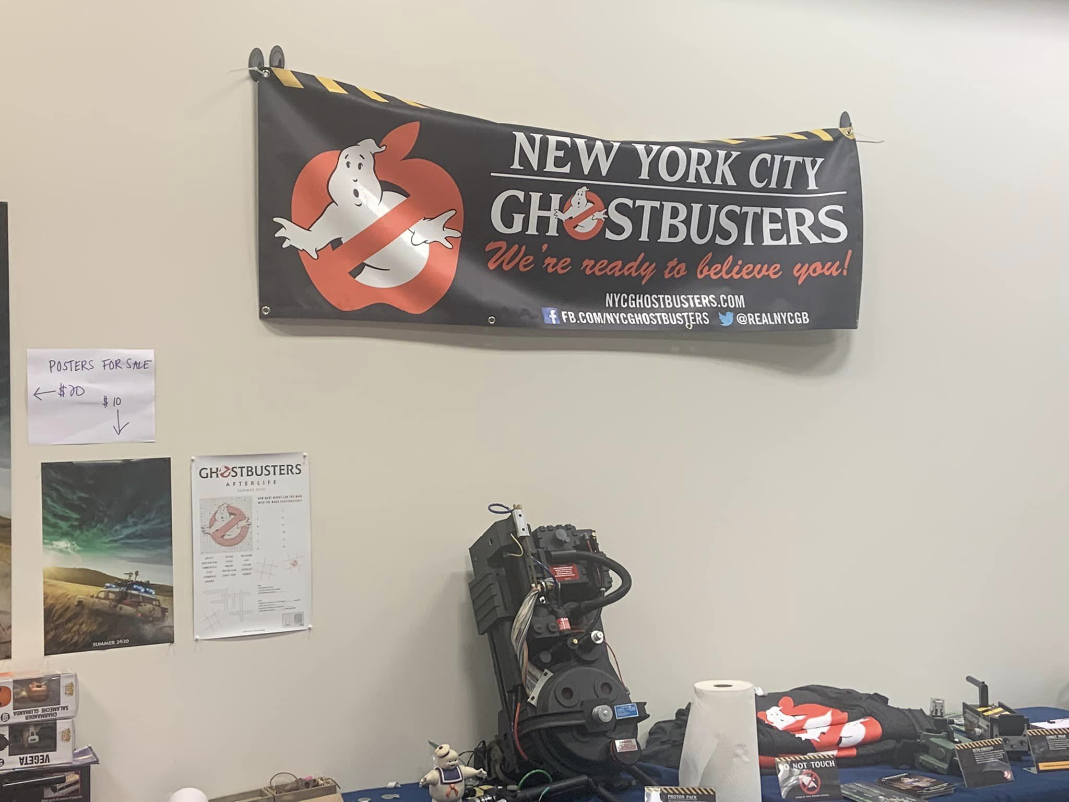

To conclude, conventions have become large events which highlight different aspects of pop culture where different modalities are used to create a sensory experience that taps into feelings of nostalgia and belongingness. For scholars, conventions are rich sites for investigating the intersections between language, culture and practices. Significant here is the use of props, costumes, signs to reinterpret understandings of characters, events and pop culture properties which resonate well among participants. Moreover, language becomes a powerful tool to describe the rich processes of how fandom is represented to a diverse audience. For teachers, conventions provide opportunities for engagement with learners. Specifically, this opens doors for examining novel uses of language and multimodal resources to enact authenticity and fluidity.

References

Aljanahi, M. H., & Alsheikh, N. (2021). “There is No Such Thing as Copying in Cosplay”:
Cosplay as a Remixed Literacy Practice. Journal of Adolescent & Adult Literacy.
https://doi.org/10.1002/jaal.1193

Gee, J. P. (2017). Affinity Spaces and 21st Century Learning. Educational Technology, 57(2),
27–31. http://www.jstor.org/stable/44430520

Gray, J., Sandvoss, C., & Harrington, C. L. (2017). Fandom, Second Edition: Identities and
Communities in a mediated world. NYU Press.

Hale, M. (2014). Cosplay: Intertextuality, Public Texts, and the Body Fantastic. Western Folklore,
73(1), 5–37. http://www.jstor.org/stable/24550744

Jenkins, H. (2018). Fandom, Negotiation, and Participatory Culture. In A Companion to Media
Fandom and Fan Studies, P. Booth (Ed.). https://doi.org/10.1002/9781119237211.ch1.

McKevitt, A. C. (2010). “You Are Not Alone!”: Anime and the Globalizing of America. Diplomatic History, 34(5), 893–921. https://doi.org/10.1111/j.1467-7709.2010.00899.x

Salkowitz, R. (2022, October 6). NYCC 2022 Means Business With Packed Schedule And
Show Floor. Forbes.
https://www.forbes.com/sites/robsalkowitz/2022/10/06/nycc-2022 -means-business-with-packed-schedule-and-show-floor/?sh=1c10fff848ed.

Please check the Pilgrims f2f courses at Pilgrims website.

Please check the Pilgrims online courses at Pilgrims website.

